  - BUSINESSBOXERP Website Builder
  - Taking the aid of the BUSINESSBOXERP website builder, the end-user can create stunning websites without much of a stretch. The website feature enables any average person to develop his own company’s online presence without much coding knowledge. The website serves multiple purposes for your company. On the one hand, it publishes information about your company and on the other hand, it can function as an E-commerce site, HR Recruitment Portal, or customer portal. This documentation will discuss the basic website builder functionalities. Following are some features of the BUSINESSBOXERP Website builder.
  - Intuitive system
  - What you see is what you get Insert text styles like headers, bold, italic, lists and fonts with a simple WYSIWYG editor. Flexible and easy to use.
  - Building blocks system
  - Create your page from scratch by dragging and dropping pre-made, fully customizable building blocks.
  - Front end management
  - Click and change content directly from the front end: no complex back end to deal with.
  - Word processor text editing
  - Create and update your text content through an editor designed to replicate the word processor experience.
  - Increase visits
  - Promote Tool
  - Improve your ranking on search engines and your organic traffic thanks to keywords suggestions and the Meta tag tool
  - Convert leads
  - A/B test your pages
  - Run several versions of one page to find out which one drives better results. Analyse results directly on Google Analytics.
  - Multi-version
  - Prepare multiple versions of your website and switch from one to another in one click.
  - Link tracking
  - Add a tracking code to your URL's and measure all your marketing campaigns from the first click to the final sale. Identify which campaigns are the most effective in attracting visitors to your website and generating revenue.
  - Enhance user experience
  - Translation tool
  - Get professional standard translations with Gengo integration.
  - Mobile preview
  - See what your page will look like on a mobile device with the mobile preview button.
  - Social media call-to-action
  - Share your pages through social media networks.
  - Live chat embedded
  - Provide your visitors with information in real-time directly on your website through a popup chat window.
  - Design features
  - Bootstrap-based templates.
  - Easily design your own BUSINESSBOXERP template thanks to clean HTML structure and bootstrap CSS.
  - Fluid grid layout
  - Create the best layout corresponding to the devices on which the website is displayed.
  - Professional themes
  - Change theme in just a click and browse through BUSINESSBOXERP's catalogue of ready-to-use themes available in our app store.
  - System Users
  - By default, there are two types of users in Website related modules.
  - Editor and Designer
  - Like the manager in other modules, he can access both the front end and back end of your website. He configures your website and changes its settings like setting up a payment gateway, giving portal access to customers etc.
  - Restricted Editor
  - Front end (i.e., portal) designer. He can alter only the portal view of the site.

  - Managing Multi-Website
  - BUSINESSBOXERP’s Multi-Websites opens a large plethora of opportunities in terms of diversification and customer segmentation for the business. With BUSINESSBOXERP Website Builder, the multiplied audience and boosted revenue is no more strenuous.
  - Each website works fully independent with its theme, branding prerequisites, domain name, header & footer, pages, languages, products, blog posts, forum, slides, events, live chat channels, and much more.
  - Let us see how it is working.
  - Firstly, enable the feature, Multi-website in E-commerce configuration settings.
  - 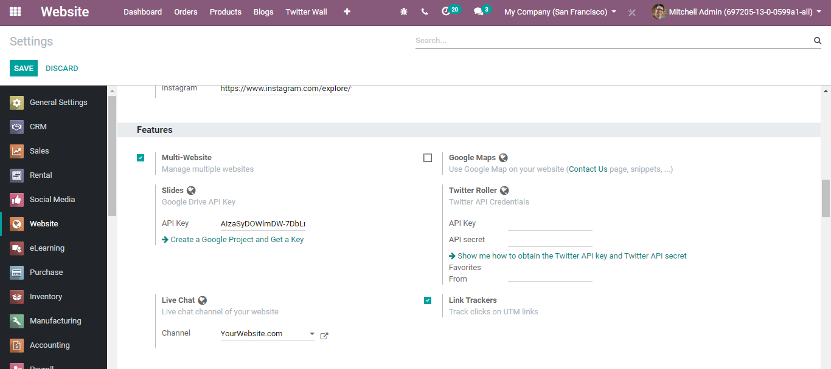
  - Now to create a new website, go to Website > Configuration> Settings.
  - 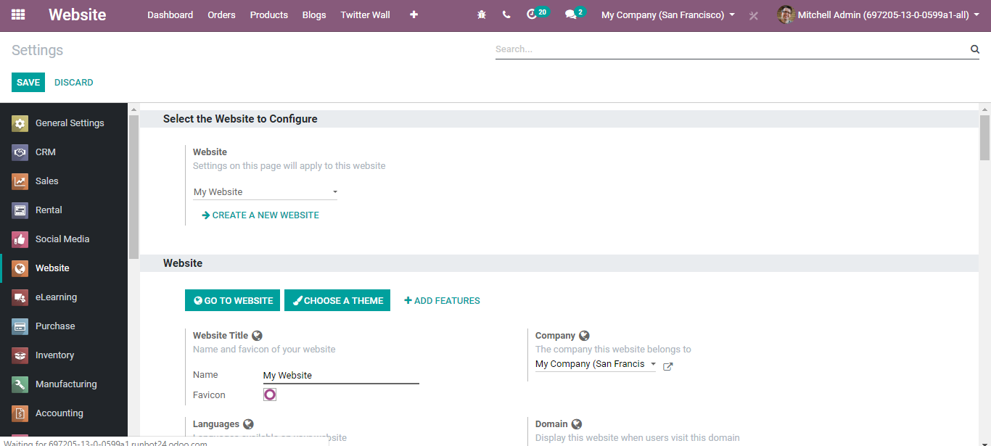
  - Click CREATE A NEW WEBSITE, you will be navigated to a new window like below:
  - 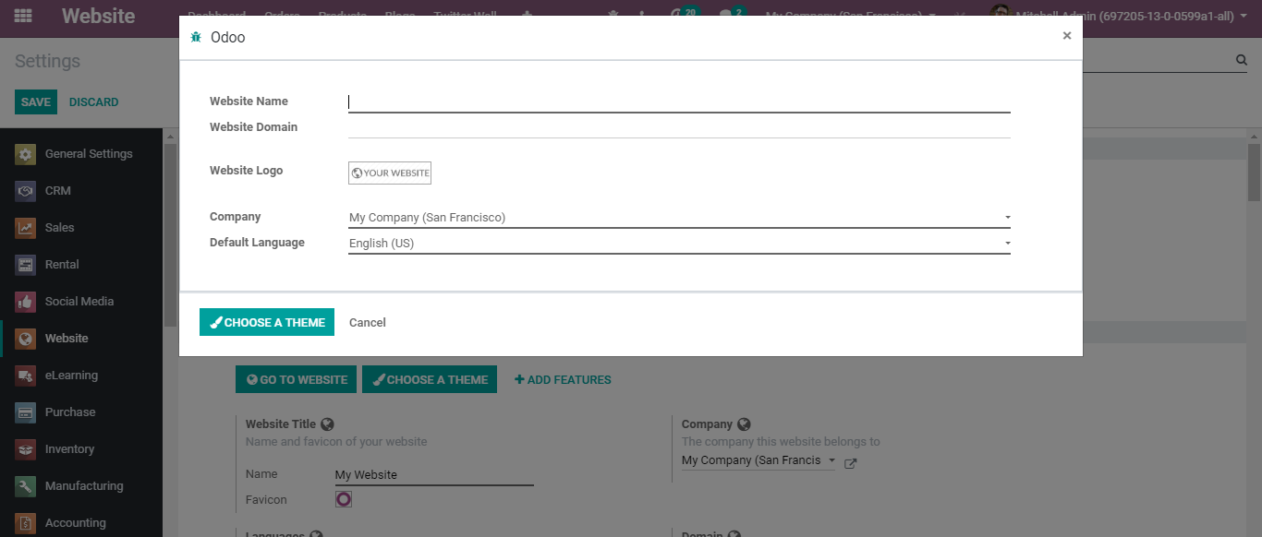
  - Here, the end-user can set a name for his company website and set a specific domain name too. Leave empty to publish the new website under the default domain of your BUSINESSBOXERP database. One can also select logo, company, and default language for the website. Upon clicking choose a theme button, you can easily select a theme for your website.
  - Add all desired parameters, and you get your new website all set.
  - 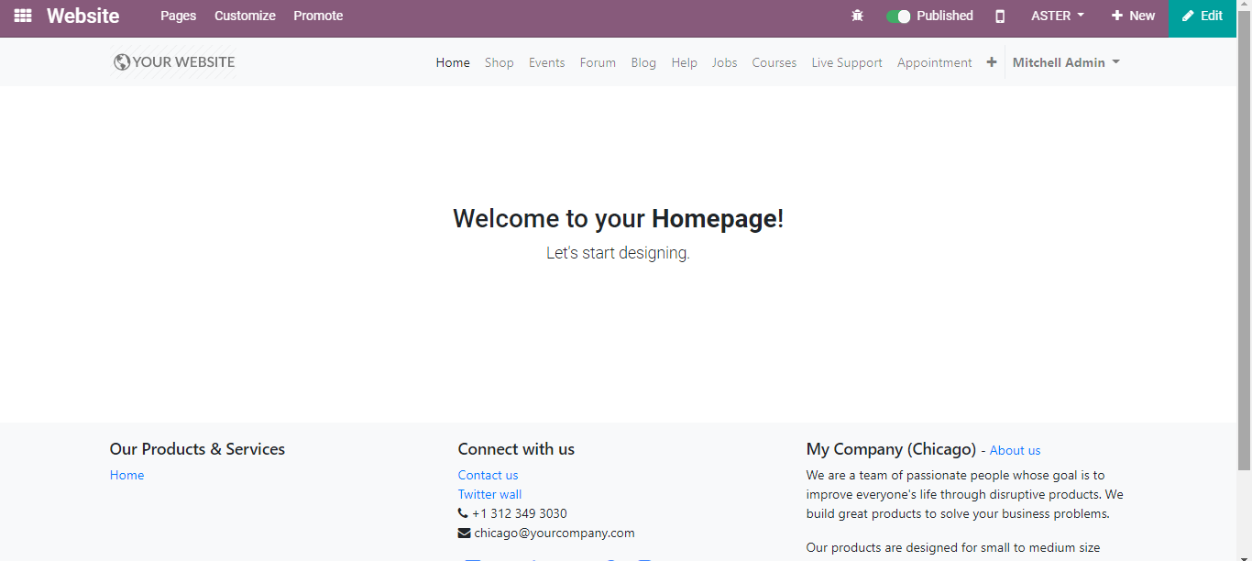
  - One can see the other created websites from the menu bar.
  - 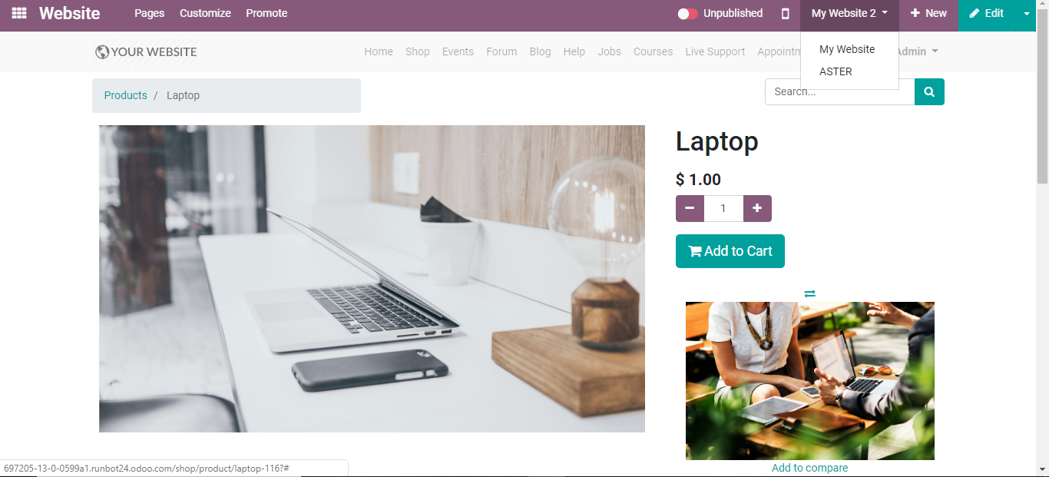
  - Managing Multi-Language
  - BUSINESSBOXERP helps you to go international. The BUSINESSBOXERP eCommerce comes with a language translation feature allowing you to translate languages automatically with a click. One can easily edit the expert page and BUSINESSBOXERP’s on-demand professional translation service, change the necessary part of the website for any language.
  - To do so,
  - Go to Website > Configuration >Settings.
  - 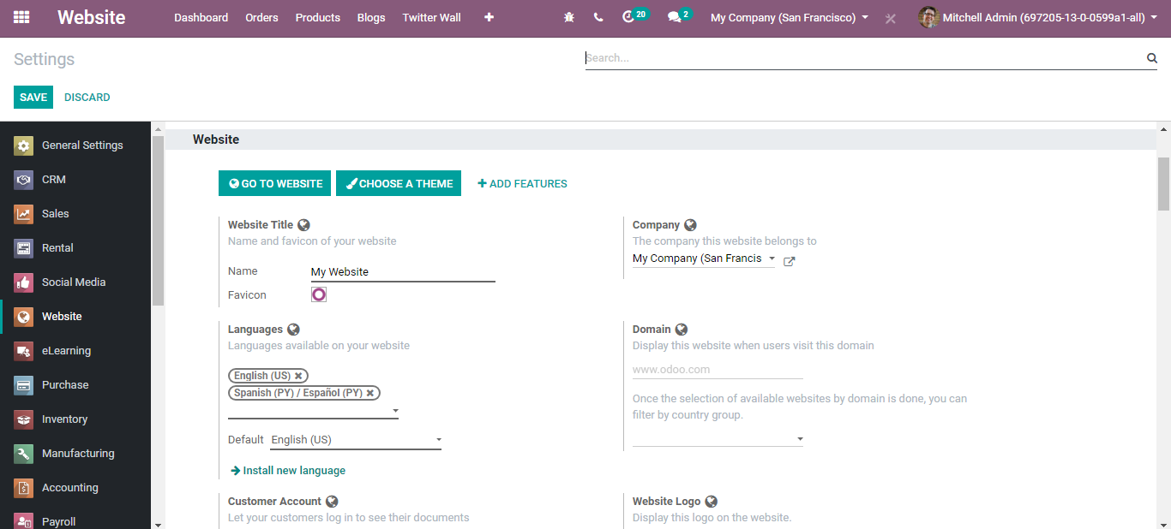
  - Type the languages you need and click SAVE to mark the changes. Now if you go to the website dashboard you can see the current language and the provision to change into new.
  - 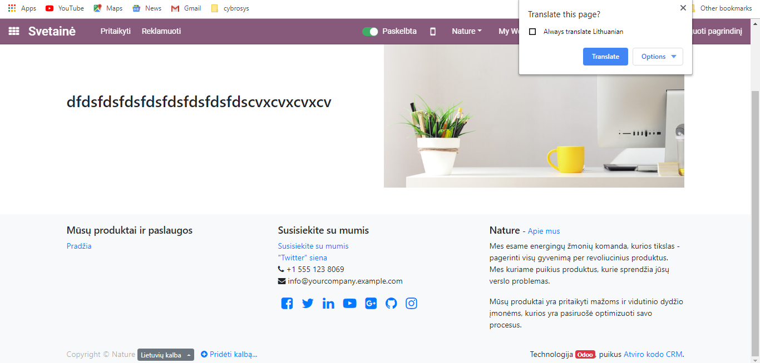
  - You can select the language and the system automatically asks for the translation. Click translate to get your website in a new language.

  - Building your Page
  - From the eCommerce dashboard, click on GO TO WEBSITE option.
  - 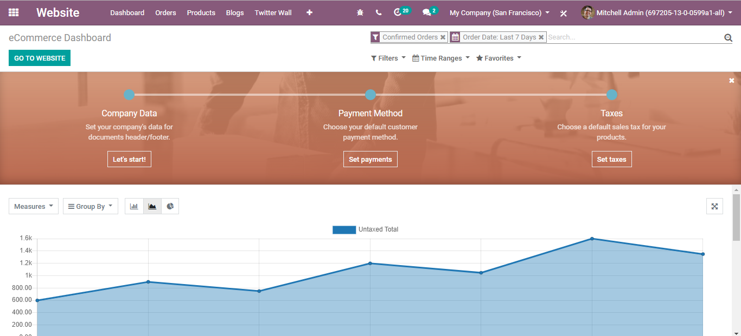
  - Upon clicking, you will be navigated to the Website page as shown in the below image.
  - 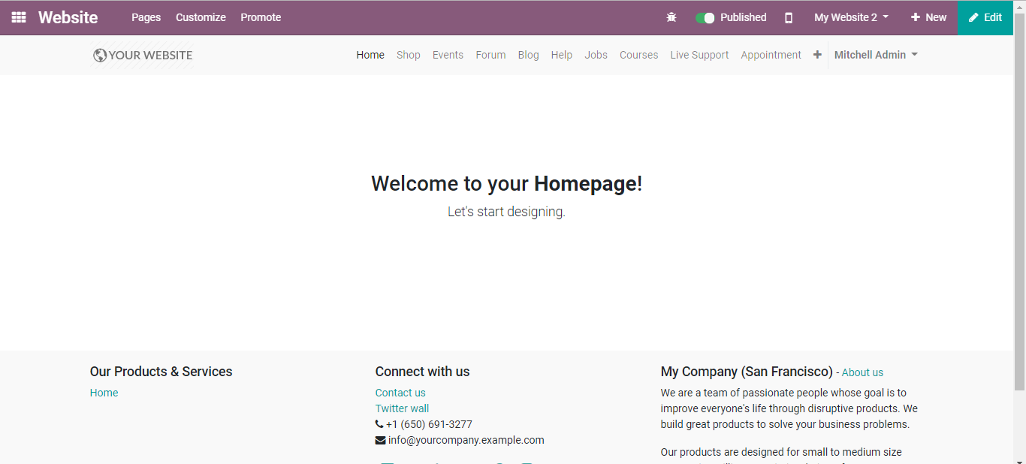
  - To manage your page, click on the Edit button in the top right corner. It will give you a default page and tools for designing the page. All you need to do is just Drag and Drop the contents.
  - Click on any element to customize it.
  - 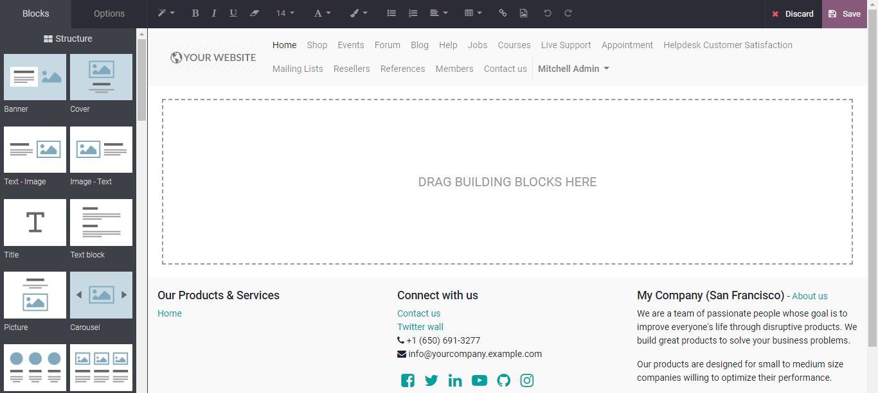
  - Make use of different design tools to make your website more attractive and inviting. However, do not forget to save the changes- the current design once you finish. Select a theme via simple drag and drop of structure blocks. You can select your theme based on the website purpose. Once the theme is selected, you can start to build the homepage of your website.
  - 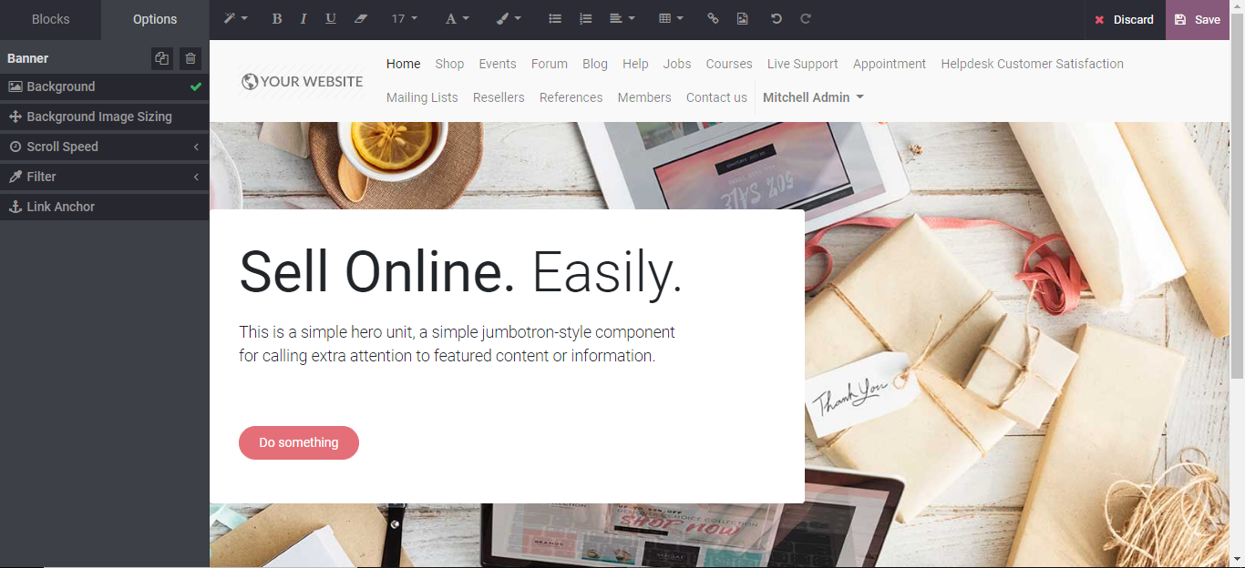
  - Click SAVE to mark the changes.
  - To get the mobile view of your website, you can click on the mobile preview button which is placed on the top left side of the menu bar.
  - 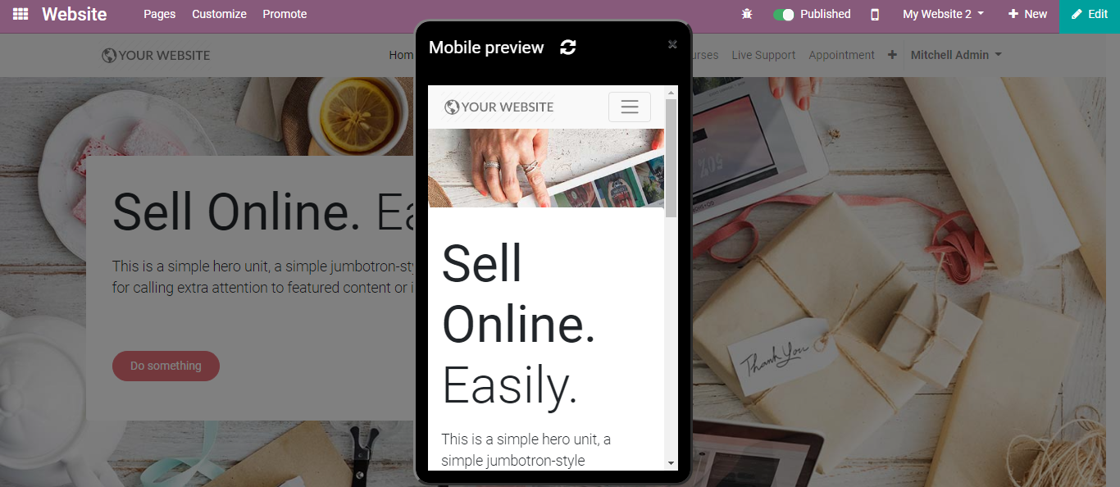
  - Customize Menu and Appearance
  - Menu and page customization
  - One can easily make changes in the appearance of their website. The changes can be made concerning Menu, Product view and more. To customize the menu, follow the below
  - configuration
  - Website > Pages > Edit Menu
  - 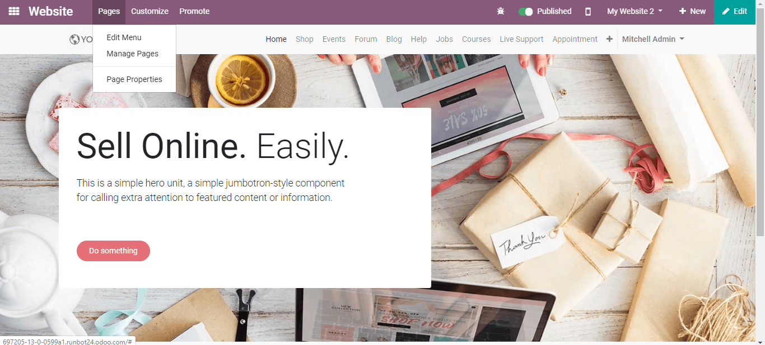
  - Create the menu
  - The new website will be encompassing with default menu with all the installed applications. To make changes or edit them click Pages > Edit Menu. Moving forward you can easily edit the menu of your current business website.

  - 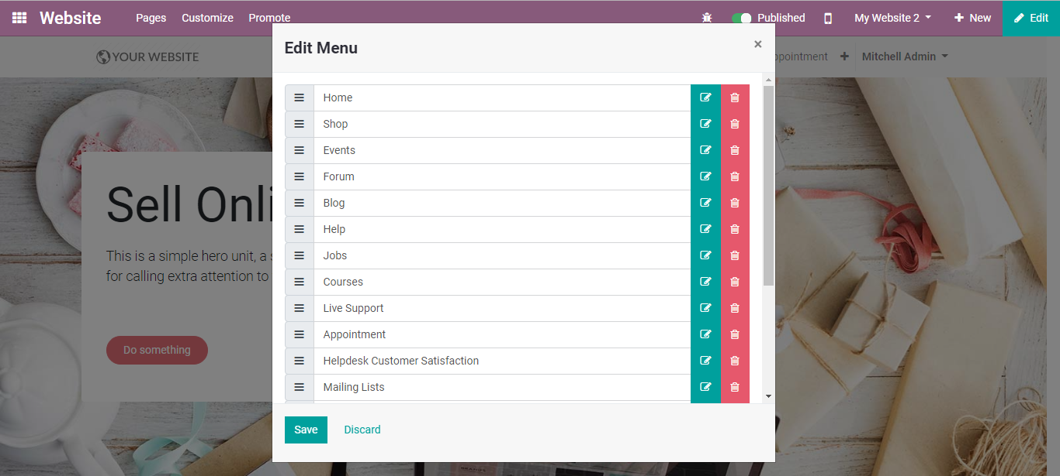
  - This window shall assist you to create new menu options, creating submenu and deleting menu options.
  - Via going to Website> Pages> Manage Pages
  - 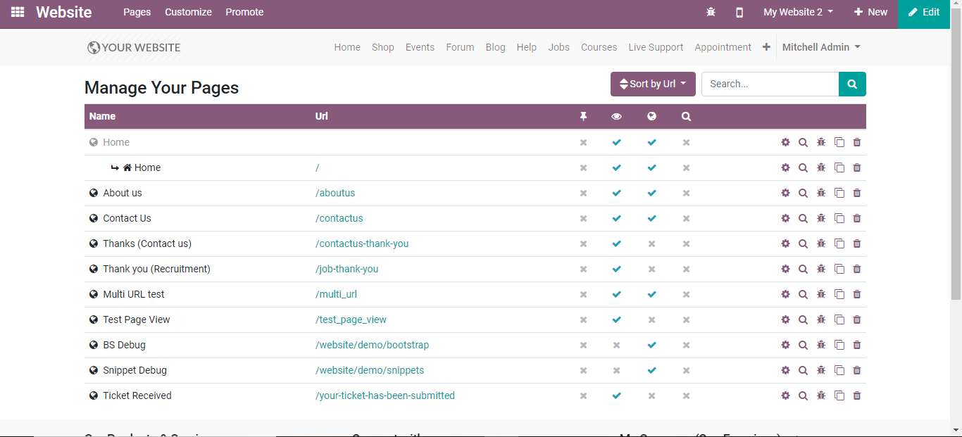
  - You can manage your website pages easily, also optimize SEO for this page, clone this page or delete this page
  - Appearance customization
  - The customer experience can be modified in all respects significantly on account of the menu *Customize*. All the visual choices accessible there are explicit to every site. Experience the various pages to adjust them to this new group of spectators. Concentrate on workflows, and automatic pages (e-Commerce checkout, blogs, events, and so on.) as the number of accessible choices is higher there.
  - To change the appearance of your website like the way your products are listed etc. follow
  - Website > Customize
  - 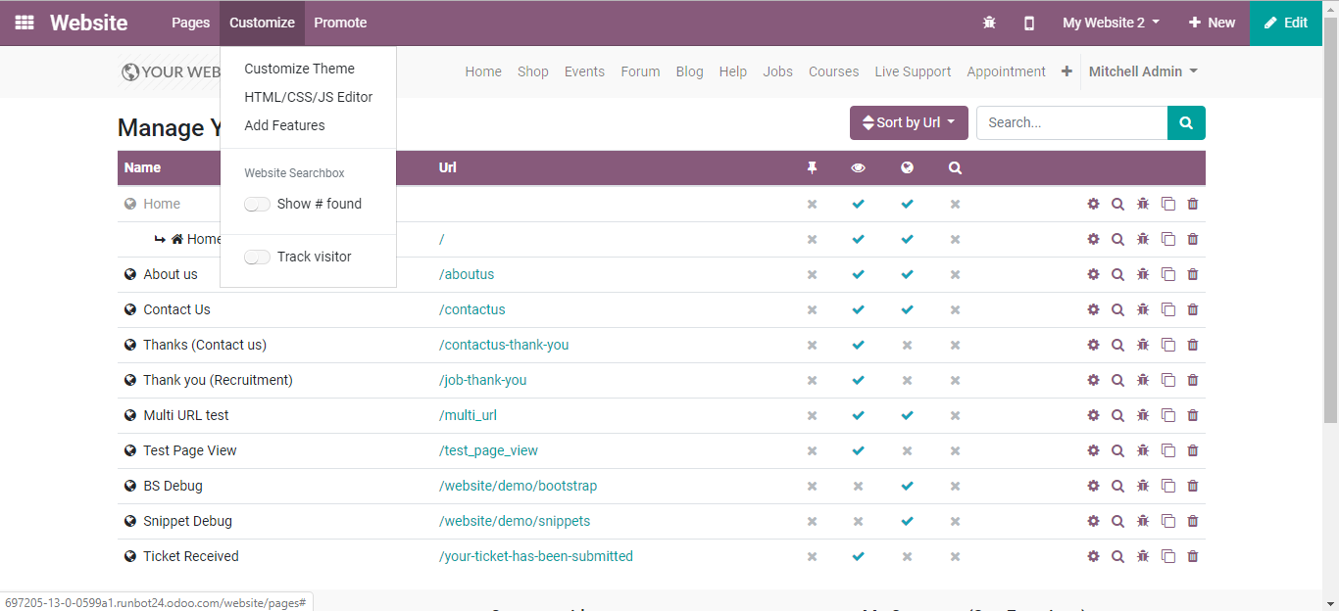

  - List your Products on Site
  - To list your products on the website, go to
  - Website > New > New product
  - 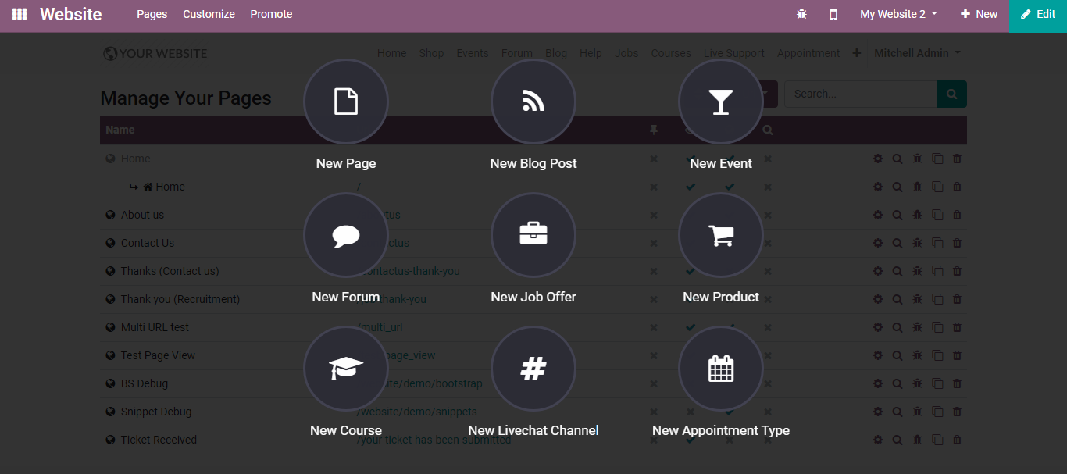
  - 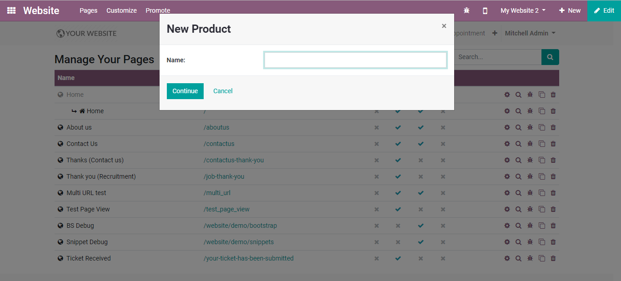
  - Upon entering the name, you will be navigated to a new menu like below.
  - 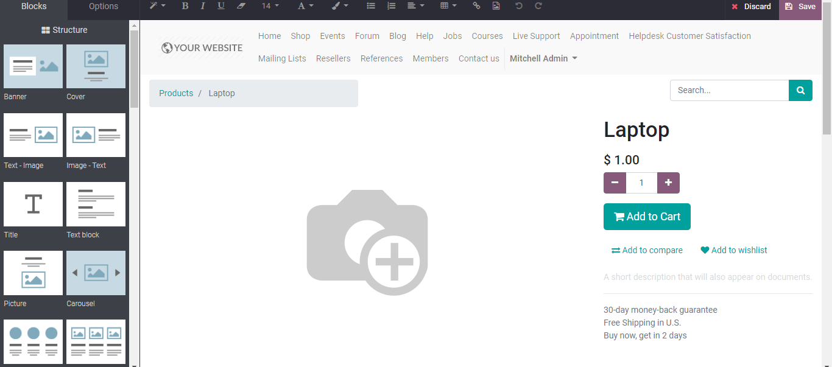
  - One can easily design the product page using builder blocks, also add the image and cost of the product. Via clicking ADD TO COMPARE, you can feature more images of the product.
  - 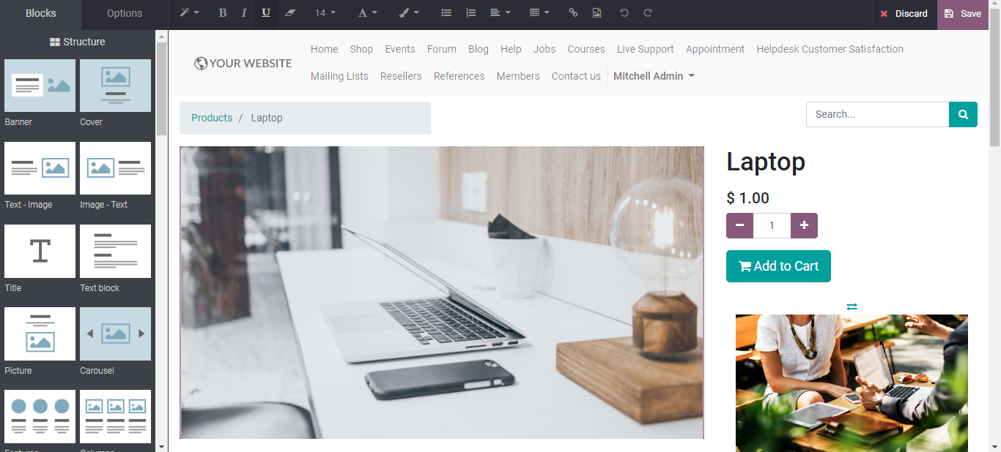
  - Upon entering the details Click Save.
  - 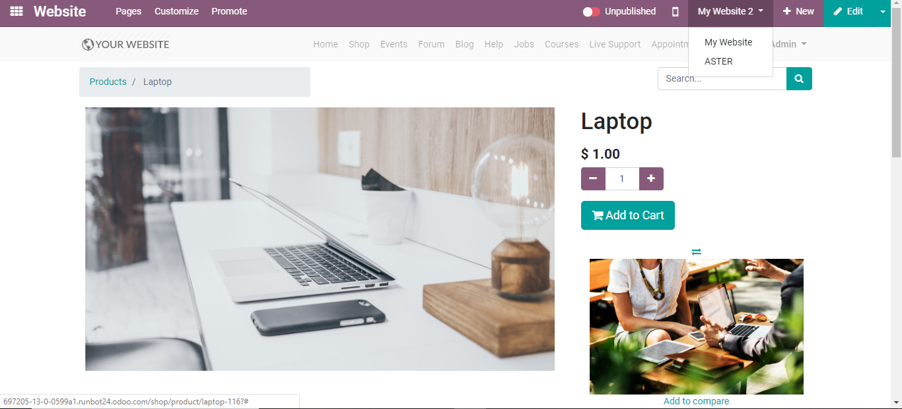
  - Via tapping the PUBLISHED/UNPUBLISHED button, you can make the presence of the product on the website.

  - Customizing your Product Catalog Page
  - The product catalogue can be seen on your website under the product page.
  - 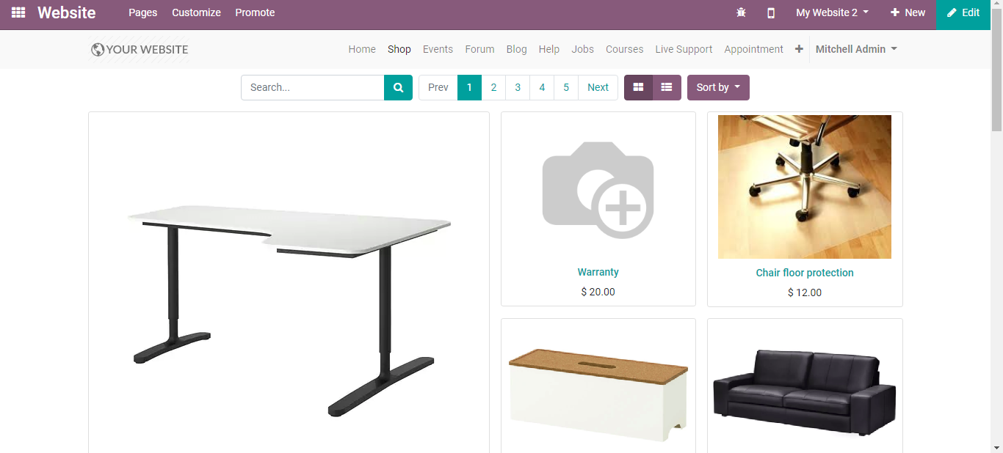
  - One can customize the product catalogue via choosing over different options under
  - 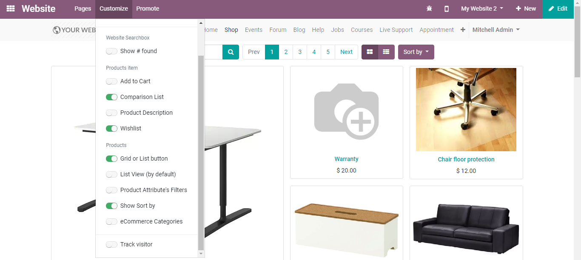
  - One can display attributes, website categories etc.
  - 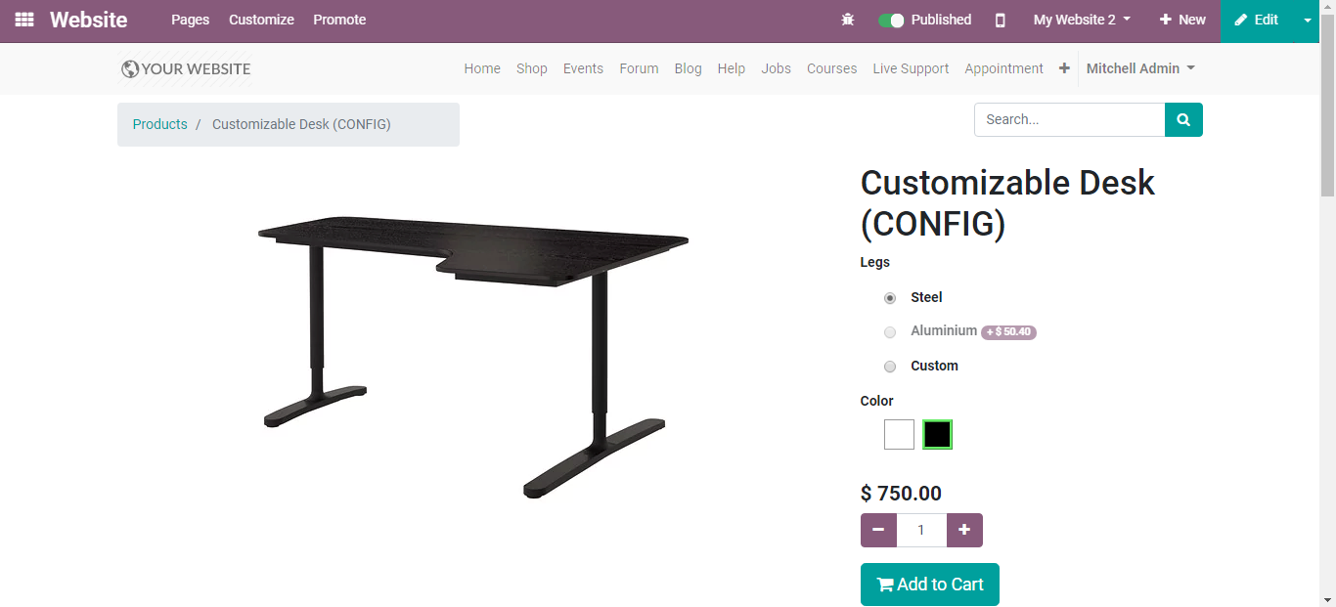
  - Via embellishing Wishlist and Comparison list, you can give your customers a new experience in the shopping
  - 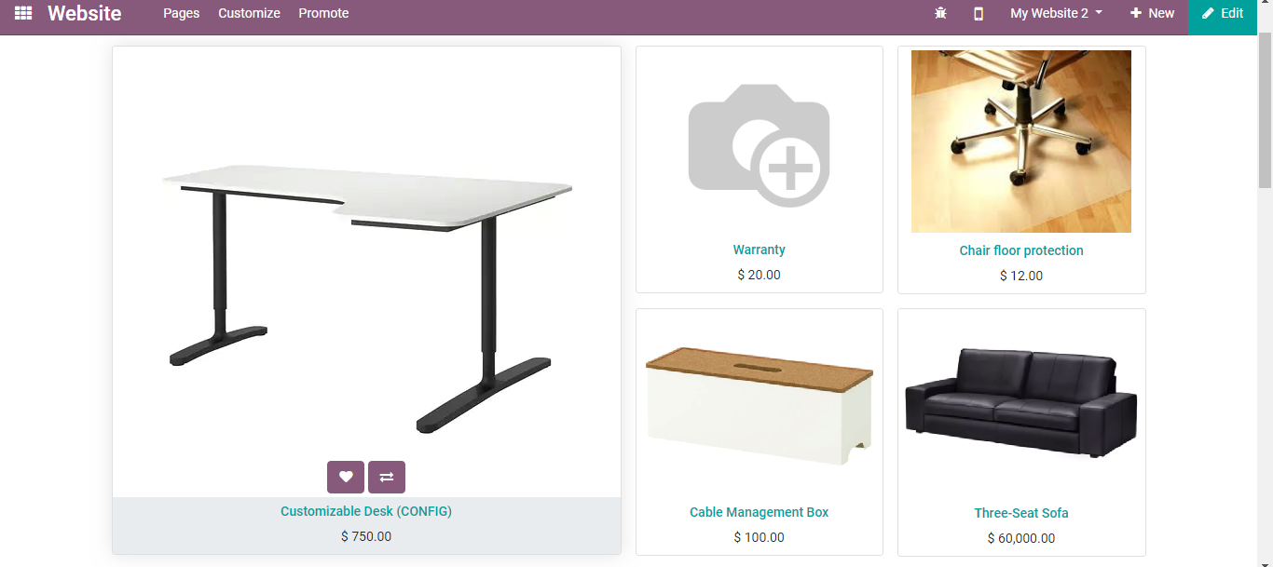
  - Quick add to cart
  - Via turning on the options such as Product Description, Add to Cart, List View in Customize menu, you can help the customers with easy purchasing.
  - 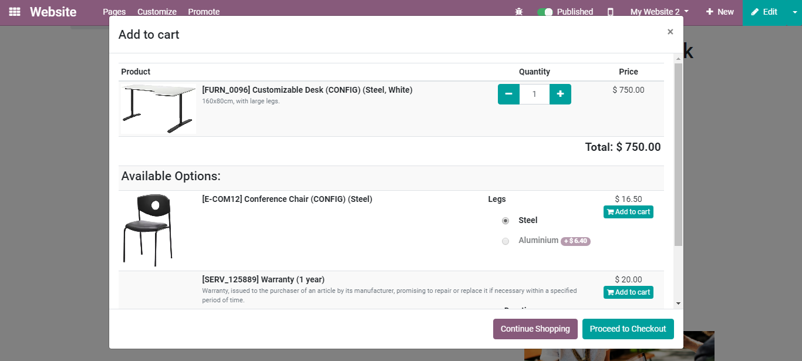
  - Via clicking the option CONTINUE SHOPPING the customers can continue with their purchase, or else proceed to pay via clicking PROCEED TO CHECKOUT.
  - 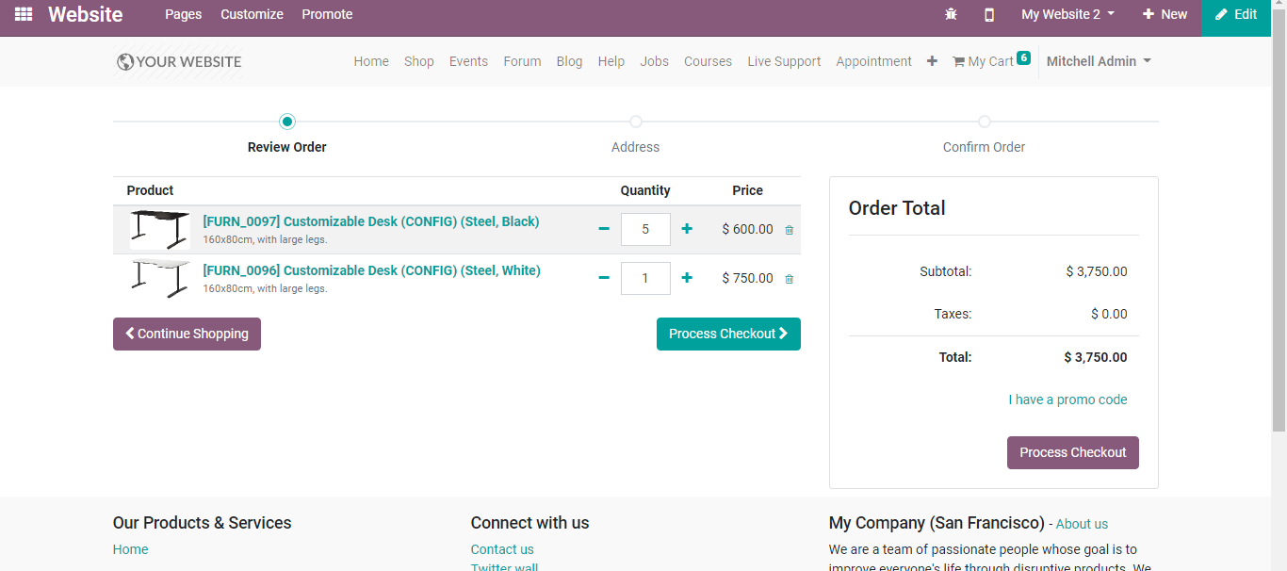
  - 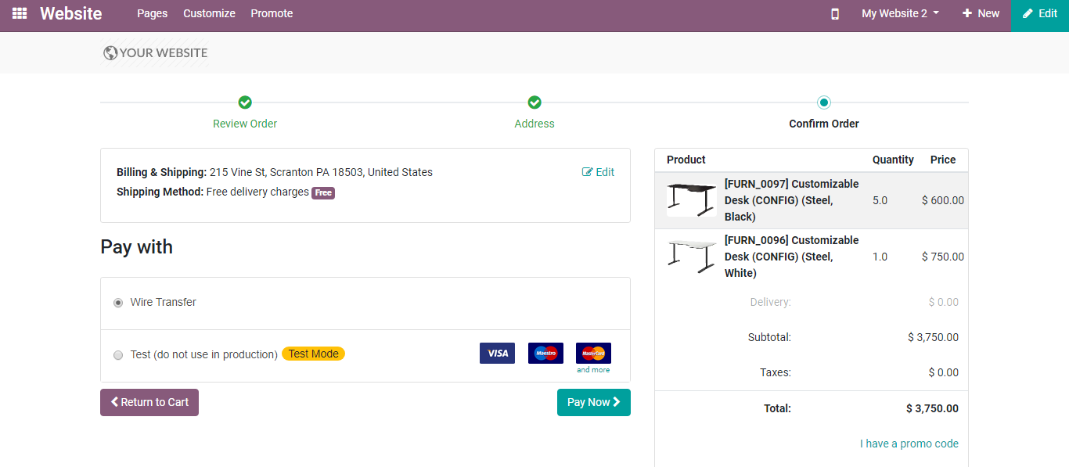
  - 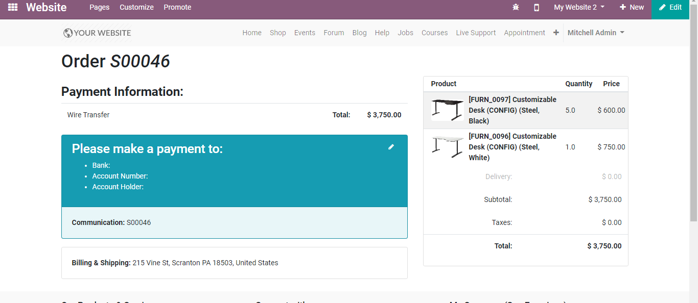

  - Switch From one Website to Another
  - As simple as ABC! There is a website switcher in the right corner of the edit bar. Switching over to another site will associate with the domain of this website. If you utilize another domain for the site, the client is mentioned to sign in.
  - 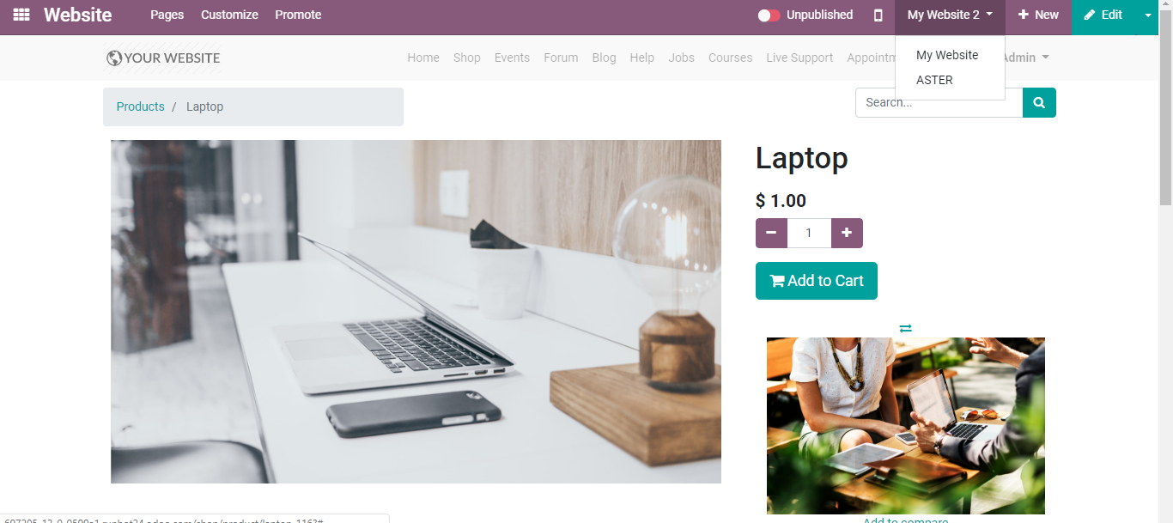
  - Publish Specific Content per Website
  - Like static pages, any content made from the front-end (product, blog entry, and so on.) is in every case only published on the current site. However, one can change that from the edit form view in the backend and leave the Website field clear. This will publish it in every one of the sites.
  - 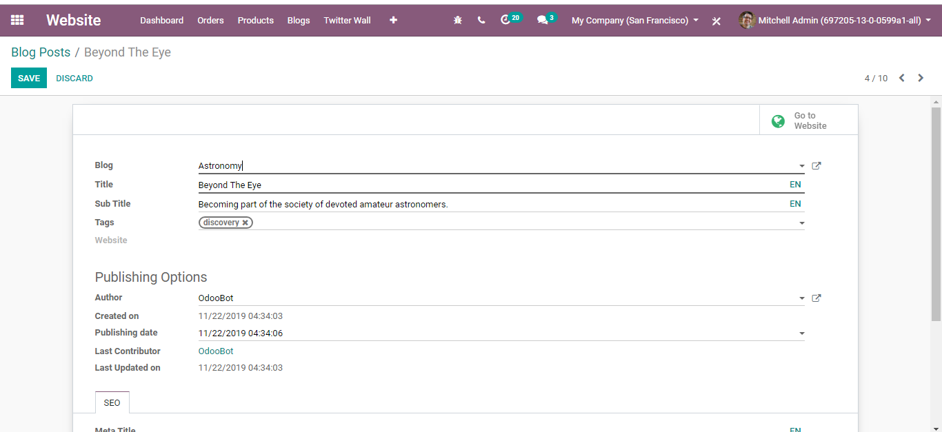
  - Here are all the objects that you can link to either one or all the websites are
- Products
- Product Categories for eCommerce
- Blogs
- Slide Channels
- Forums
- Events
- Events
- Note
  - Upon creating a record from the backend, followed by publishing it, a product/event is made available on all websites.
  - Customizing your Product Catalog Page
  - A static page is created and made accessible on the current website. Later you can copy it to different other websites from Website >Configuration > Pages. To do this, leave the Website field vacant. On the off chance that you need to duplicate/copy it in one other website, duplicate the page and set the new site.
  - 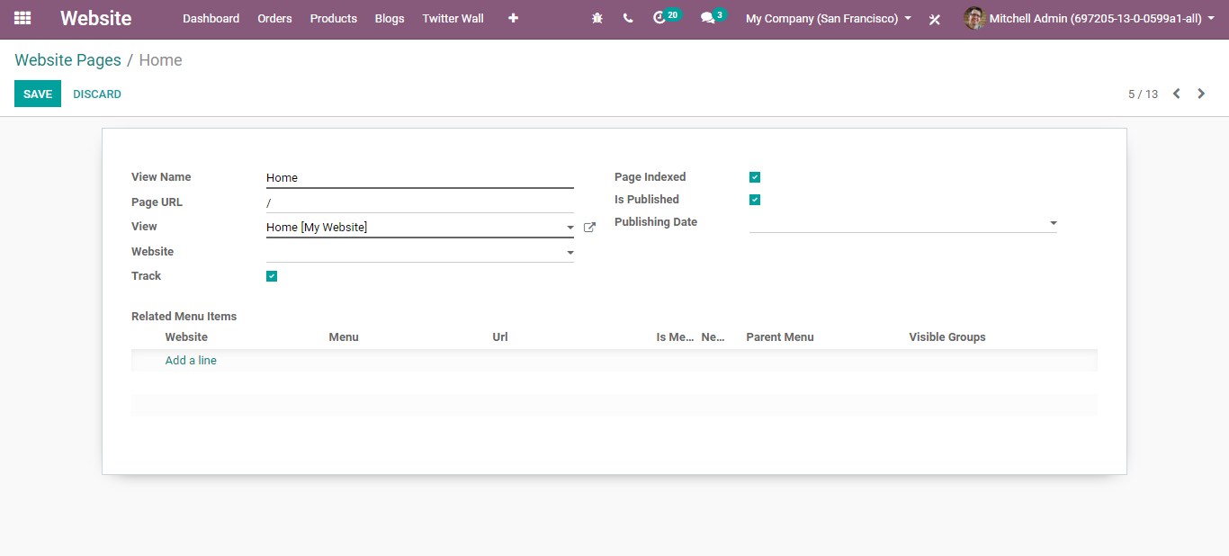
  - However, upon editing the page again, the end-user can see that the change only affects the current website. A new page is duplicated and tied up to the website. The original page is still being linked to all websites.

  - Multi-companies
  - BUSINESSBOXERP provision to manage multi-companies. Each website can be linked to a specific company of your system, in a multi-company environment.
  - 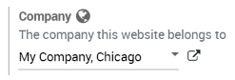
  - The advantage of such configuration is that in such cases only the company-related data appear on the website (products, jobs, events, etc.). The Website editors can thereby only view and edit those pages to which they have access (ones belonging to their current company)
  - 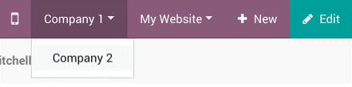
  - Configure your E-commerce website
  - E-commerce is a vital component in the multi-website’s environment. We made it with the goal that the whole stream can be altered to fit the very crowd of every site.
  - Products only available on one website
  - We previously observed before how to distribute a particular record in just a single site. You will discover the *Website* field in the E-commerce tab of the product edit form. Empty means accessible in all sites.
  - 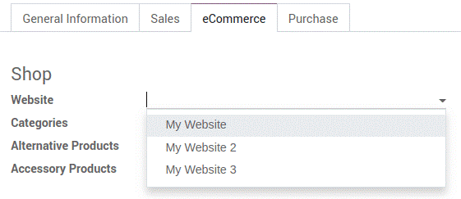
  - Products available on some websites
  - To make the product available on a few selected websites, not all of them, the end-user needs to duplicate the product for each website.
  - However, if you need a unique reference for managing the inventory, you need to install a Manufacturing module and create *Kits BoMs (bills of materials). Each kit shall link each published “virtual” product to the main reference.
  - Pricelists
  - To manage specific prices by the websites, one can activate Multiple Sales Prices per Product in Website settings.
  - Configuration
  - Go to Website > Products >Pricelists for creating additional pricelists.
  - Select a website to make pricelist only available on this website.
  - 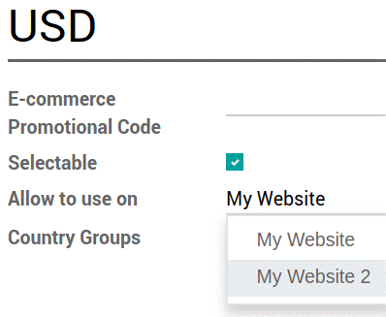
  - Leaving the field empty denotes that you shall make it work in all websites if Selectable is selected. Otherwise, it makes it only available for backend operations of Sales and Point of Sale applications.
  - Payment Acquirers and Delivery Methods
  - By default, published payment acquirers and delivery methods are deployed on all websites. One could use specific payment acquirers per country using Geo IP by defining countries in the configuration settings.
  - Customer accounts
  - BUSINESSBOXERP provisions a setting to choose customer accounts in Website settings. You can either allow customers to use one account through all the websites or compel them to create one account for each website. This last option is convenient if your websites should not be related to each other in the visitor mind.
  - 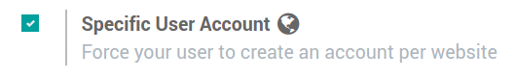
  - SEO Integration
  - BUSINESSBOXERP SEO tool combined with Google to check the relevancy of your content in real-time. Get more visitors with better-targeted content. Admin can access this facility from
  - Website Admin > Settings
  - 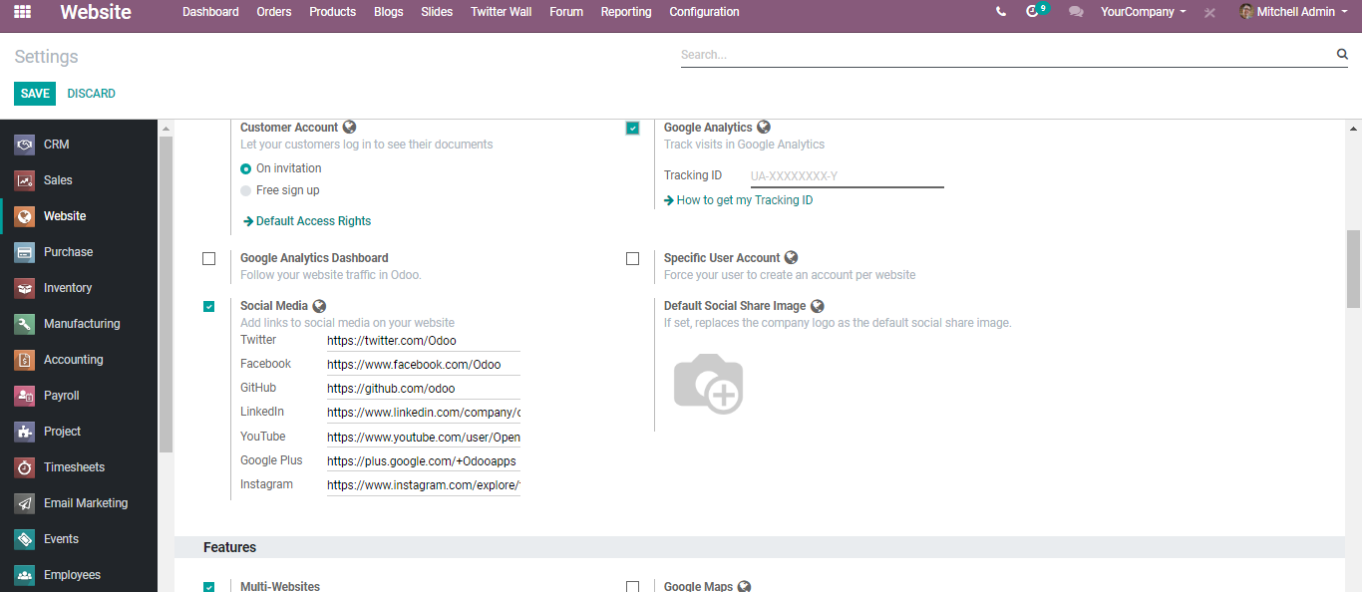
  - Here you can see the options to track and manage the performance of your website. And you can access some other settings from
  - Website > Promote > Optimize SEO
  - 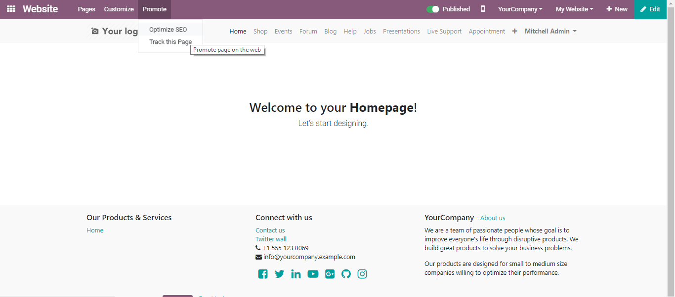
  - 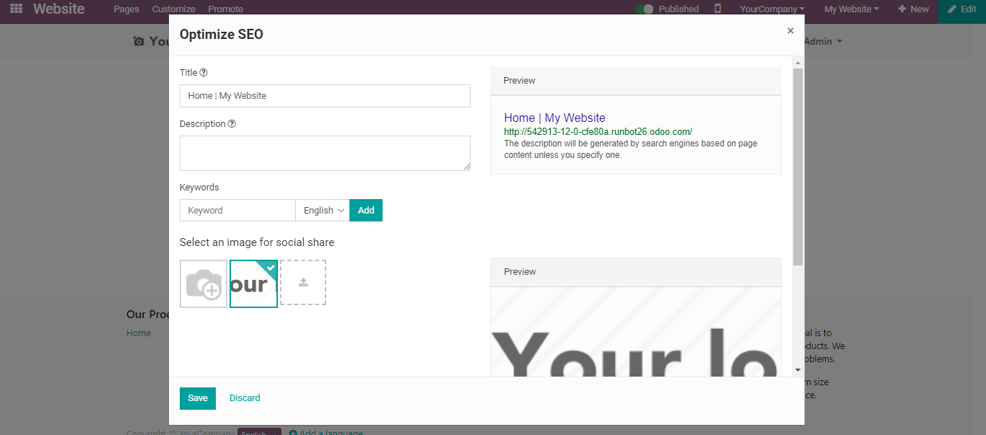
  - Via this feature, one can seamlessly search, find out and identify new customers. This can be initiated with the help of dedicated keywords which are mostly used on Google search using keyword research tools in BUSINESSBOXERP e-commerce.

