**Customer Relationship Management**

Client Relationship Management, which is the most significant piece of a business, is streamlined with the BUSINESSBOXERP CRM framework. BUSINESSBOXERP CRM is a blend of 8 Apps and Plugins. For productive administration of client connection, you should introduce all the accompanying Apps/Plugins.

CRM

And enlisted apps can further improve the CRM capabilities

* CRM Gamification
* Marketing campaign
* Survey CRM
* Contact Form
* Resellers
* Lead to Issue
* Opportunity to quotation

**Some of the useful features of BUSINESSBOXERP CRM includes**

**Priorities activities *-*** Priorities the subsequent activities in the pipeline and meet your objectives proficiently.

**Track your sales activities** - Track the business organizes all the more effectively through deals pipeline Kanban see.

**Schedule Meetings -** Schedule meetings straightforwardly from the customer opportunity.

**Dashboards -** Collect all pivotal details about ongoing and done business activities from Dashboard.

**Get in touch with customers -** Keep up Communication with clients using email, telephone, visit, and internet-based life from inside your BUSINESSBOXERP CRM.

**Leads Promotion -** Begin campaign by sending auto produced emails to customers in Leads. Appoint a sales rep to pursue the lead and promote it.

**Opportunities Analysis -** Dissect your chances pipeline with cutting edge channels, gathering, drilling down, and so forth.

**Lead Scoring -** Score your leads dependent on unequivocal and verifiable criteria and choose which lead fulfils the benchmark to progress toward becoming chance.

**Customized Alerts -** Set custom alarms for circumstances dependent on certain exercises

**Analyze Opportunity lost -** Analyze the reasons behind the loss of opportunities and improve your sales efficiency.

**GeoIP -** Distinguish nations, states and urban areas of leads consequently from your guest IP address.

**Automate routines and Focus on sales - a**utomate routine business exercises, don't sit around idly to look after the information.

**BUSINESSBOXERP CRM general workflow**

CRM in BUSINESSBOXERP can be clarified as a progression of occasions that begin with distinguishing a Lead (a future deal probability) and goes through various stages like Opportunity, Quotation, Sale Order and genuine deal (receipt age and instalment). BUSINESSBOXERP coordinates the Customer Management module alongside these procedures to achieve compelling Customer Relationship Management. The fundamental advances engaged with following a deal can be recorded as beneath.

**Lead** - A conceivable future deal, it might be made because a client enquired about an item

**Opportunity** - More plausibility of the offer. Here onwards the association may name an individual to catch up with the client.

**Pipeline -** Pipeline: - it is an advantageous instrument given by BUSINESSBOXERP to follow Opportunity. You can make numerous stages dependent on the likelihood of the Sale and track all the more adequately.

**Quotation -** When an opportunity wons, then the next action triggered is sending a quotation to the customer.

Followed the **Quotation** changes to **Sale Order,** later to **Invoice Generation** and **Payment**.

**System Users**

There are three kinds of default clients to the extent CRM (Including Sales + Purchase + Customer Management) module is concerned.

**Manager** - who will have total access over every one of these Sales, Purchase modules.

**User - Own documents only -** This client will have the consent to control the reports and passages made by him. For instance, you can limit a business official from getting to another business administrators records.

**User - All documents** - might be a business head, he needs to see every one of the reports by all deals speak to.

**Plan Your Activities and Get Organized**

Planning activities is the ideal method to keep on track with your work. Get helped to remember what should be done and plan the following activities to attempt.

Your activities are accessible any place you are in BUSINESSBOXERP . It is seamless to manage priorities needs.

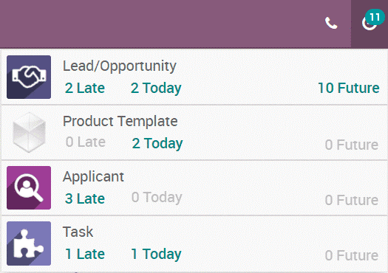

Activities can be arranged and overseen from the chatters or in the Kanban views. Here is a case for opportunities:

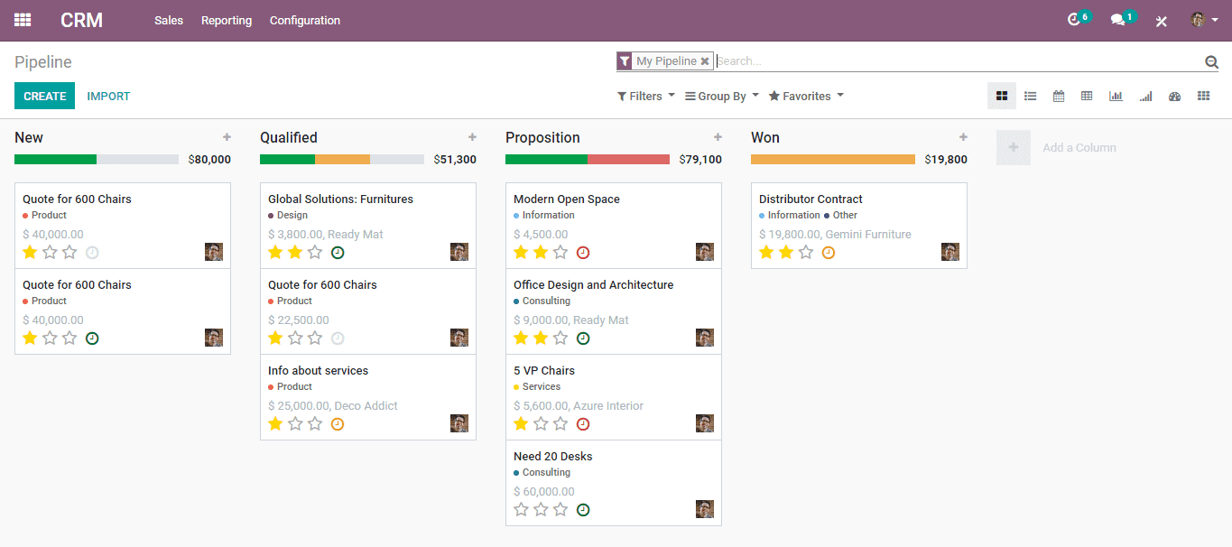

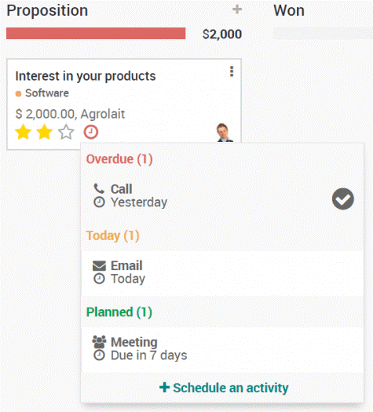

You can without much of a stretch make a lead from the CRM pipeline itself. You should simply CLICK the + BUTTON defined in the pipeline organize.

BUSINESSBOXERP likewise enables to you make new and distinctive pipeline stages as indicated by your need. You click the **Add a Column** choice laid there.

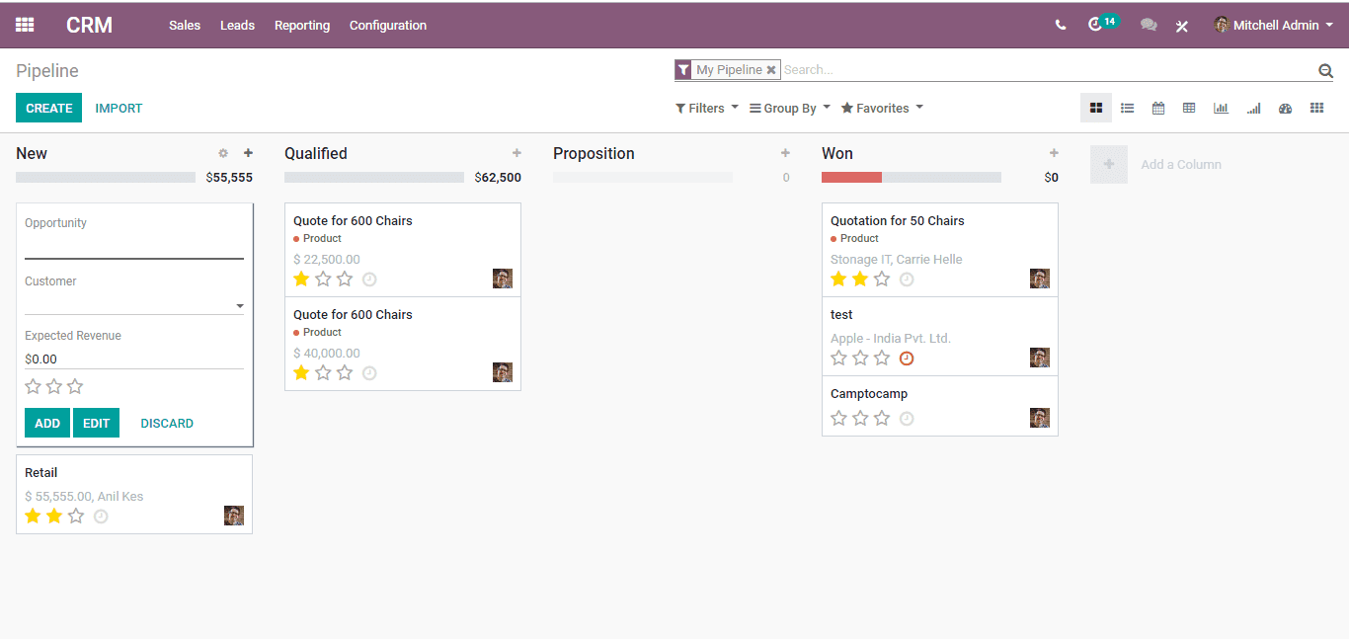

**TRACKING ACTIVITIES**

BUSINESSBOXERP enables you to track the activities in the least complex manner. Activities can be tracked on every archive. One can view the exercises like – activities in due, or activities to be performed today or in future.

Activities can be followed from two spots i.e. from both Kanban card and from the form view.

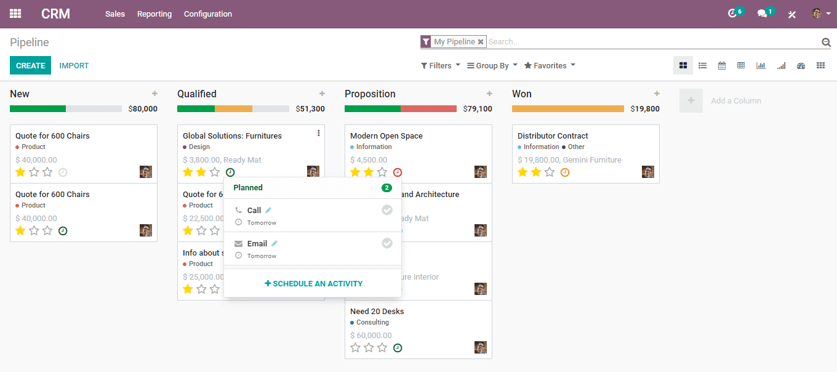

**SETTING ACTIVITY TYPES**

By default, BUSINESSBOXERP brings in several generic activity types such as call, email, meeting and so forth. If the user needs to set a new activity, he can go to **Settings? General settings? Activity types.**

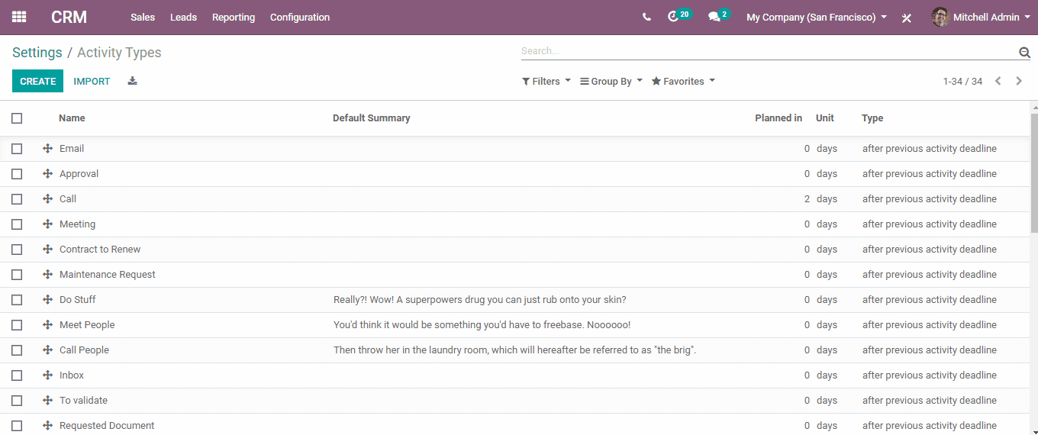

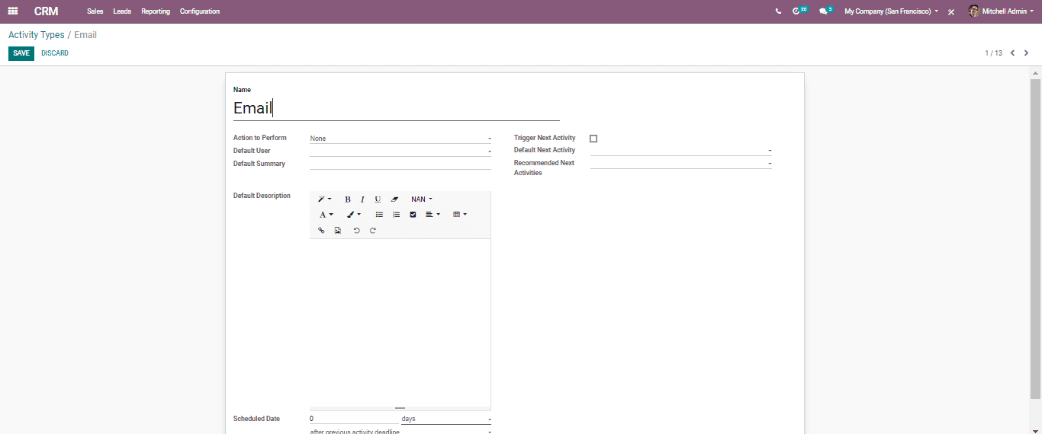

**Schedule meetings**

Activities usually get planned for certain/specific days. However, in case, if you would like to set hours for your activity, under BUSINESSBOXERP CRM, you can go with the Meeting activity type.

Under the Meeting Activity Type, a calendar opens up for setting a preferred time slot.

**Schedule chain of activities to follow**

With BUSINESSBOXERP , the user can easily plan their flow of activities. For that Go to **Configuration? Activity Types.**

Later set the common following steps as Recommended next activities.

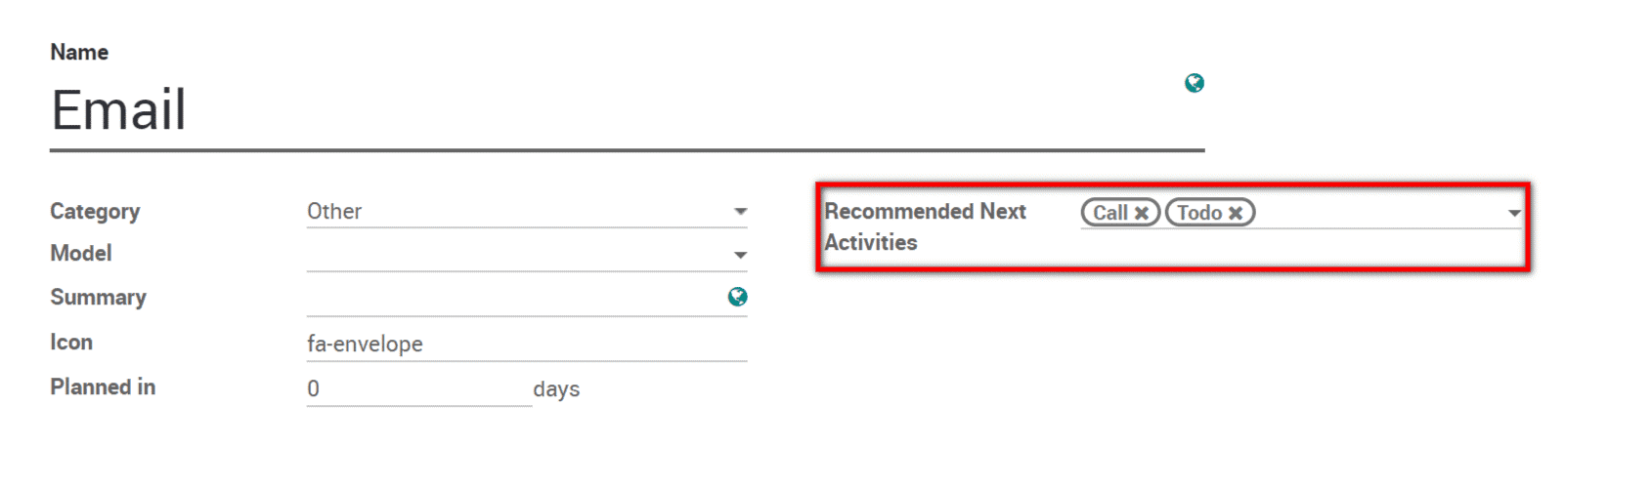

Once your activity finishes, select **Done & schedule next.** The action triggers for the next steps automatically.

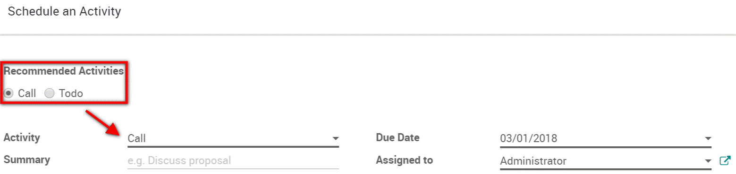

One would also be able to plan the following action for your lead. BUSINESSBOXERP provisions next movement alternatives like Email, Call, Meeting, Follow up Quote, Call for Demo and so on.

**MANAGING LOST OPPORTUNITIES**

It is quite common to lose certain opportunities in business. However, you need to monitor the reasons why you lost them. BUSINESSBOXERP can help you in recuperating them later on.

**Mark a lead as lost**

While in your pipeline, select any opportunity you need and you will see a **Mark Lost button.**

You would then be able to choose a current Lost Reason or make another one in that spot.

[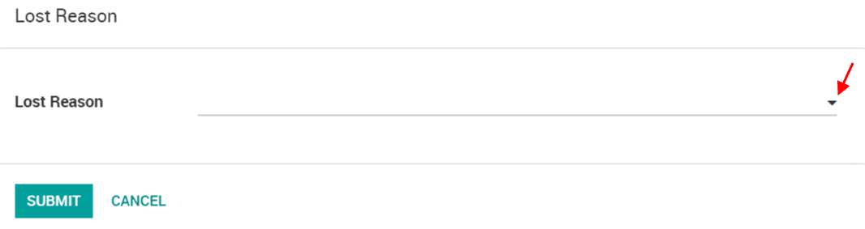](https://www.images.cybrosys.com/images/odoo-book-13/odoo-book-v13-crm-10.png)

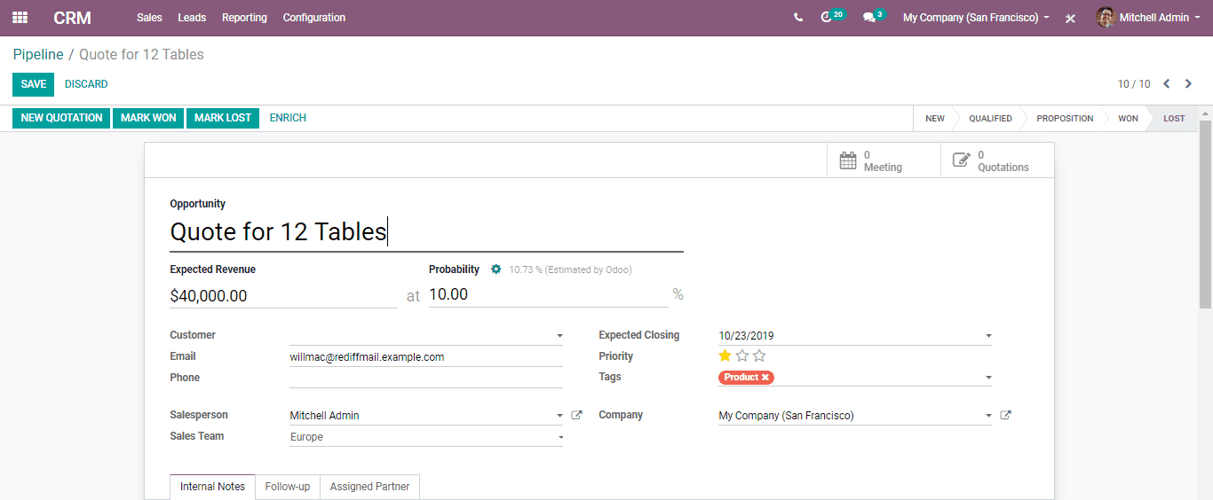

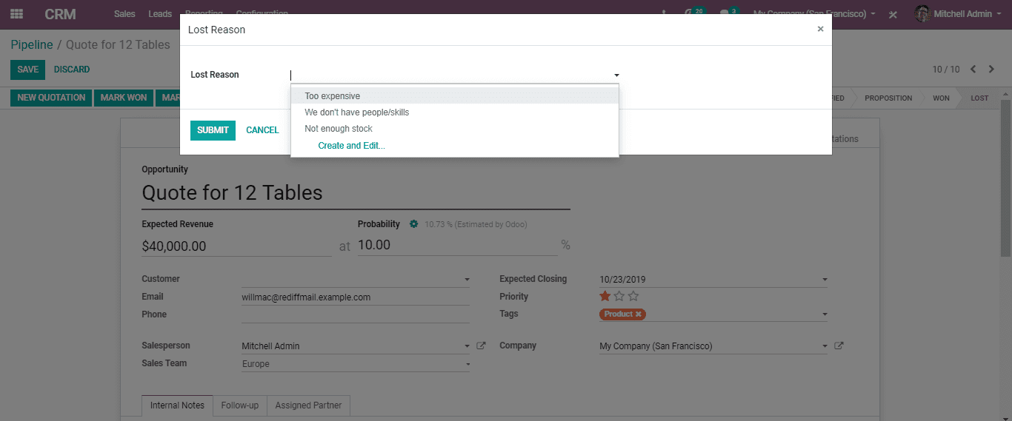

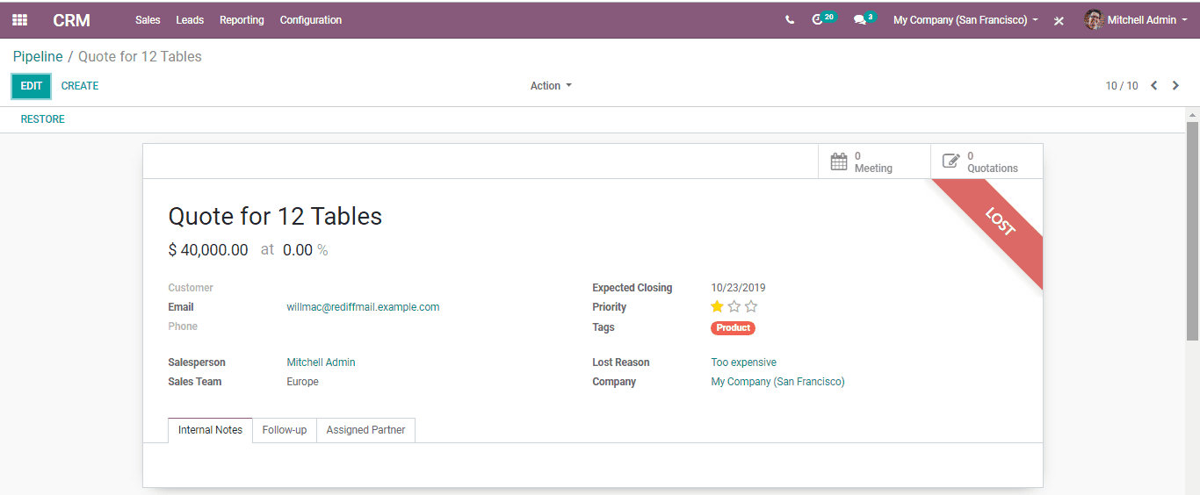

**Manage & create lost reasons**

One can define their Lost Reasons under **Configuration? Lost Reasons.**

One can also select and rename the enlisted as well as make a new one from the spot.

**Retrieving Lost Opportunities**

To retrieve your lost opportunities and conduct certain actions on them (send an email, make a feedback call, etc.), go to the Lost filter in the search bar.

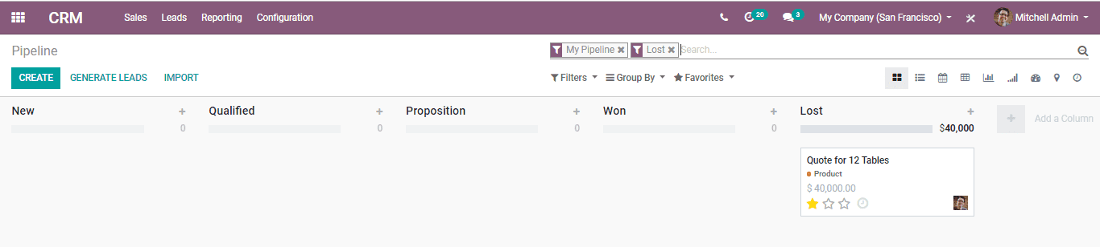

There you can see all the lost opportunities.

Add a filter on the Lost Reason to refine the.

For Example, Too Expensive.

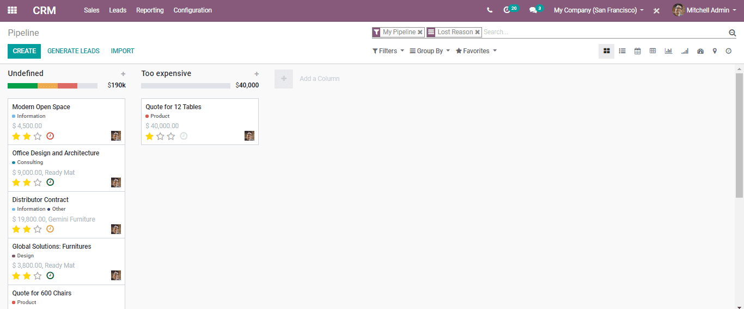

**Restore lost opportunities**

From the Kanban view with the filter(s) set up, one can choose any opportunity you wish and work on it of course.

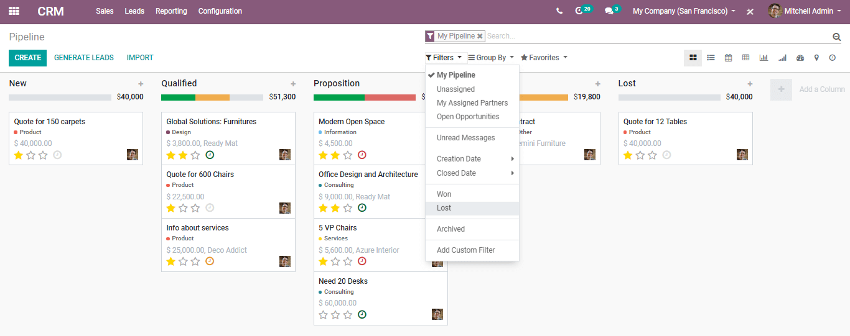

You can likewise reestablish it by clicking on Archived.

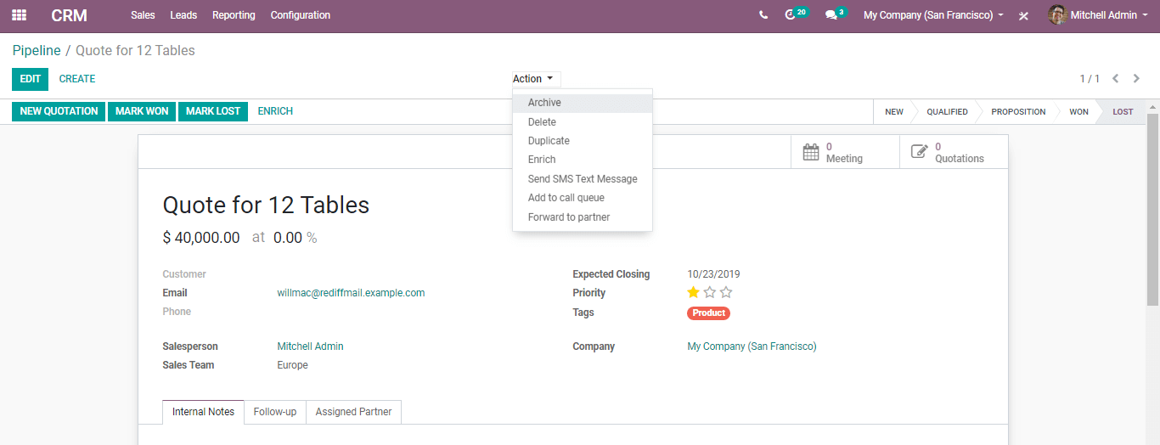

You can likewise reestablish/restore things in batch from the Kanban view when they have a place with a similar stage. Select Restore Records in the column options. You can likewise archive the similar way.

**Acquiring Leads**

**Automatic leads assignation to team members**

There will be various sales reps working inside the business group, with the number of leads expanded, you need to build the number of individuals to take a shot at it. The issue begins for the team manager to appoint the leads to them when the group develops, BUSINESSBOXERP helps in making the team manager life simple with automatic lead assignation.

**Qualification step before creating an opportunity**

The default sales activity is dealt with the opportunity pipeline; you can change that to add the qualification stage before making an opportunity.

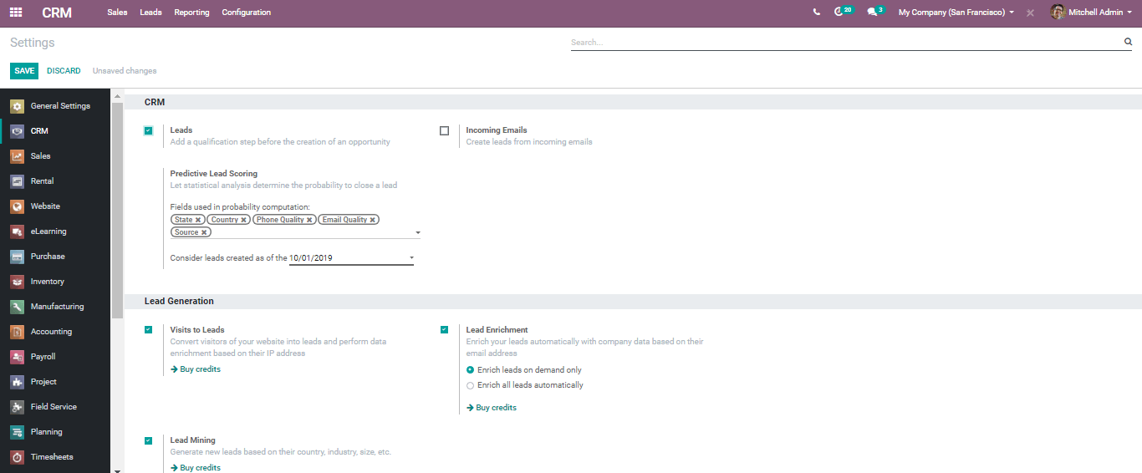

**Lead Mining (IAP)**

Straightly from a pipeline, generate new leads depending on the country, technologies, size, etc.

**Lead Scoring**

The statistical analysis determines the probability of closing a lead.

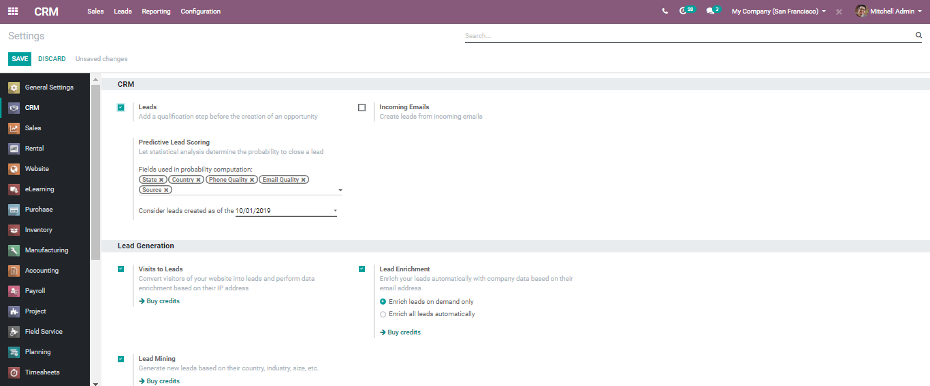

**Lead Enrichment (IAP)**

Enriching leads with corporate data based on email addresses.

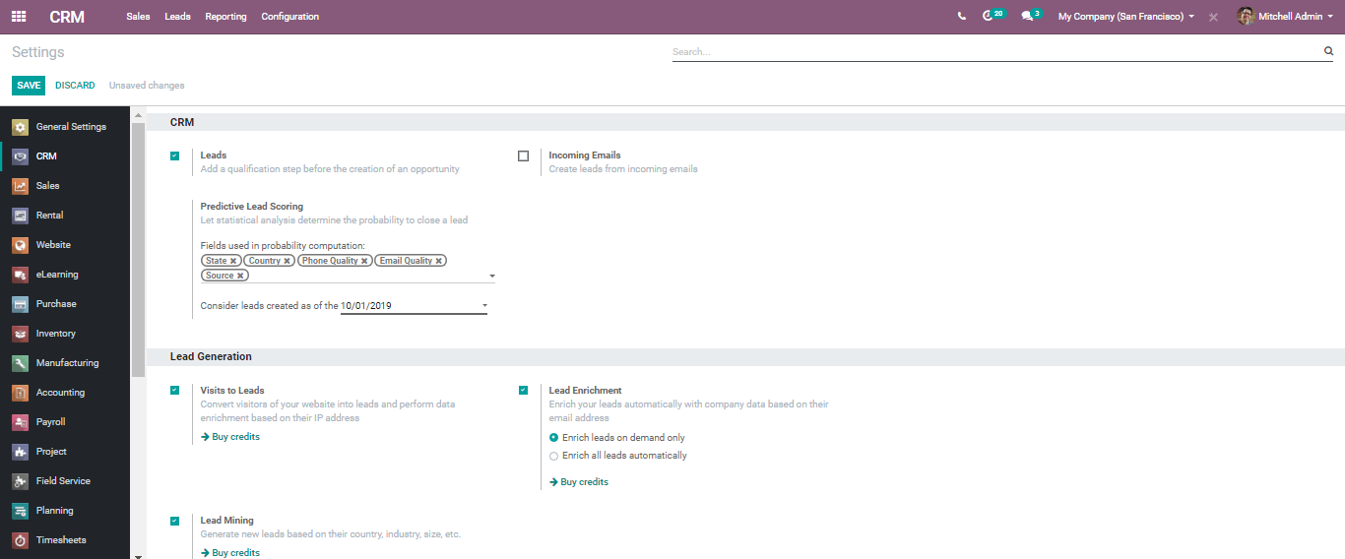

**SMS**

The user can also send SMS Text Messages from leads and opportunities.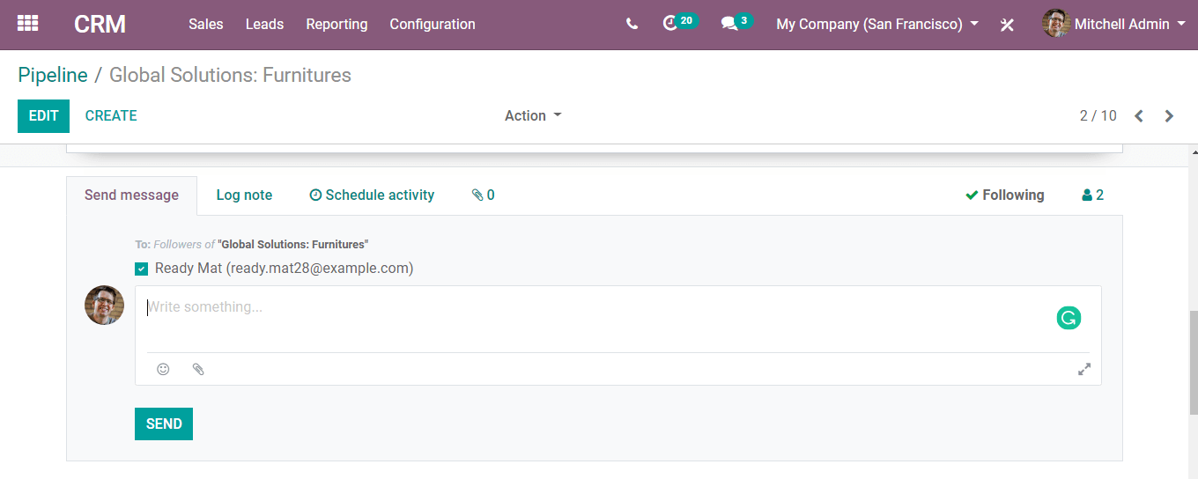

Assumed that you start getting leads into the team, by default all those leads are unassigned.

Add members to your sales channel

One can add members to the sales team; that way those members will see the pipeline structure of the sales team when opening it. Any lead/opportunity appointed to them will connect to the sales team Hence, you must be an individual/member from one channel.

You can define maximum leads that ought to be relegated to the part inside 30 days, this will facilitate the way toward assigning leads to the member effectively.

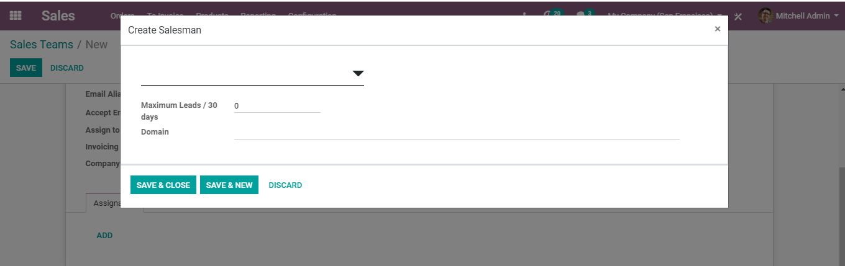

One can also add an explicit domain to each user to assure that each user gets specific leads to work on based on their field of expertise or country, so on…

**MANAGE MULTIPLE SALES TEAM**

BUSINESSBOXERP aids you to deal with several sales teams, offices or channels with explicit sales processes. One can spread their business exercises or the sales activities into the numerous sales team, contingent upon the product, service or region, the motivation behind setting various sales groups may likewise be to set up the various sales process as well.

**To do so, we use the concept of Sales Team.**  
Create a new sales team

To create a new Sales Team, go to **Configuration? Sales Team.**

There the end-user can provide an email alias to it. All messages sent across to that email address shall generate a lead/opportunity.

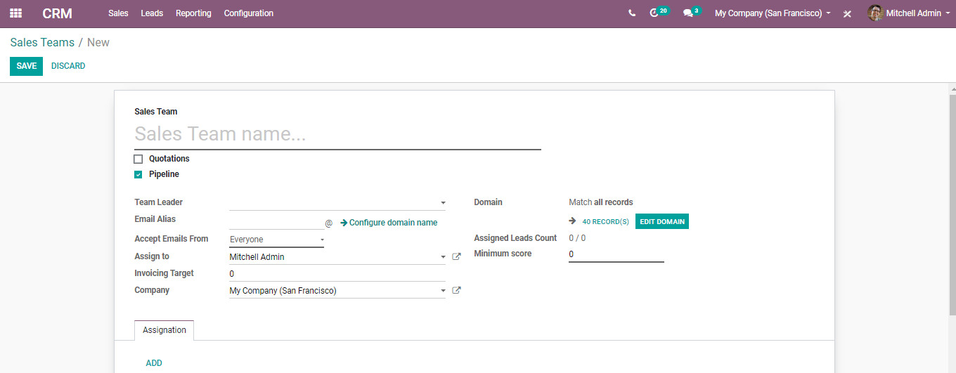

**Add members to your sales team**

You can add members to any business channel or sales group; that way those members will see the pipeline structure of the business group when opening it. Any lead/opportunity doled out to them will connect to the sales team. Subsequently, you must be an individual from one group.

This will facilitate the process review of the group administrator/team manager.

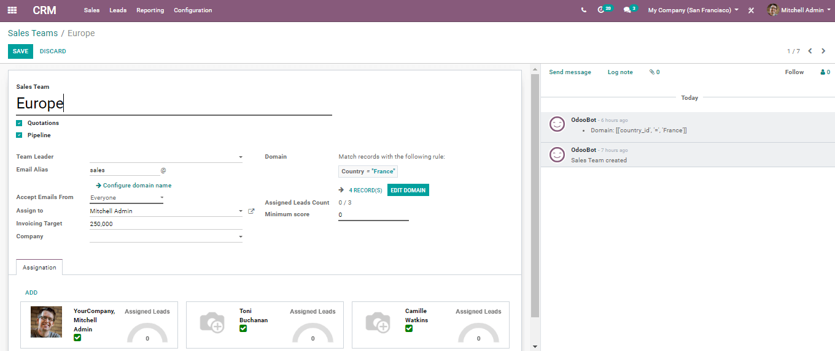

Upon filtering the specific channel in the pipeline, one can view all the opportunities.

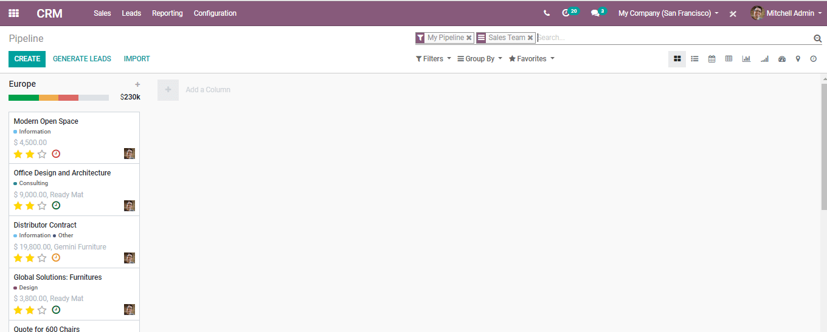

**Sales channel dashboard**

From the sales Team Dashboard under-reporting, one can preview all the operations and sales channel results at a glance.

It is imparted to the entire system so every income stream is incorporated into it: Sales, e-Commerce, PoS, and so on.

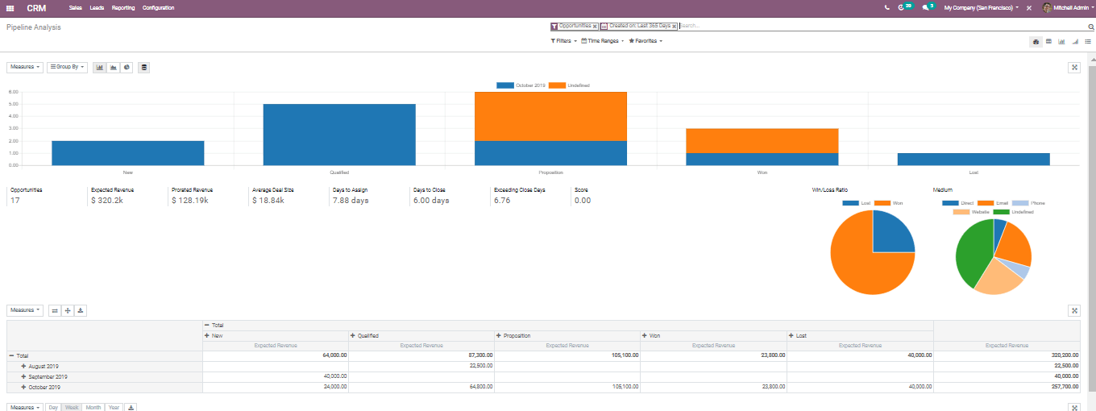

**Convert Leads into Opportunities**

Opportunity is a certified lead. The particular arrangement has met certain criteria and shows a high incentive to the business, or a high likelihood of closing, you have to get enough subtleties from your visitors. On the off chance, it matches with your business intrigue, you can change over them into opportunities.

You can gather the leads instead of creating an opportunity and set up the procedure to qualify those leads before you convert them into opportunities.

BUSINESSBOXERP helps you to convert a lead into an opportunity and assign them to the correct sales reps. One can activate this mode from the CRM Settings. It applies to every one of your business channels by default. Yet, you can make it explicit for explicit channels from their configuration form.

On the off chance if you already have an opportunity with that client BUSINESSBOXERP will automatically offer you to converge with that opportunity. Similarly, BUSINESSBOXERP will consequently offer you to link to a current client if that client as of now exists. By default, if you have an opportunity made in the sales channel, you can have leads when somebody gets in touch with you on the website contact us page or send an email to the predefined email address.

When you click on a Lead, you will have the choice to change over it to an opportunity and decide if it should even now be doled out to a similar channel/person and if you need to make another client.

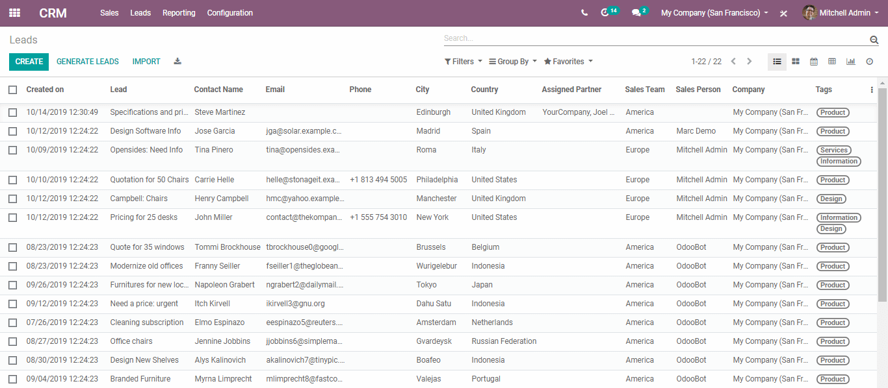

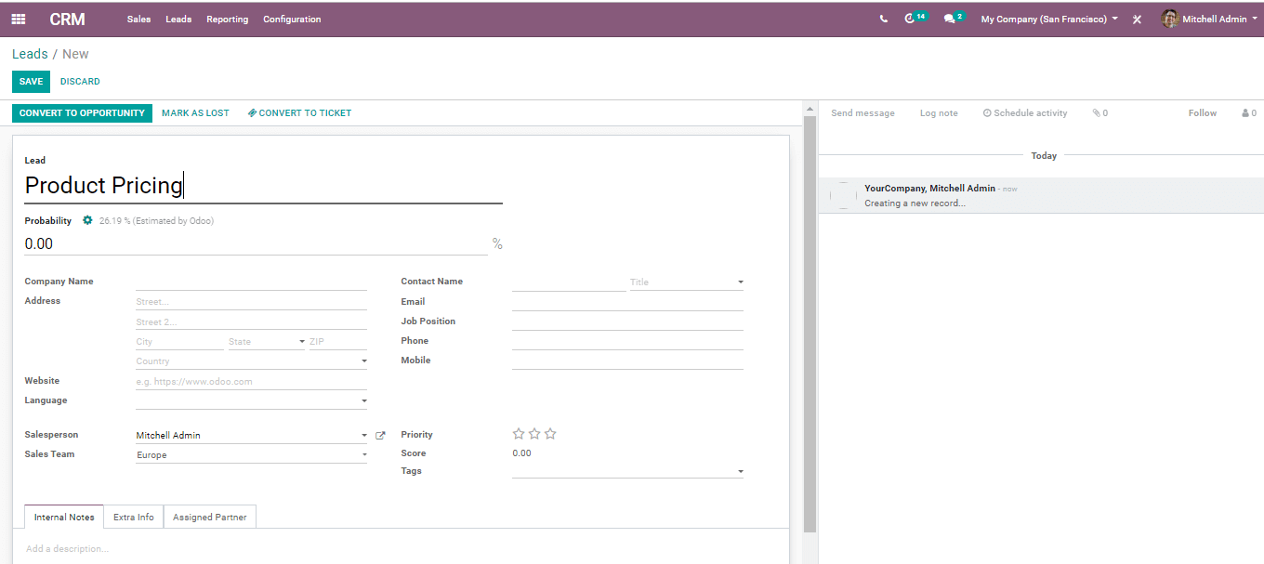

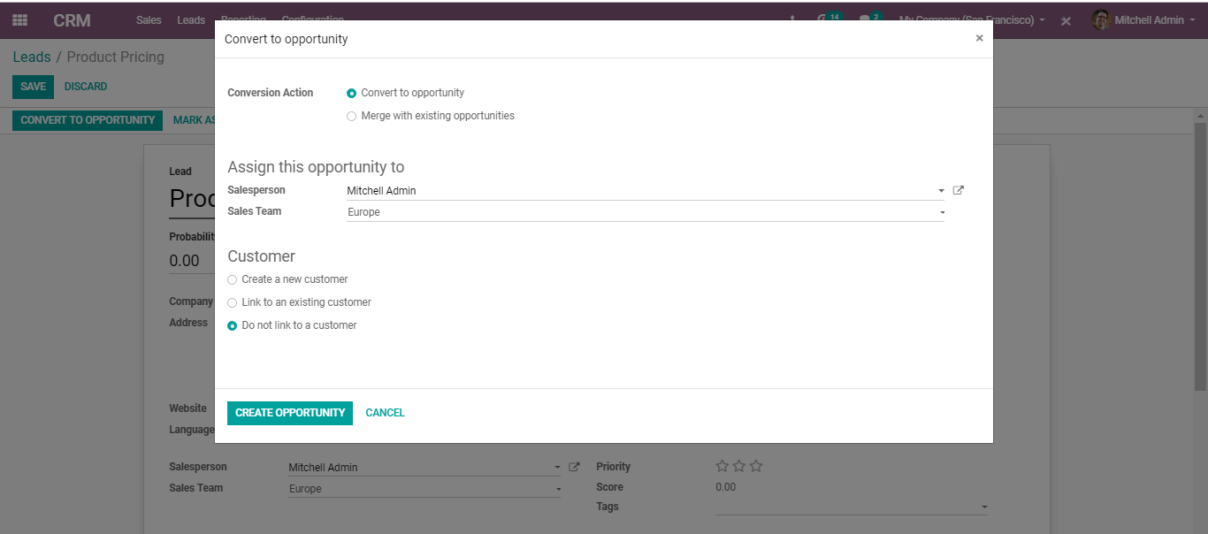

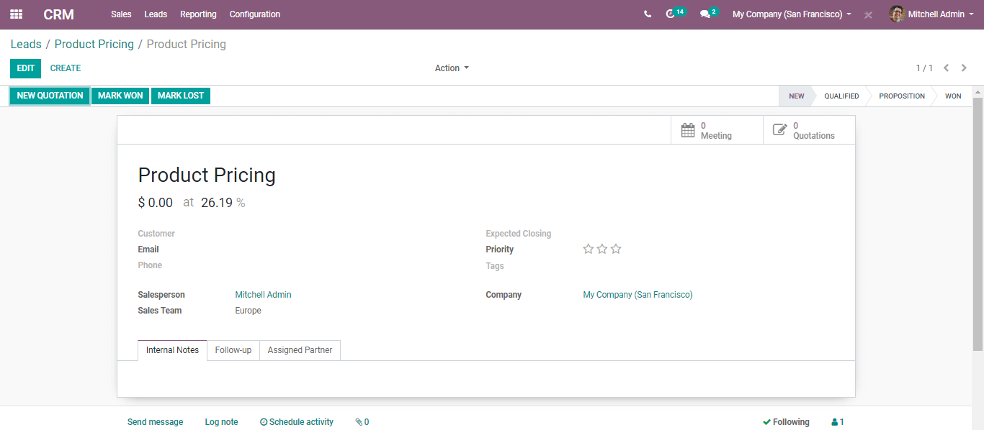

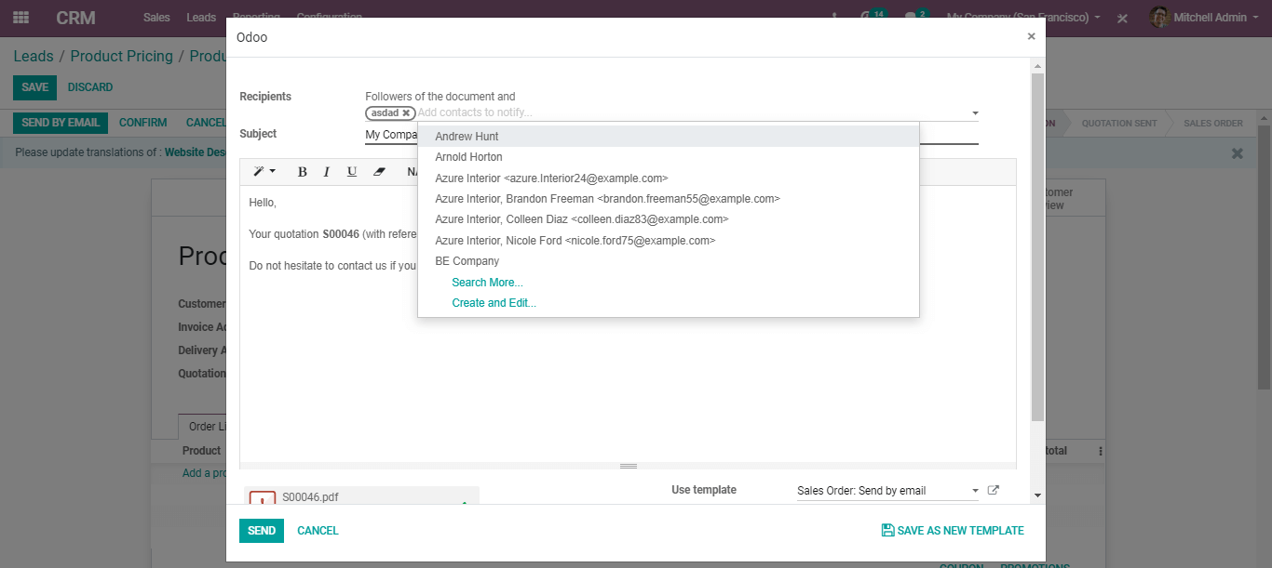

**Assign leads based on scoring rules**

With Leads Scoring you can automatically rank your leads dependent on chosen criteria's. For instance, you could score clients from your nation higher or the ones that visited explicit pages on your site. Simply saying you can gauge the score for an opportunity dependent on the client conduct on-site.

**Create scoring rules**

You get a new tab in the CRM app titled Leads Management, where the end-user can manage the scoring rules.

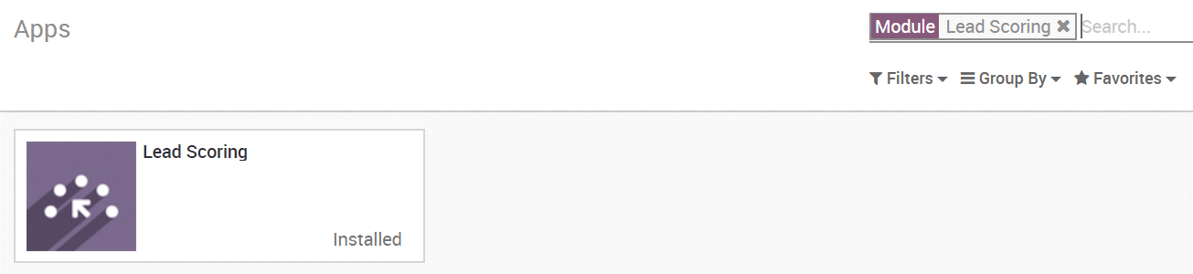

For instance, you have a Canadian lead, you can modify it with different criteria to score your leads

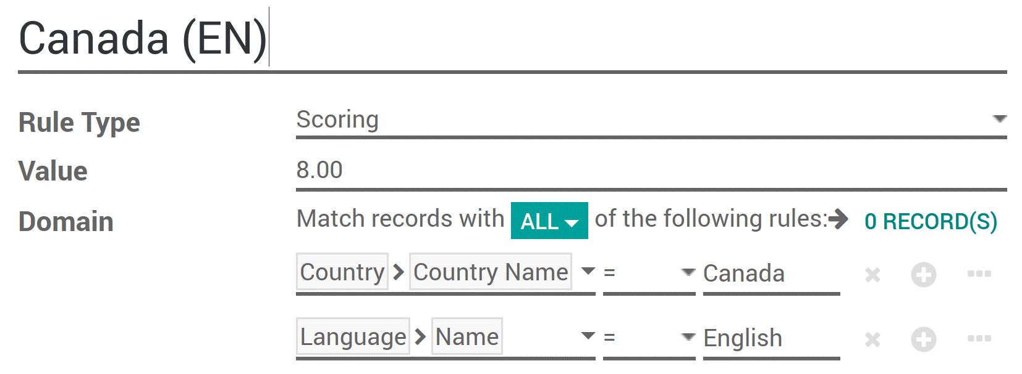

Every hour every lead without a score will be automatically scanned and assigned their right score according to your scoring rules.

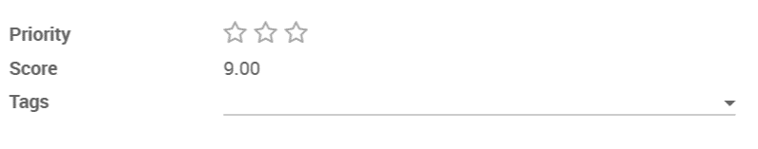

**Assign leads**

When the scores are computed, leads can be doled out to explicit groups utilizing a similar area component. **To do so go to CRM? Leads Management? Team Assignation** and apply a particular domain on each team. This domain can incorporate scores.

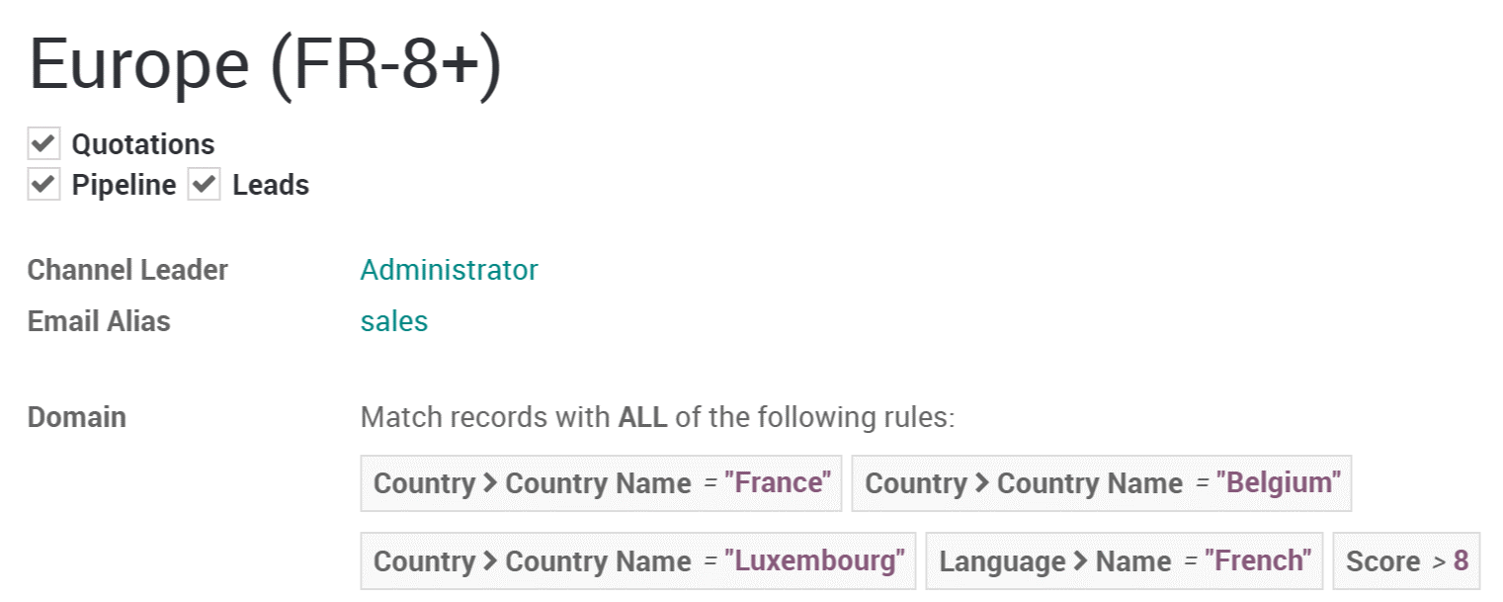

Moving on, the end-user can assign to a specific vendor within the team an even more refined domain.

To do so go to **CRM? Leads Management? Leads Assignation.**

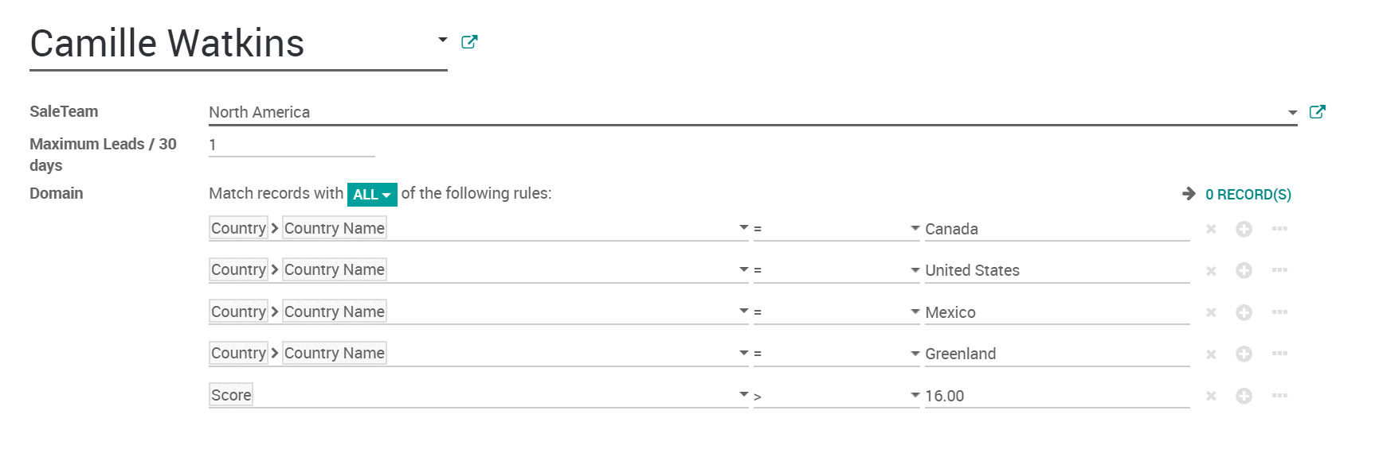

**Evaluate & use the unassigned leads**

When your scoring standards are set up you will in all likelihood still have some unassigned leads. Some of them could in any case lead to a chance so it is valuable to accomplish something with them.

On your leads page, you can put a channel to locate your unassigned leads.

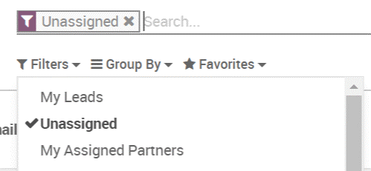

Why not utilize Email Marketing or Marketing Automation applications to send a mass email to them? You can likewise effectively find such unassigned leads from that point.

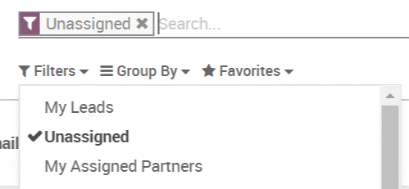

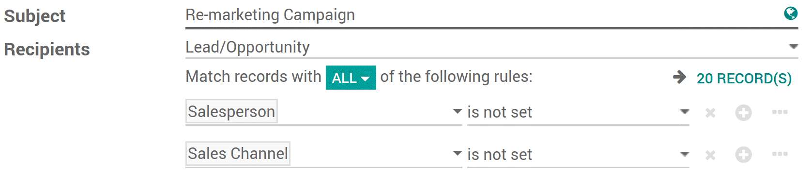

**Generating leads or opportunities from Email**

Each sales channel is equipped for making a lead/opportunity from the incoming emails.

**Configure email aliases**

Every sales channel can have its very own email alias, to create leads/opportunities automatically. This element is valuable if you deal with a sales team with explicit business processes. You will discover the configuration of sales channels under **Configuration? Sales Team.**

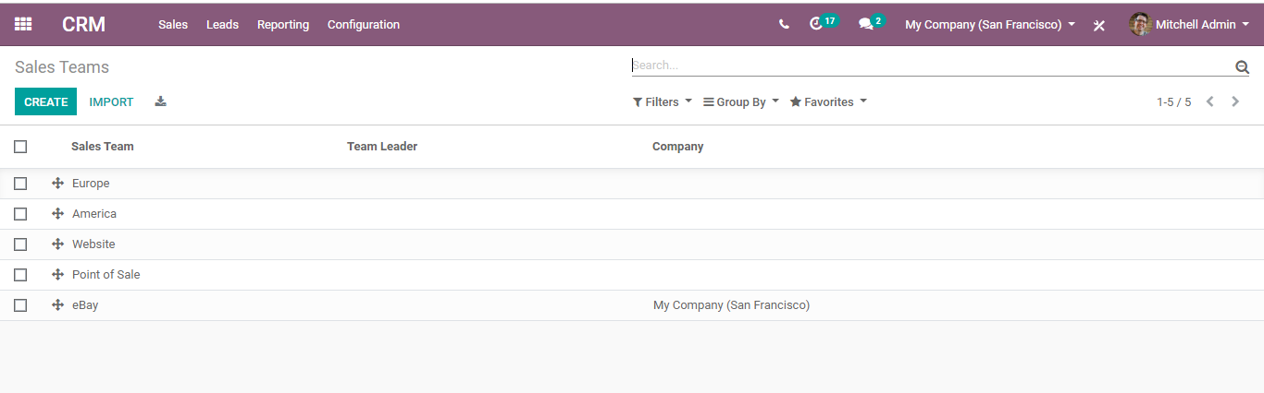

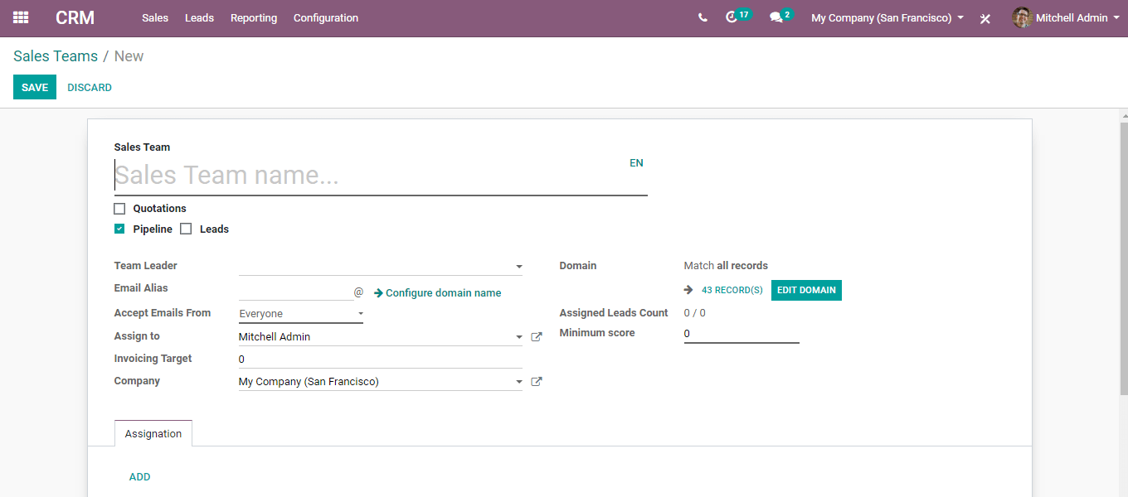

Any email sent to the endorsed email alias will make an opportunity in the pipeline for the particular sales channel or sales group.

**Generating leads or opportunities from Email**

Automating the lead/opportunity generation will significantly improve operational efficiency. Any visitor utilizing the contact form on the website will make a lead/opportunity in the pipeline.

To make the feature work, use contacts us on the website.

You should first go to your website app.

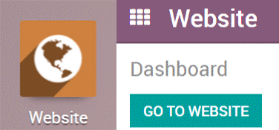

With the CRM app installed, you benefit from a ready-to-use contact form on your BUSINESSBOXERP website that will create leads/opportunities automatically.

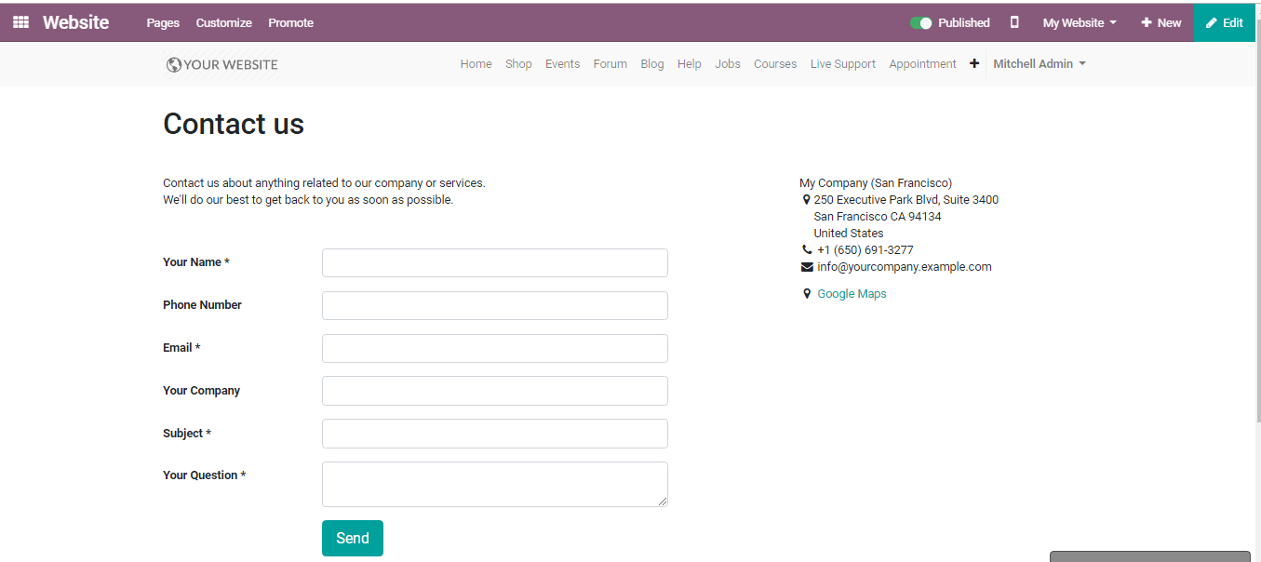

To change it to a specific sales channel, go to the **Website? Configuration? Settings,** under the Communication field, one can view the Contact Form info and field to change the Sales Team and Salesperson.

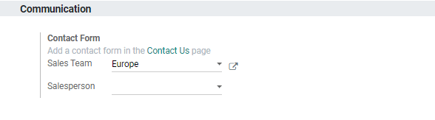

**Sending Quotations**

Upon successfully qualifying your lead into an opportunity, the following step is to send a quotation to the customer. One can initiate the action directly from the BUSINESSBOXERP CRM application.

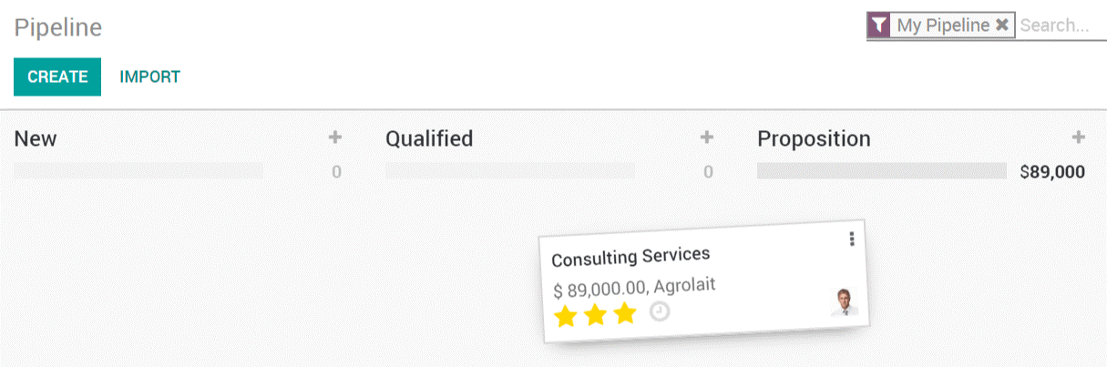

**Create a new quotation**

To create a new quotation, go to **CRM->Sales->My quotations.**

Upon clicking any opportunity/ lead, one can see a New Quotation button. This will eventually bring in a new menu to manage the end user’s quote.

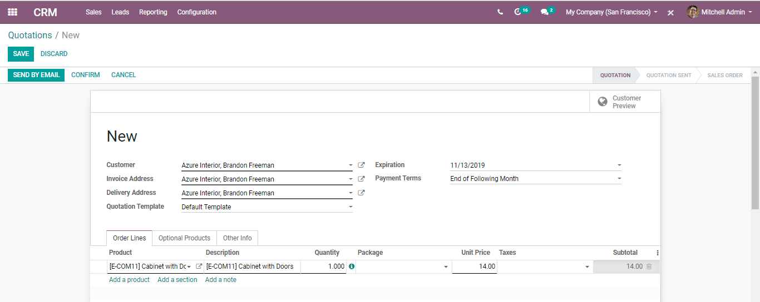

Upon clicking send via email-

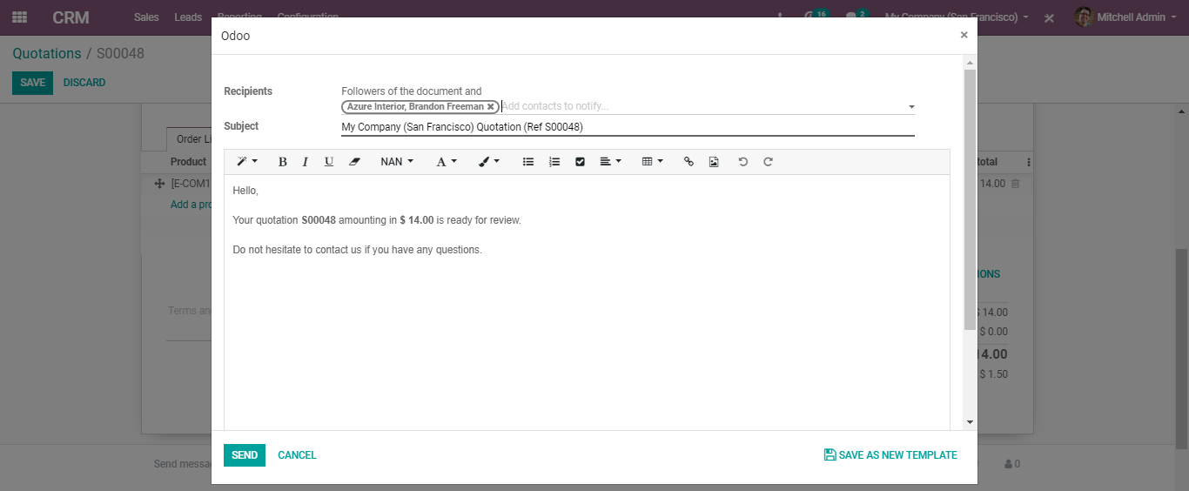

One can find all their quotes dependent on a specific opportunity under the Quotations menu.

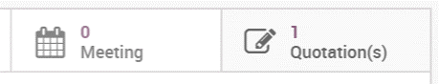

**Mark them as won/lost**

The next step is to mark the opportunity either as won or lost for moving the process along.

Upon marking them as won, eventually, they will be moved to the Won column in the Kanban view. However, upon marking them as Lost they will be archived.