**Calendar**

As soon as you enter the Calendar module, from the dashboard you see the scheduled activities, or the online appointments created.

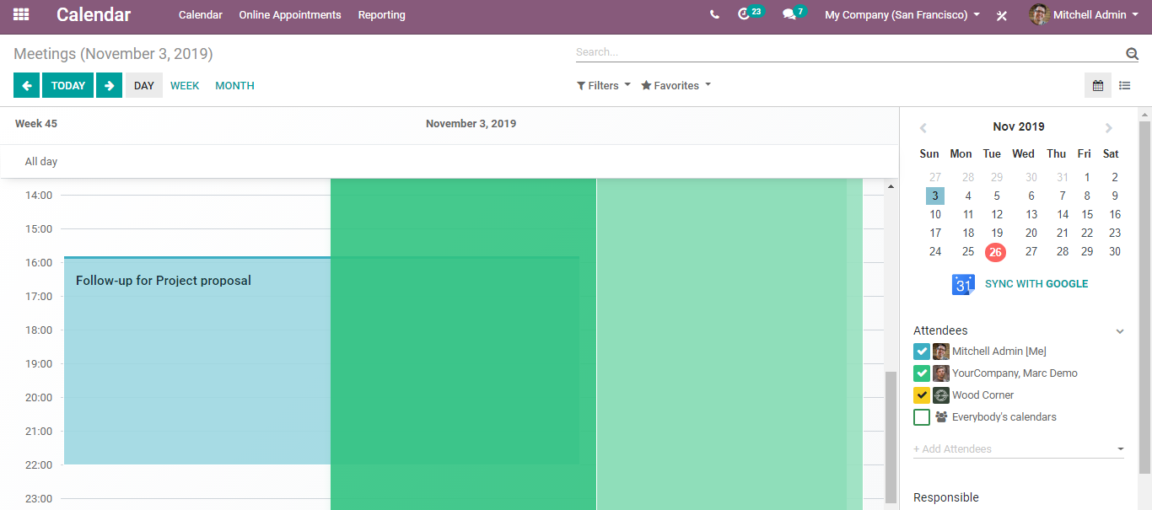

From the right side, you can easily get to the view of the attendees and the response of the activity. And to search easier, you can make use of the filters provided on top. This helps in easy accessing of the required information.

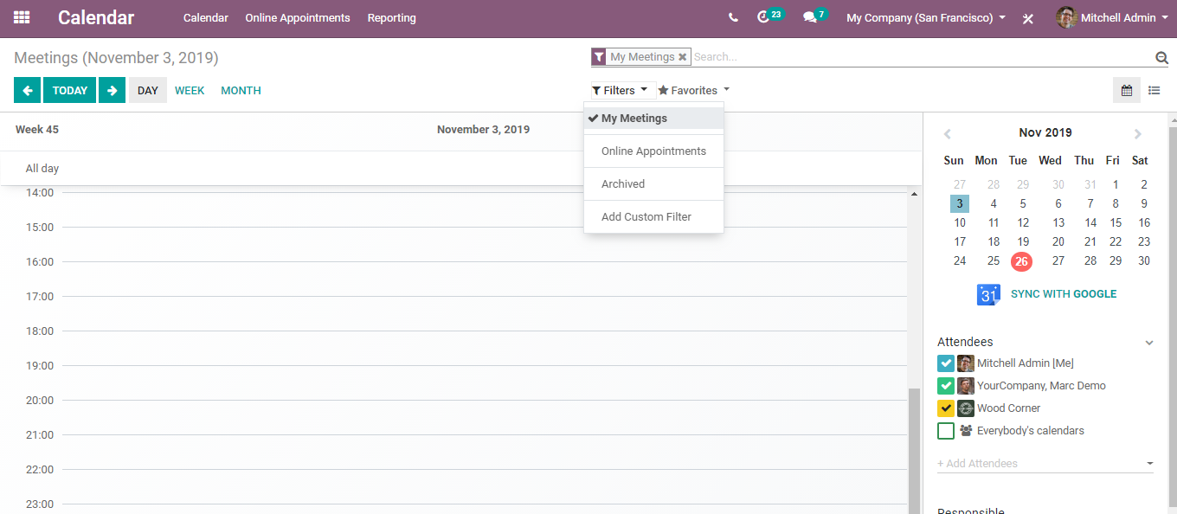

Now if you go to the online appointments, you can create new online appointments.

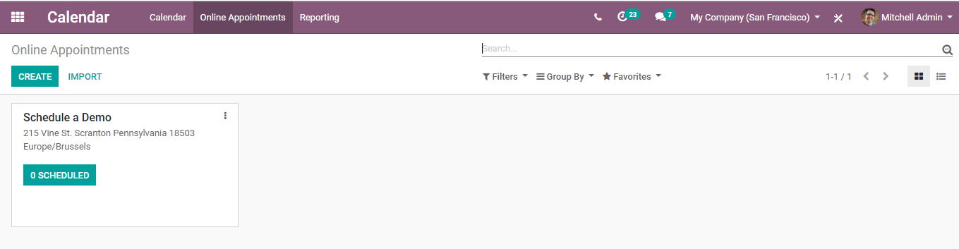

Click CREATE to make new online appointments.

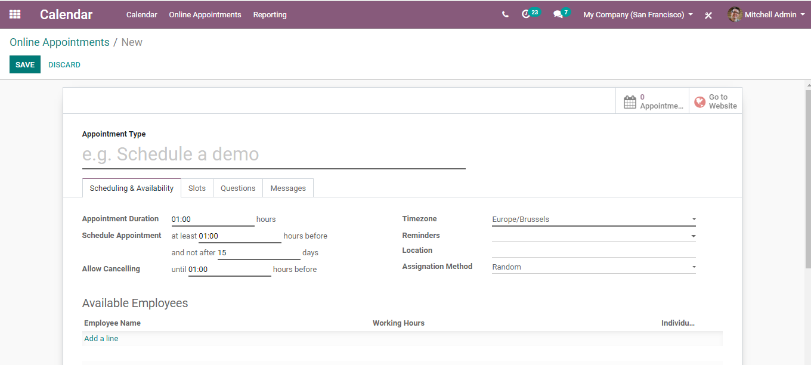

Under the Appointment create the form you can give away the **Appointment type** for instance Schedule a demo.

Under Scheduling and Availability Tab,

You can set the duration of the appointment, duration to **schedule the appointment before and not after, duration of cancelling of appointments.**

Also, one can set here the **time zone**where appointment takes place, reminders say- notification -15 minutes, Notification - 1 hour etc.

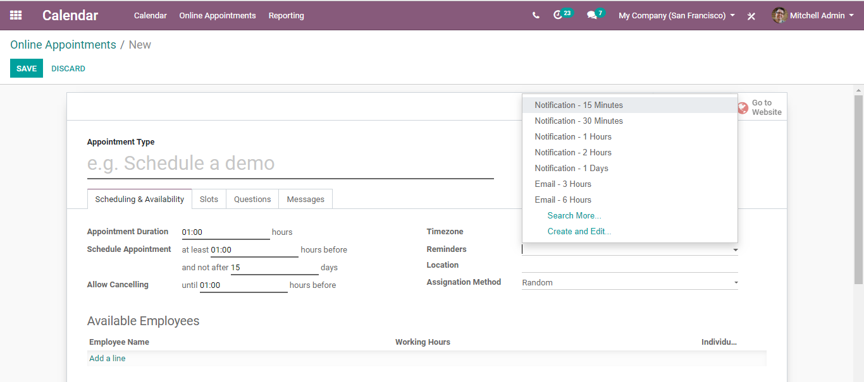

**Location** of the appointments, **Assignation Methods-** How employees will be assigned to meetings customers book on the website.

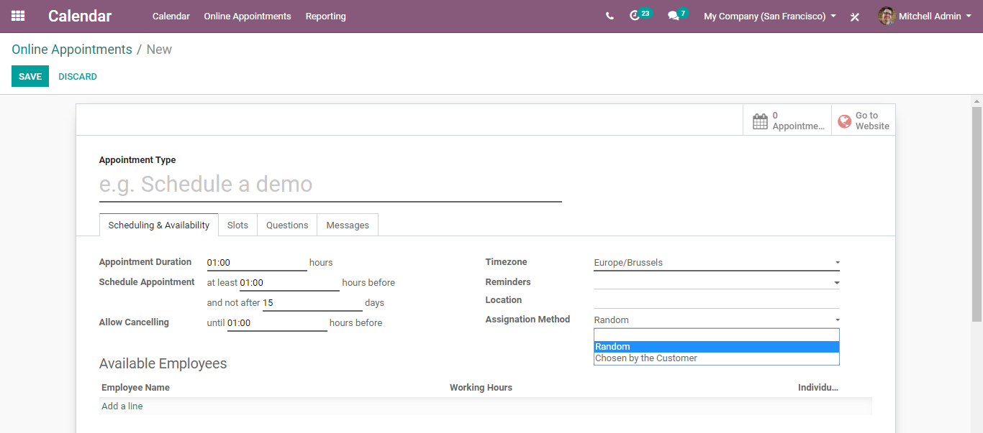

Assignation methods can be either **chosen by the customer or randomly assigned by people**on calendars when they set up the meetings.

Down there, one can also add available employees, their working hours.

Under Slots Tab,

You can set here the time; the employee will be available for the meetings- say Monday at 9:00 hours.

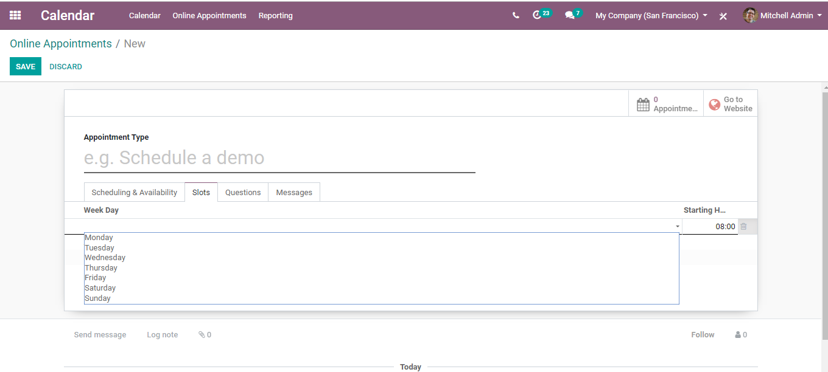

Now when the employees click on the calendar on the website, they will be able to schedule a meeting for that time.

Under the questions tab,

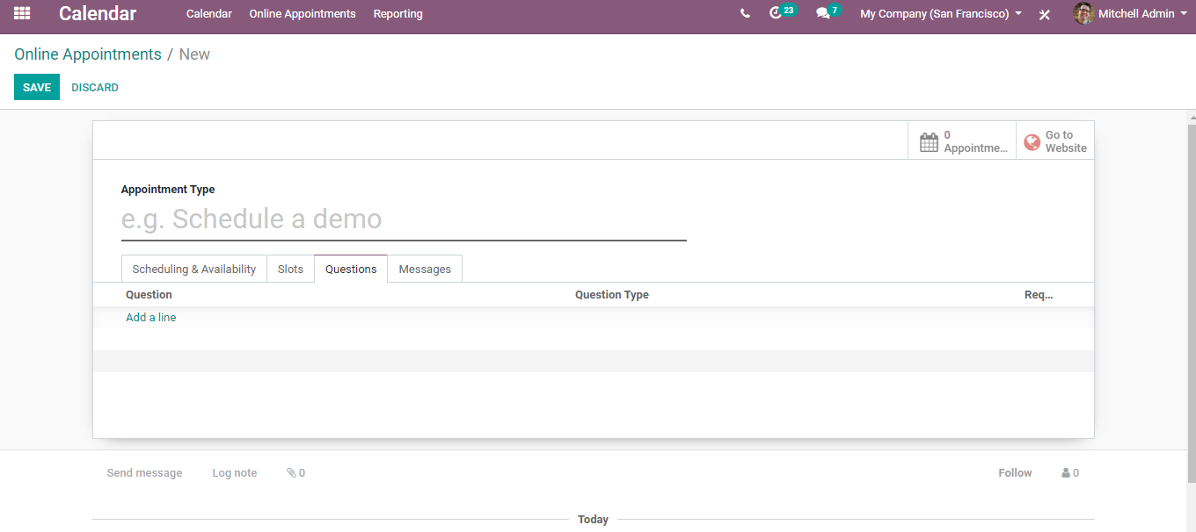

One can set up questions for the potential client or client to be able to understand what you going to talk about ahead of time for the meeting.

Upon clicking ADD A LINE button, you are navigated to a new window like below:

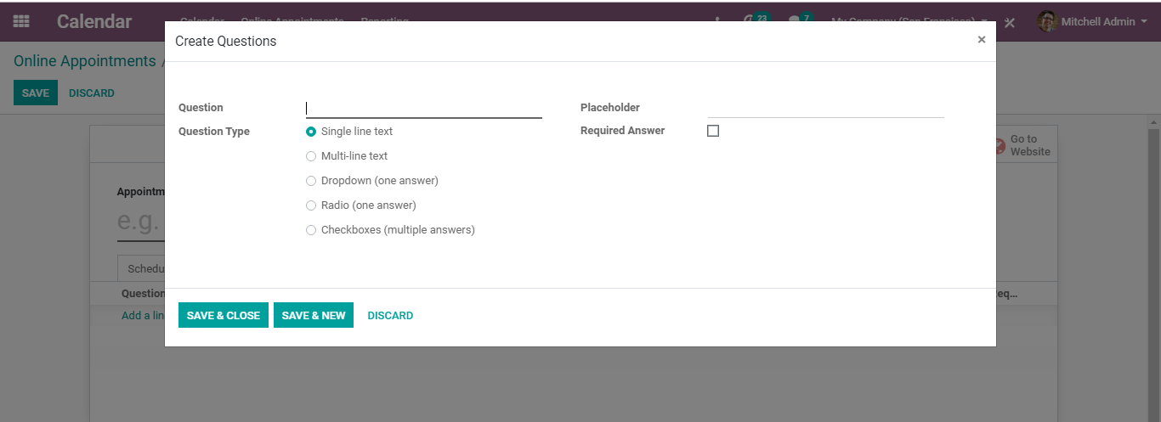

Here you can add the question say what is the name of your company?

Secondly the question type (single-line text/multi-line text/ drop down one answer),

And click on Required Answer if all these answers are required by you for further correspondence.

Messages

Also, one can send messages for example you can give a message as appointment introduction, appointment confirmation.

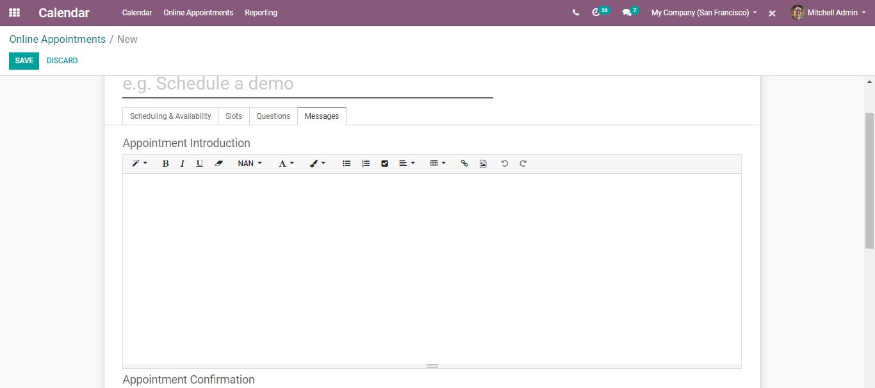

The message is automatically sent across the client.

Enter all the desired elements and click save to mark changes.

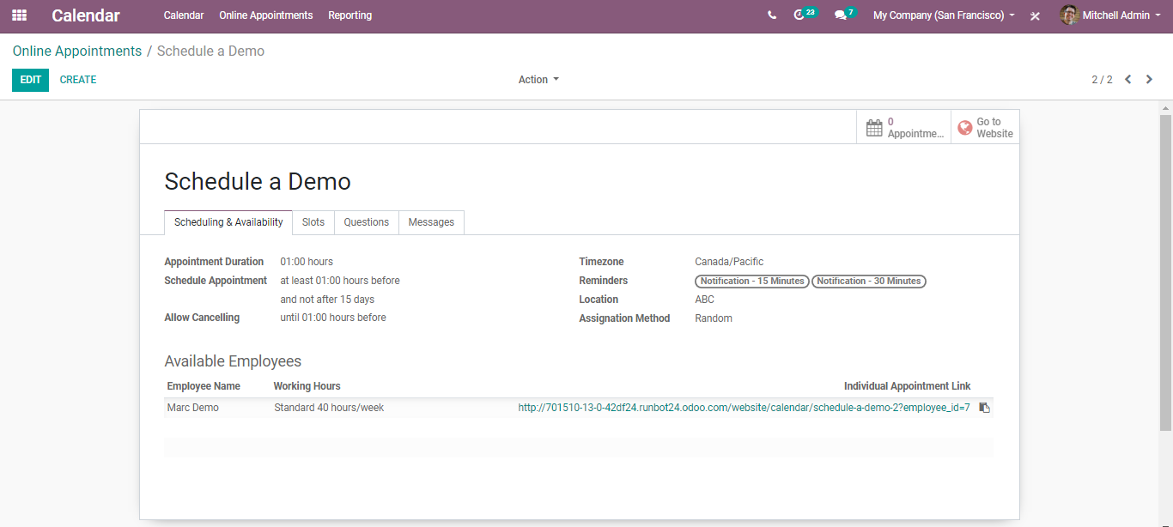

One can see here the individual appointment link, that notifies about the process of schedules in the meeting. This can be either sent via email or can be retrieved from the website by the employee/user.

Via going to the Reporting tab of the calendar module, one can see the Online Appointments or the All Appointments.

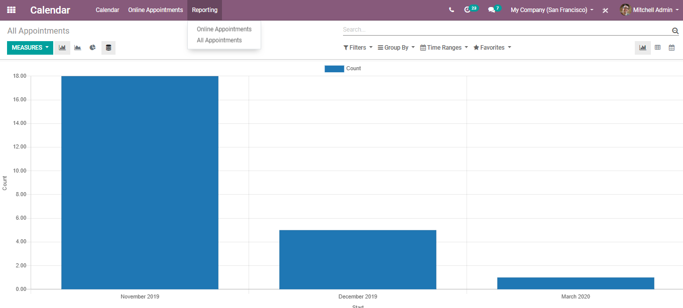

**SYNC WITH GOOGLE**

BUSINESSBOXERP can be integrated with Google Calendar so that you can see and manage your meetings from both platforms.

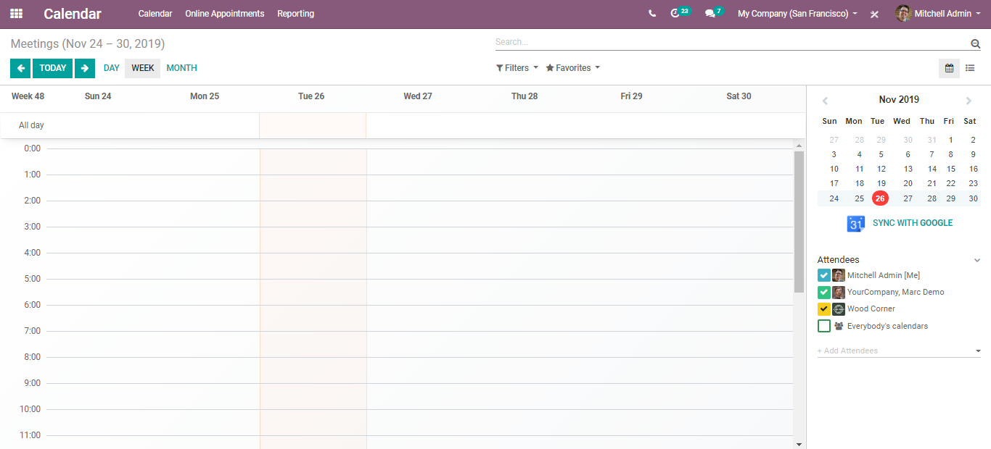

To sync with google, go to**Calendar> Configurations>Integrations.**

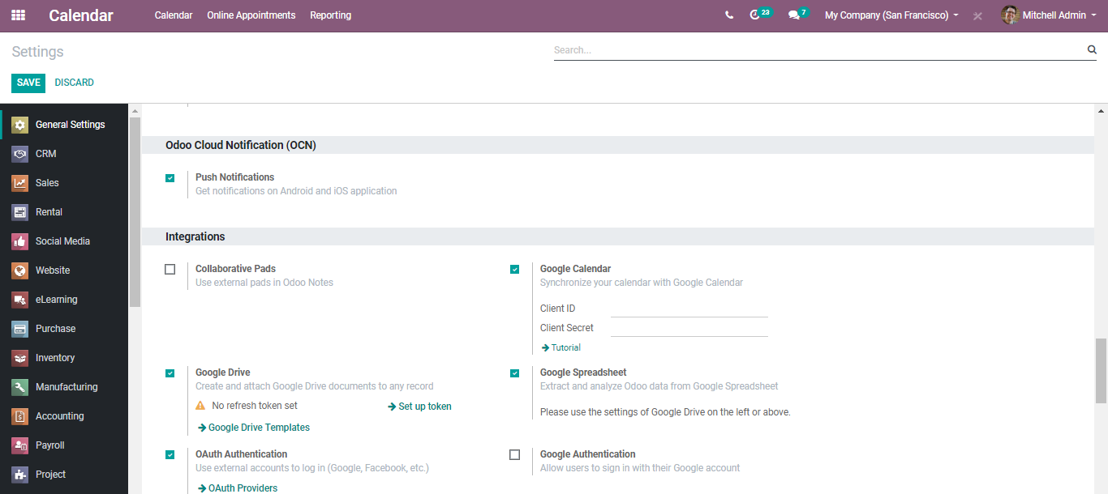

Via clicking the tutorial button, you get the steps of setting up in google.

