**Events**

No matter your industry is big or small, every organization is into conducting some official or non-official events as part of their work. BUSINESSBOXERP Event management module can be a strong choice for businesses as it helps with the smooth conduction of programs say events without many hurdles. Even if your events are for marketing purposes expressing your business strategies or annual conclaves, BUSINESSBOXERP makes everything straight.

BUSINESSBOXERP Events module is a simple and easy to manage interface. One can efficiently plan and execute the events using the event management module in BUSINESSBOXERP.

Install Events module from BUSINESSBOXERP Apps.

As soon as you enter the dashboard, you see the already created events here.

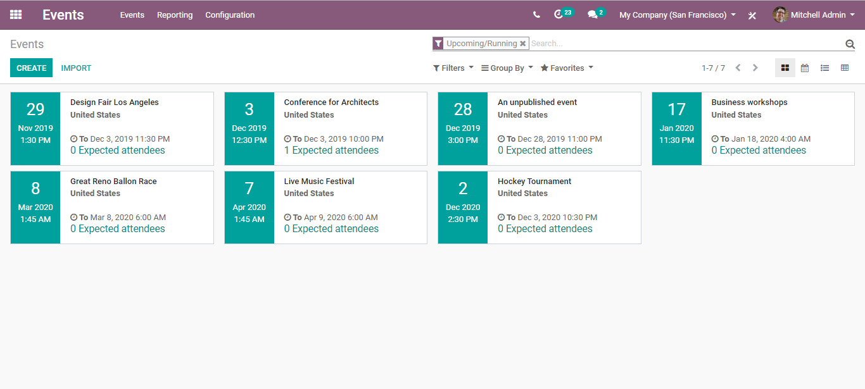

Immediately, the user gets the overall picture of the event. As you see, the date is highlighted on the left and over right the event name, expected attendees, date and time.

To create a new event, click the CREATE button.

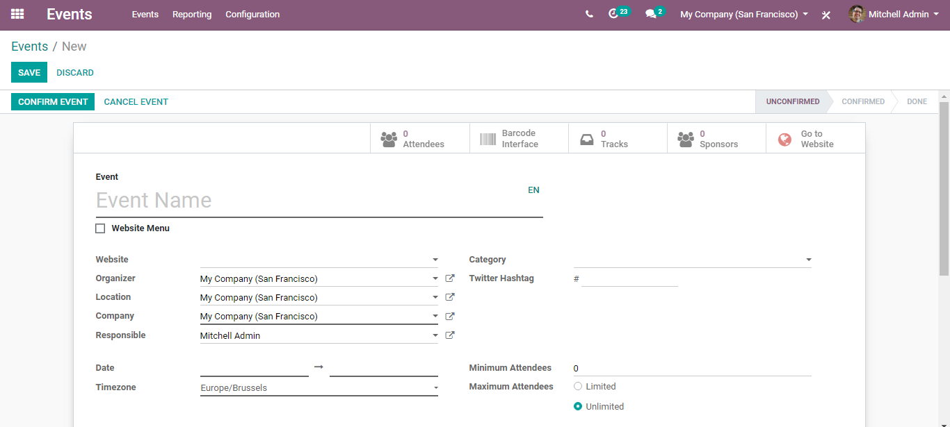

Under the event create form, one can give away the Event Name, Website where the event is planned to get published, Organizer, Location, Company, Responsible Designate, Date (from and to) Time zone, Twitter Hashtag, also the conditions say minimum/ maximum attendees. If chosen, the minimum attendee’s option, one can set the number in the additional column that appears.

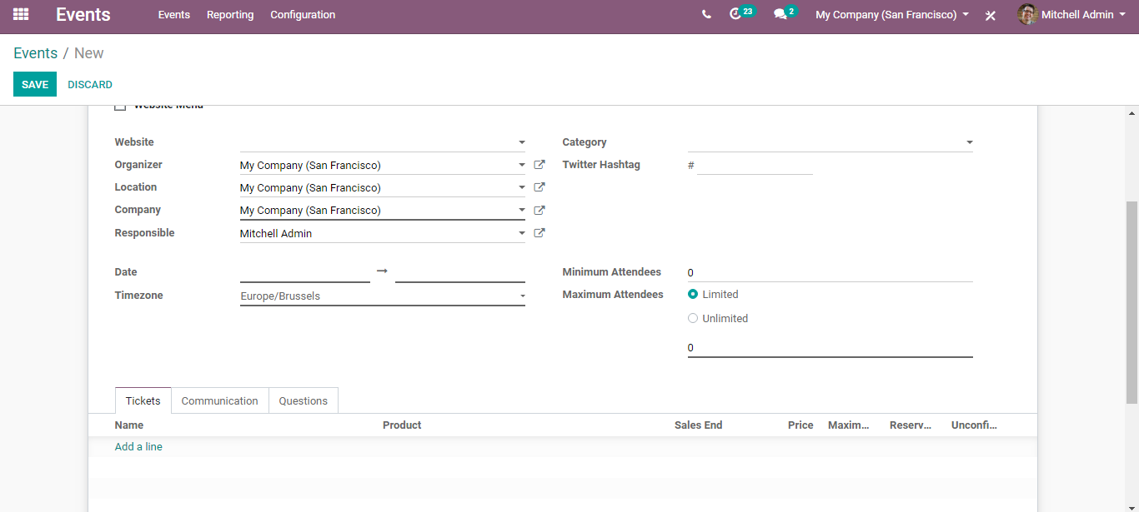

Under the Tickets tab, one can add different types of tickets,

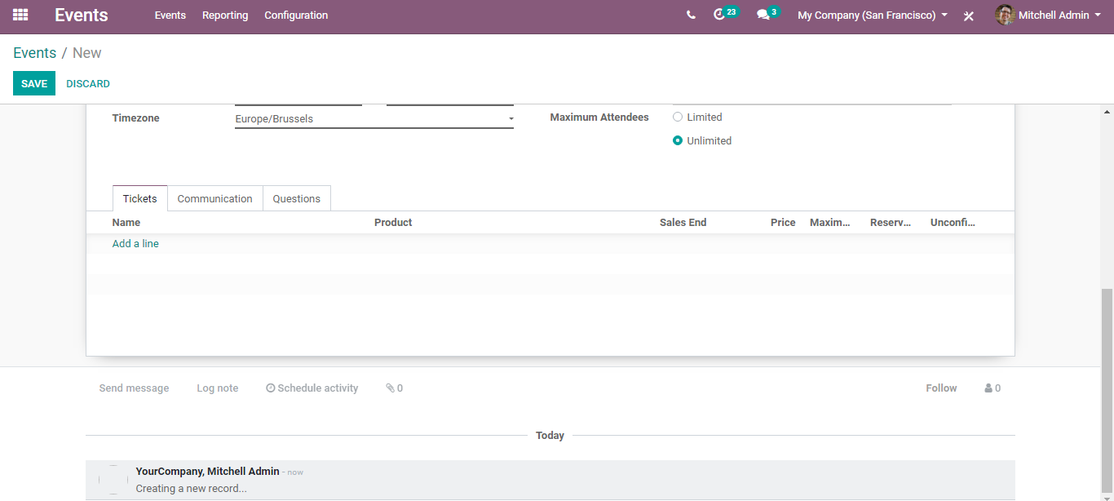

To add ticket type, click ADD A LINE option.

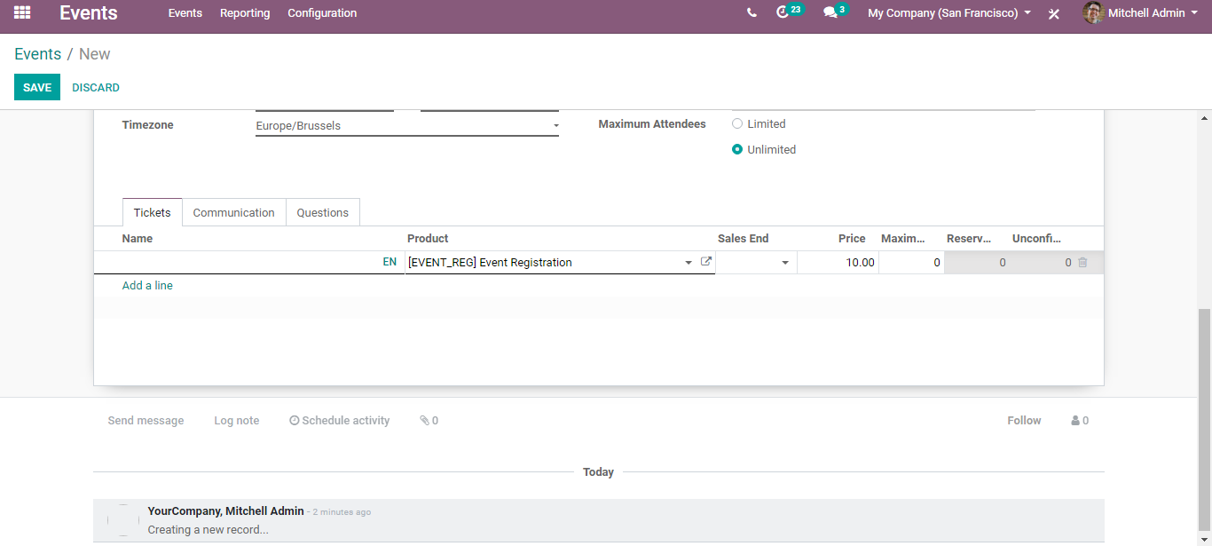

You can see an already created product for the ticket. This is because we sell tickets through sales orders.

You can set here the price, maximum available seats, reserved seats and so on.

Under the communication tab, one can select the mode of communication with the customer say email or SMS. Corresponding to your mode of communication, you can select the template from the drop-down menu. One can also select here the units, trigger option for messaging says before the event, after the event and so on.

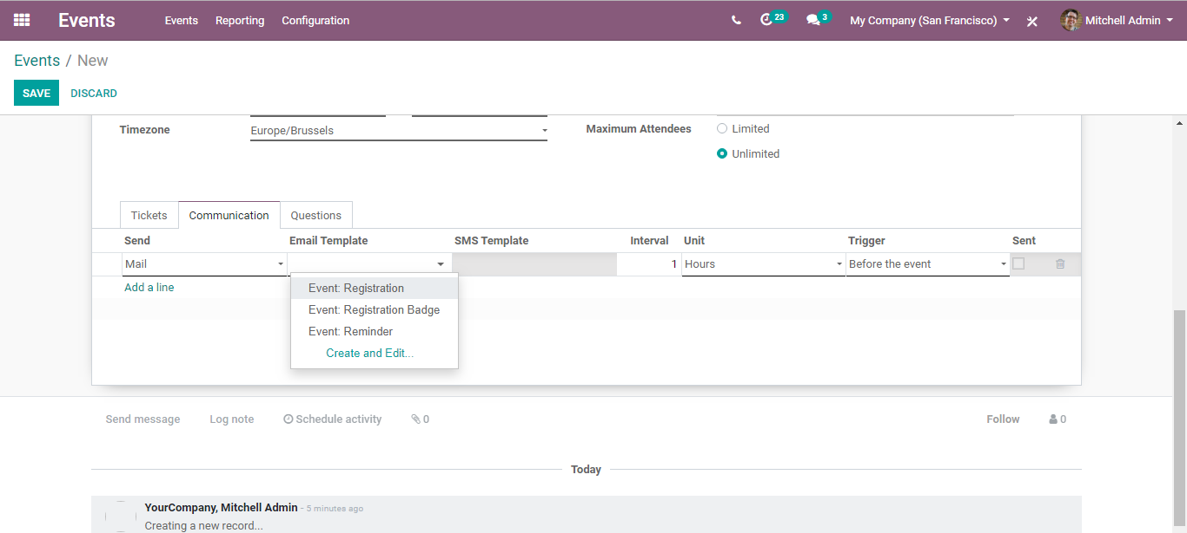

And under the question tab, one can add questions to the participant. For instance, if you are providing any lunch in the event, you can post in the question whether the participant is a veg or non-veg.

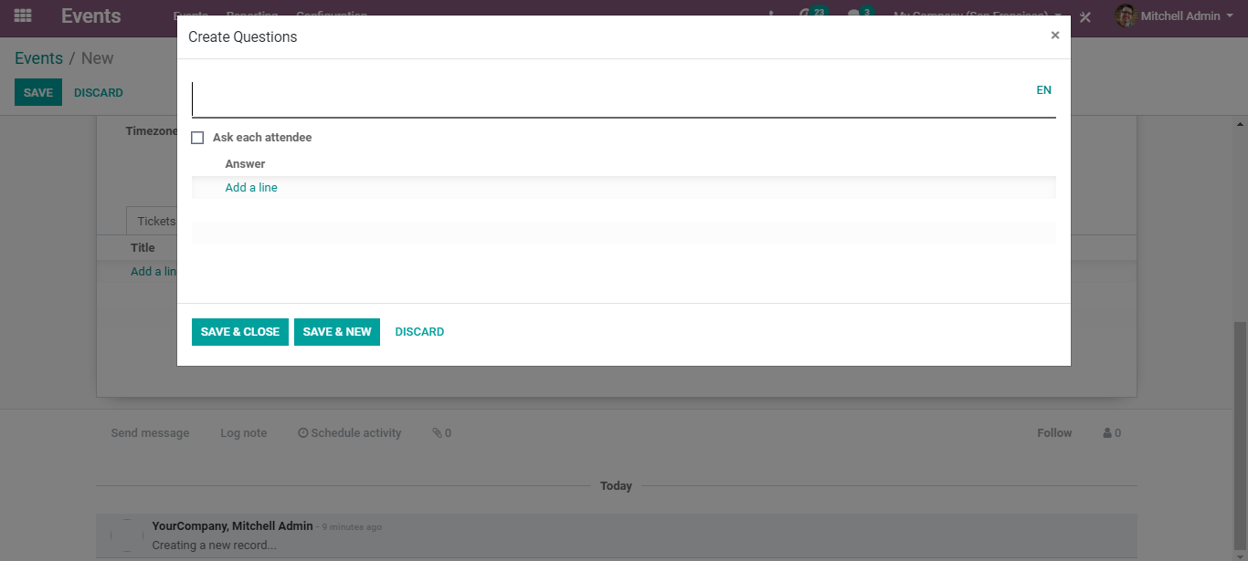

Once you are done, you can confirm the EVENT.

To publish the event on the website, click on GO TO WEBSITE option.

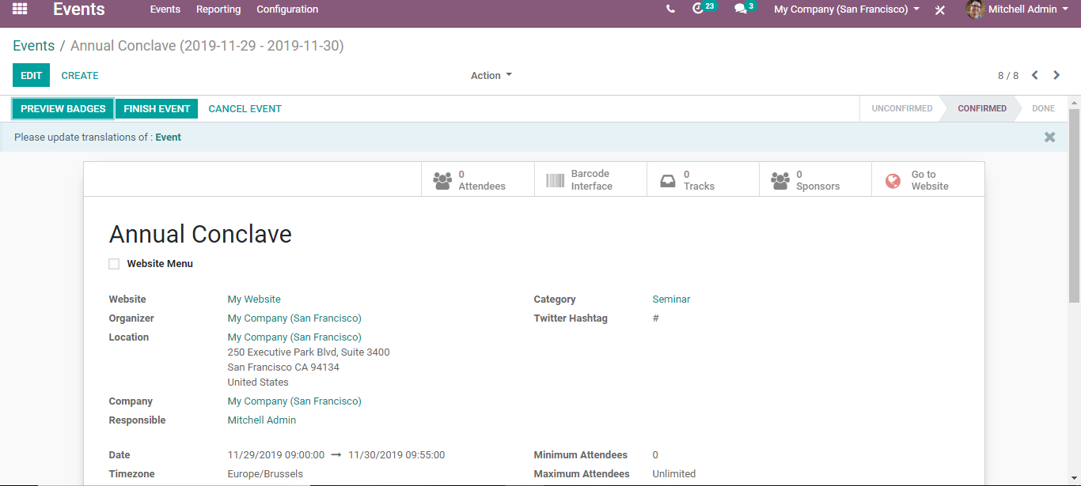

It will redirect you to the website page where you can turn on PUBLISHED. And the event gets published.

Upon clicking the EDIT button, one can make customizations in the website view of the page.

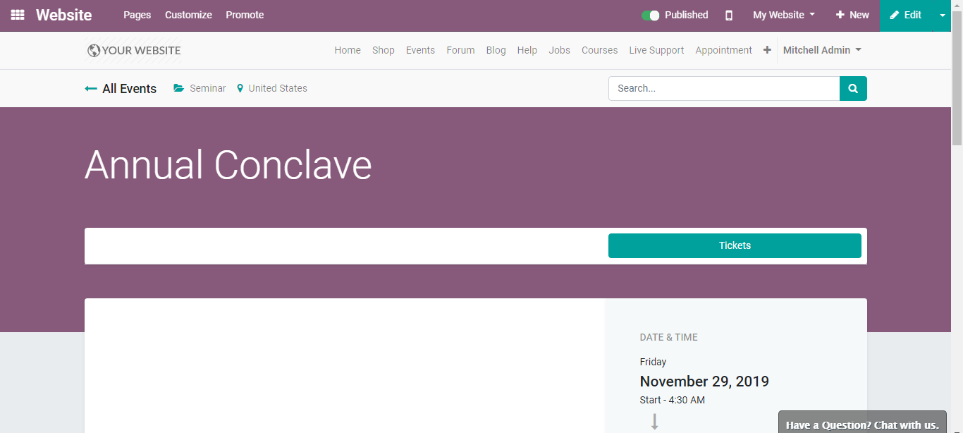

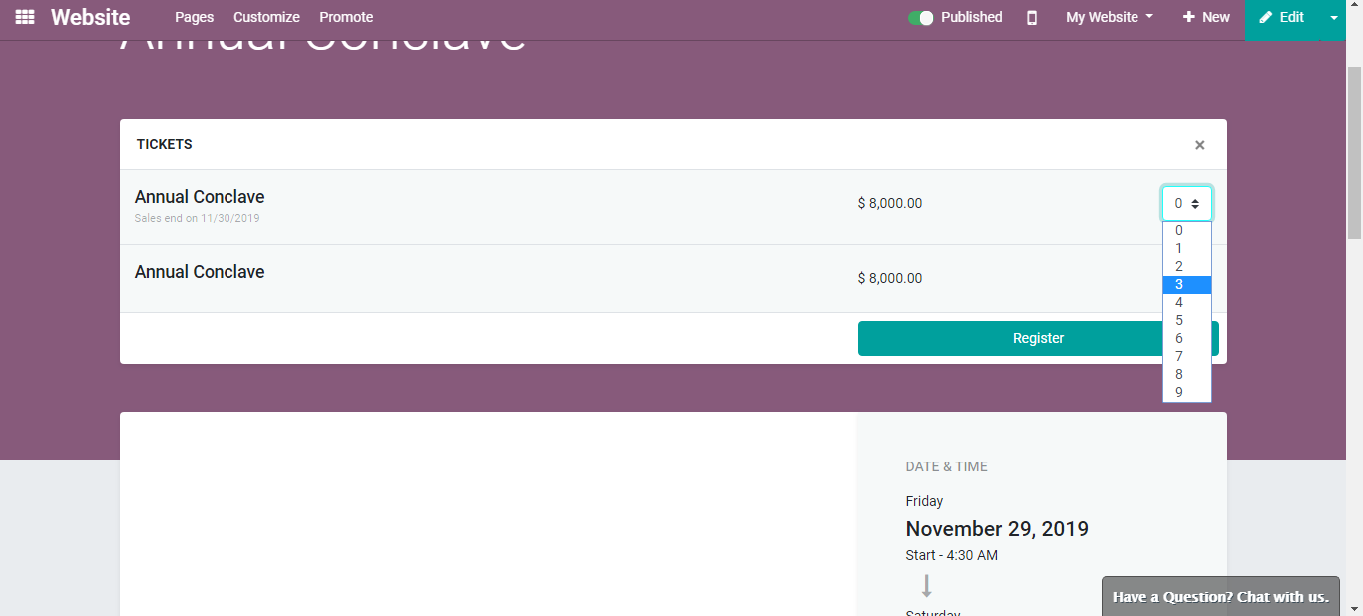

One can select here the number of participants for the event.

Click REGISTER for registering for the event.

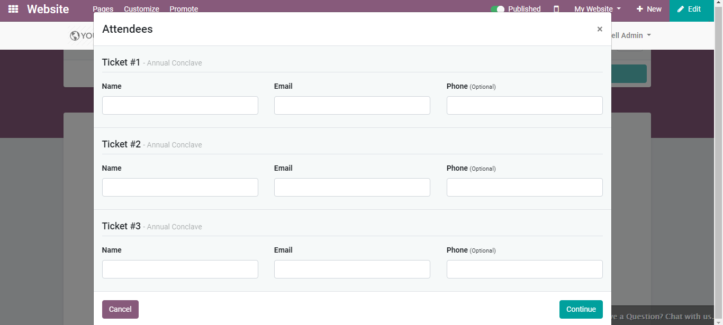

You can name your attendees, email, and phone numbers here.

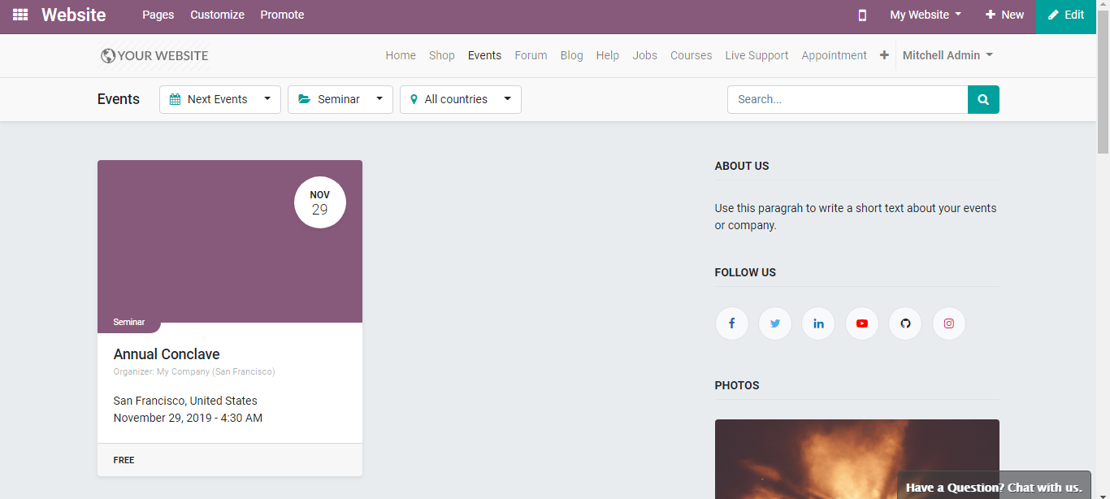

From the website, one can also get the info about the next events.

Now if you go back to your events, Via clicking the PREVIEW BADGES option, you get to see the badge preview.

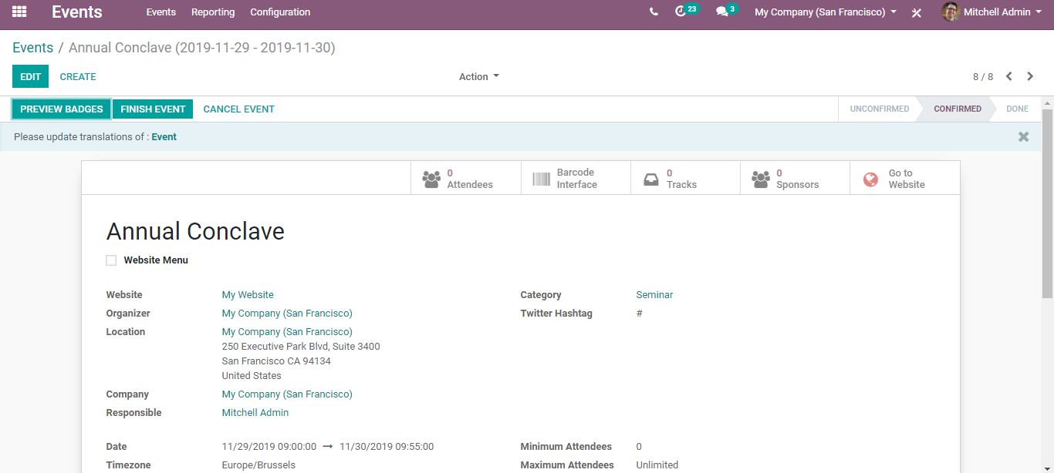

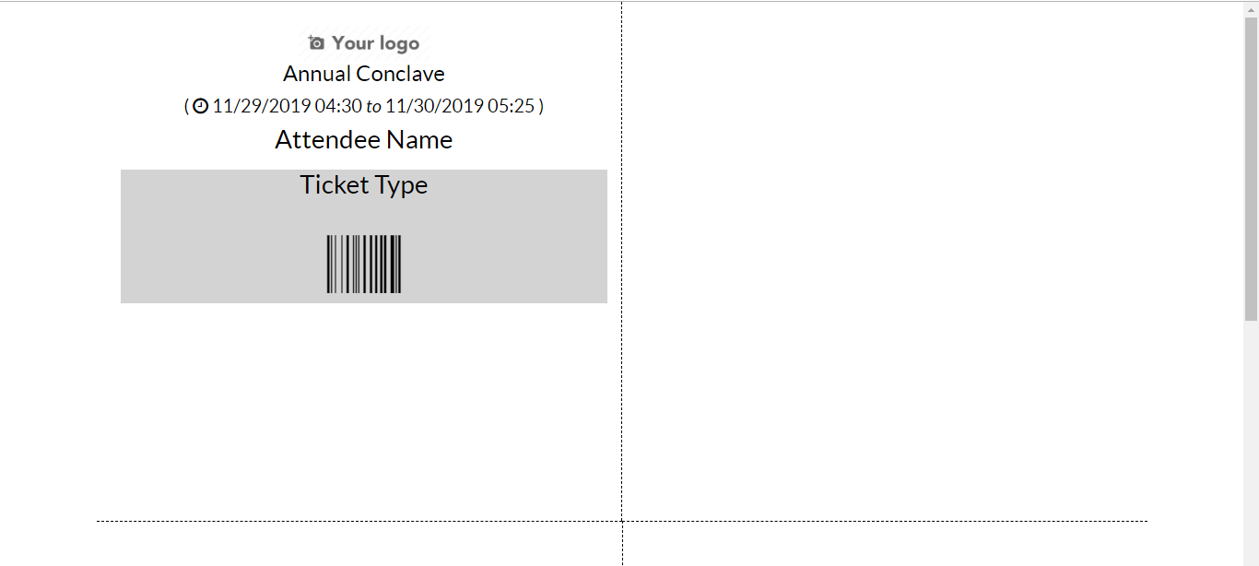

Reporting

Via going to Events>Reporting, one can see the event analysis.

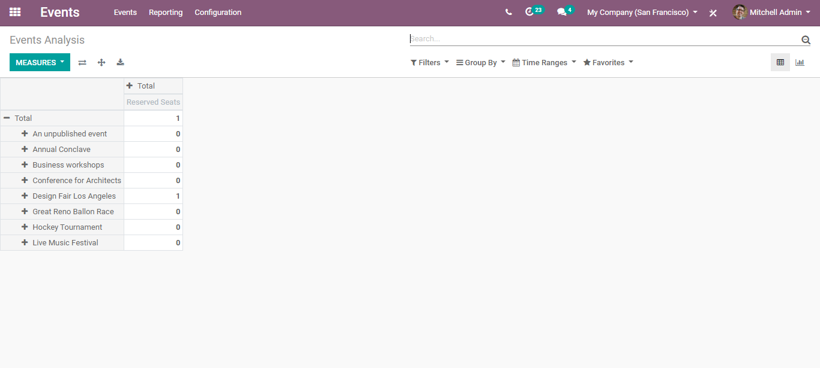

You get to see the list of unpublished events and other conducts.