  - Human Resource
  - BUSINESSBOXERP human resource management module is a comprehensive package to meet all your HR-related needs. It can manage the functions from Recruiting to, Employee Directory Management, Attendance and Leave management, Expense, and Timesheet management.
  - You must install the following apps from BUSINESSBOXERP apps to enable HR management features.
  - Employee Directory
  - This application allows you to create and manage the employee directory of your organization. You can create your organization's department hierarchy and add employees under different departments matching your organization’s structure. Employee contract details are configured using this module. So, this is the base of the HR module.
  - Attendance
  - Employee attendance can be managed by installing this module. There are different attendance marking options available with BUSINESSBOXERP. You can also add hardware for attendance marking. The module is integrated with Payroll, Leave Management, and Timesheet so that it provides a consistent attendance tracking mechanism.
  - Leave Management
  - Integrated with Attendance, Payroll, and Timesheet, Leave Management allows the administrator to make efficient decisions on employee leave requests.
  - Expense Management
  - The expense management module enables the management of expenses that occurred to employees. The employee can submit their expenses and appropriate officers can act on such requests.
  - Recruitment
  - You can automate and monitor all recruitment with this module. Recruitment stages, criteria, qualifications etc. can be configured with this module. You can install the Online Jobs app to channelize recruitment via your website.
  - There are some other useful apps and plugins that you can find in BUSINESSBOXERP App store.
  - Payroll
  - The Payroll Management module helps in generating a payslip for each employee via configuring their contracts first. Under them, one can easily specify the basic pay, working schedules, duration, and other employee payroll related data.
  - Some of the features of the BUSINESSBOXERP HRM module are:
  - Create employee profiles
  - Gather all information concerning each employee in one place.
  - Manage contracts
  - Keep track of your employees’ status, job titles, contract type and dates, and their schedule.
  - Manage timesheets
  - Create weekly and monthly timesheets and follow the time spent by your employees on projects.
  - Handle attendance
  - Keep track of your employees’ presence at work. HR managers can easily report employees' monthly presence with the menu entry and state.
  - Manage leaves
  - Manage holidays, legal leaves, and sick days.
  - Dashboards
  - Get a dashboard per manager.
  - Collaborate
  - Enterprise social network
Follow employees and documents, join discussion groups, share files, and chat in real-time.
  - Gamification
  - Design challenges, goals and rewards with clear targets and objectives to drive engagement and reward your employees’ performance.
  - System Users: -
  - There are three types of users in the HR management process
  - Employee: - Normal employee of the office. He can mark his attendance, access the tasks assigned to him, manage his timesheet, and perform other tasks associated with him.
  - Officer: - A higher level employee who has better powers and access rights like sanction leave, sanction timesheet etc.
  - Manager: - Manager who control and configure every procedure in the HR module. Complete control overall level.
  - Employee Directory
  - CREATING EMPLOYEES
  - As soon as you enter the BUSINESSBOXERP Employee dashboard, you see is the employee database. One can straight away see the name of the employee, his job position, and other pertinent details.
  - 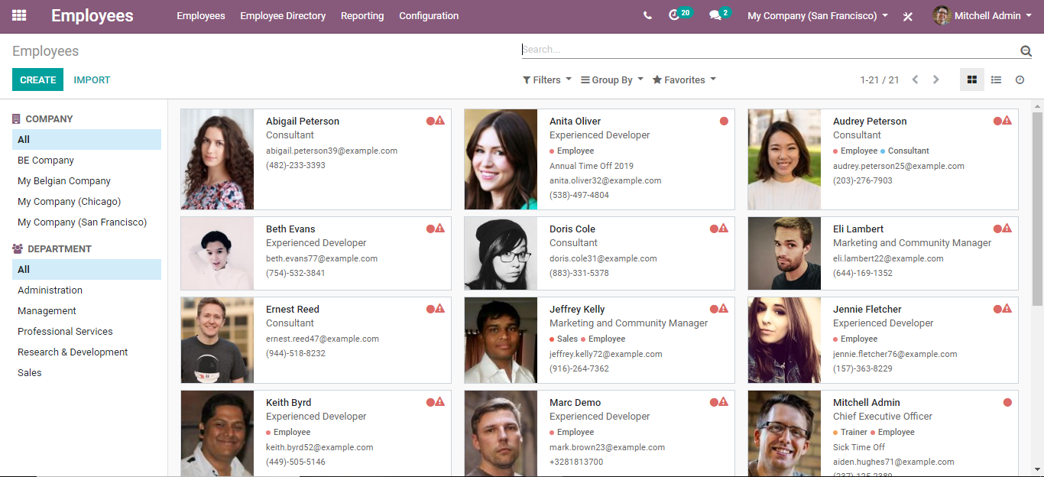
  - One can also easily filter the employee based on his company and the department.
  - 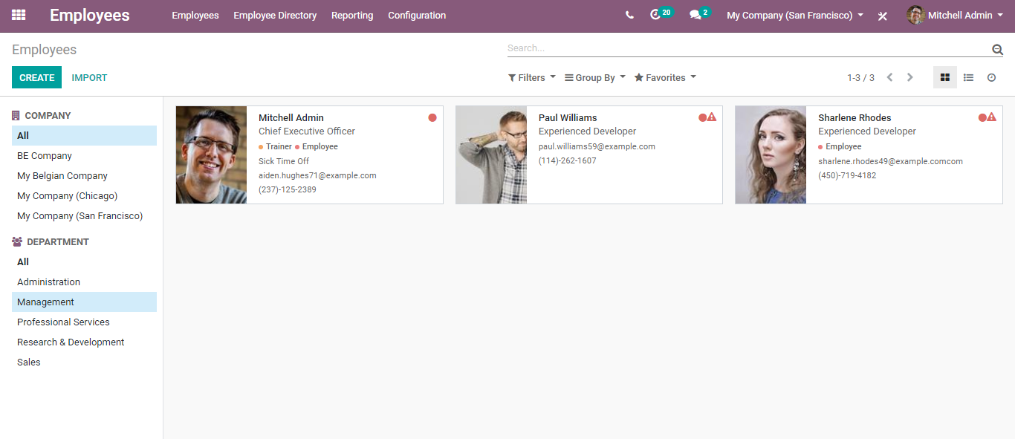
  - To create a new employee, click create button.
  - 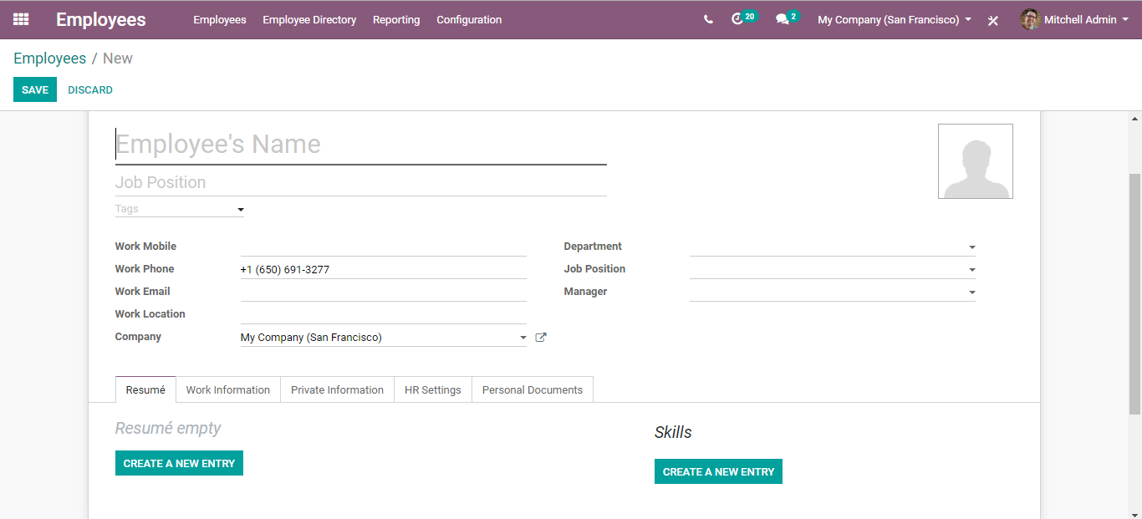
  - Under the create form one can include all the vital information related to an employee such as Employee Name, Job Position, Tags (such as trainer, employee, or a consultant), Work Mobile, Work Phone, Work Email, Work Location, Company, Department, Manager and so on.
  - Under the resume tab, one can enter the resume and skills of the employee.
  - 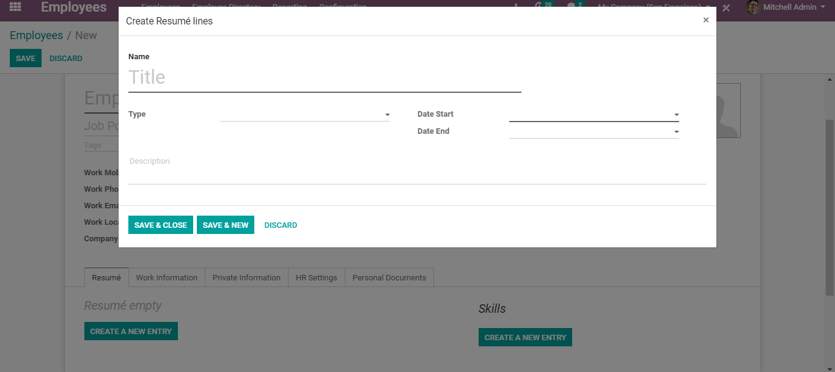
  - After entering the info in fly, it will look like below:
  - 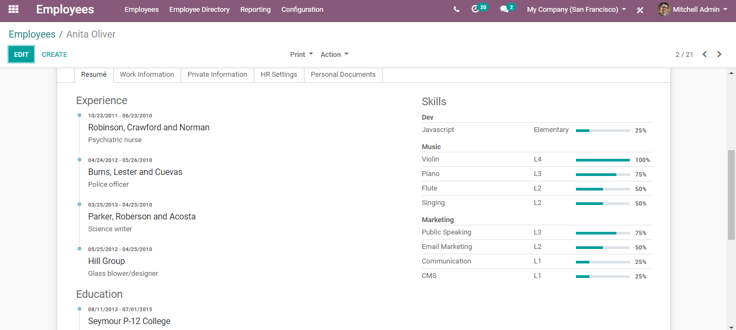
  - Coming back, under the work information tab of employee create form,
  - 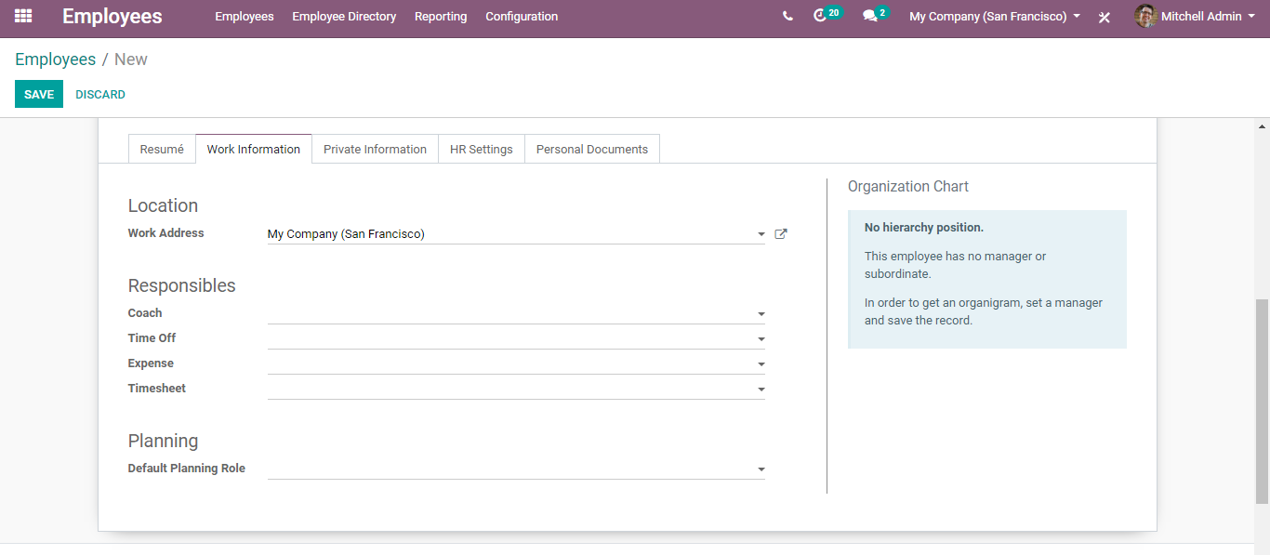
  - One can add the work-related information such as work address, his coach, the user responsible for his leave approval, the user responsible for his expense approval, the user responsible for timesheet validation and so on.
  - After entering all this, one gets to see the hierarchical position of the employee. One gets to see the organization chart positioning who is supervising the employee, n under him which team members fall in and so on.
  - 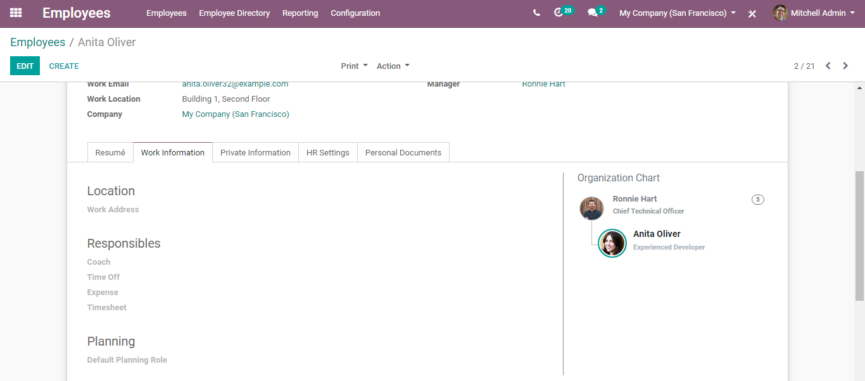
  - Under the Private Information tab,
  - 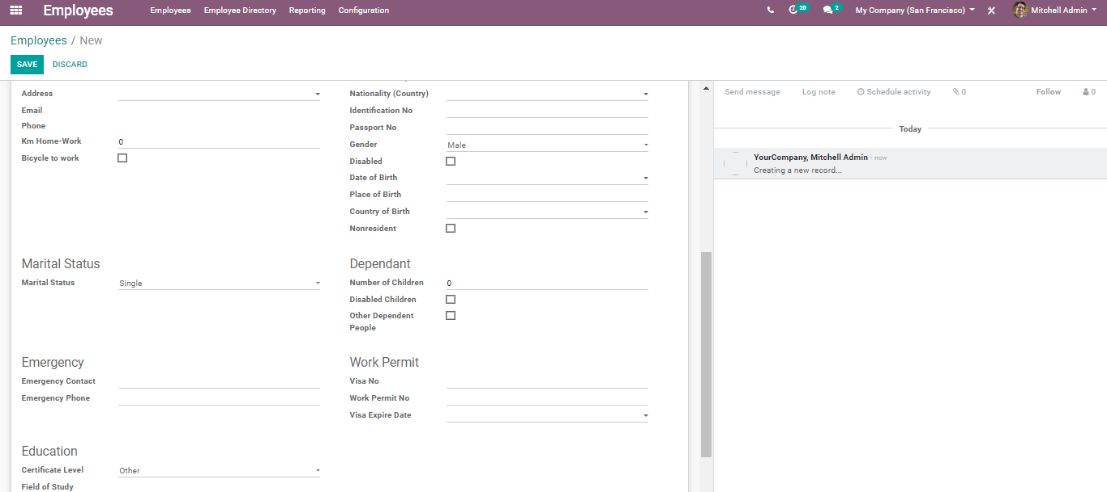
  - One can enter all the personal information related to the employee such as his address, marital status, education background, work permit, dependents and so on.
  - Under HR Settings Tab,
  - 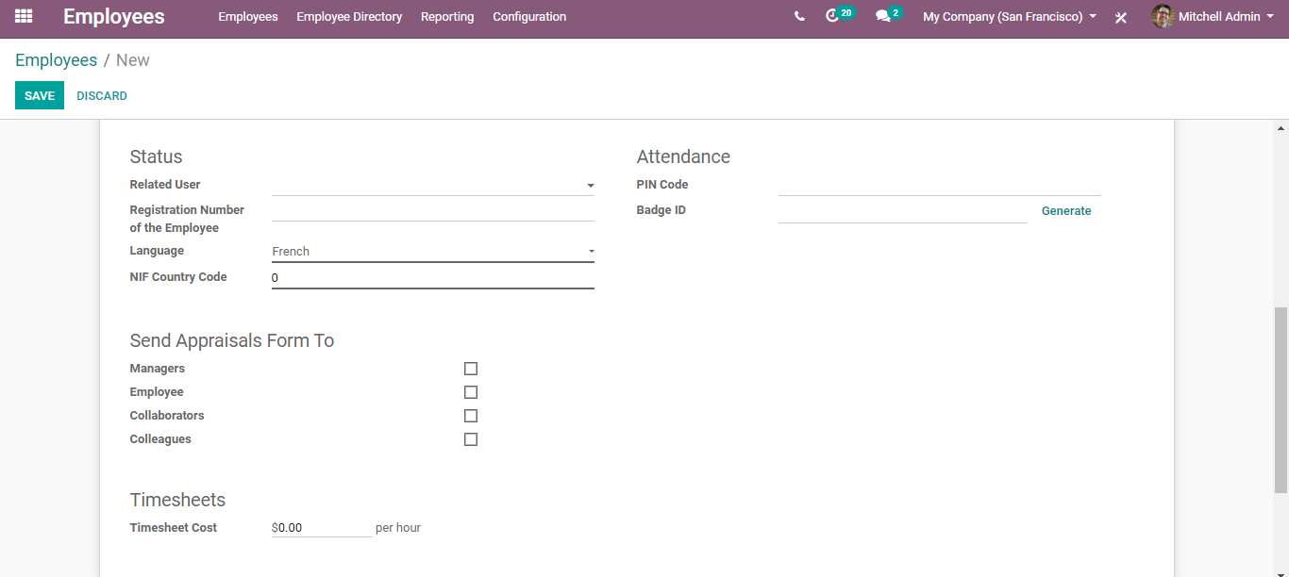
  - You can specify the related username for the resource to manage its access, Registration number, Language, Attendance details such as Pin Code and Badge Id, Appraisal Form settings and the timesheet details.
  - Under the form of the personal document, the user can add all his documents such as ID Card Copy, driving license, Mobile Subscription Invoice, SIM Card Copy etc.
  - 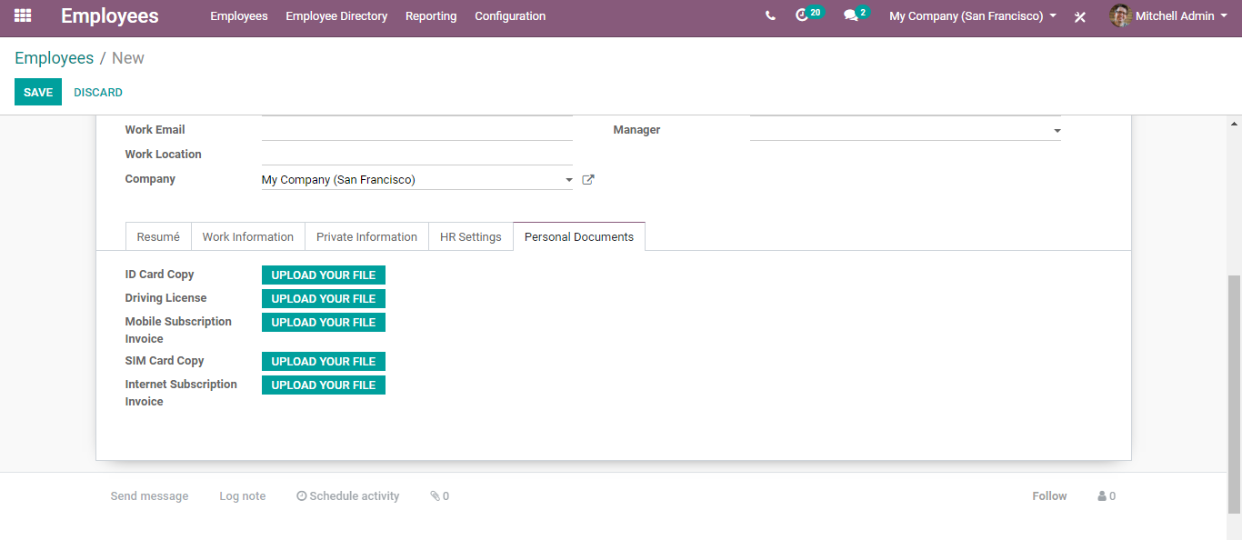
  - Update/Delete an employee
- Employees > Dashboard
  - Select any of the employees from the list and click on the EDIT button to mark the sufficient changes.
  - 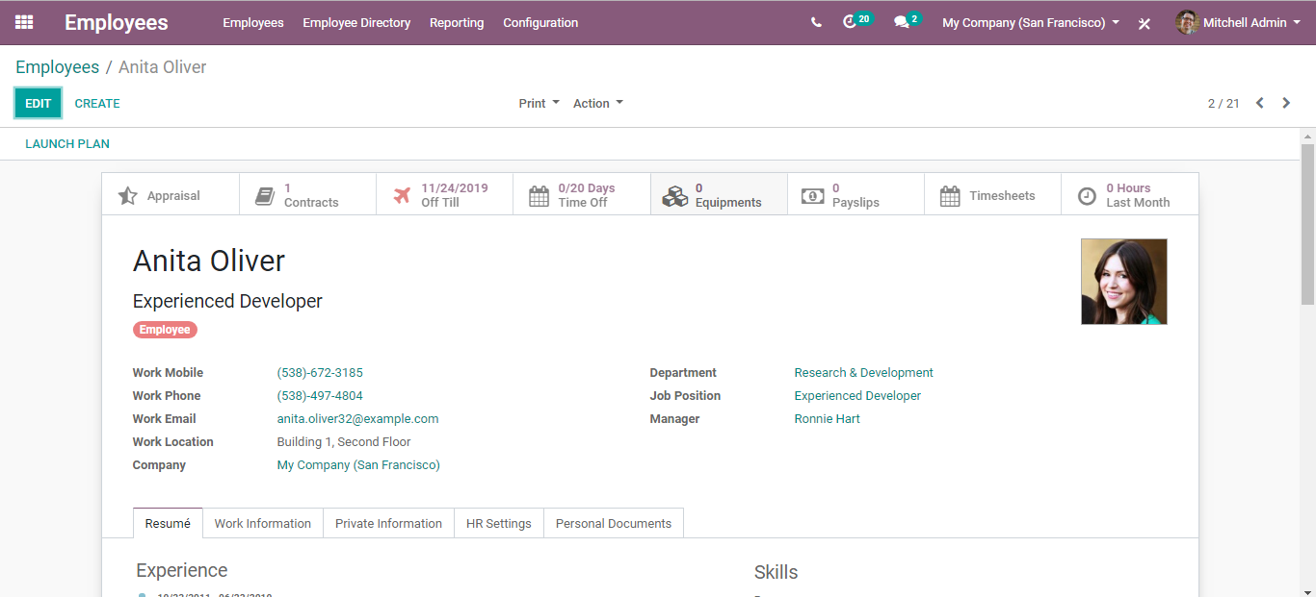
  - To delete an employee, click on ‘Action’ > Delete.
  - 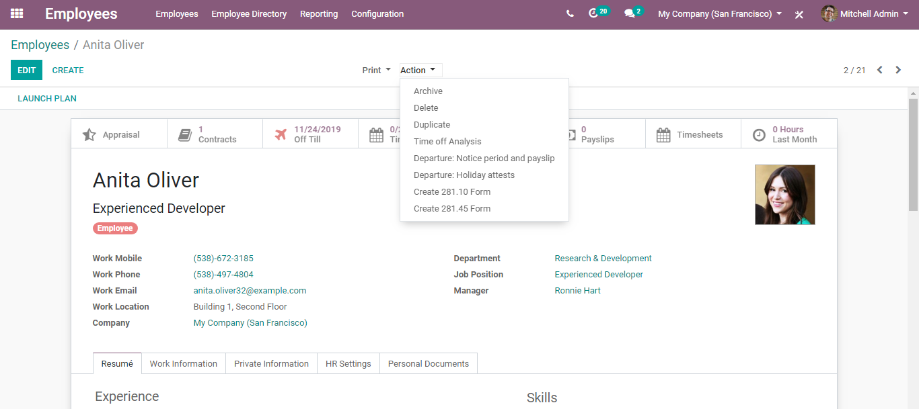
  - Note: - “In HR Tab there is field “Related User,” using this option you can assign an employee to any ‘system user.’ For example, the project manager can be an employee of the firm as well as he can be the “Administrator” of the system.”

  - Basic Configurations under Employee Module
  - CREATING JOB POSITION
  - Configuration
  - Employees> Configuration> Job Positions
  - 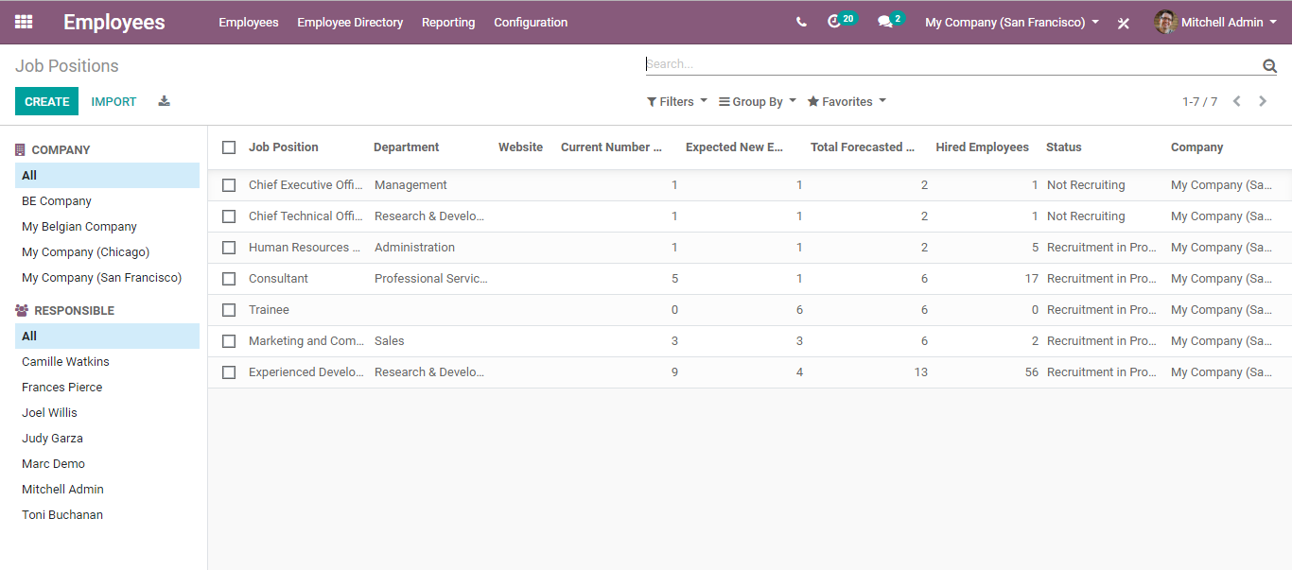
  - Upon clicking create button, you can add a new job position.
  - 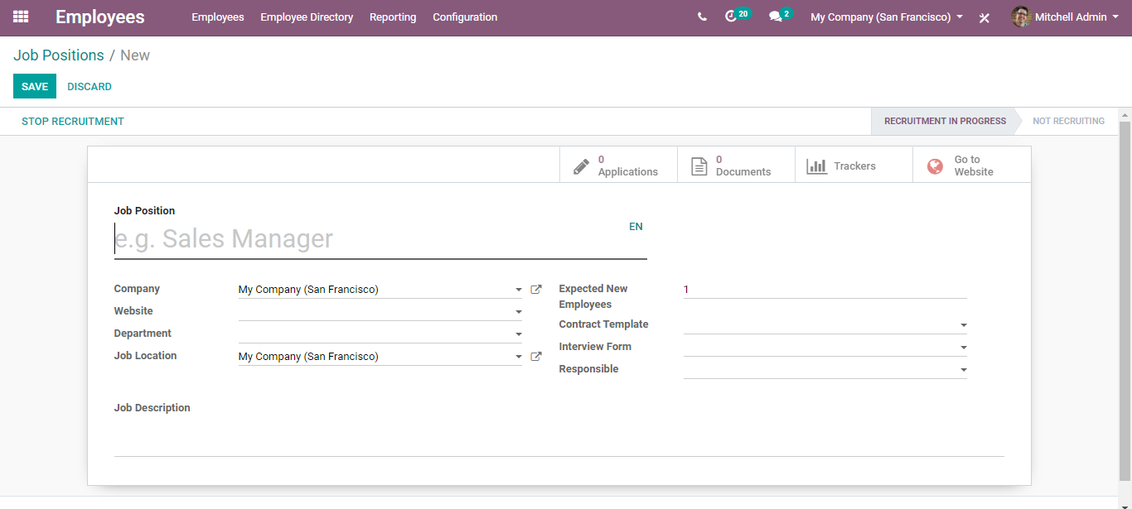
  - On the fly, one can enter the name of the new job position, the company under which the position is created, job location and description, expected new employees under the position, contract template (default contract used when making an offer to the applicant).
  - One can either use the existing contract or create a new one. To create a new contract, click create and edit option.
  - 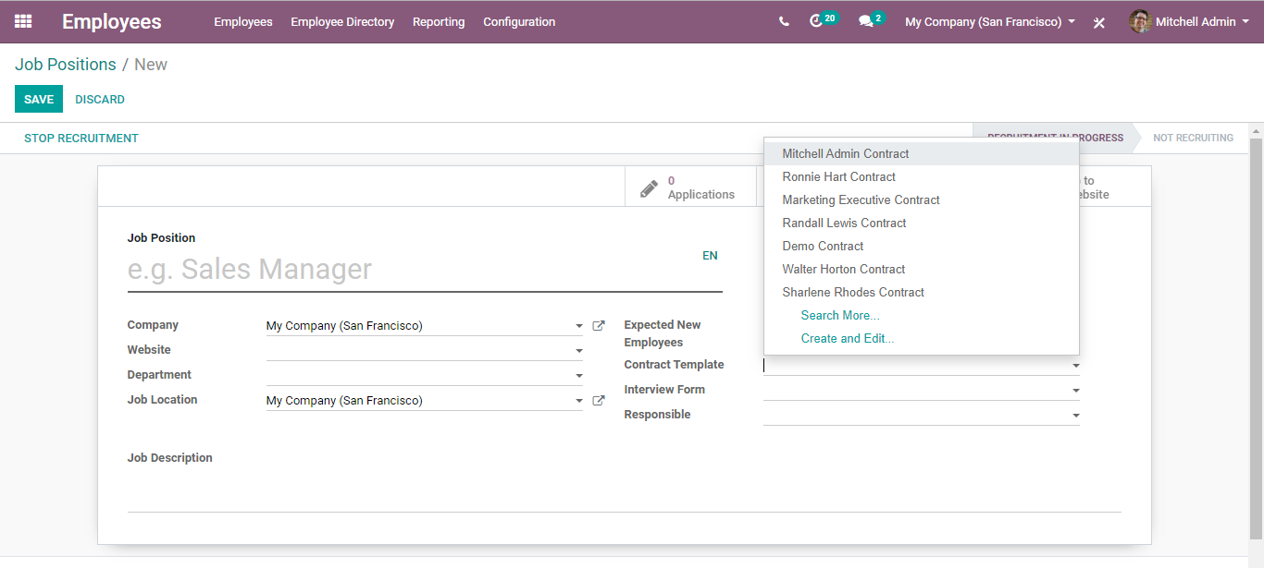
  - You will be navigated to a new window like below:
  - 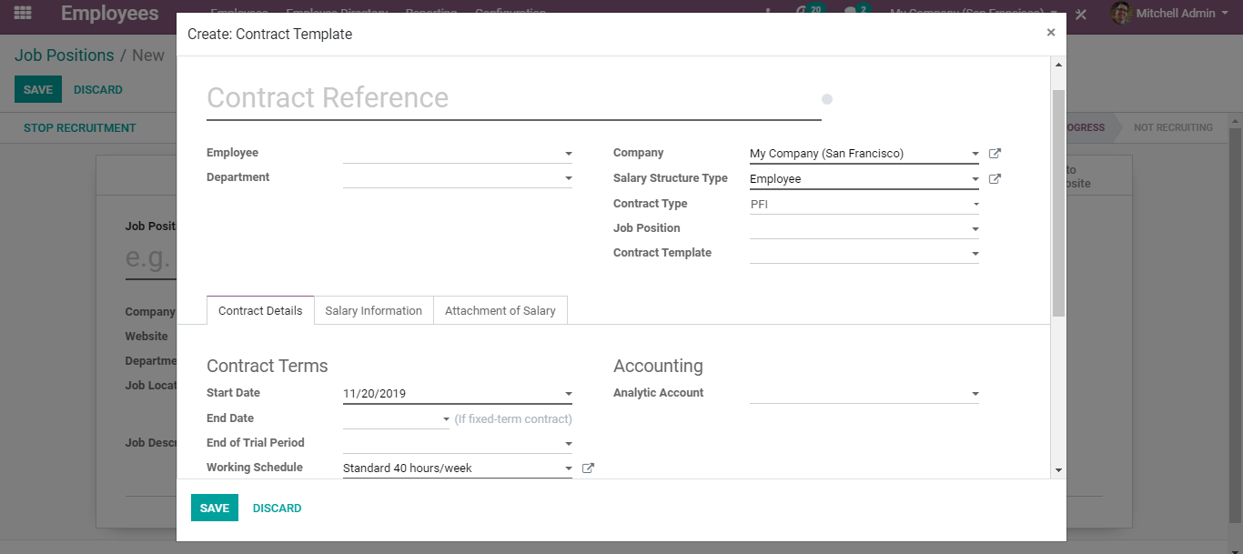
  - There you can enter information related to the contract such as Employee name, Department, Contract Terms such as start date, end date, trial period, working schedule, accounting details, also the salary structure type and many more.
  - Also, one can add the interview form under the Job position create form. Adding an interview form in the position helps in printing and getting answered this interview form all applicants who apply for this position.
  - 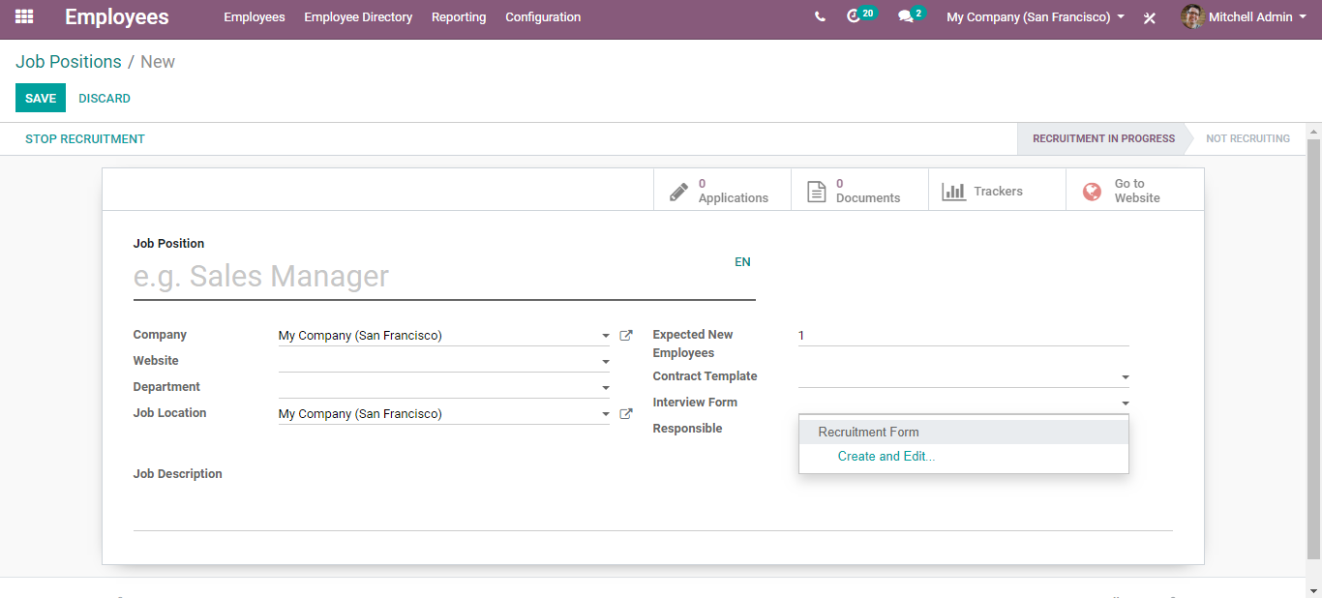
  - To create a new interview form, click CREATE and EDIT button,
  - 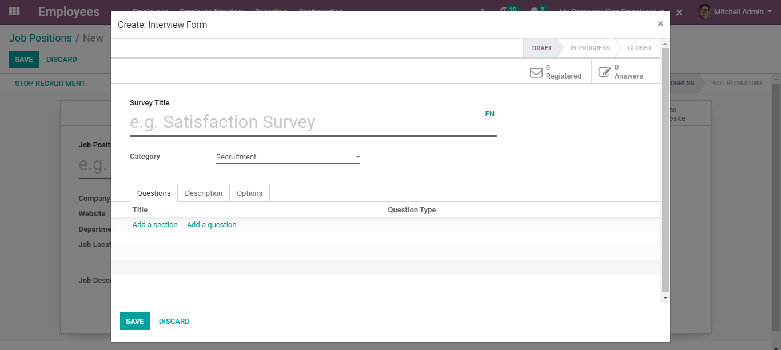
  - Here you can add the survey title, category, questions and so on.
  - CREATING DEPARTMENTS
  - BUSINESSBOXERP enables you to create and manage your organization's departmental hierarchy in the simplest manner.
  - To create a new department,
  - Go to Employee > Configuration > Departments > Create.
  - 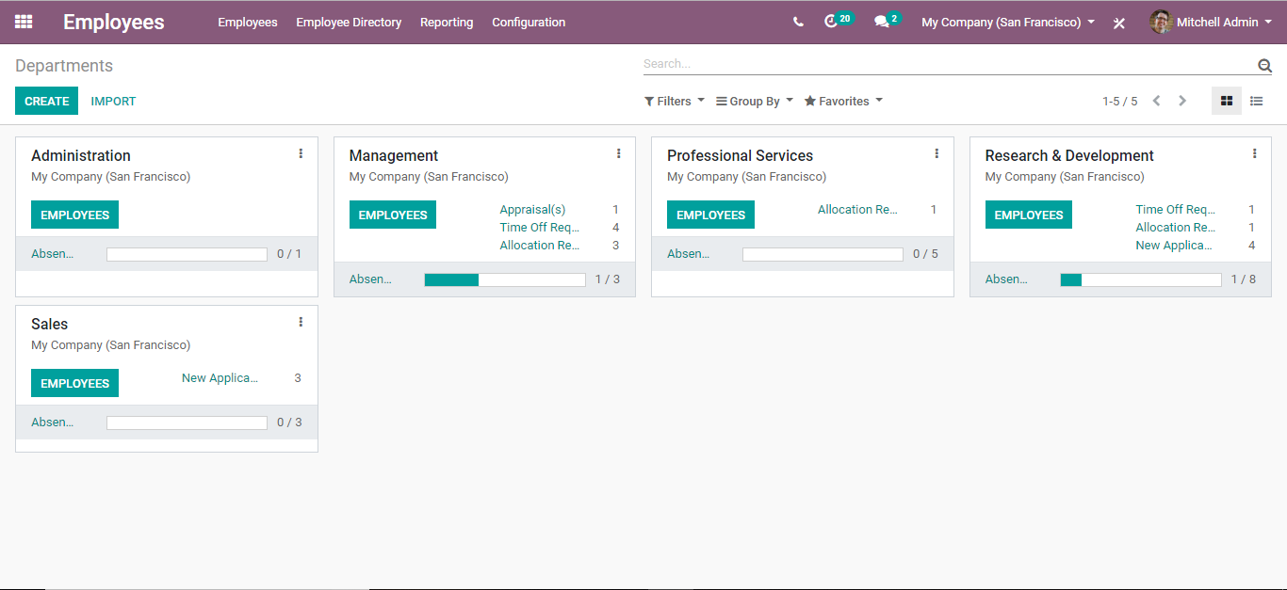
  - From the Employee Department dashboard, one can view the already created departments also certain information related to each of them.
  - For instance, upon clicking the EMPLOYEES link, one gets to know the employees listed under this department.
  - 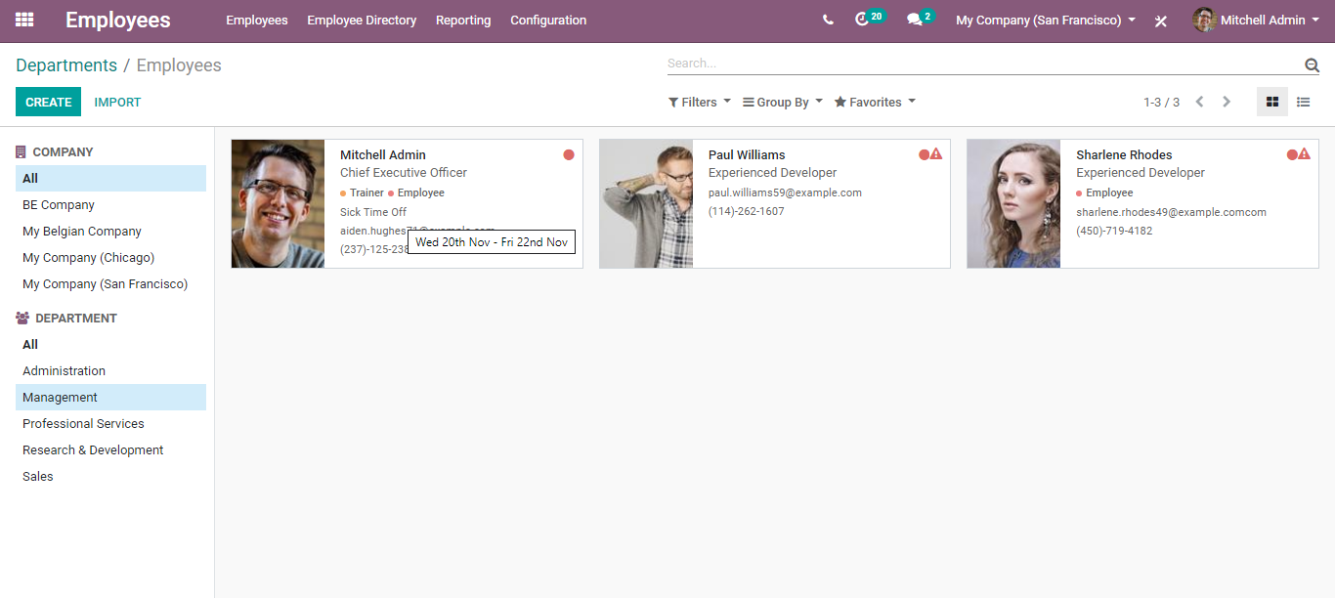
  - The same way you can directly get to the department wise reports such as appraisals, time off requests, allocation requests, absentees in the department etc. Via clicking it, you get its details.
  - To create a new department, click the CREATE button.
  - 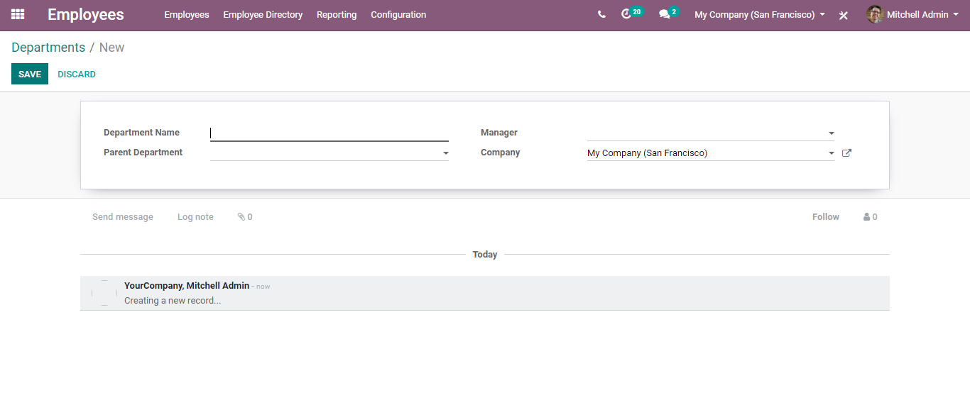
  - A create form will appear like above:
  - Under the form you will have the following fields:
- Department Name
- Parent Department
- Manager
- Company
  - Fill in the fields and click SAVE.

  - EMPLOYEE CONTRACTS
  - An employment contract standoff is a consensual agreement between an employer and an employee. It is the thread that binds together the relationship between the employer and employee. Under the BUSINESSBOXERP employee database, one can seamlessly create employee contract templates, to add them under the job positions and other relevant places.
  - To create a new contract template, go to Employees> Configuration> Contracts> Templates> Create.
  - 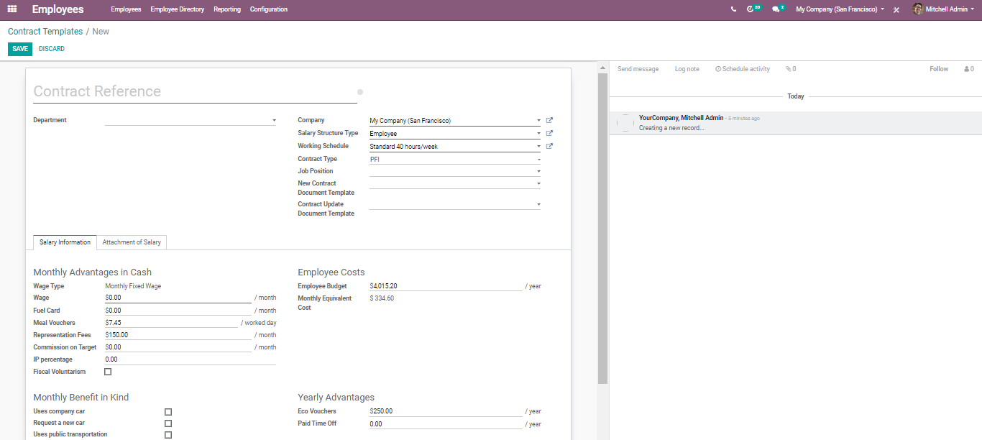
  - Under the template, one can add information such as Salary details amounting to all monthly advantages drawn by the employee in a company, Monthly Benefit in kind, Employee costs, Yearly advantages, salary structure type, working schedule, contract type and so on.
  - CREATING PLANS
  - It is quite natural for a person to feel tense and anxious on their first day of work. However, this tension can be put to rest if the HR or the management tends them with care. With the Employee planning option in BUSINESSBOXERP, the employee onboarding can be efficiently conducted. One can implement several onboarding exercises such as sharing office handbooks, diaries, and other sources of data with the employees. Supplying these kinds of materials can help the fresh recruits to figure things and fit themselves in the company shoes at the earliest.
  - To configure new plans,
  - Go to Employees> Configuration> Activity Planning>Plans
  - 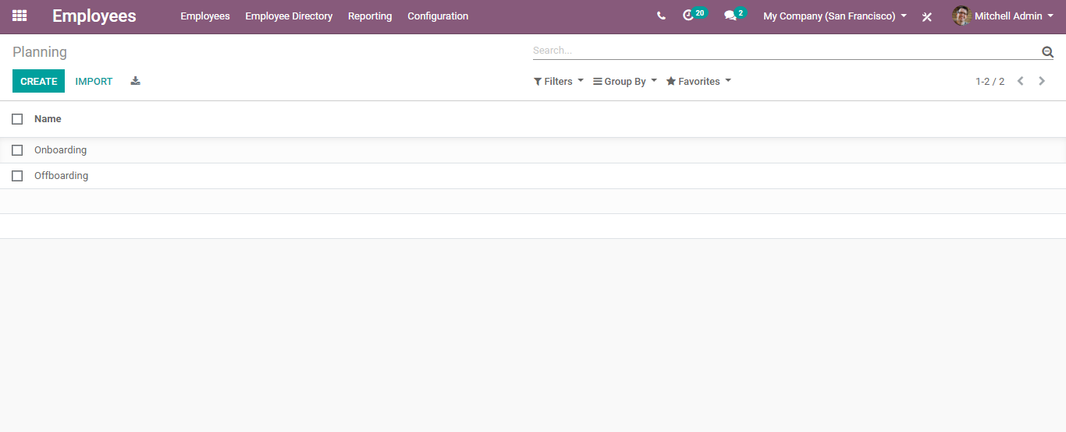
  - To create a new plan, click on create button.
  - 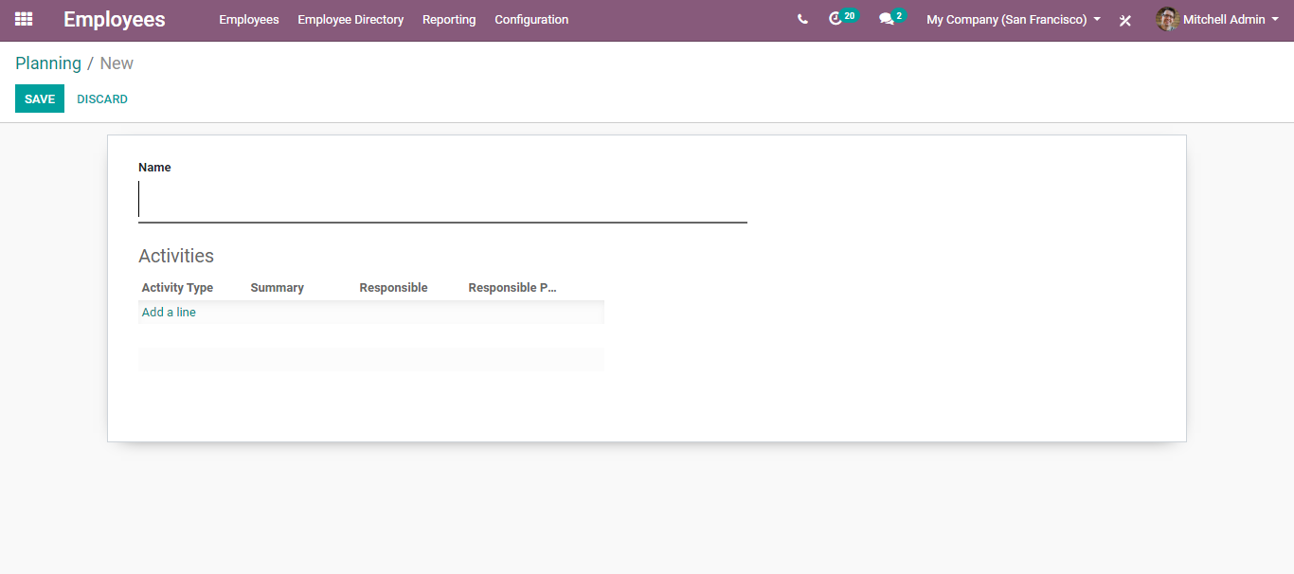
  - You can enter the name, Activity Types such as Training, Material Distribution etc. To add, the activity type, click Add a line option.
  - 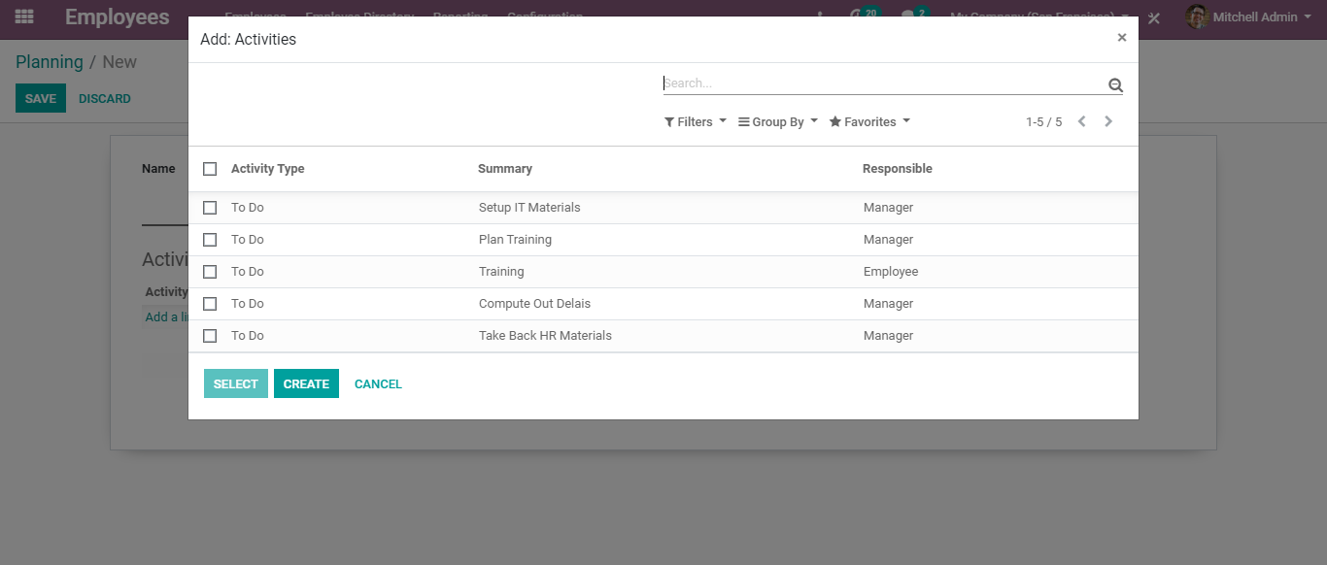
  - Create save to mark the changes.
  - GAMIFICATION
  - When it comes to Human resources, gamification has its own special place. It helps in keeping the employees’ spirit alive and motivating them to do more in the workplace. Many companies have adopted game traits to motivate employees and give them a home feel atmosphere in the office. Under BUSINESSBOXERP, one can execute several challenges as part of gamification. Here, users get evaluated through goals and numerical objectives.
  - Challenges
  - To assign goals, under BUSINESSBOXERP one can set challenges.
  - To configure a new challenge, go to Employees> Configuration> Challenges> Challenge> Create.
  - 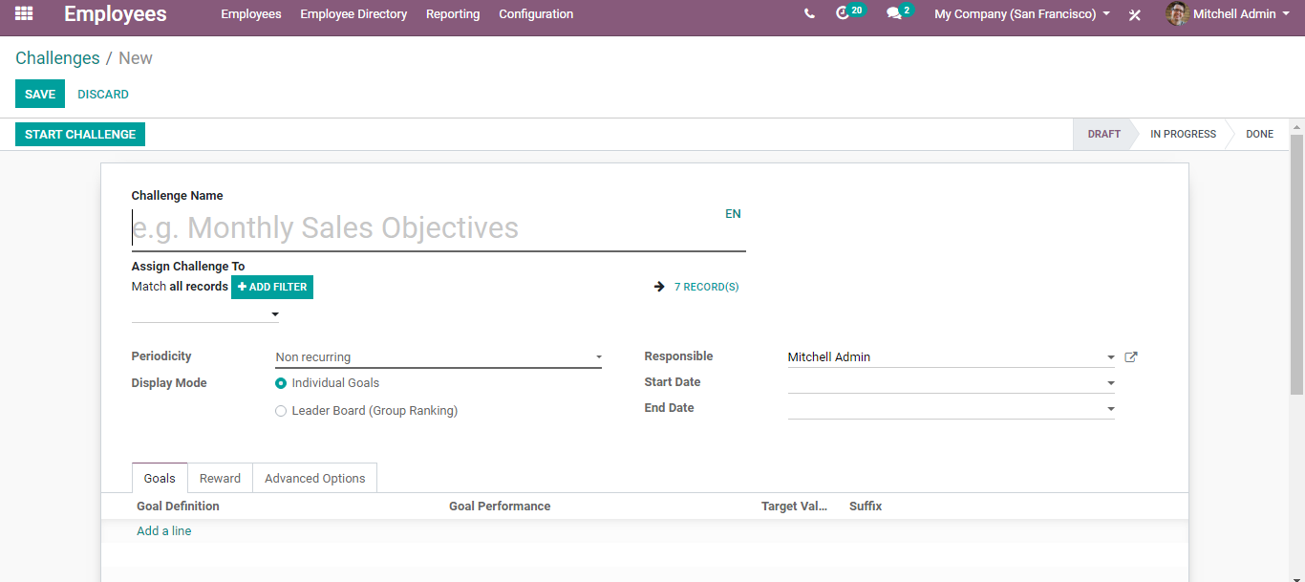
  - Under the fly, one can enter the challenge name for instance MONTHLY SALES OBJECTIVE, periodicity of the challenge, Display Modes: Individual Goals/ Group Ranking, User responsible for the challenge, start date and end date, Goal definition.
  - Badges
  - For non-numerical achievements, users are granted badges. Badges can be the best medium to show gratitude to the user for his/her achievement. No matter it represents a mere “thank you” or big achievement.
  - To create a new badge, go to
  - Employees> Configuration> Challenges> Badges> Create.
  - 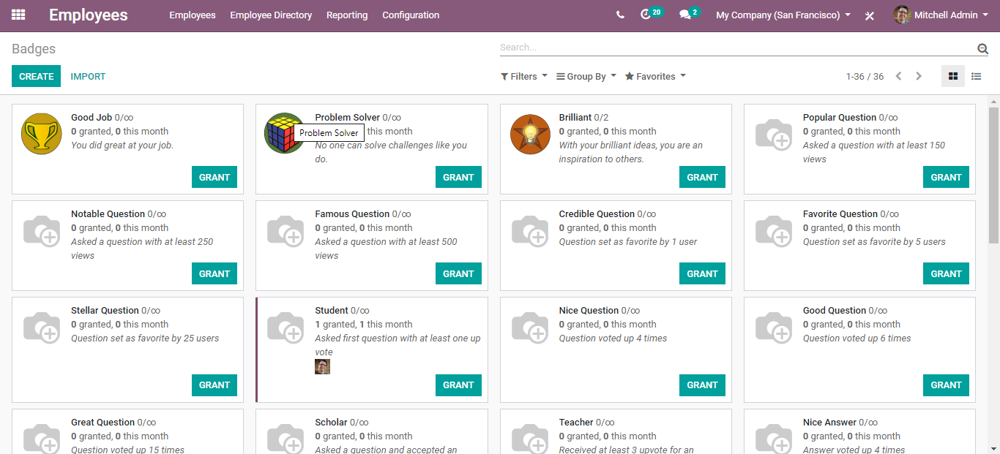
  - From the dashboard, one can see the already created badges with a small background. For example, from the dashboard, one can make out information such as how many were granted with this badge this month, description note and so on.
  - To create a new badge,
  - Click on CREATE button. You will be navigated to a new window like below:
  - 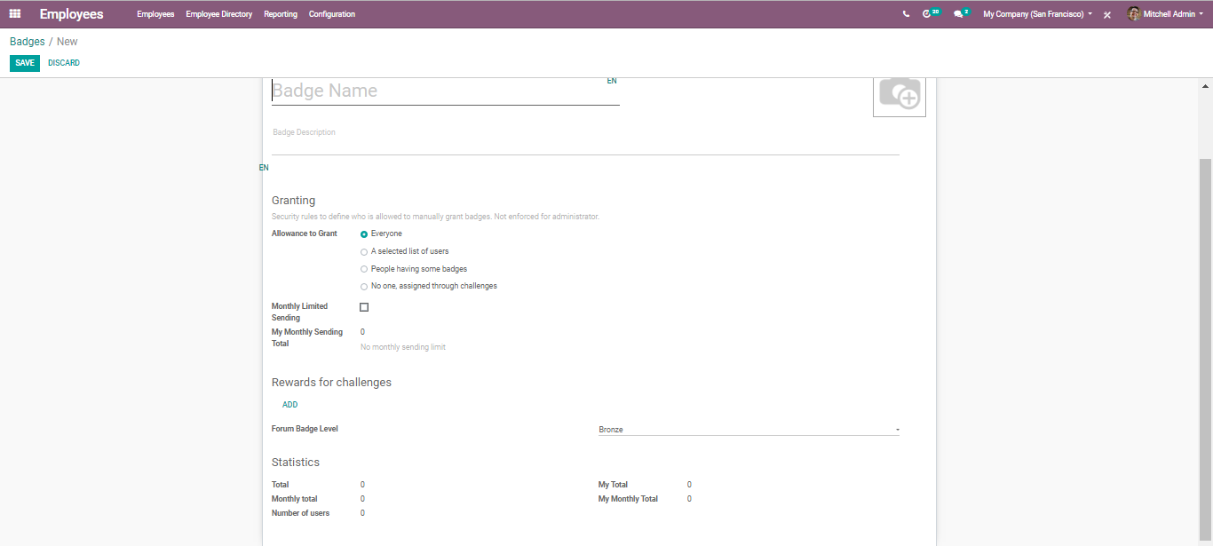
  - On the create a fly, one can add the Badge name and Badge description. One can also select who can grant this badge.
  - 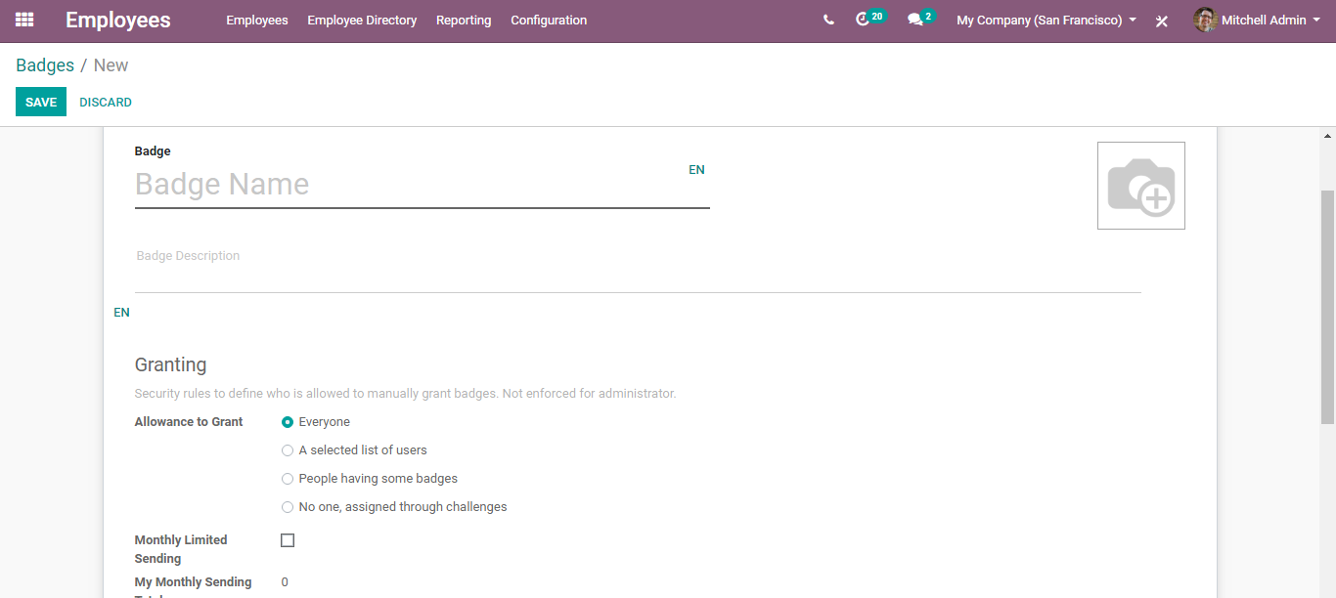
  - Upon selecting a monthly limited sending option, one can set a monthly limit per person for sending this badge.
  - REPORTING
  - To acquire the employee analysis report, go to Employees> Reporting
  - 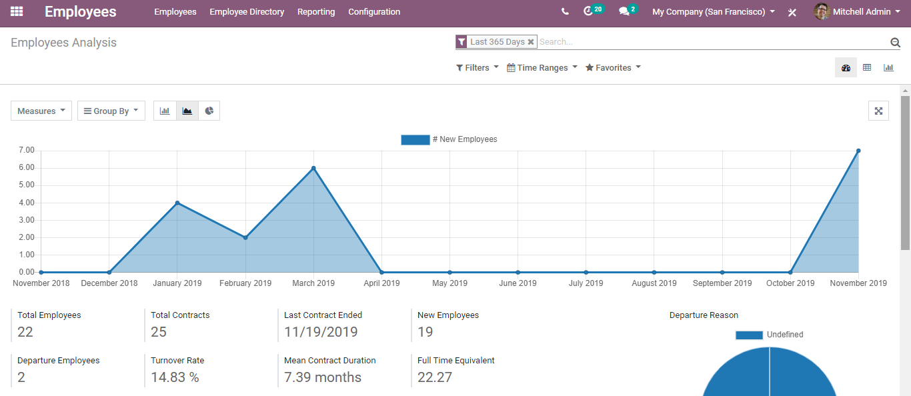
  - One gets to see the complete statistical data about employees such as
- Total Employees
- Total Contracts
- Last Contract Ended Date and so on. Via using the application, the user can create several custom reports choosing parameters like Filters, Time ranges and more.

  - Employee Attendance
  - To manage efficiently employee attendance, BUSINESSBOXERP HR management has produced the attendance module. Under the module, the attendance of employees can be recorded based on Employee’s Check-in/ Check-Out actions.
  - Attendance Entry
  - There are two ways to mark employee attendance.
- Direct login and marking attendance
- Kiosk Mode
  - Direct login and mark attendance
  - Since system login credentials are available to officer level employees this attendance marking facility is available only for those employees who have a system login Username and Password. They can log in to the system and mark their attendance from the Attendance menu.
  - Login > Attendance
  - 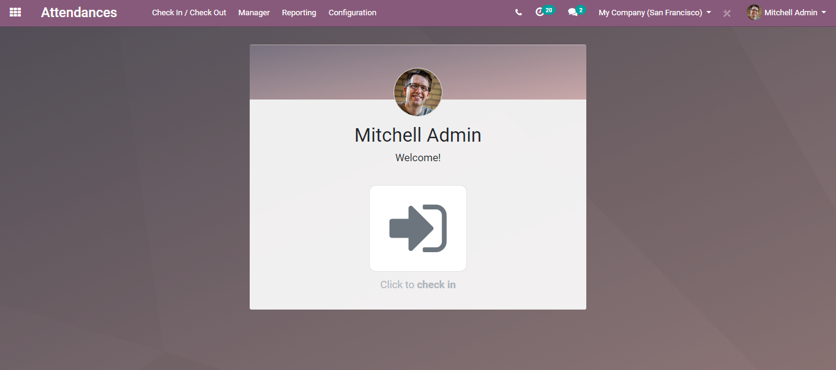
  - Click the image to check-in and click again to check out.
  - 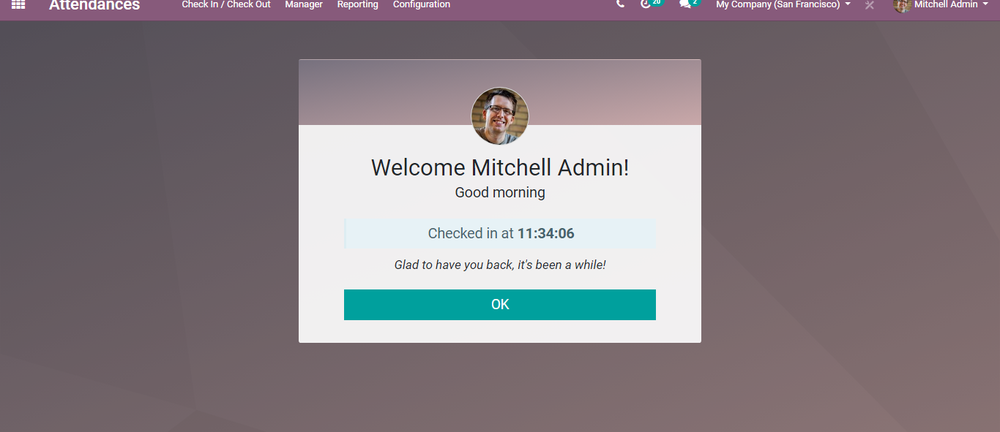
  - 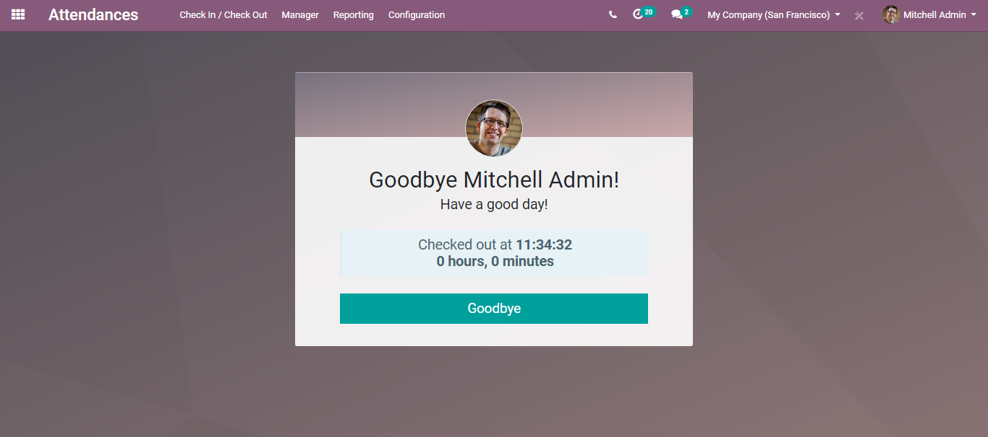

  - Kiosk Mode
  - Here, the interface feeds attendances of an employee using their badges or pin. The badges can print from the employee form.
  - 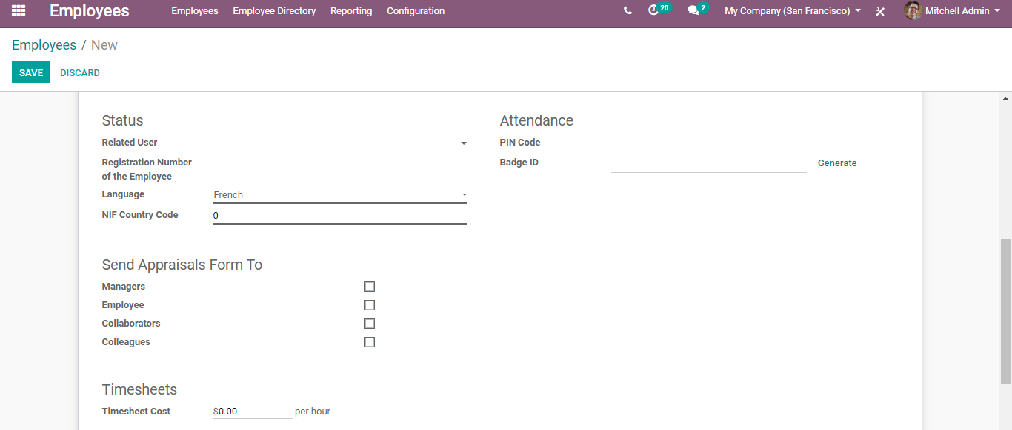
  - Using these badges, employees can Check-In/out.
  - Attendances> Manager> Kiosk Mode
  - 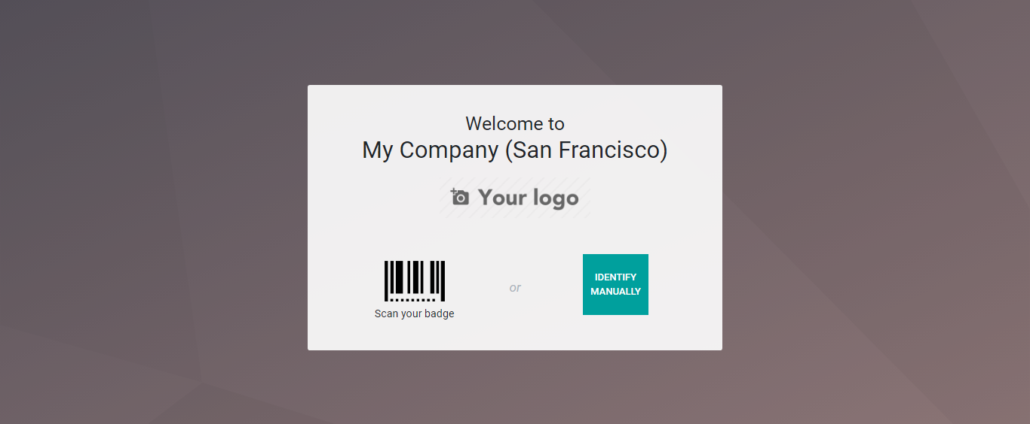
  - Another option is Check-in/out using a pin. For this, we must enable Configurations under the Attendance menu.
  - 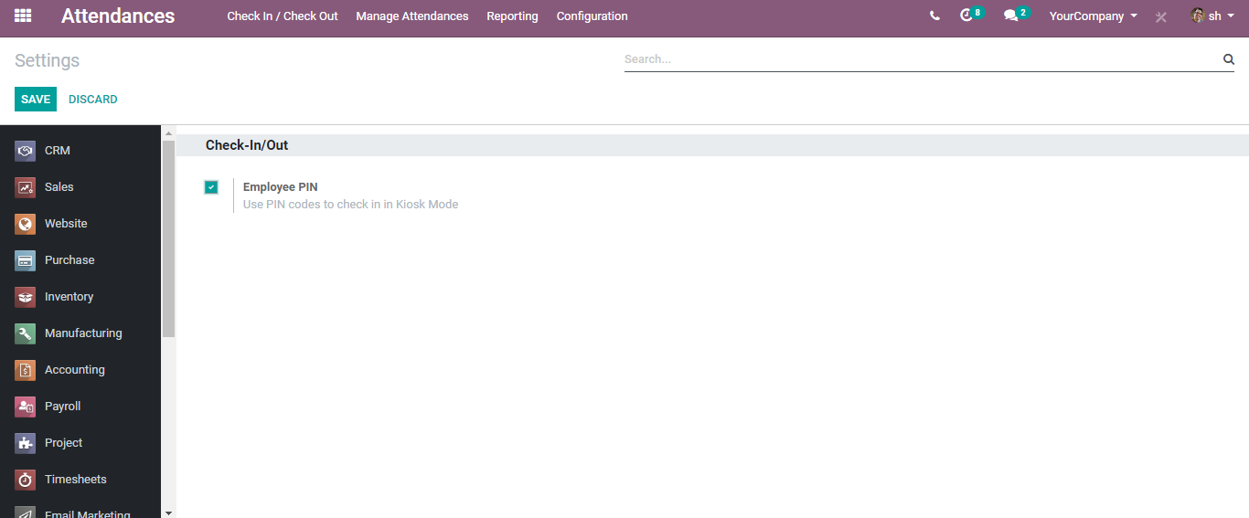
  - Upon clicking IDENTIFY MANUALLY button, the module provides an interface to enter the pin.
  - 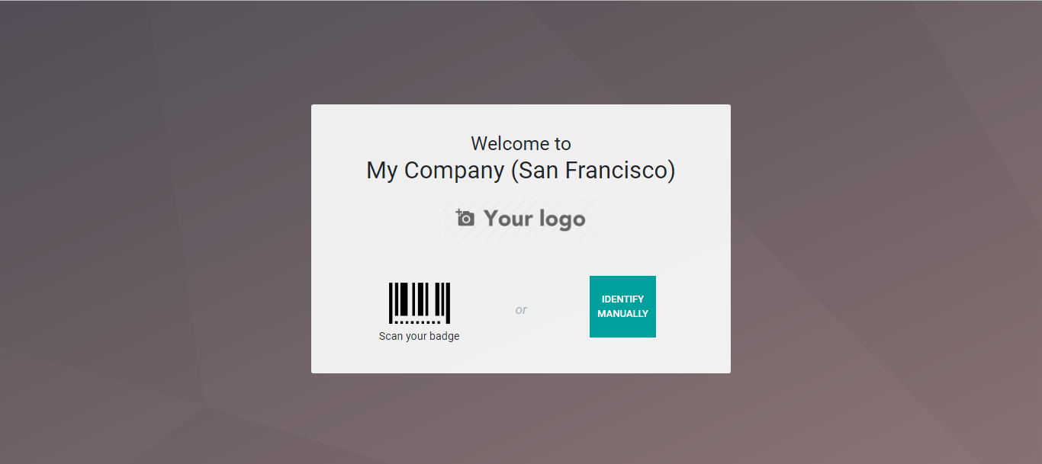
  - 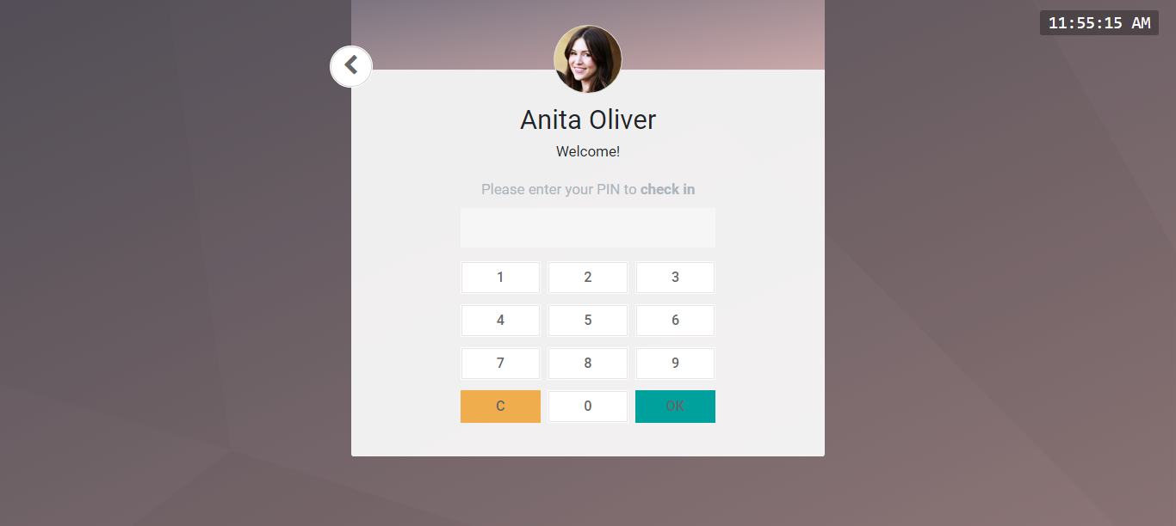
  - Employee Recruitment
  - BUSINESSBOXERP makes the recruitment process seamless by ensuring a feasible HR Process. Here we have recruitment plugins related to HR. Officers or managers can create and launch various job positions for recruitment. For these positions users can either manually apply or through the website.
  - From the recruitment dashboard, one can get the overall information about the recruitment processes carried in the organization. You get to see the different openings created, alongside its state of published on the website, how many new applications received for each post, how many more to recruit, and so on.
  - Upon clicking the more button, one can start the recruitment process from there itself, also edit the job openings created, also get access to the interview form.
  - 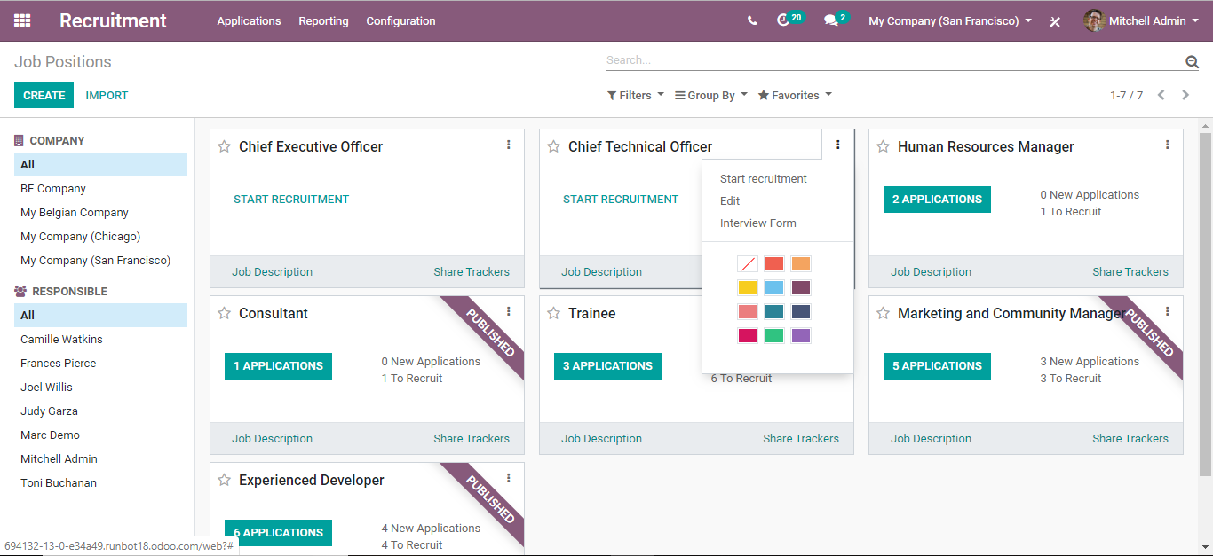

  - CREATE JOB OPENINGS
  - To create a new job position, either you can create it directly from the dashboard or via going to go to Recruitment >Configuration >Job positions >Create
  - 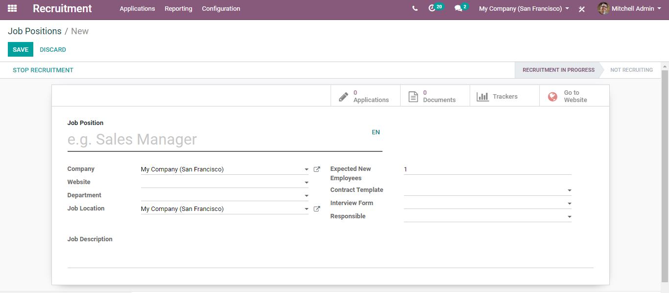
  - Here, one can specify the Job position, recruitment details like the company, website, department, Interview form, job location, recruitment responsible, job description and much more. Once you have saved all the changes you can see on top the RECRUITMENT IN PROGRESS.

  - From here, one can also view the number of applications for this job position, no of employees, documents attached, also add some trackers to know what medium the applicants are using.
  - Via clicking the GO TO WEBSITE Button, you can preview the website view of the opening.
  - 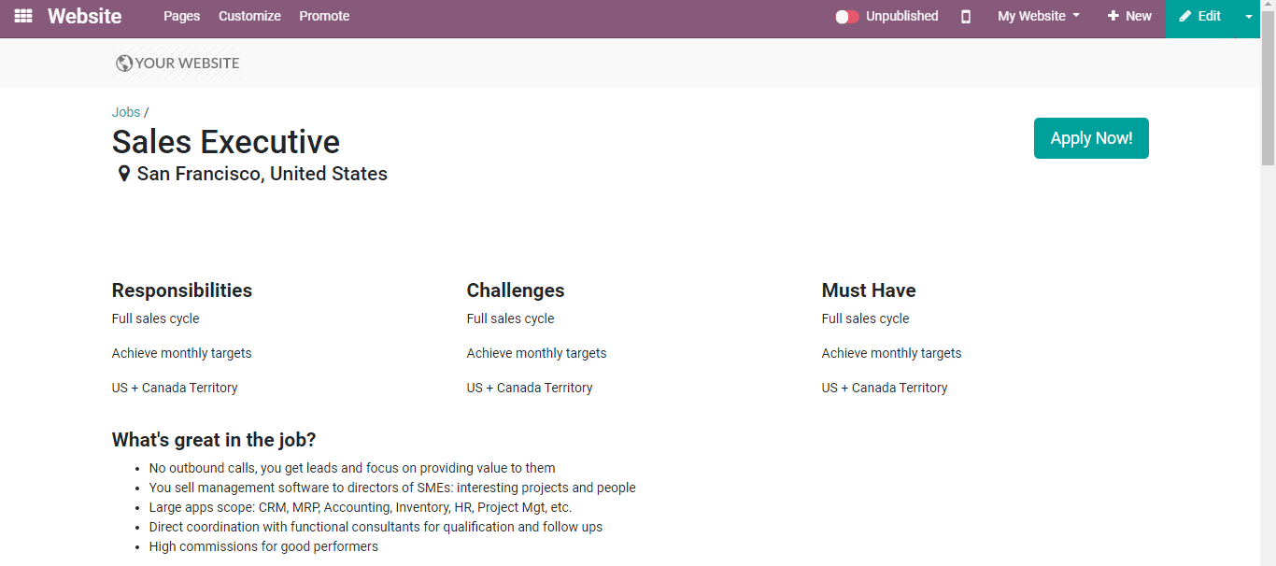
  - If you want to make editions in the job description, you can click on the EDIT button on top.
  - 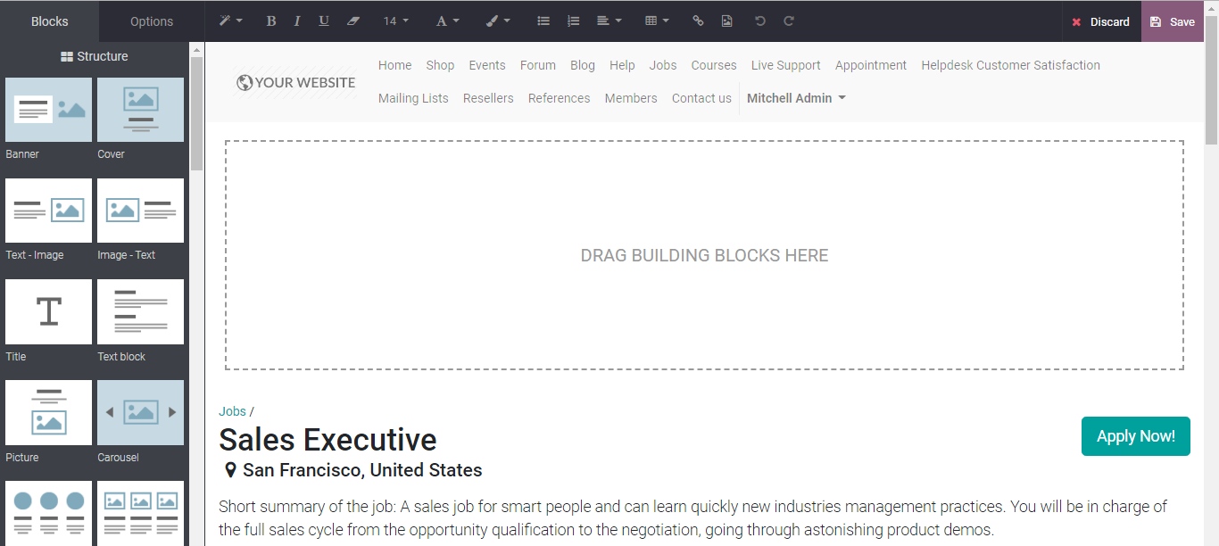
  - You get building blocks on left to customize your website look. Edit accordingly the way it should get published on the website and save changes.
  - APPLYING FOR JOB
  - BUSINESSBOXERP provides a complete solution for the recruitment process. Once you publish the created opportunities on the website, job seekers can view the same. Users can view detailed advertisements and apply by just clicking on the advertisement.
  - 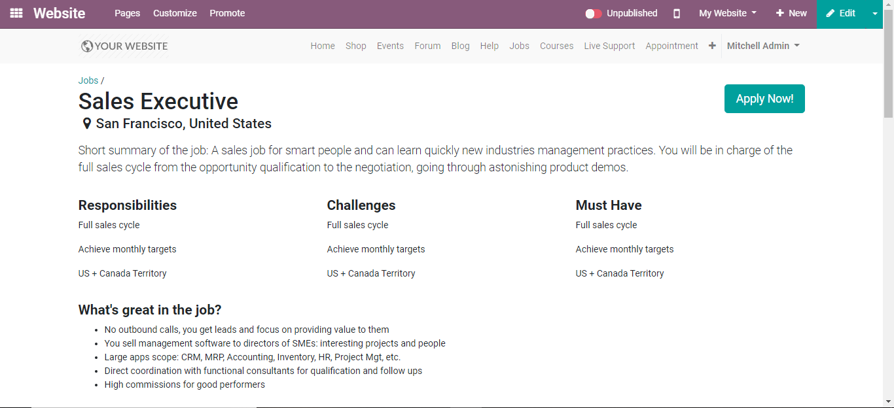
  - Upon clicking the apply now button, the job seeker will be navigated to a new window like below, where he can add his basic details like name, phone number, small introduction, email address and attach the resume.
  - 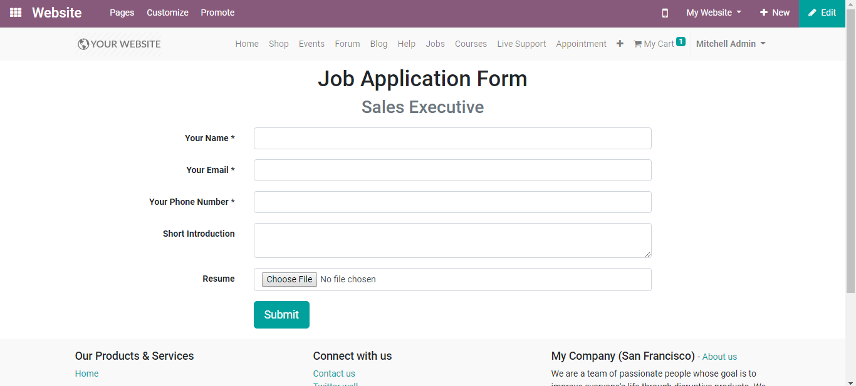
  - By clicking on SUBMIT button, the user can submit his application. Upon the action, again the user will be redirected to a Congratulations page. Can later continue to check out the rest of the website pages.
  - 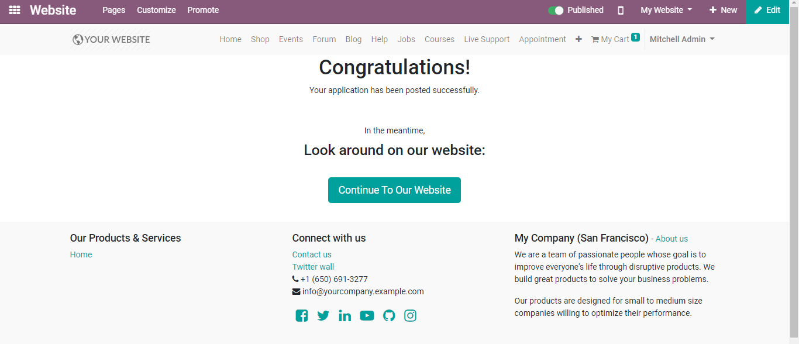

  - PROCESS JOB APPLICATION
  - The recruitment administrator can view all the applications and related personal information listed in his dashboard.
  - Recruitment > Applications
  - Via clicking the option, you will be redirected to a new page listed with various applications. One can see from there the application’s recruitment statuses.
  - 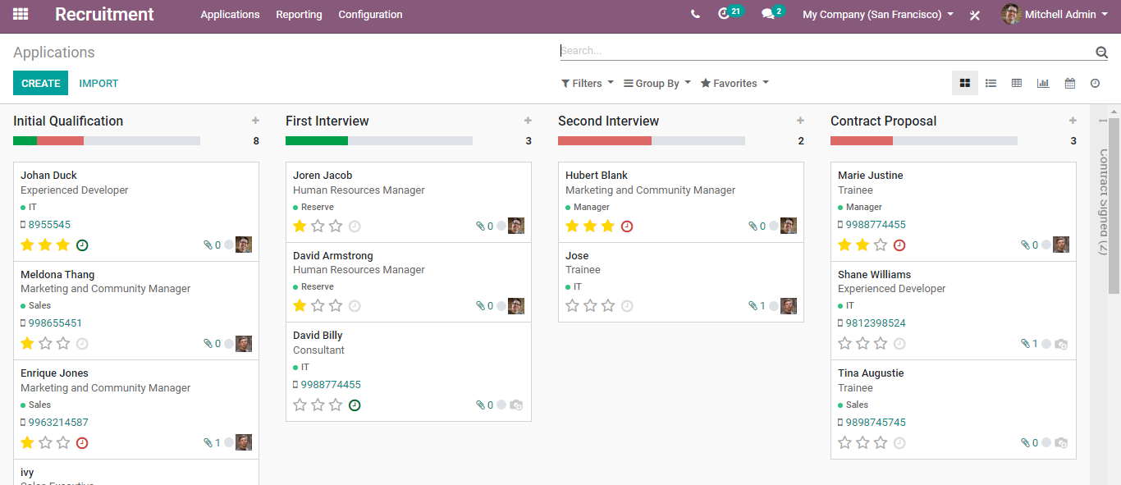
  - You can see the initially qualified applicants, applicants who completed their first round.
  - Via clicking any, you get complete information of the applicant.
  - 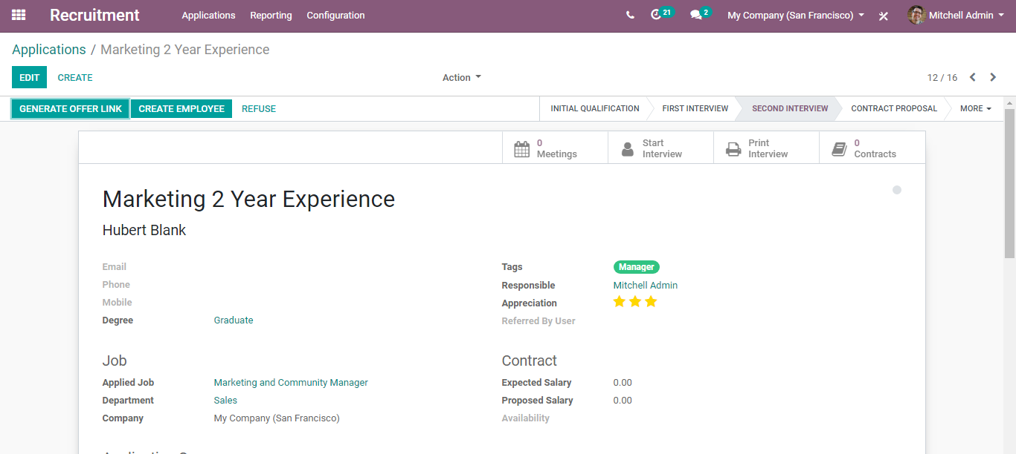
  - 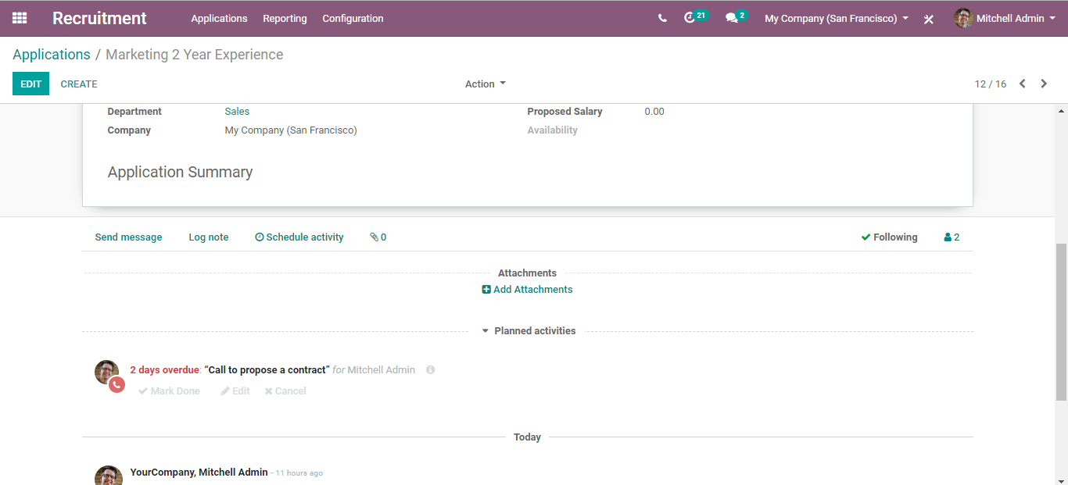
  - Also, one can find if the applicant has attached any documents, if there are any planned activities with him.
  - Via clicking the edit button, one can plan a new activity say a meeting or call with the customer.
  - 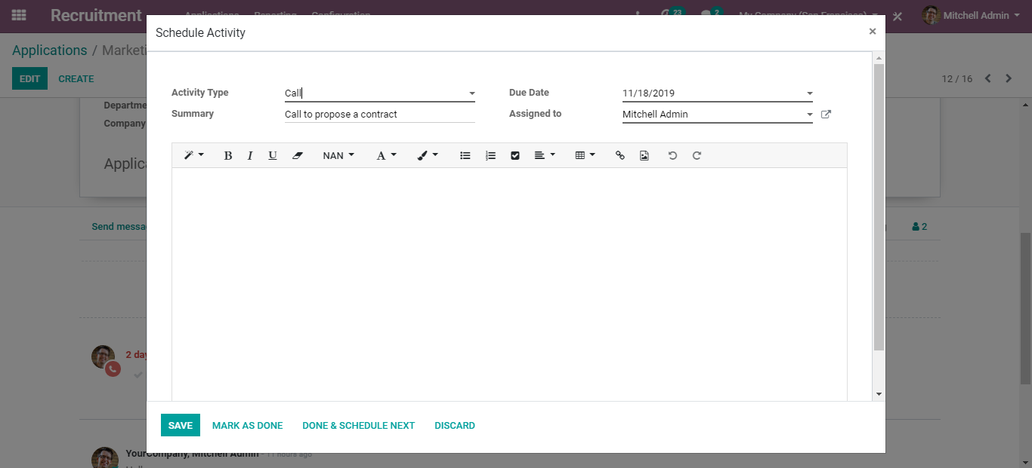
  - Via clicking the start interview button, you get the questions designed for the position.
  - To print the interview report, make use of the Print interview button.
  - One can also see the proposed contracts from this page.
  - If everything is well in place, from the very same page, the applicant can be sent with the offer letter. To send, click GENERATE OFFER LINK.
  - Upon clicking it, you will be navigated to a new window like below:
  - 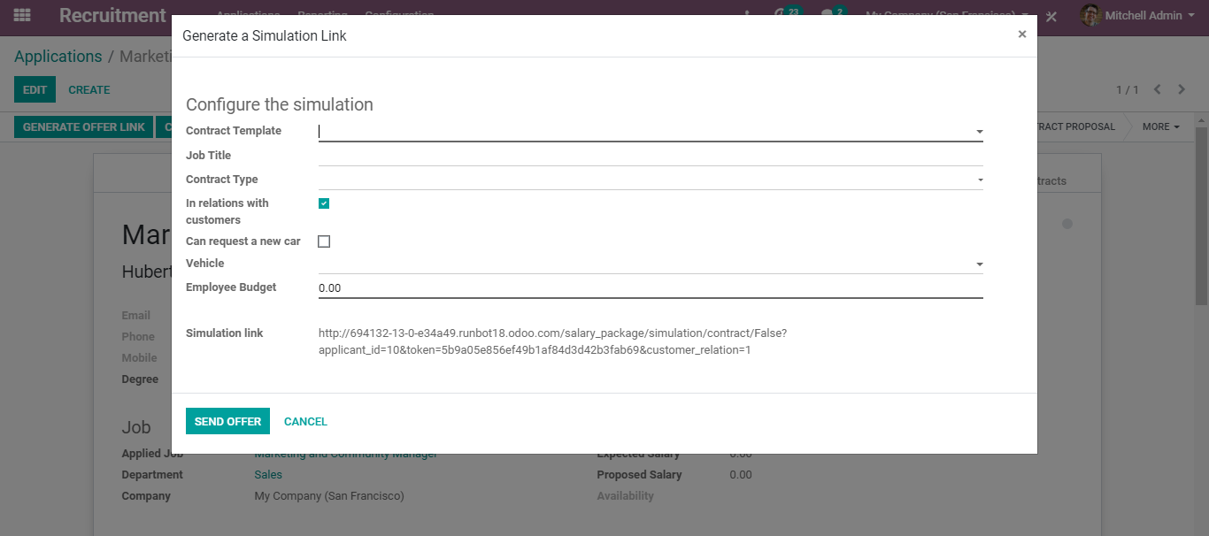
  - One can add here the contract template, job title, contract type, vehicle info and employee budget

  - REPORTS
  - Managers or the head of departments can easily analyse the recruitment process and export it to excel. For that go to Recruitment>Reporting.
  - You get with the recruitment analysis data over the set parameters.
  - 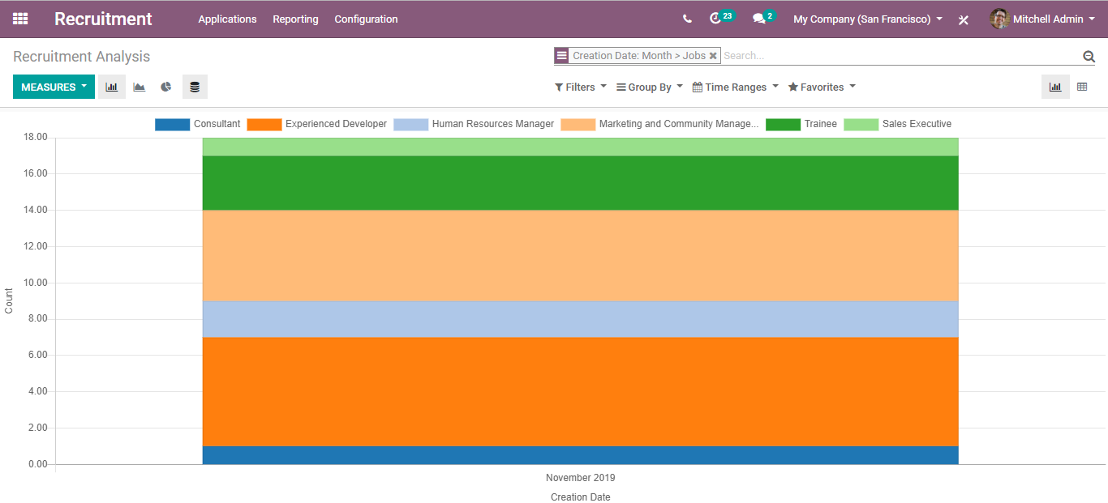
  - Employee Leaves
  - From BUSINESSBOXERP, Leave Management Module is re-titled to Time off. In BUSINESSBOXERP, leave management is done in two phases. First, the employee request leaves and in the second phase the HR manager or concerned level officer sanction the leave. BUSINESSBOXERP generates a detailed report to analyse the left behaviour. Admin or concerned officer can view these reports before sanctioning leave to an employee.
  - Firstly, Install the Time off module.
  - As you enter the dashboard of the time of module, you can see leaves for the current day/ week/ month.
  - 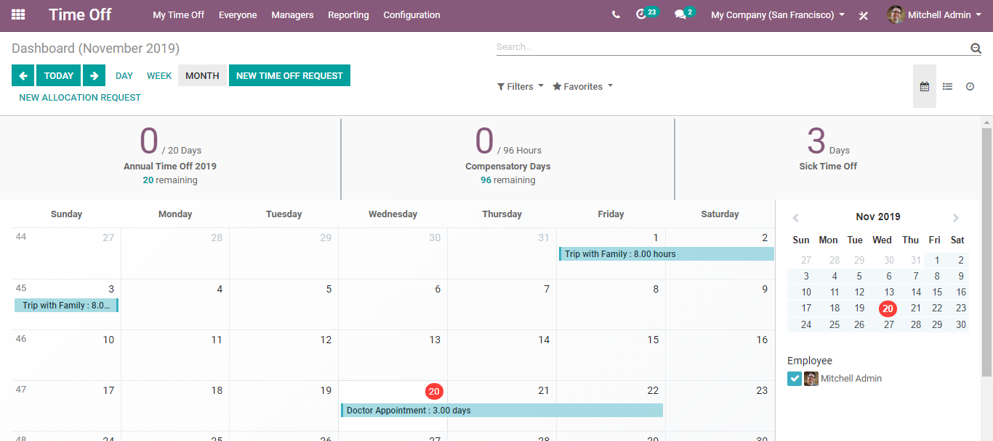
  - Via clicking the NEW TIME OFF REQUEST, you can create a new leave request.
  - 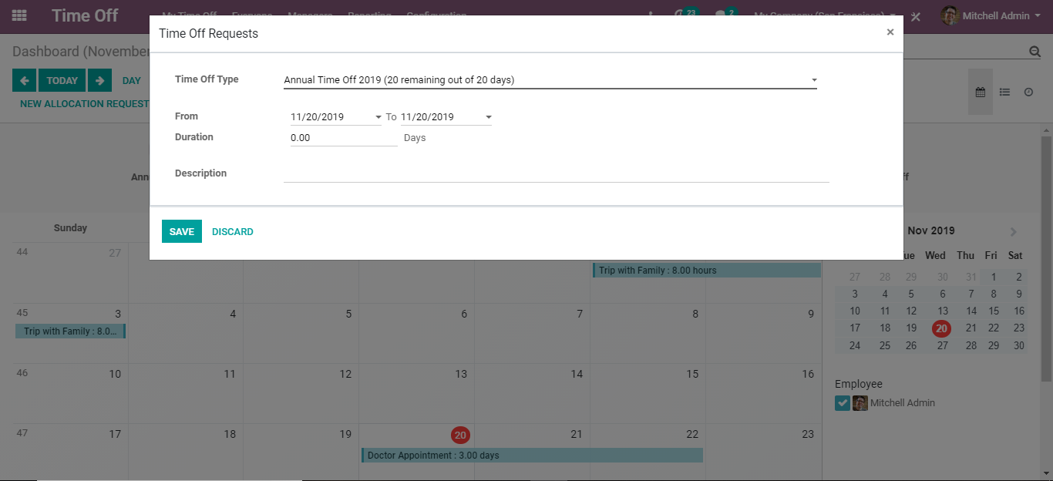
  - Under the Time off type, one can select the leave type, dates of leave, duration, and description.

  - LEAVE TYPES/TIME OFF TYPES
  - To configure leave/ time off types, go to Time off> Configuration> Time off Types.
  - 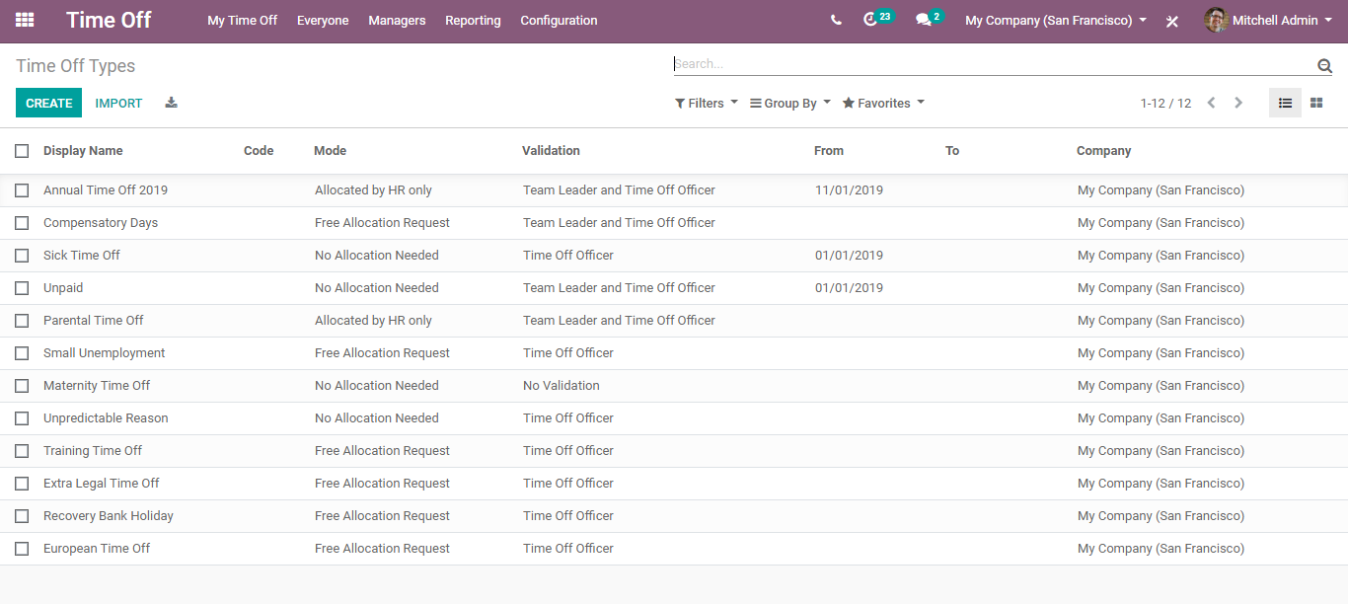
  - Here one can see the already created time-off types, however, to create a new one, click on the CREATE button.
  - 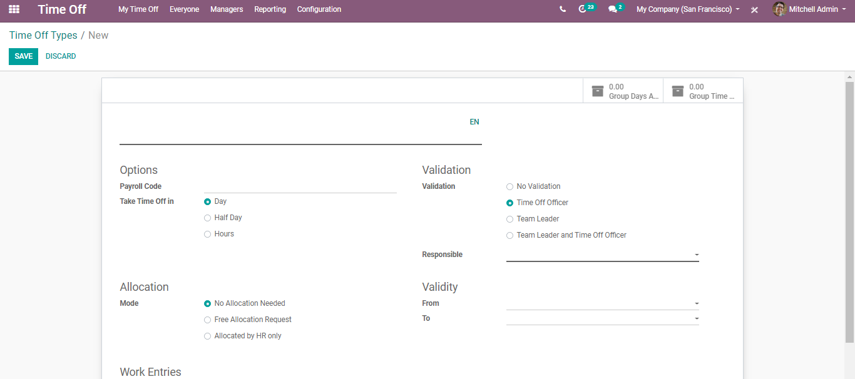
  - Here one can specify the payroll code, Take time off during Day/Half Day/ Hours, Allocation modes
  - 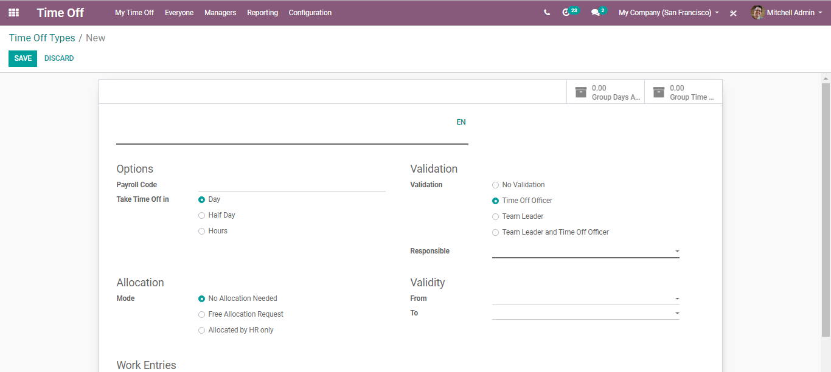
  - No Allocation Needed: No allocation by default, users can freely request time off.
  - Free Allocation Request: Allocated by HR and users can request time off and allocations.
  - Allocations by HR only: Allocated by HR only and cannot be bypassed by anyone; users can request time off.
  - Work Entry Type:
  - 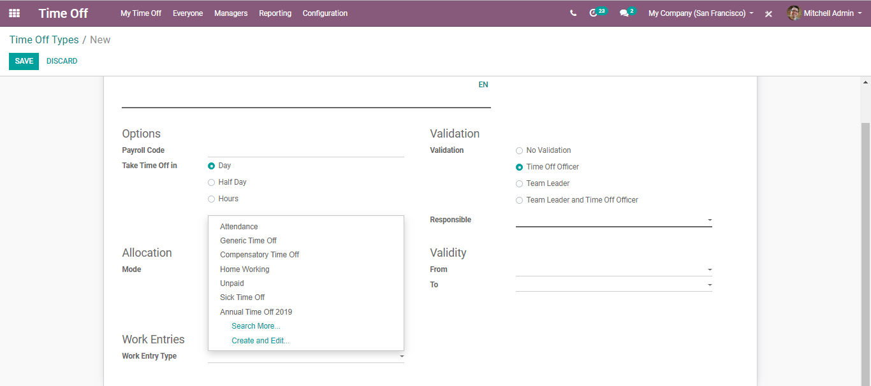
  - Validation: The options to set the validation of leaves. Also, the person responsible for approving this type of time off.
  - 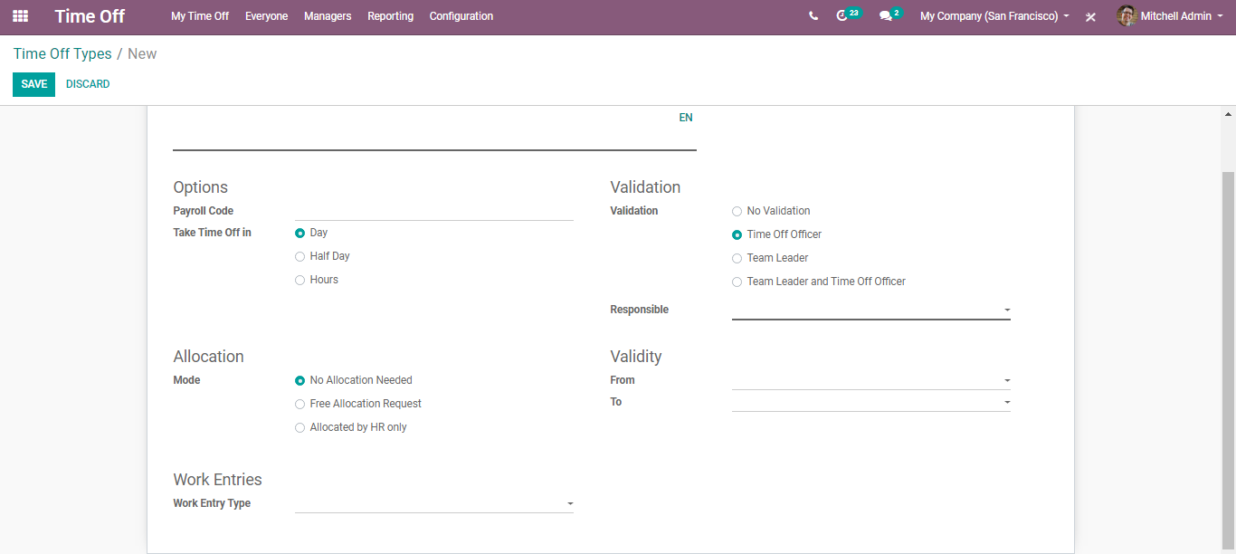
  - Validity Period: Adding validity to types of time off so that it cannot be selected outside this time
  - MAKING THE TIME OFF REQUEST
  - To configure the time of the request, go to Time off> My Time off > Time off Requests> Create.
  - 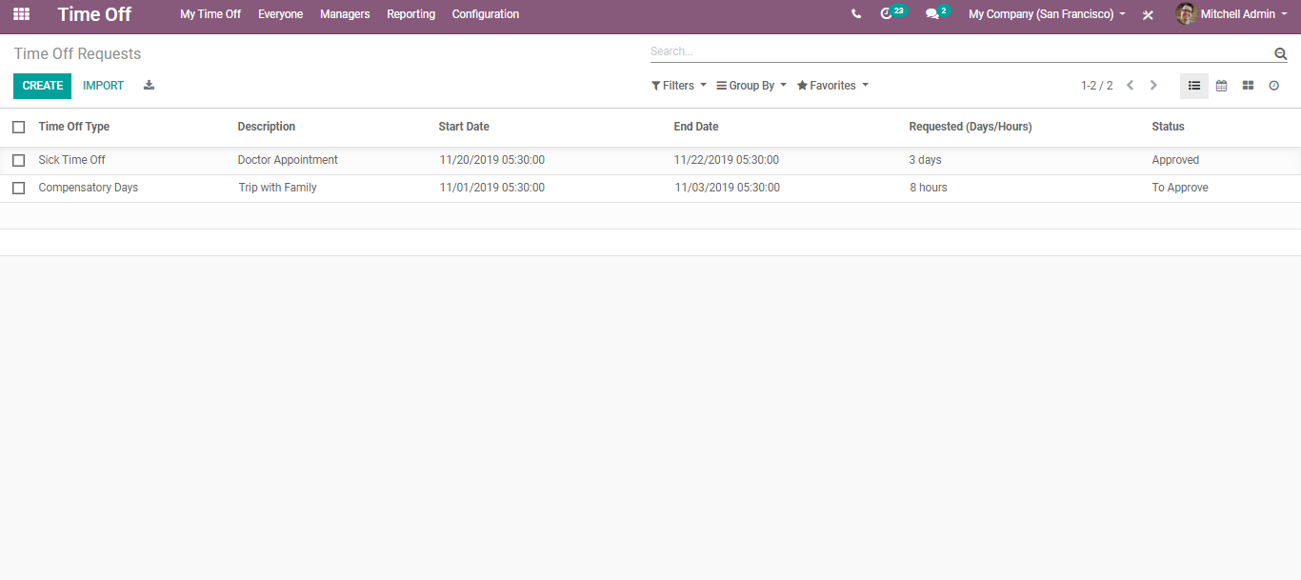
  - Upon clicking the CREATE button, you can add a new time-off request.
  - 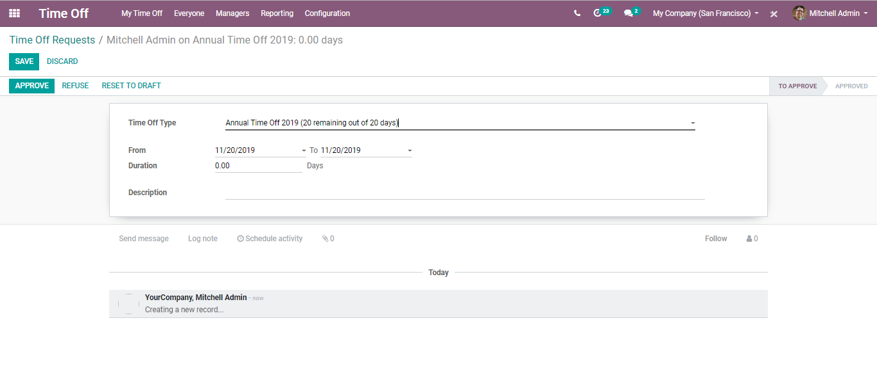
  - Here one can specify the time-off type from the dropdown menu, the duration of the leave, from date and to date, also the description of the time off.
  - Click save to mark the changes.
  - Now the status of your time off is “To Approve,” it will change soon after the concerned officer approves the time off.
  - APPROVE TIME OFF
  - Once the user makes the time off request, it is the responsibility of the concerned officer like HR admin to approve and sanction the time off requested.
  - Configuration
  - Time off> Managers> Time off
  - As soon as you enter the dashboard you get to see the time off requested. From the list select the time-off request. Approve or refuse after looking reviewing it.
  - 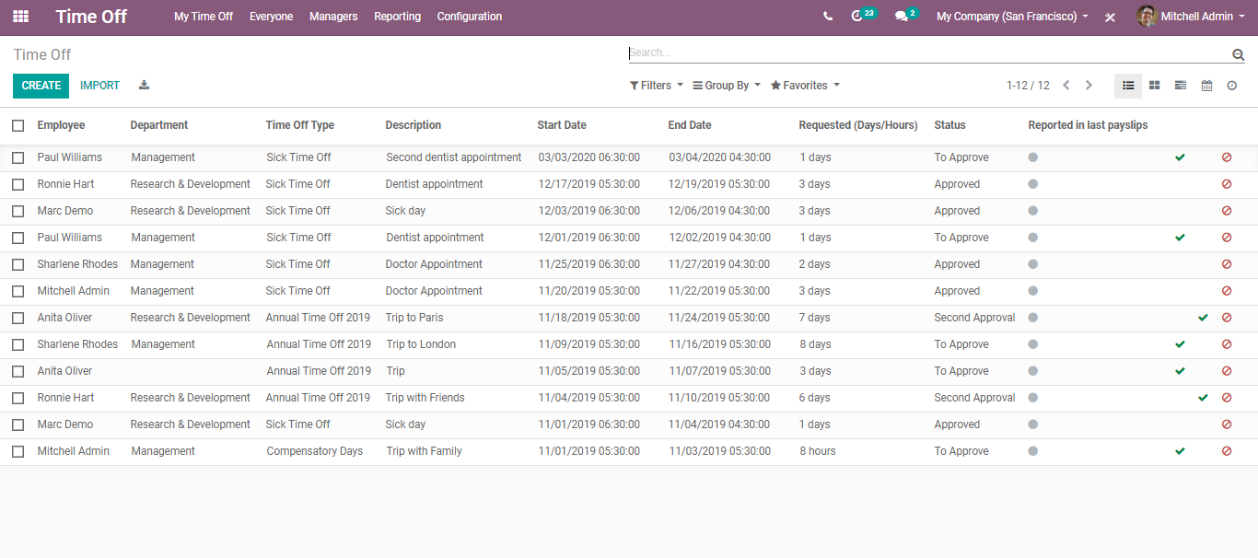
  - 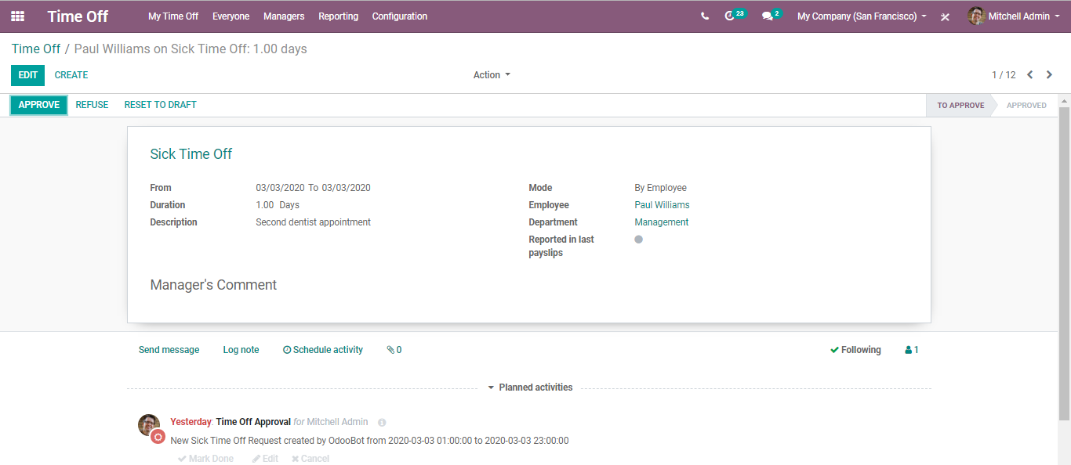

  - TIME OFF REPORTING
  - The administrator can view detailed and varying reports in his dashboard.
  - Go to Time off > Reporting
  - 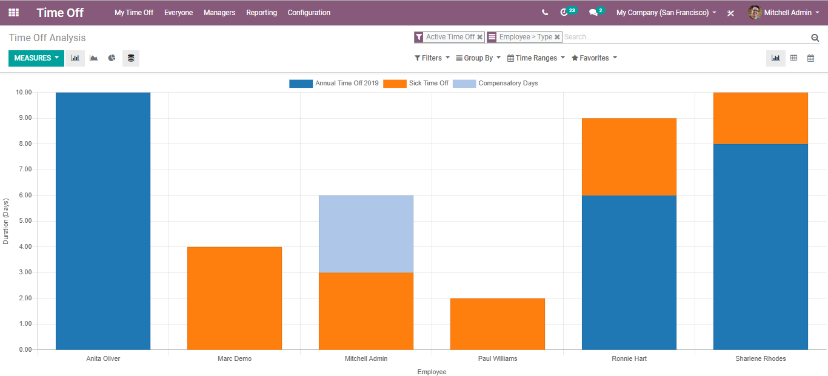
  - TIME OFF ALLOCATION
  - Unlike time-off requests, time off allocation is more of a planned leave request. The employee can request to allocate time off for him (in case of long leaves).
  - Configuration
  - Time off > My Time BUSINESSBOXERP > Allocation Request > Create
  - From the dashboard, the user can see the allocation types listed. However, to create a new one, click on CREATE button.
  - 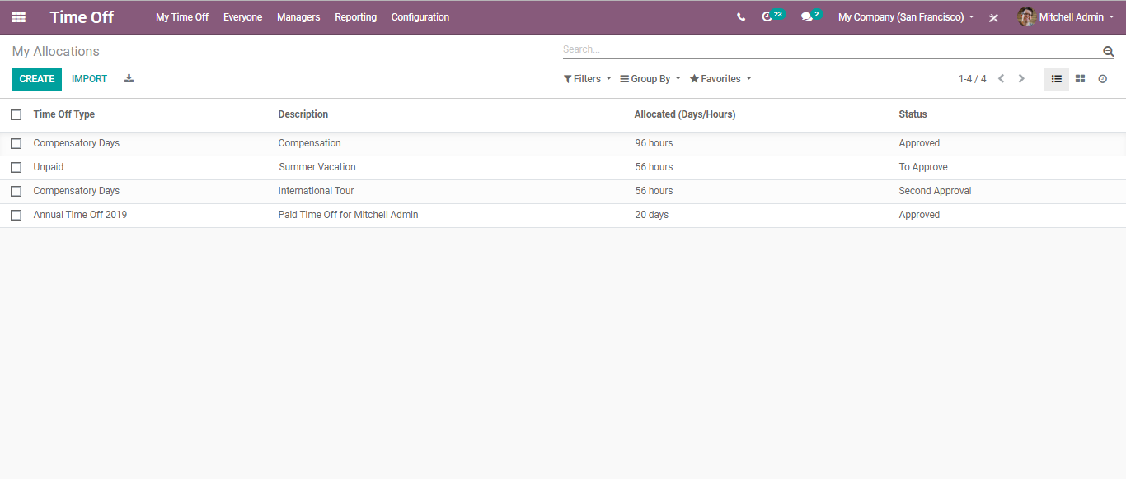
  - 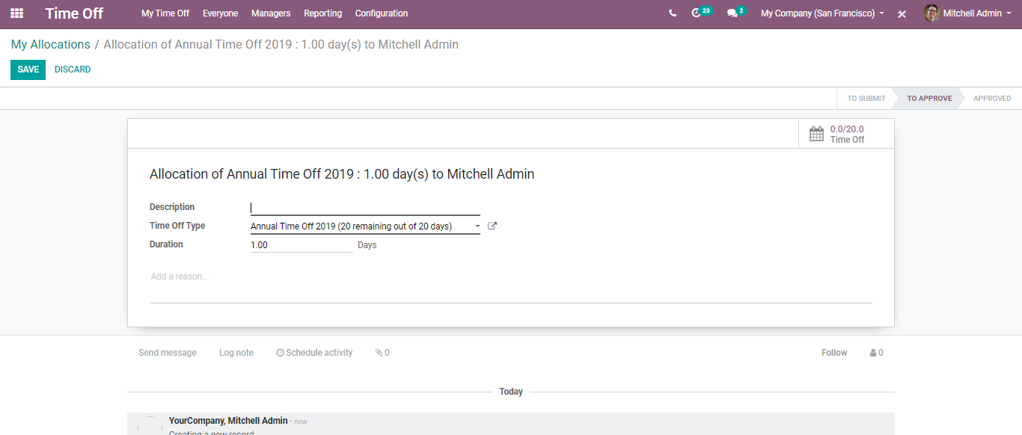
  - Here one can add the description, time off type and duration of leaves. Fill in the fields and click Save to submit the leave to the manager for approval.
  - To view the current leave requests of the employees, go to Time off > Everyone.
  - 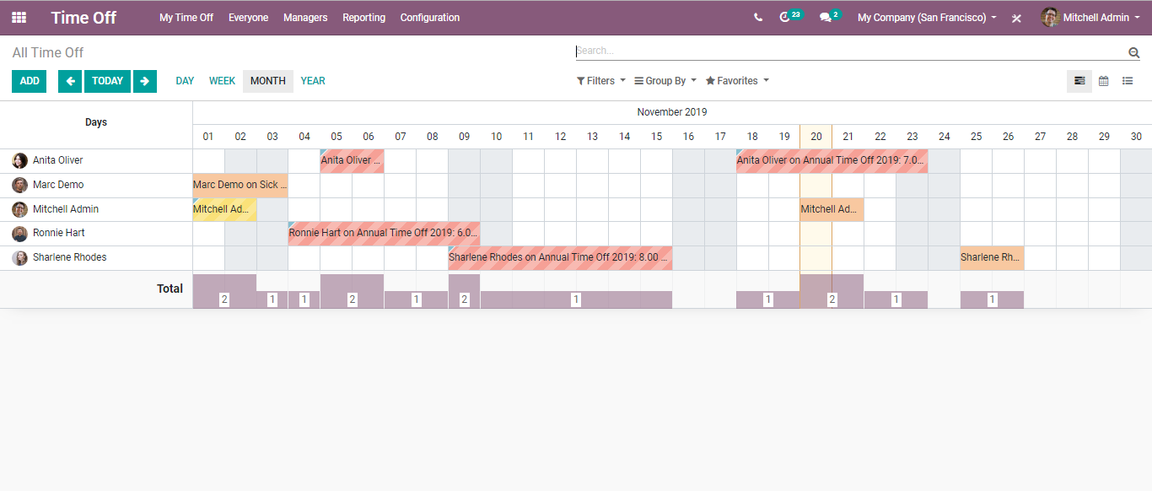
  - Via clicking any employee, from straight there, the HR or concerned manager can approve/refuse the time-off request.
  - 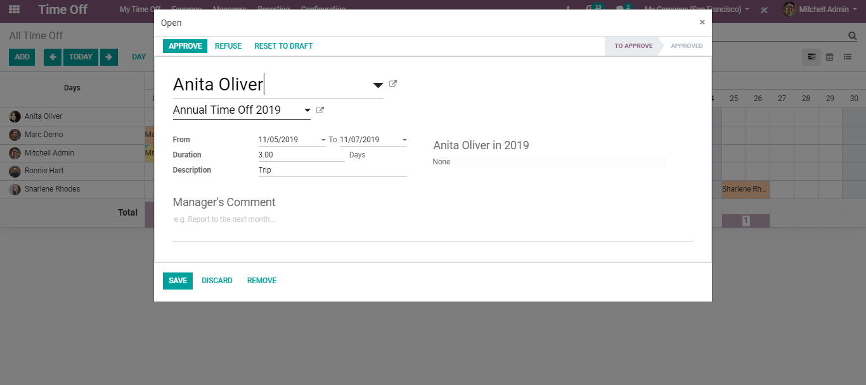

  - Employee Payroll
  - Payroll management revolves in and around the management of employee salary in an organization. The management includes timely issuance of salary, employee benefits/ allowances, deducting employee loan amount. To manage employee payroll, BUSINESSBOXERP has produced the payroll module.
  - As soon as you enter the payroll module, you see the employees in the organization. One can easily filter the employees based on their company or the department. Also, you can see certain indications marked in red. The red dot indicates that the employee is absent, and the red triangle indicates that there is something wrong with the contract. Either there is no running contract for this employee or the employee’s contract is about to expire.
  - 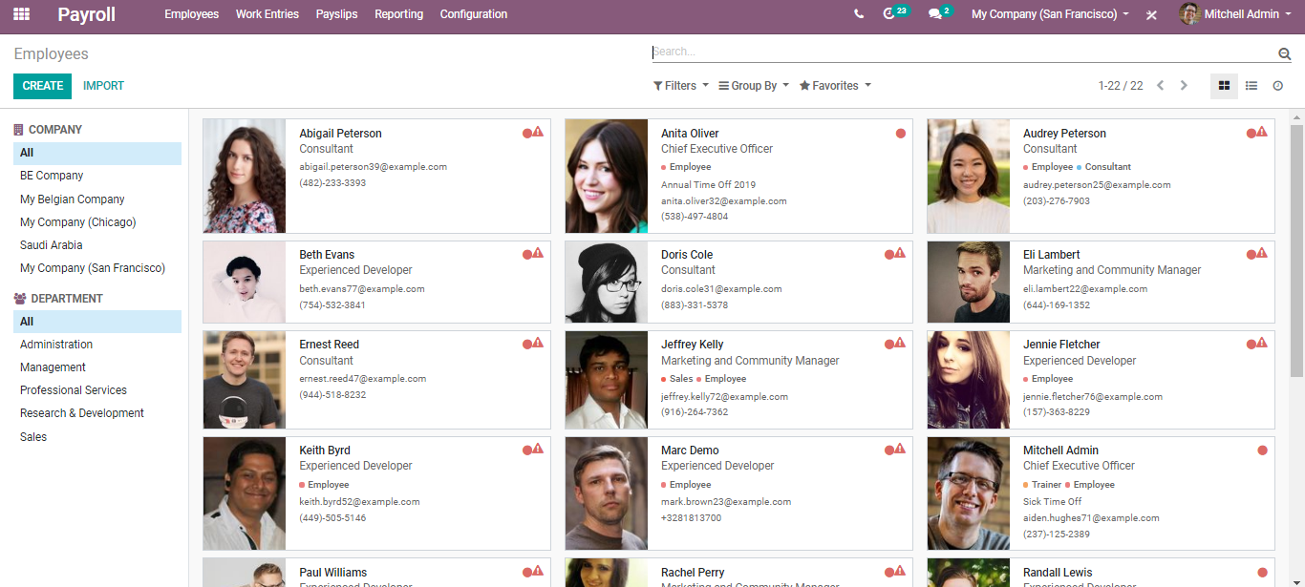
  - Therefore, the first step to initiate the payroll is creating an Employee Contract. For that go to Employees> Configuration> Contracts> Templates> Create.
  - 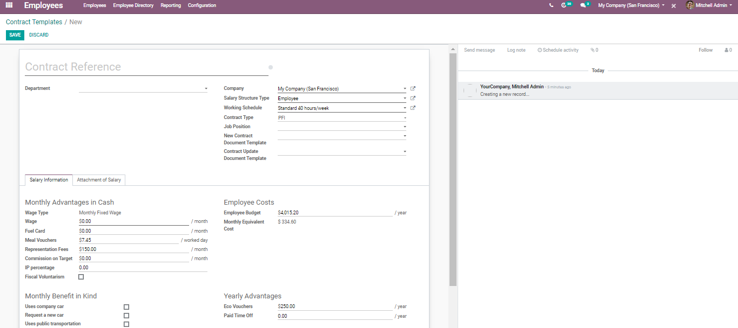
  - Under the template, one can add information such as Salary details amounting to all monthly advantages drawn by the employee in a company, Monthly Benefit in kind, Employee costs, Yearly advantages, salary structure type, working schedule, contract type.
  - CONFIGURING SALARY RULES
  - Salary rules are important to precisely compute the employee’s allowances, taxes, deductions, net, contributions etc. To configure salary rules for employees, go to Payroll> Configuration> Salary Rules> Create
  - 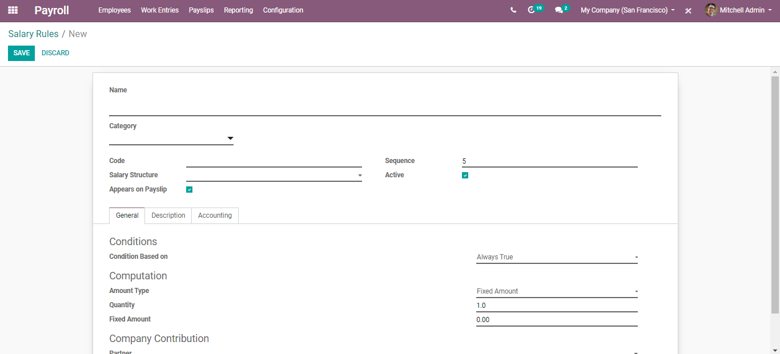
  - Here one can define a number of things on the fly:
- Name A name for the salary rule.
- Category: Choose the category early created.
- Code: It is used for easily accessing while computing net salary.
- Active: It will allow you to hide the salary rule without removing it.
- Appear on Payslip: Used to display the salary rule on the payslip.
- Sequence: Use to arrange calculation sequence.
- Active: If the active field is set to false, it will allow you to hide the salary rule without deleting it.
  - Under General Info Tab,
  - 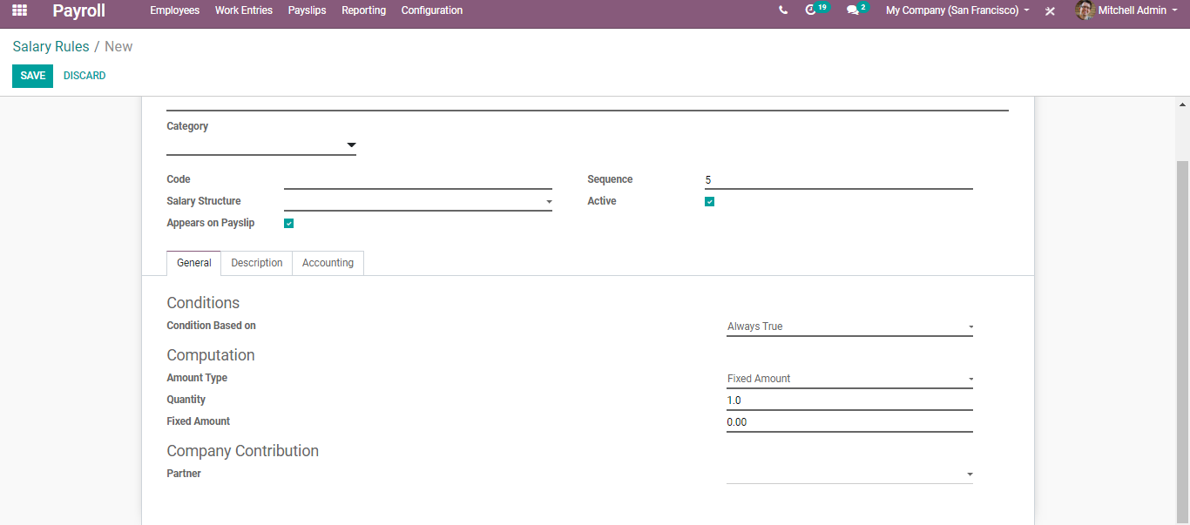
  - One can see some fields:
- Condition-based on: Here one can set how the category wants to perform in each salary computation. There are three conditions under this field.
- Always True: If we set this condition, the rule becomes available in every salary computation.
- Range: In this case, we can see another some fields
  - 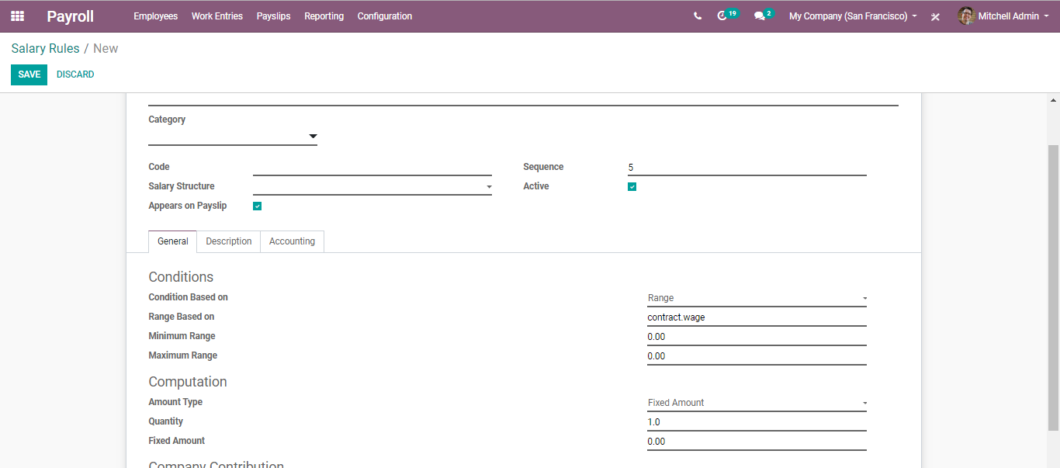
  - Here we can see Minimum Range and Maximum Range. The rule only performs when the wage of an employee falls in between these two ranges.
  - Python Expression: In this case, we can see some comment lines helping to create python conditions. By default, BUSINESSBOXERP provides an equation based on the result.
  - 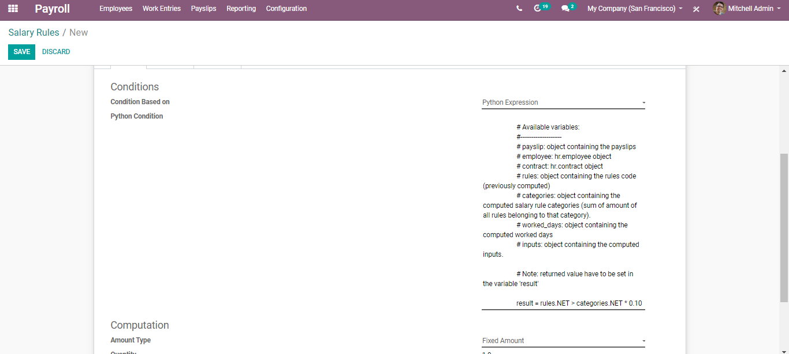
  - We can access the values in the objects when we create a python condition.
  - Computation: The salary computation is common in three types.
- Fixed amount
- Percentage
- Python code
  - Fixed amount: In this case, we can provide a fixed amount and Quantity.
  - 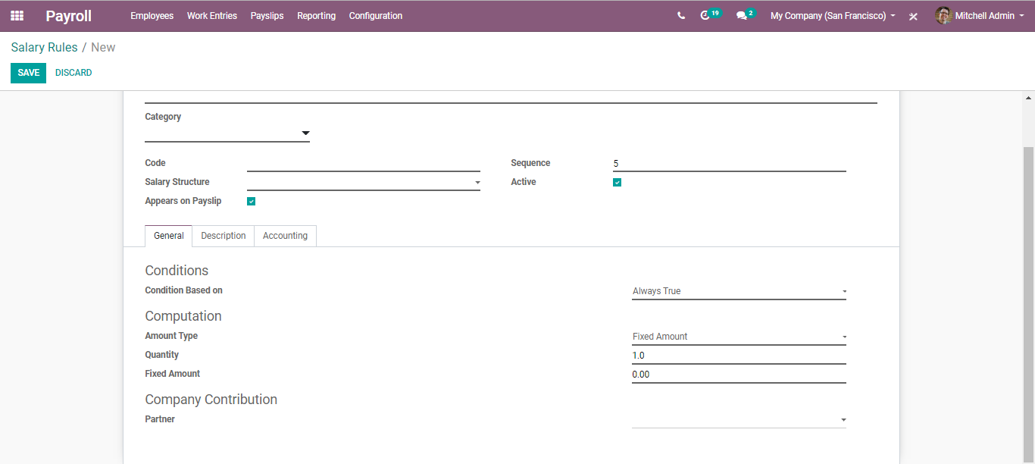

  - Percentage: In this case, the computation is based on the fields underneath it.
  - 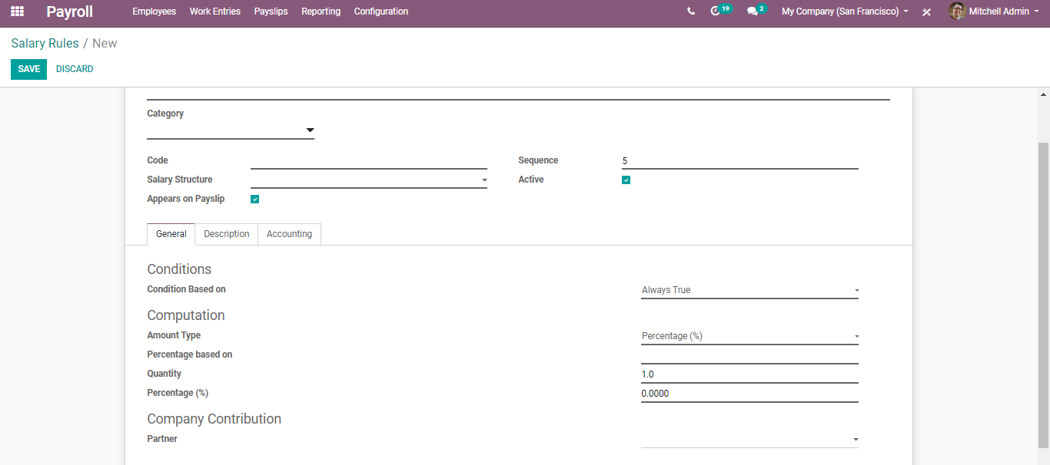
  - Percentage based on: Specify the variable we want to get the percentage.
  - Percentage: Specify the percentage value.
  - Python Code
  - 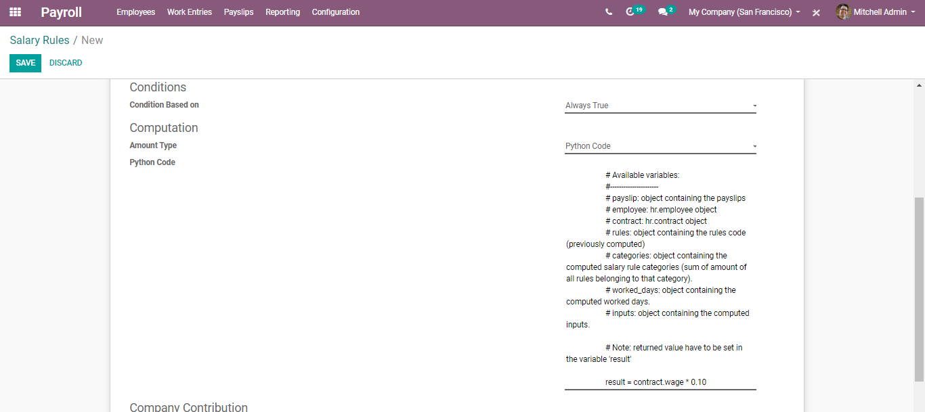
  - Here the computation is based on the Python code.
  - CONFIGURING SALARY STRUCTURE
  - Each company follows a different salary structure based on its rules and conditions. To configure new salary structure, go to Payroll> Configuration > Structures> Create.

  - Name of the structure.
  - Type: Name of the structure type. One can either select the type from the drop-down menu or via going to Payroll> Configuration> Structure Types.
  - 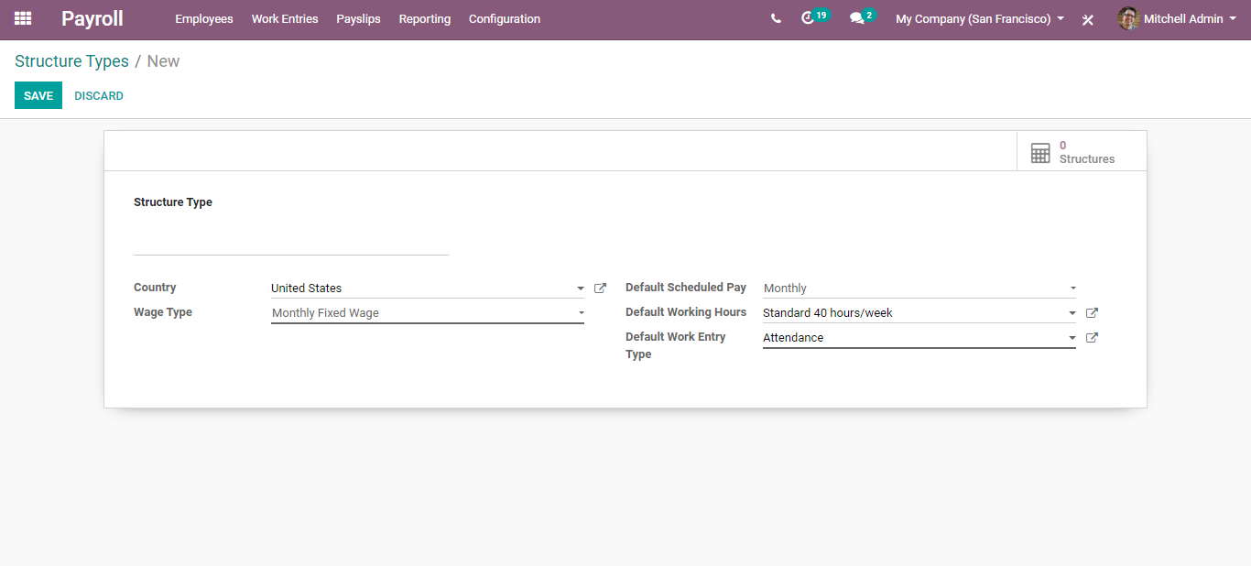
  - Here in the fly, one can add:
- Structure Type name,
- Wage Type: Hourly Wage/Monthly Fixed Wage.
- Default Scheduled Pay: Defines the frequency of the wage payment.
  - 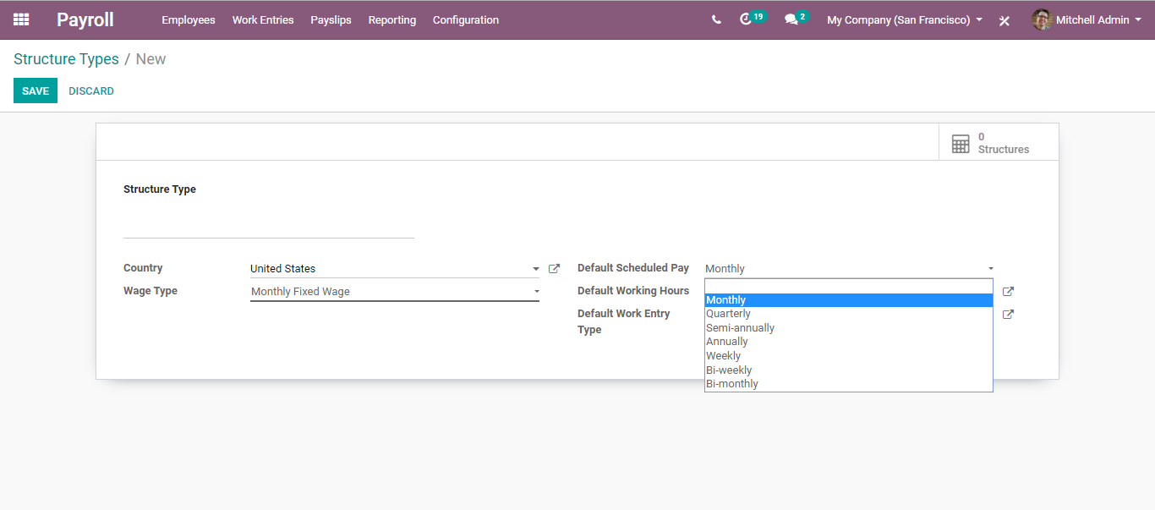
- Default Working Hours:
  - 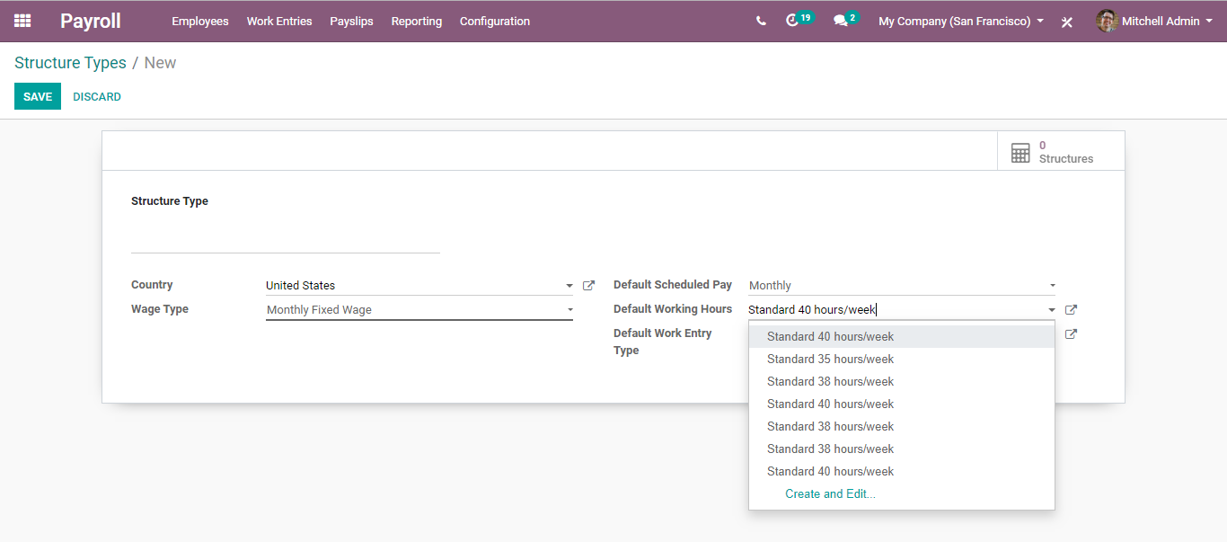
- Default Work Entry Types.
  - 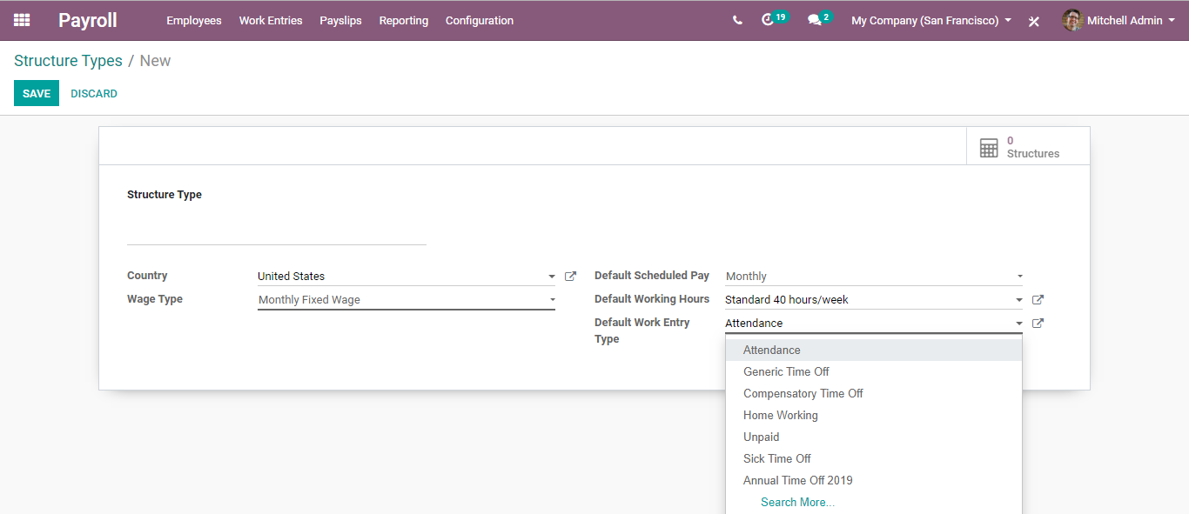
  - Coming back to salary structure,
  - The other fields include:
  - Use Worked Day Lines: Workdays will not be displayed on payslips.
  - Regular Pay: Check this option if this structure is the common one.

  - EMPLOYEE PAYSLIPS
  - Payslips will be generated only for those employees who have valid contracts with the organization. If your employee is new, firstly an employment contract should be built between the employee and the organization.
  - Configuration
  - Payroll> Payslips
  - From the dashboard, one can see the already created payslips. However, to create a new click on the create button.
  - 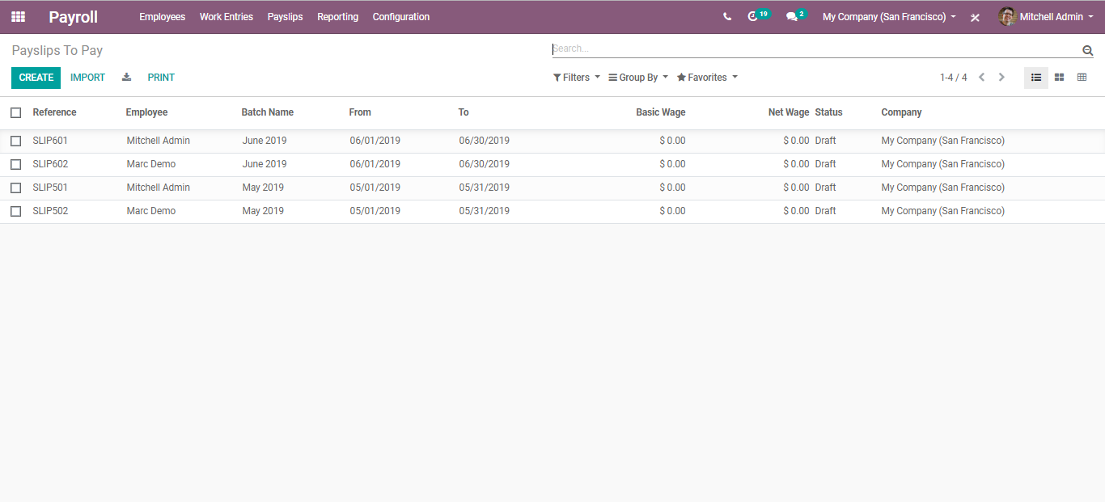
  - Upon clicking the CREATE button, you will be navigated to a new window like below:
  - 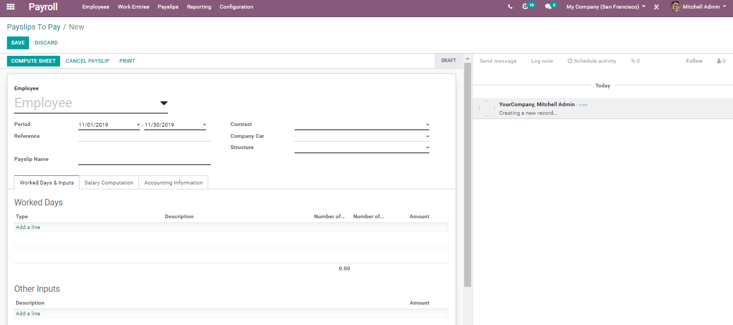
  - Here one can select the employee, period, reference, contract, play slip name. Under the workdays and input tab, one can add the Worked days.
  - 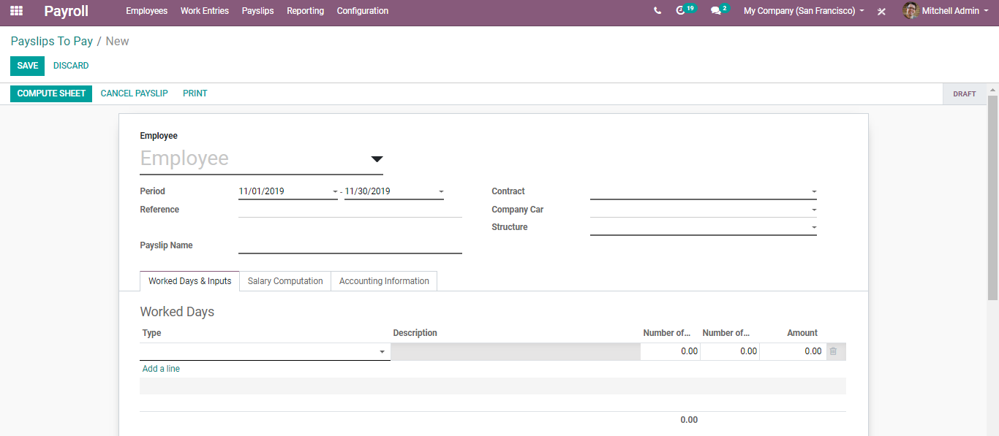
  - One can define here the number of days and number of works worked by the employee. Also, the amount can be added.
  - After entering all the fields,
  - Click COMPUTE SHEET to see calculations as per salary rules.
  - 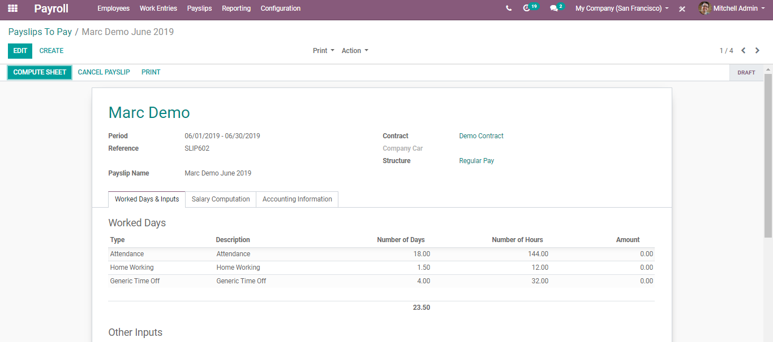
  - You can see the computed Unpaid leaves pay as a deduction on the computer sheet. One can also cancel the payslip via clicking the CANCEL PAYSLIP button and print it via clicking the PRINT button.
  - 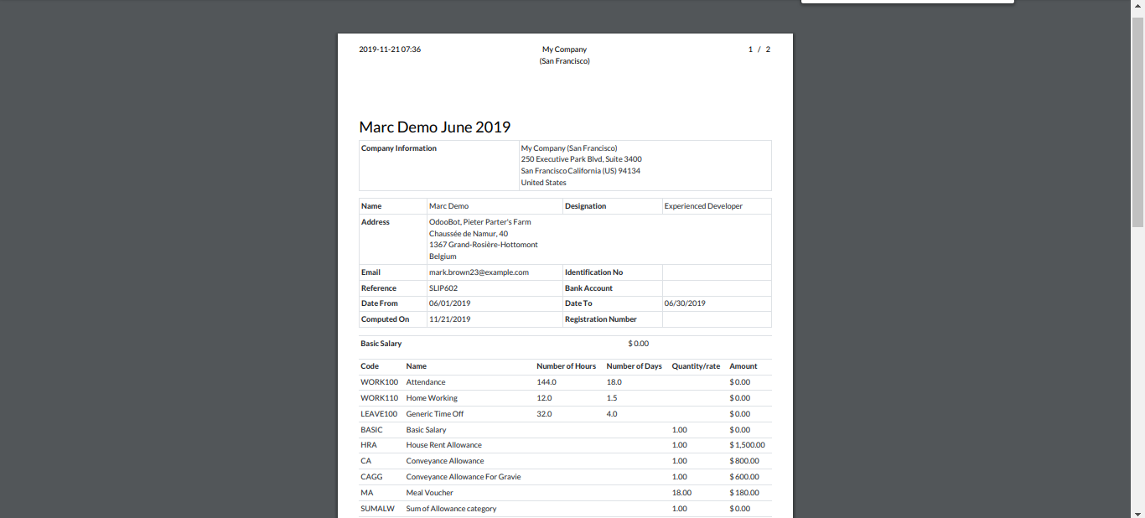
  - To view all, pay slips created, go to Payroll> Pay slips> All Payslips.
  - 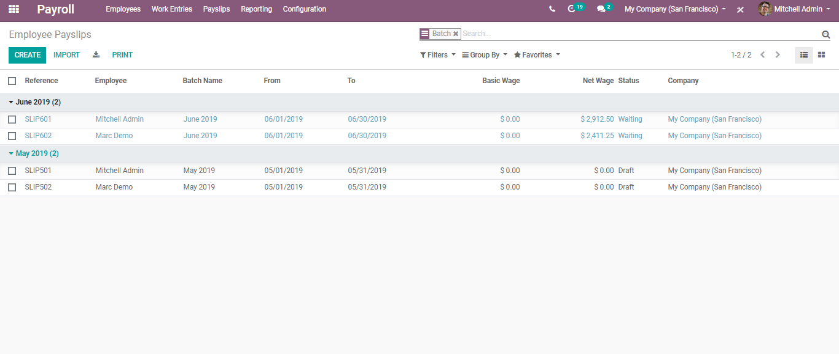
  - Payslips in Batches
  - Earlier we saw individual payslip generation. However, in BUSINESSBOXERP, one can create pay slips in batches making your task a lot simpler and quicker.
  - For that go to Payroll> Pay slips> Batches.
  - 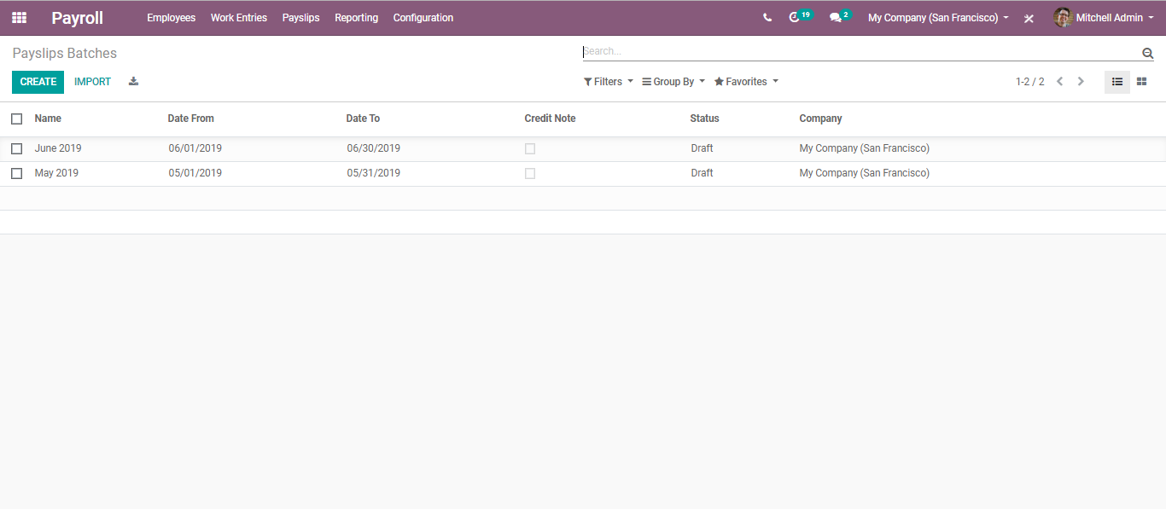
  - Upon clicking create button, you will be navigated to a new menu like below:
  - 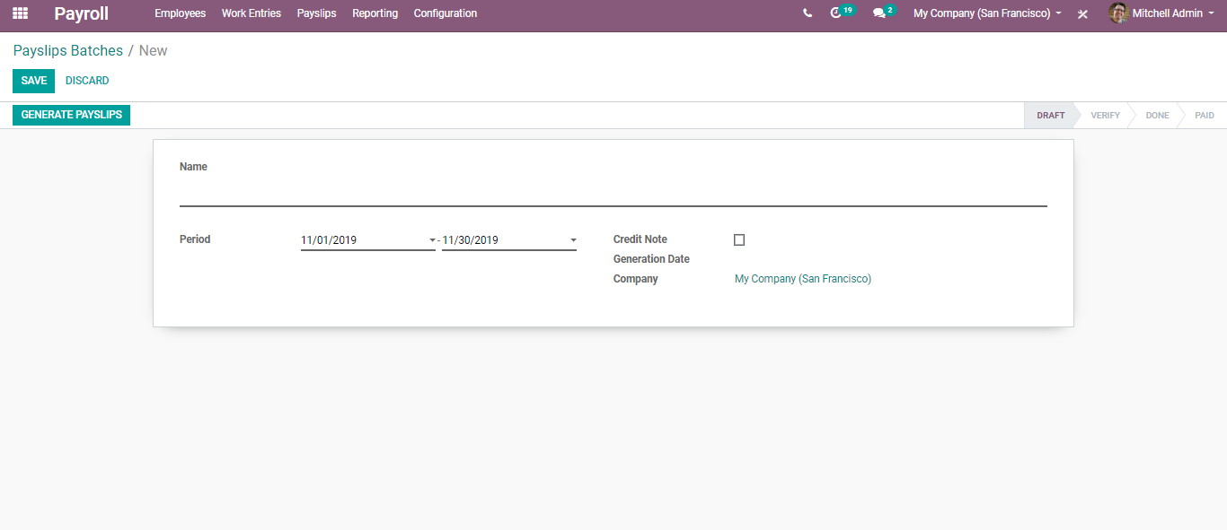
  - Here you can define the name, period, credit note generation date and company. Adding all these fields and clicking GENERATE PAYSLIPS, you get navigated to another window like below:
  - 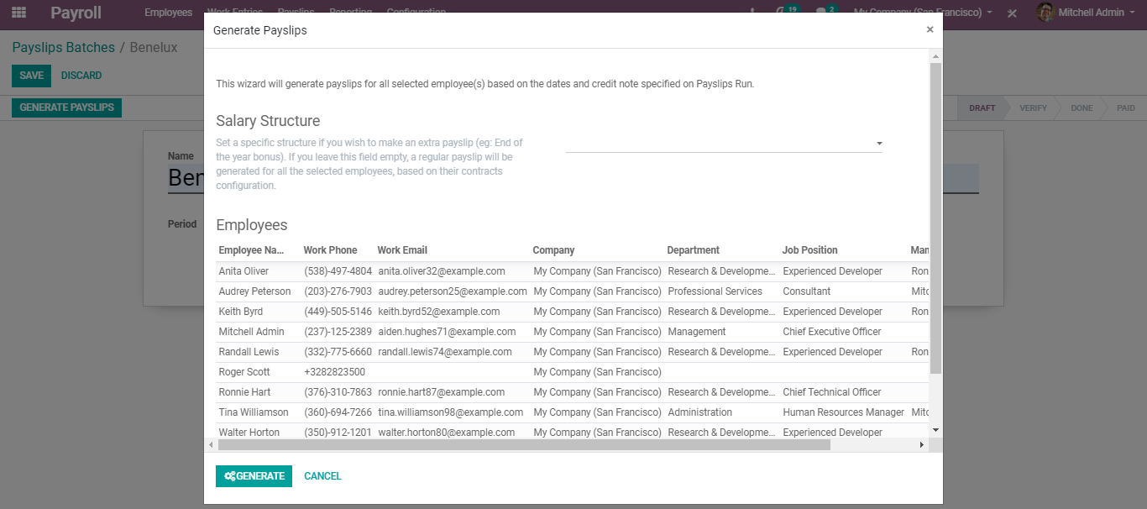
  - From here, one can select the employee for whom you need to create payslips. Later click GENERATE button to create payslips in batches.

