**Marketing Automation**

Marketing automation in BUSINESSBOXERP creates automatic and targeted marketing campaigns. The feature helps in automating the workflows and thereby scaling the business. It crafts simplified end-to-end customer journeys, designs engaging email campaigns and the required email templates in minutes. Simply saying it automates much more than just emails. One can trigger any kind of action in marketing automation that demands the streamline of the workflow.

Install Marketing Automation Module from BUSINESSBOXERP Apps

As soon as you enter the app post installing it, you enter the dashboard of the application.

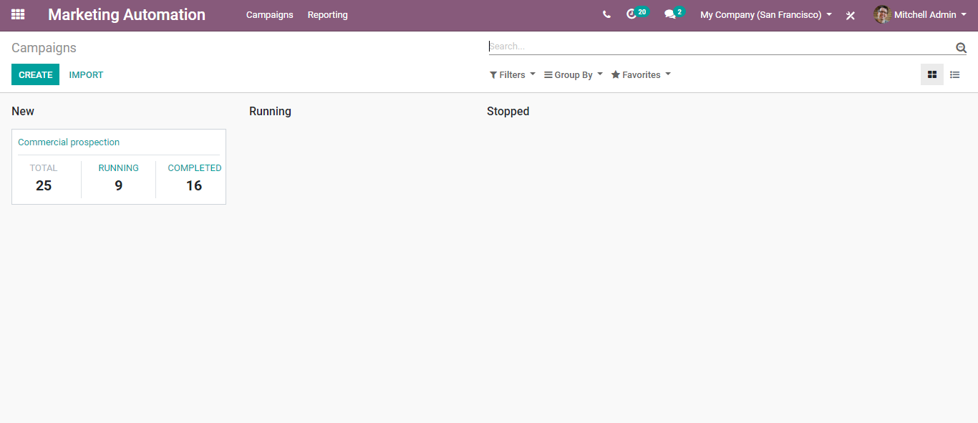

From the dashboard, you can see the already created campaigns along with their status and other info. Other info includes- the name of the campaign and total, active, and completed the number of participants of that campaign.

Upon clicking the CREATE button, you can create new campaigns.

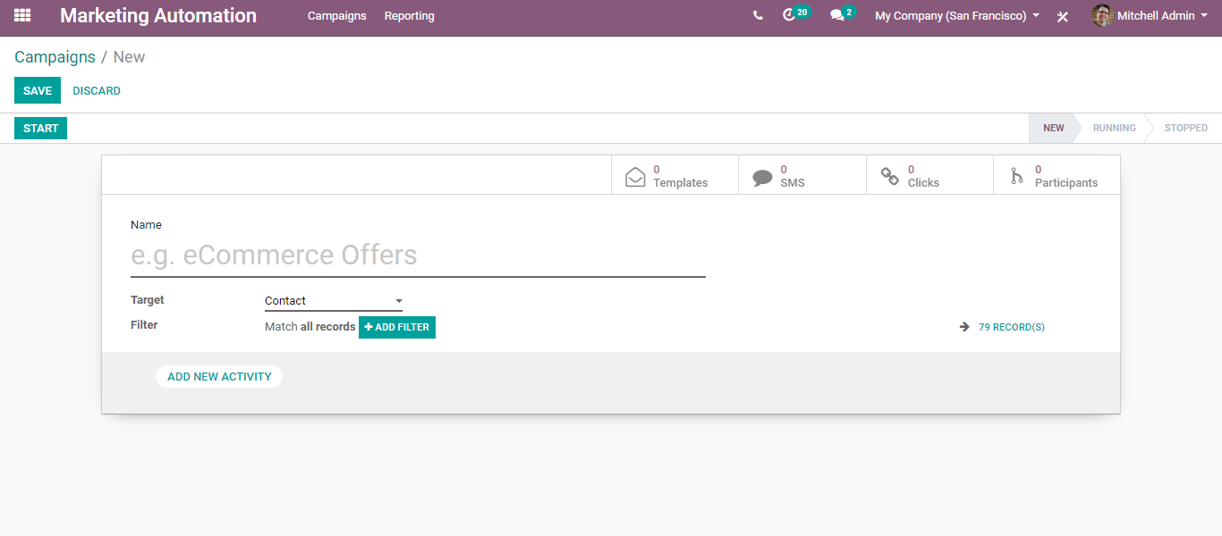

The create form includes the following fields:

Name The name of the campaign.

Target: The model that wants to be targeted say contacts.

Add a recent activity: Via clicking the option, one can create multiple activities that should be included in the campaign.

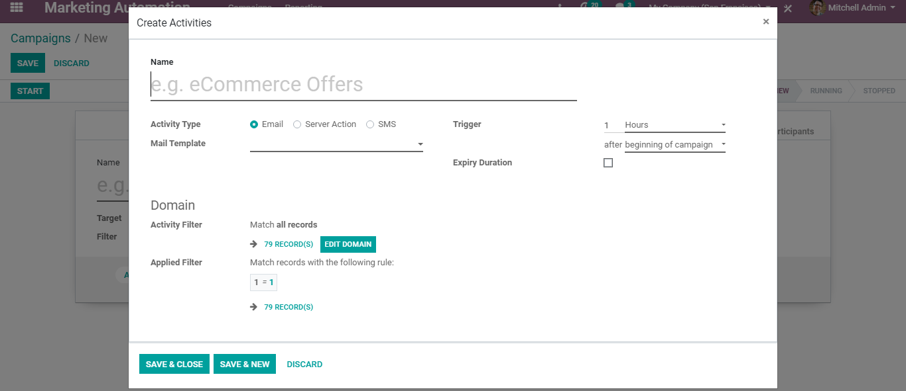

Here, you have the following fields:

* Name The name of the activity.
* Activity Type: Whether it is an Email or Server action or SMS.
* Email Template: The email template that is used for the activity.

**Configuring Email Template**

To configure a new email template for the activities, click on the link button on the email template selection field,

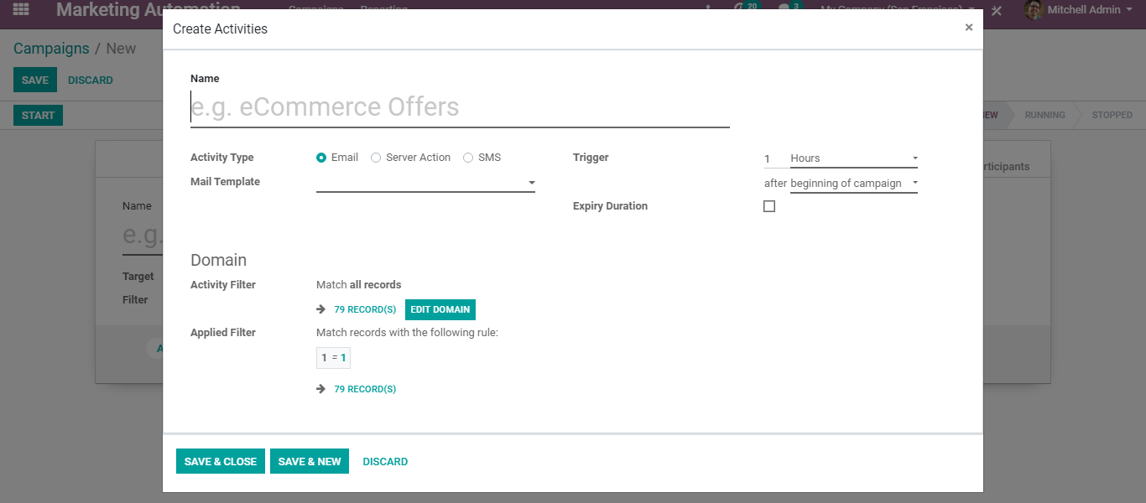

Upon clicking you will be navigated to a new page like below, with which you can create and configure new.

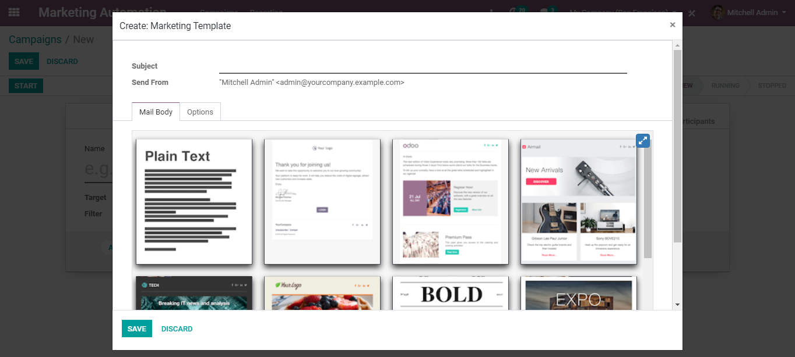

You can see different building blocks for the main body of the email. One can via dragging and dropping the required building blocks.

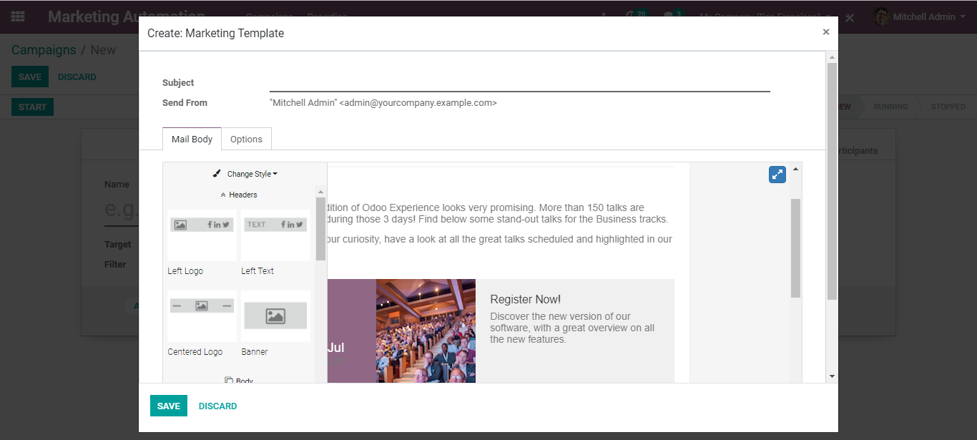

Under the options tab, you get more features which include,

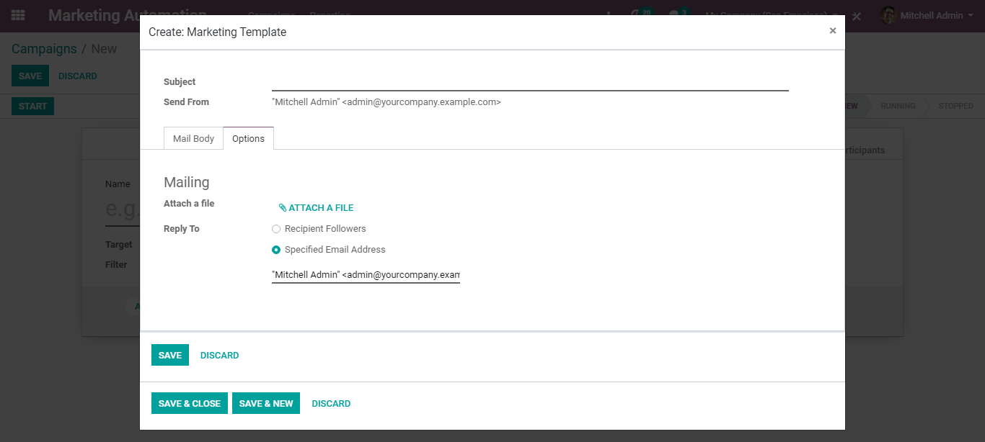

Mailing Options such as Attaching files, replying to option.

Click SAVE AND CLOSE to create and schedule the activity.

Coming back to campaigns, the field includes the following as well:

* Trigger: Here one can schedule the action period of the activity.
* Expiry Duration: Check this to make sure your actions are not executed after a specific amount of time after the scheduled date.
* Domain: If we want to add any filtration to this activity, then we can add the domain from here.

Once you have added all the valuables, Click SAVE.

Then start the campaign via clicking the START button.

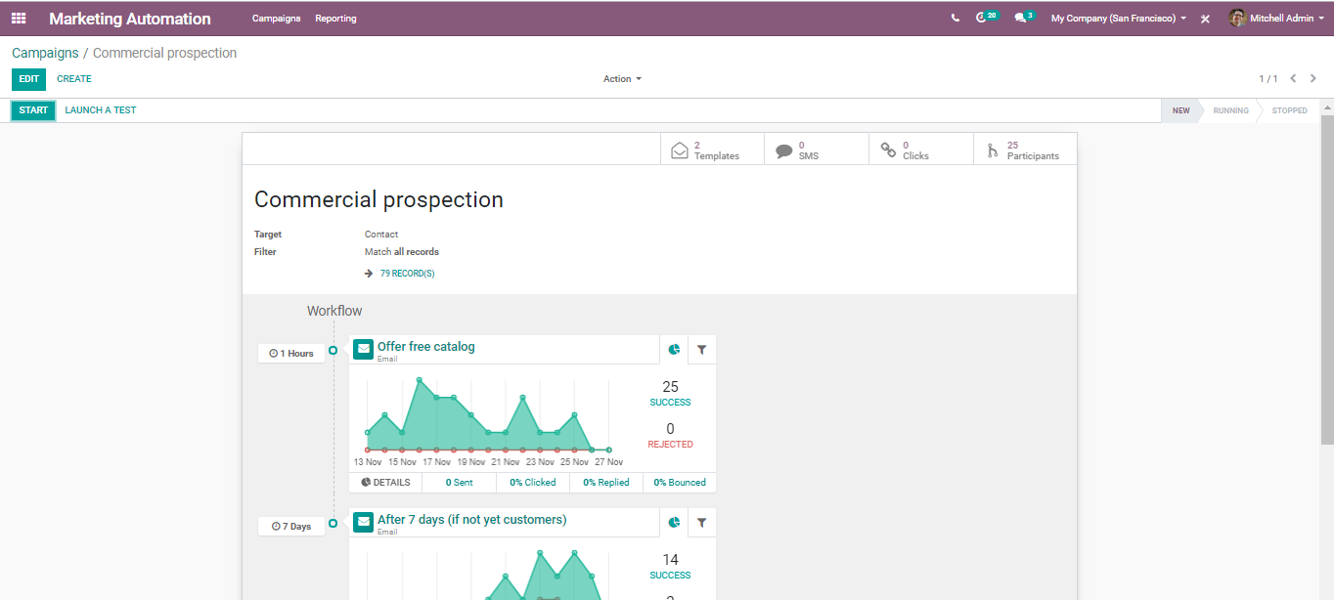

Click STOP to stop the campaign.

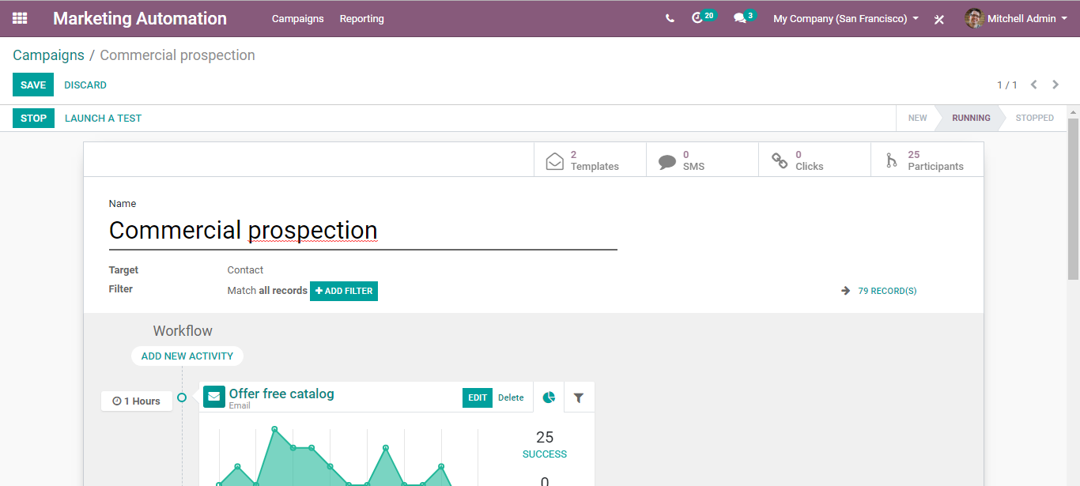

Via clicking the PARTICIPANTS, you can get the participant’s list.

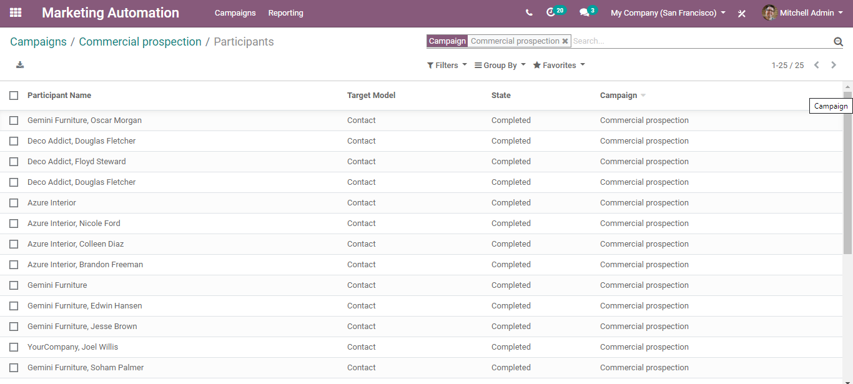

If you click on any of the participants, you can see the activities scheduled for the participant.

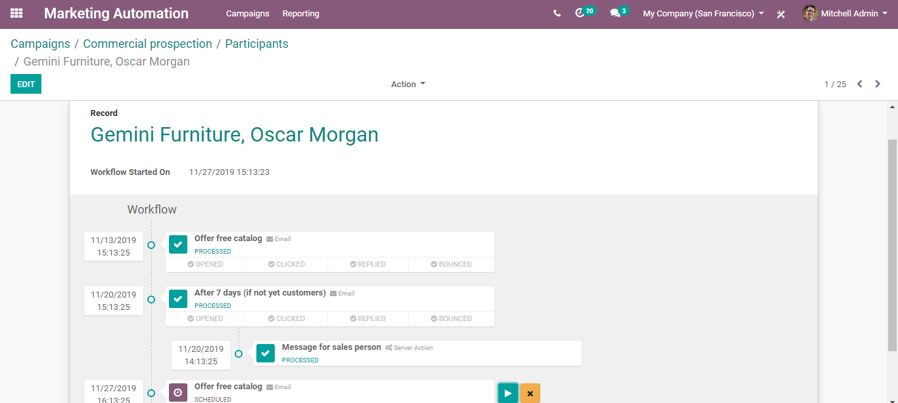

Via clicking the PLAY button, one can immediately run the activity for this participant.