**Members**

BUSINESSBOXERP ERP is known for its adaptive mechanism. Each component in BUSINESSBOXERP can be modified to any degree, making it superbly pitched to the ideal business need. BUSINESSBOXERP's Membership Management Module is one such application, which can be modified by the need of the end client. Each membership enrolment, regardless of how enormous or little they can be modified effortlessly with the BUSINESSBOXERP Members module. One of the significant components of this module is that it supports several types of members such as free members, associated members, paid members, or special members. Moreover, being integrated with other management modules such as sales and accounting helps in the quick fixing of things related to invoicing or proposition sending on membership renewals.

**Features of BUSINESSBOXERP Member Module**

* Creation and configuration of membership products.
* Creating Members.
* Free Membership.
* Invoicing and payment of memberships.
* Adding attachments in membership products.

To start with, firstly install the BUSINESSBOXERP Member module from BUSINESSBOXERP Apps.

Enter the application and first, you see the members created within. However, here we do not have any. So, to create a new member, you can click the CREATE button provided on top.

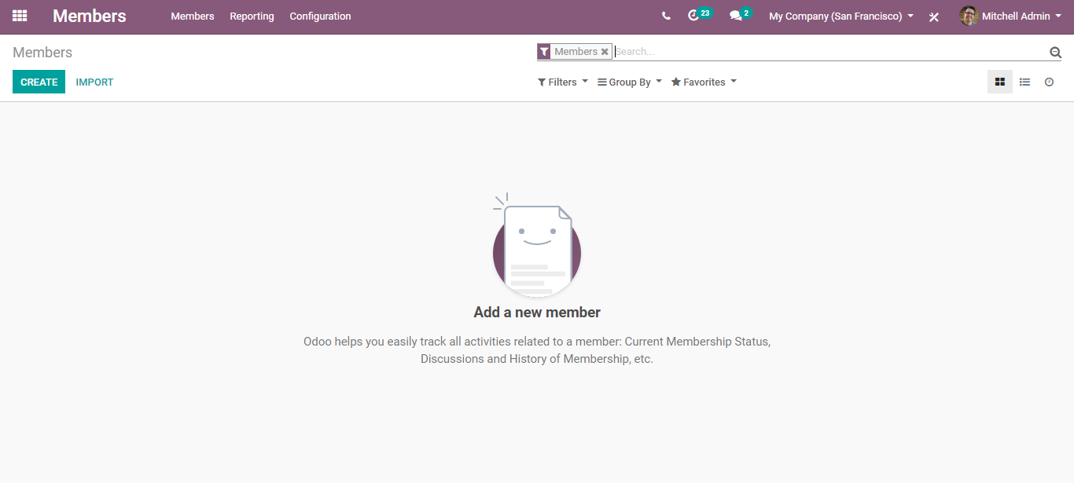

**Membership Products**

Before adding the members, firstly we need to create membership products. One can create the membership products, via clicking the Configuration menu provided on top of the member application.

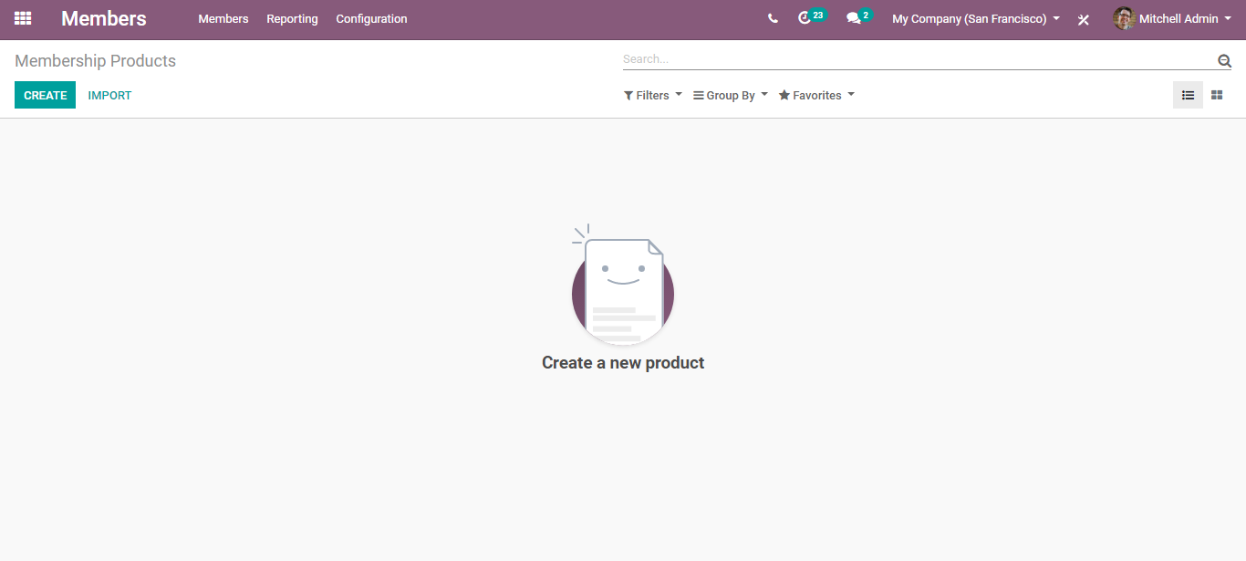

Click CREATE.

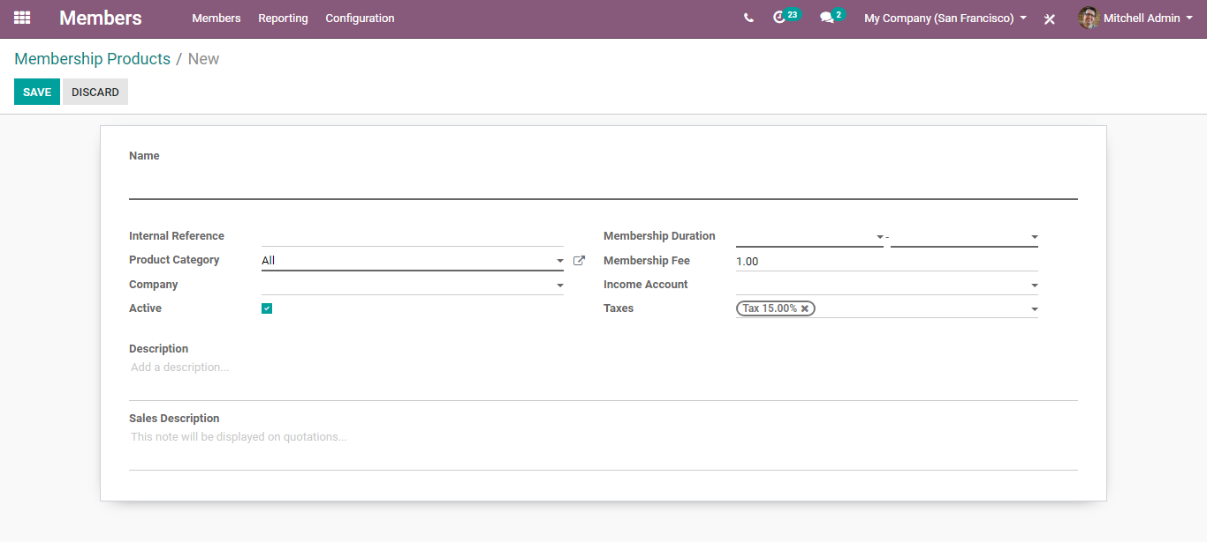

To configure the product, you need to fill certain fields as shown in the above image.

Under the create form you need to fill in the name of your product, internal reference, product category, company, and so on. The mandatory details include the Membership Duration (date from which the membership becomes active), Membership fee (Price at which the product is sold to the customer), Income Account (Keep this field empty to use the default value from the product category) and so on.

Under the create form one can also view two types of description fields, where the details in the field “Sale Description” will appear in the sales quotation.

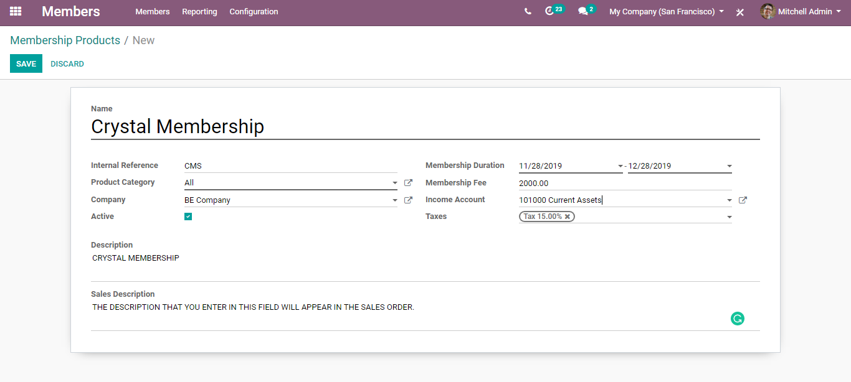

Click SAVE to mark the changes.

**Creating Member**

One can create a new member via going to Members> Members> Create.

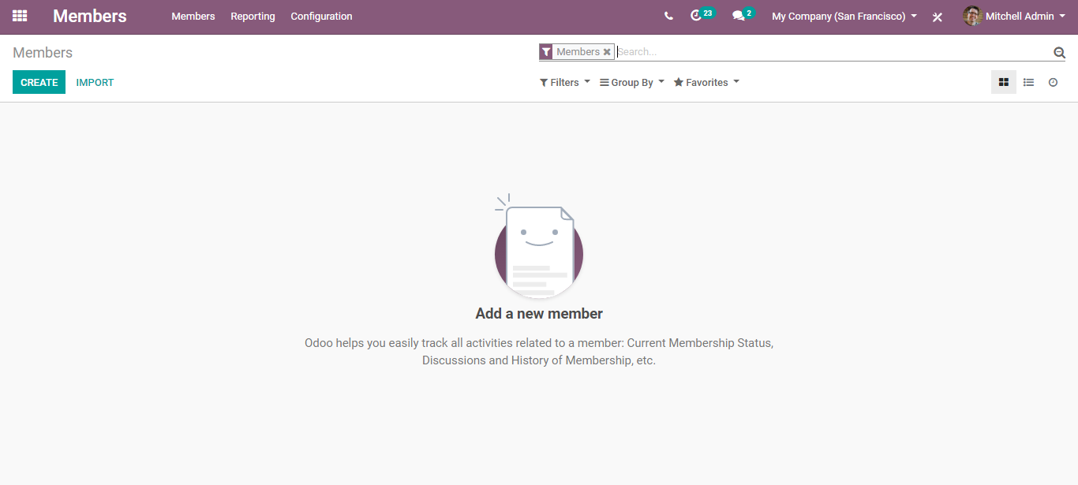

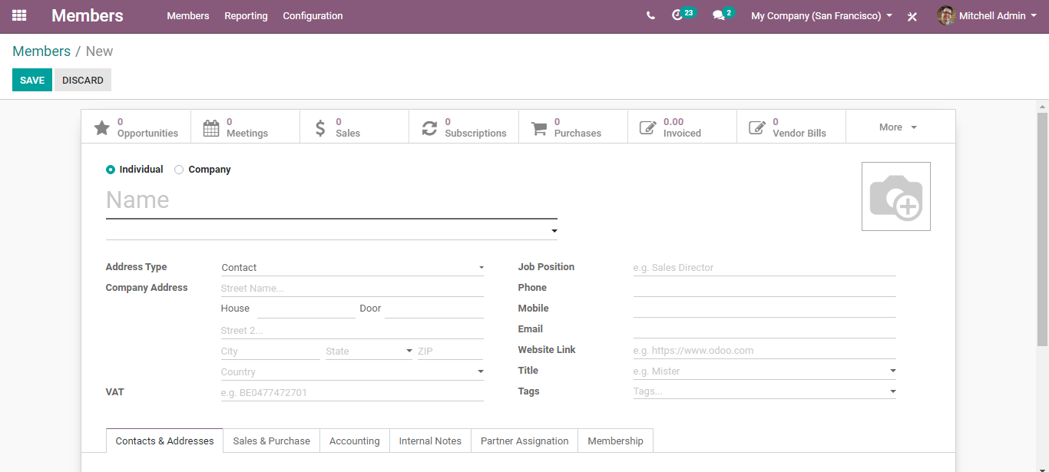

Here one can enter all the basic and contact information of the member. The members can either be either an individual or the company.

**Member Types**

**Free Membership**

Under the membership tab of the member create form, one can choose the membership options for the member created.

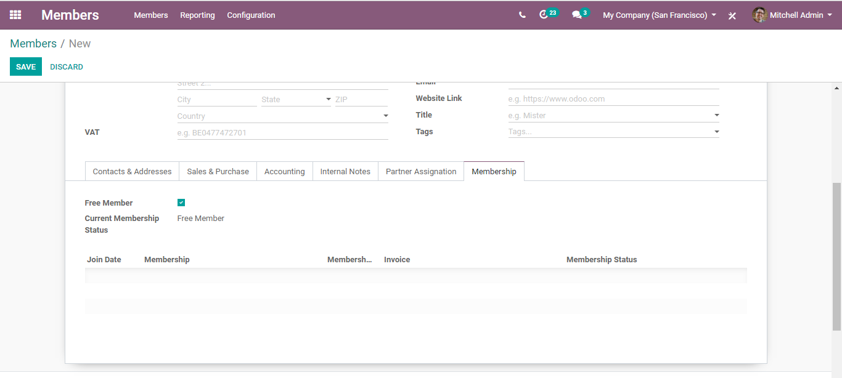

Tick the option free member if the created member wants a free membership. Corresponding to it, the current membership status gets changed to “Free Member”. You can see no invoice or payment for the free membership status.

**Buy Membership**

If the member needs any of the membership products, click “Buy Membership”.

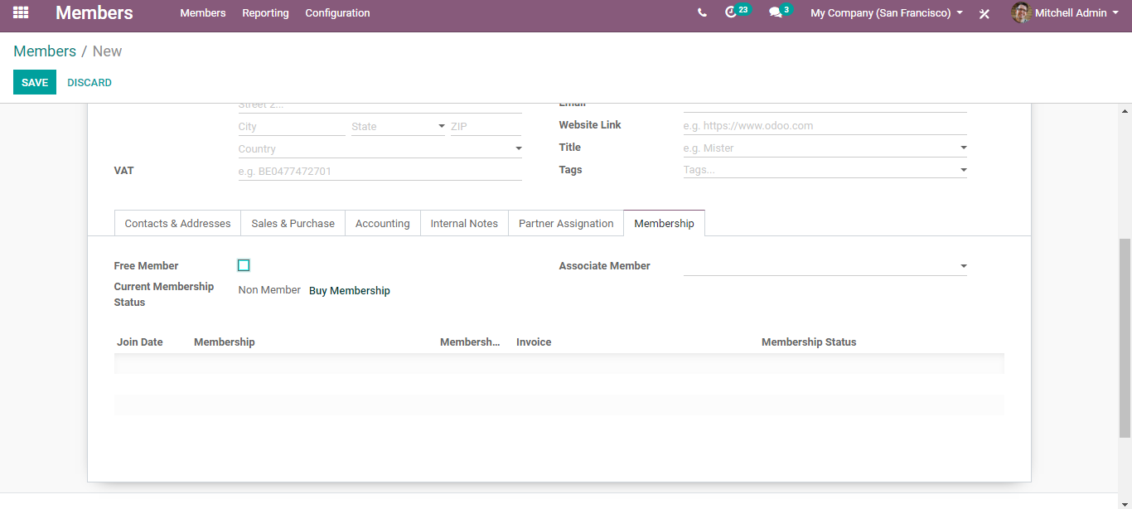

By assigning “Associate Member”, the current member gets the membership corresponding to the membership period of the associated member.