**Notes**

BUSINESSBOXERP notes can be a major help to businesses as it helps in getting things done more simply. The module simply organizes your tasks with notes and to-do lists.

Firstly, install the BUSINESSBOXERP Notes module from BUSINESSBOXERP apps.

As soon as you enter the dashboard, you see the various stages created such as new, meetings, notes, to do and so on. As you see, these stages are in their sequential order starting from the initial point moving towards the finishing line.

One can simply break down the to-do list into stages which shall be converted to columns in the dashboard.

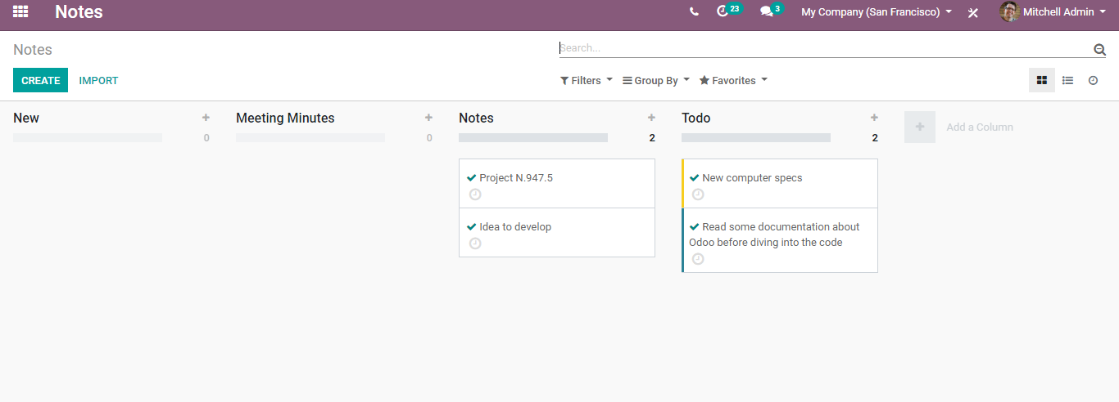

**Build your to-do list**

Accomplish your objectives and goals simpler than at any other time. Get composed with effective to-do lists and notes. From individual assignments to collective meeting minutes, increase the profitability and productivity of your representatives by giving them the correct instruments to organize their work, share their thoughts and team up on reports.

One can either create the to-do list via clicking the + icon on the various stages or via creating notes directly from the dashboard via clicking the CREATE button.

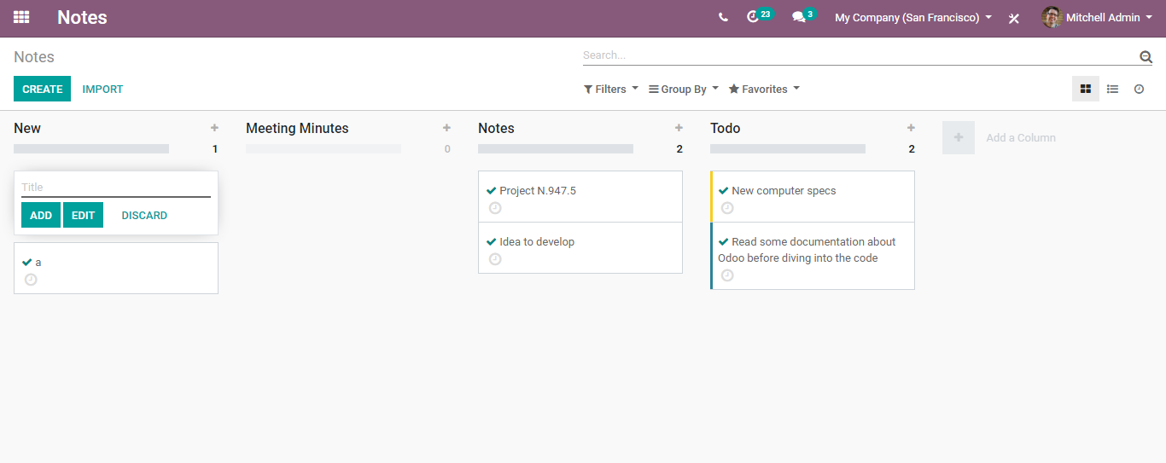

**Create notes**

One can easily add the notes here and each note moreover resembles a mini project.

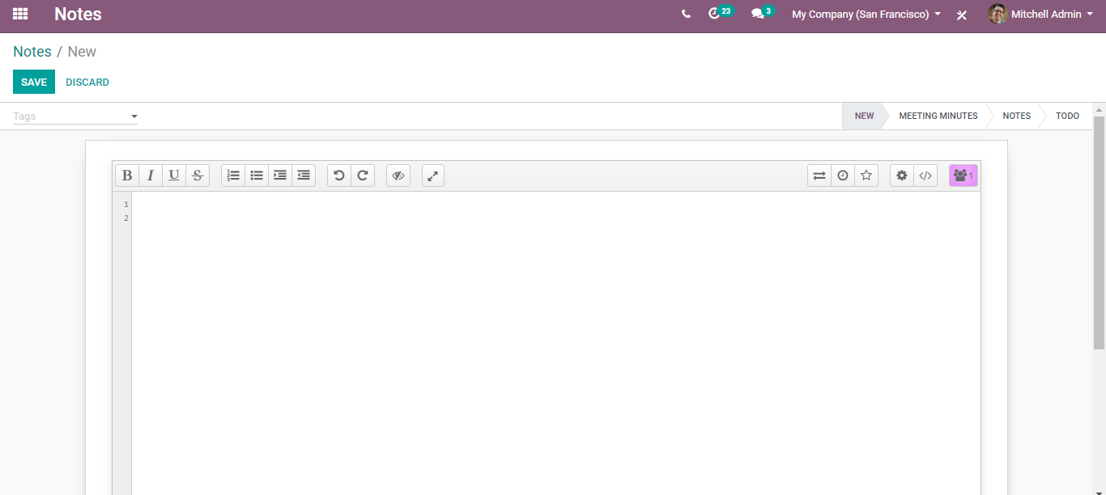

BUSINESSBOXERP notes make it easier to organize the notes. One can easily customize them using different tools provided here. For instance, one can insert text styles like headers, bold, italics, with a simple WYSIWYG editor. Also, in BUSINESSBOXERP notes it is possible to attach text files, image files, even document files to your notes.

For a clear organization, one can even add tags to it.

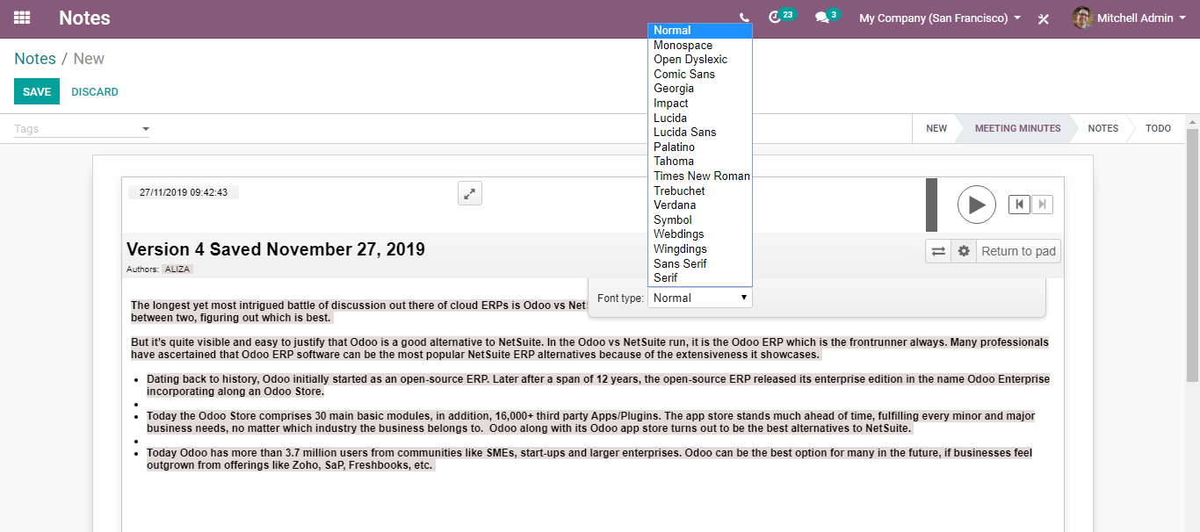

The note will move from one stage to another as the project moves forward.

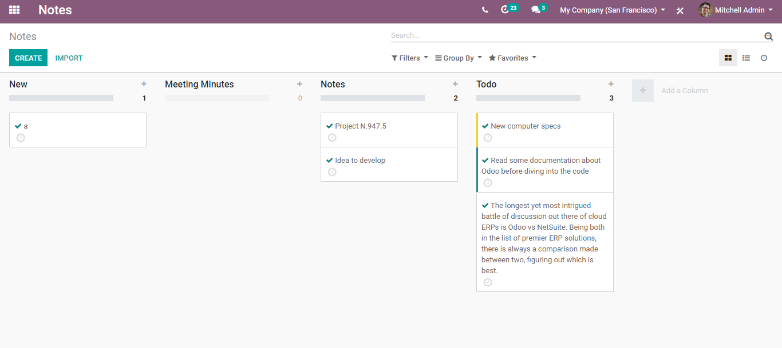

From Kanban view, one can easily drag and drop notes from one stage to another.

Filters and groups function as the smart filters to instantly search your created notes.

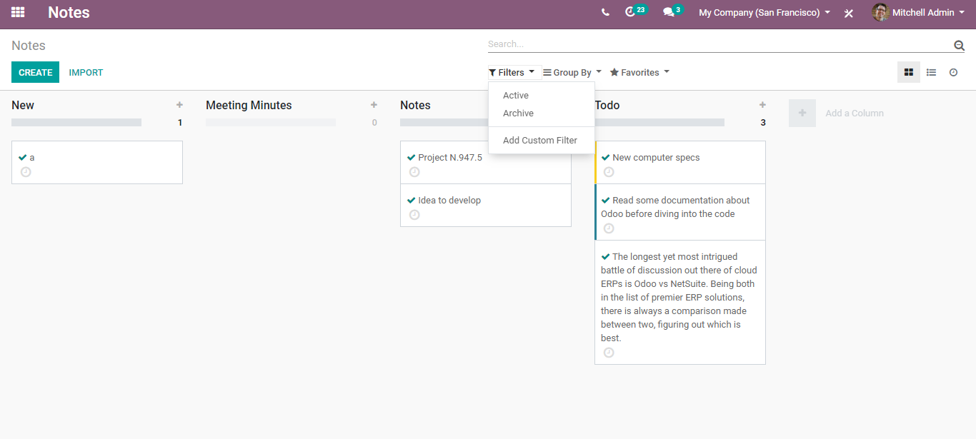

Colours: Make use of it to group your notes based on the task.

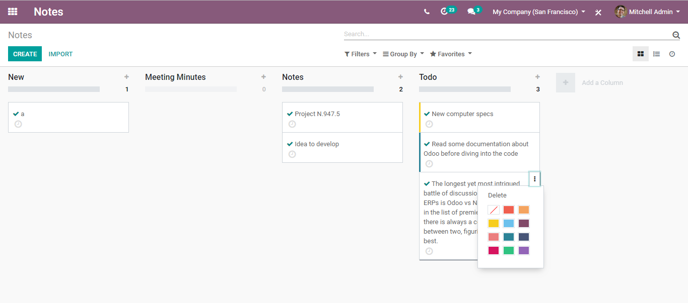

BUSINESSBOXERP provides nine colours to choose from.

Schedule the activity; Right from the notes, one can schedule the activity for it via clicking the button provided below. It helps you to schedule the activity types such as calls, meetings, email and so forth with the concerned.

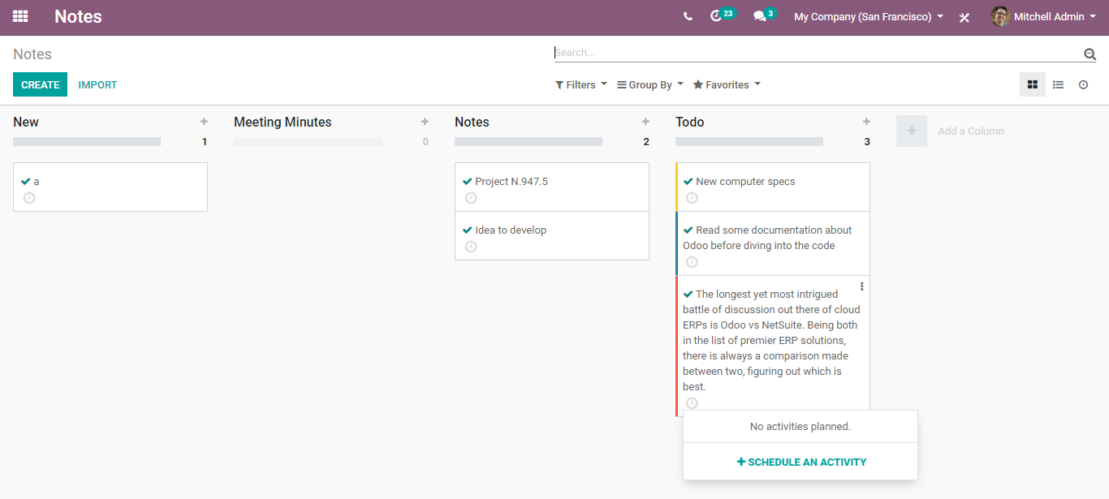

Import: For uploading any text file or documents to your notes, you can make use of the button IMPORT.