  - Point of sale
  - POS is a unique application of the BUSINESSBOXERP application set which is working on a 100% web-based environment. It has two parts- a Front-end and a Backend. The front-end interface allows you to sell products quickly and it also enables you to deal with multiple customers at a time. On the other hand, the Backend interface allows you to configure your point of sale and print reports and analyse your sales.
  - The Point-of-Sale application can be used online or offline on iPads, Android tablets or laptops. BUSINESSBOXERP Point of Sale is fully integrated with the Inventory and Accounting applications. Any transaction in your point of sale will be automatically registered in your stock and accounting entries but also in your CRM as the customer can be identified from the app. You will be able to run real-time statistics and consolidations across all your shops without the hassle of integrating several external applications.
  - Main Feature:
  - Offline Mode: The end-user can use the POS front end even if there is no internet connection.
  - Configuration:
  - Install POS Application
  - Go to Apps --> Point of Sale and install the app.
  - After installing the POS App, the next action is populating the Product Database.
  - PRODUCTS
  - Configuration:
  - Go to Point of Sales->Products->Products
  - 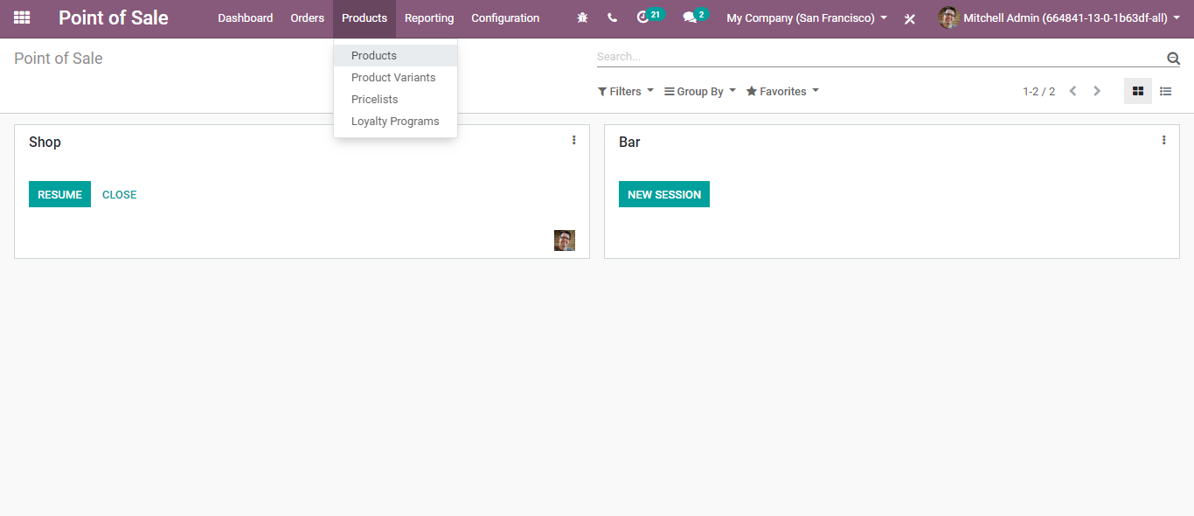
  - 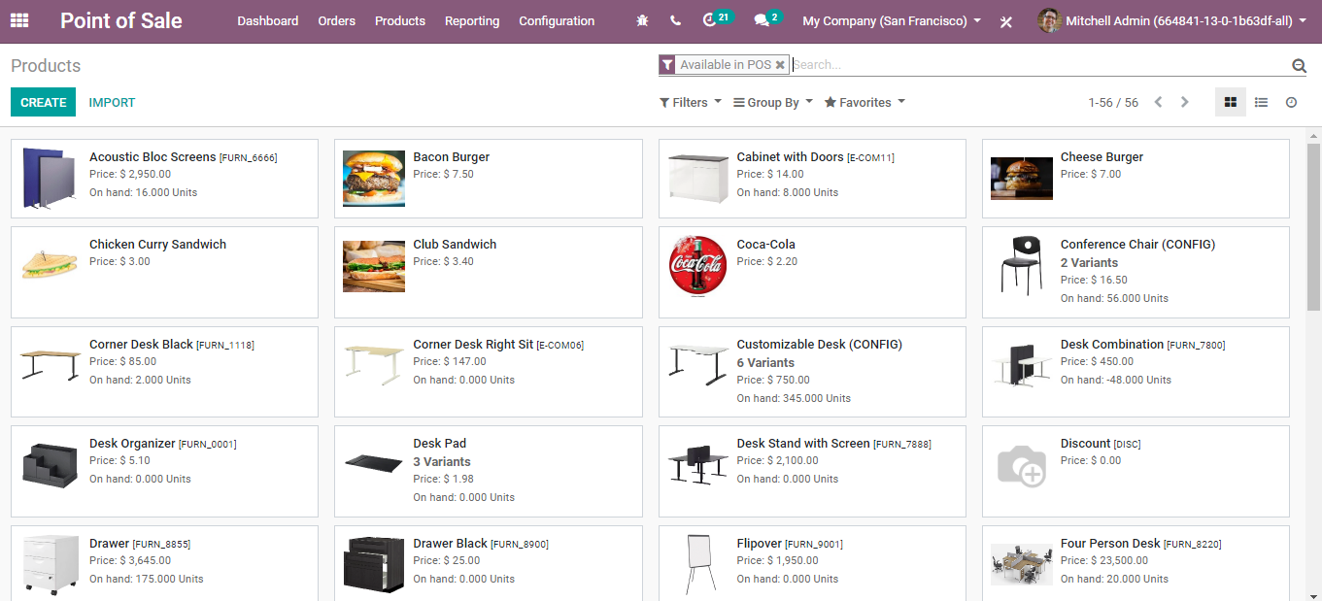
  - BUSINESSBOXERP will enlist a set of pre-configured products. However, one can create a product depending on the business requirement. Click the CREATE button to configure new products.
  - Upon clicking the CREATE button, you will be navigated to a new creative form like below.
  - 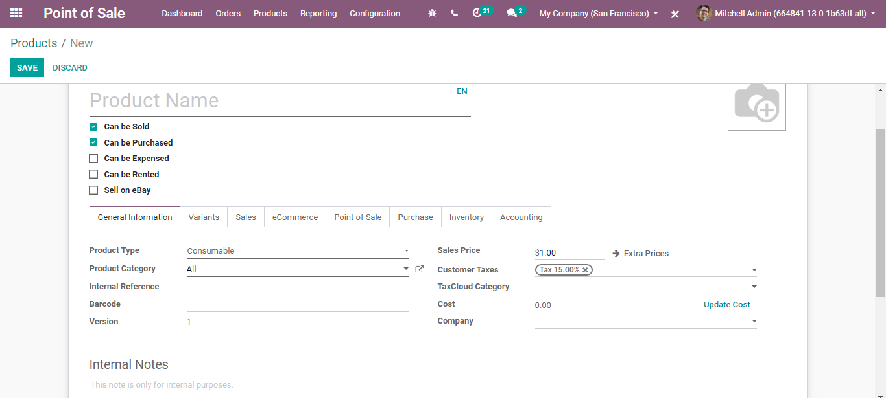
  - All the fields under this form are especially important
- Can be sold Tick this to get your products listed in sales.
- Can be Purchased: Tick this to get your products listed in a purchase.
- Can be Expensed: Specify whether a product can be selected at an expense.
- Can be Rented: Allow renting of this product.
- Sell on eBay: If you desire to sell the product on eBay.
  - Fields under General Information Tab
- Product Name: It is the name that will be displayed on all other screens that refer to this specific product.
- Product Type: When creating the product, pay attention to the Product Type field, as it is important. There are three available product types in BUSINESSBOXERP: Stackable, Service and Consumables. Products that are set as Stackable or Consumable will allow you to keep track of their inventory levels. These options imply stock management and will allow for receiving these kinds of products. Conversely, products that are set as a Service or Digital Product will not imply stock management, simply because there is no inventory to manage. You will not be able to receive products under either of these designations.
- Product Category: The field defining the category of the current product.
  - 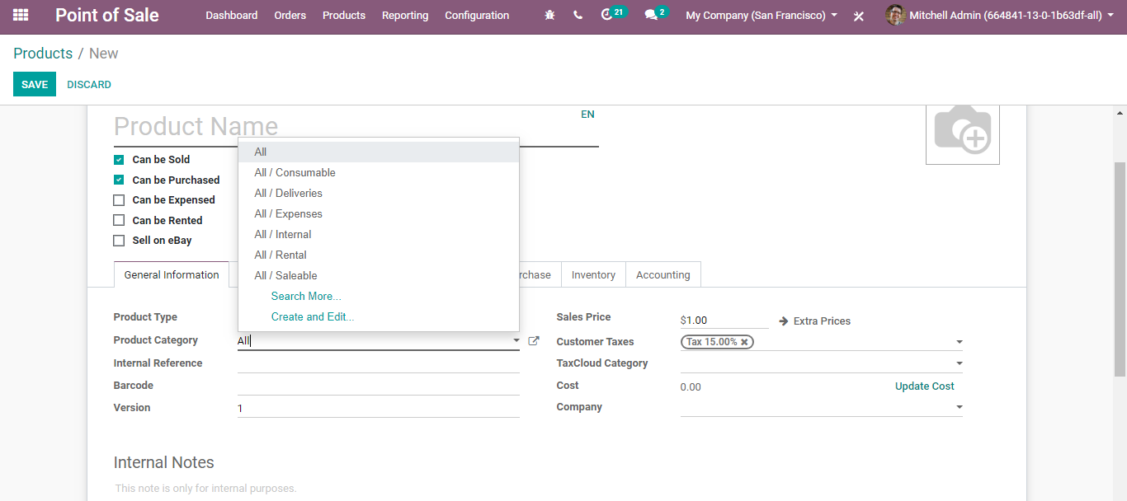
- Internal Reference: BUSINESSBOXERP utilizes the Product Name field and the description when displaying product information. Commonly, a company may have a coding system for its products. The Internal Reference field is useful to enter an alternative product code or number for the product in that case.
- Barcode: Especially, when the number of products is more, the probability of human error also increases. Now smartly and effortlessly add/update product quantity by scanning product barcodes while receiving or delivering products in your BUSINESSBOXERP.
- Version: Current version of the product.
- Sales Price: The price at which the product is sold to the customers.
- Customer Taxes: Default taxed used when selling the product.
- Tax Cloud Category: This refers to TIC (Taxability Information Codes), these are used by Tax Cloud to compute specific tax rates for each product type. The value set here prevails over the one set in the product category.
- Cost: Cost used for stock valuation in the standard price and as a first price to set in average/FIFO.
  - Fields under Variants Tab
  - You can add the attribute and attribute values for the product. If you click on the attributes button, you will get a drop-down rundown with attributes. One can likewise include new characteristics or attributes via clicking the choice CREATE AND EDIT.
  - 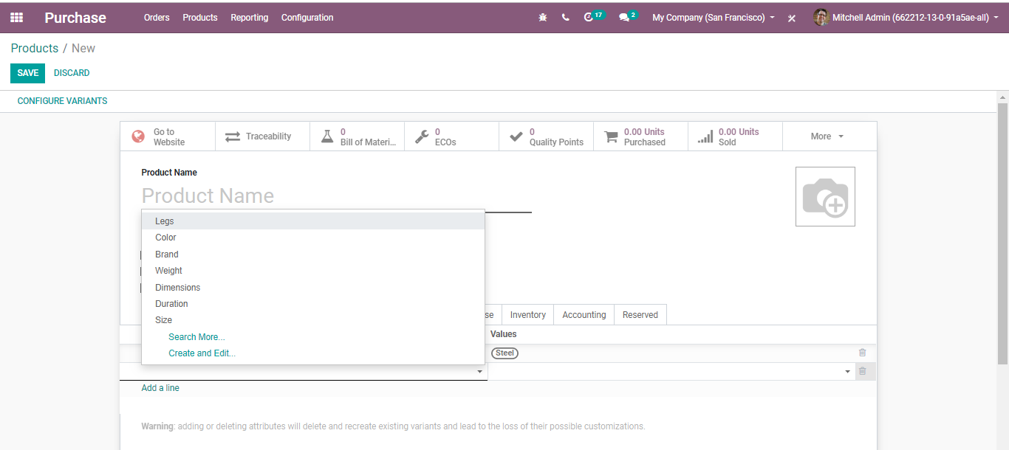
  - One can set the attribute type, attribute values, in BUSINESSBOXERP.
  - 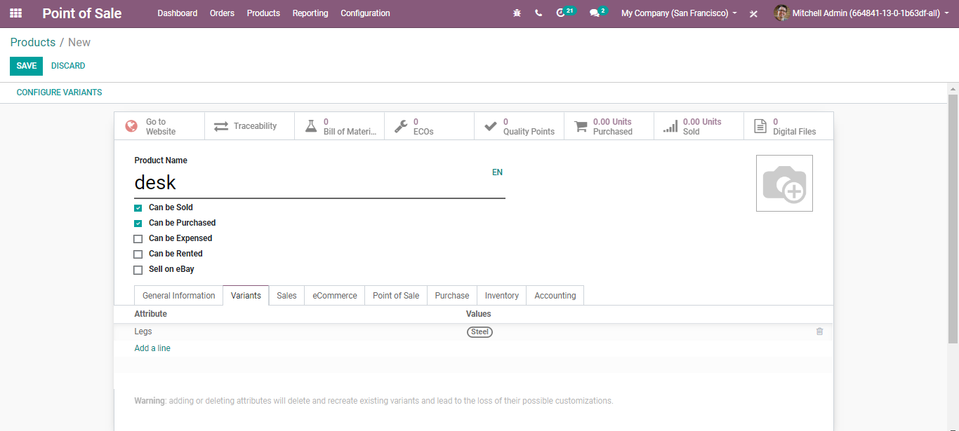
  - Upon clicking CONFIGURE VARIANTS BUTTON on the top right left, you are navigated to a new window like below:
  - 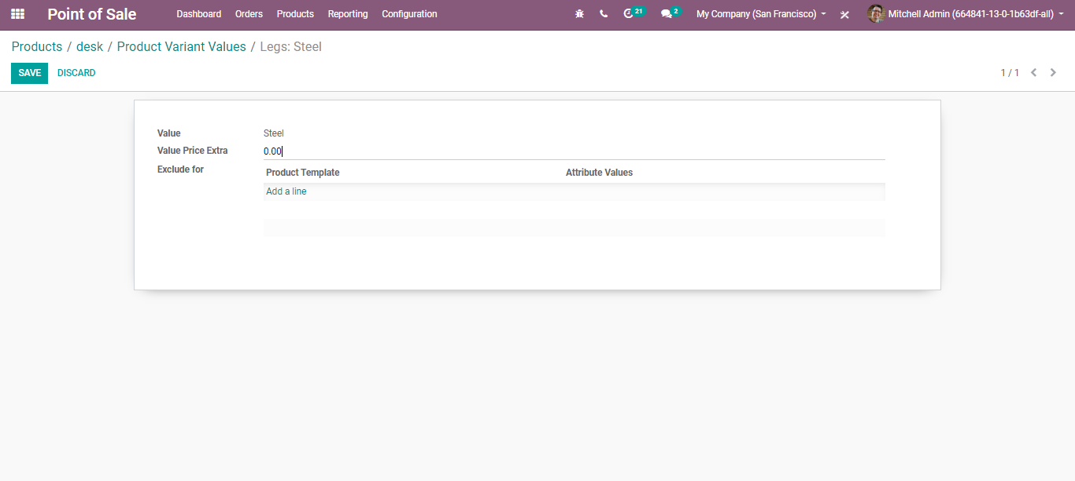
  - Here, you can add the value price extra for the variant (extra price variant with this attribute value on sale price).
  - Exclude for: By adding the field we make this attribute value not compatible with other values of the product or some attribute values of optional and accessory products.
  - Fields under Sales tab
  - 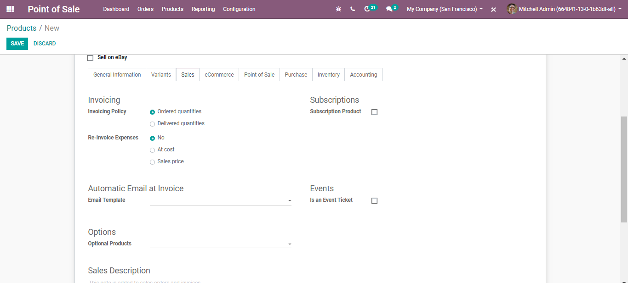
- Invoicing Policy:
  - Ordered Quantity: Invoice quantities ordered by the customer.
  - Delivered Quantities: Invoice quantities delivered to the customer.
- Re-invoice Expenses: Expenses and vendor bills can be re-invoiced to a customer. With this option, a validated expense can be re-invoice to a customer at its cost or sales price.
- Subscription Product: If set, confirming a sales order with this product will create a subscription.
- Email Template: Send a product-specific email once the invoice is validated.
- Optional Products: Optional products are suggested whenever the customer hits the” Add to cart.”
- Sales Description: A description of the product that you want to communicate to your customers. This description will be copied to every sale order, delivery order, customer invoice/credit note.
  - Fields under E-commerce Tab
  - 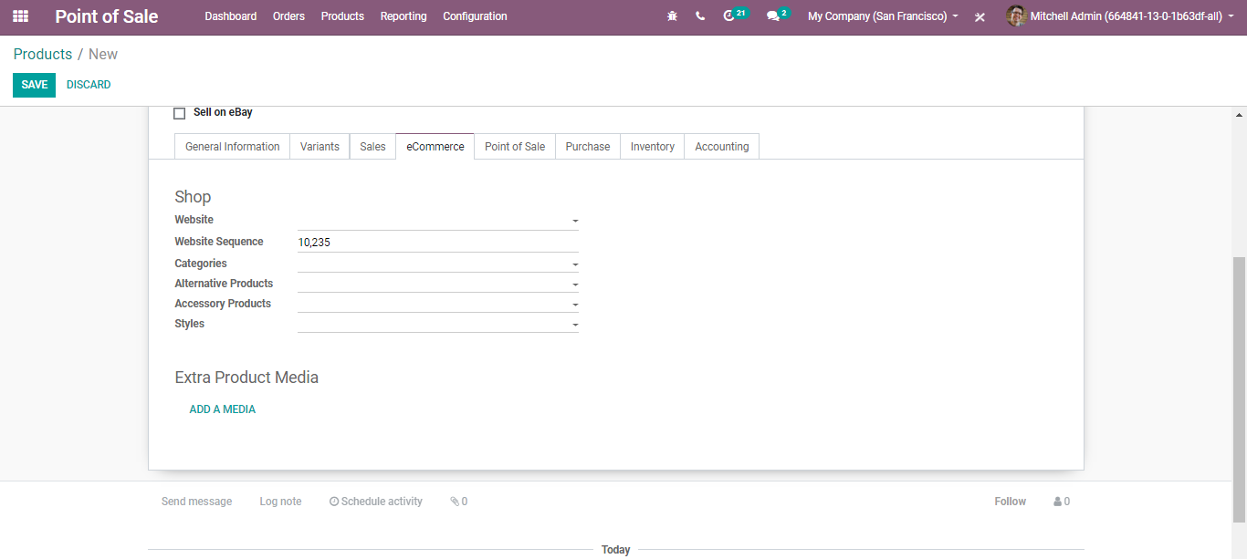
- Website: Restricting the product publishing to the defined website.
- Website Sequence: Determine the display order in the Website E-commerce.
- Categories: The product will be available in each mentioned E-commerce category. Go shopping>Customize>and Enable ‘E-commerce categories’ to view all e-commerce categories.
- Alternative Products: Alternatives to your customer (upselling strategy). Those products show up on the product page.
- Accessory Products: Accessories show up when the customer reviews the cart before payment (cross-selling strategy).
- Styles: Determines how shall be displayed on the website. For instance, full image/ sales ribbon and so forth.
- Extra Product Media:
  - 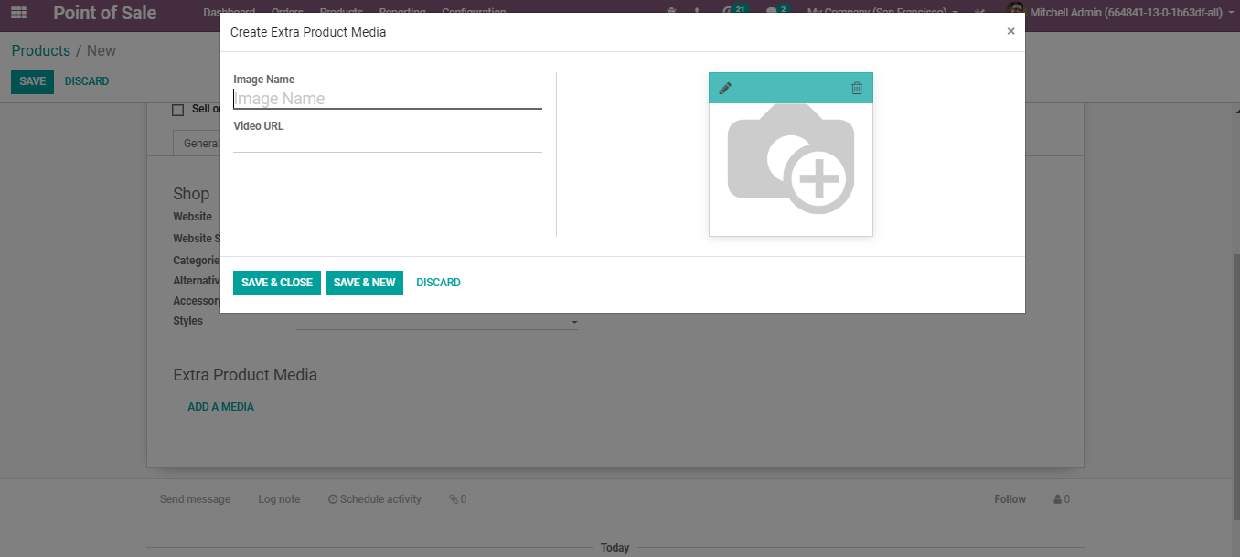
  - Under Point-of-Sale Tab
  - 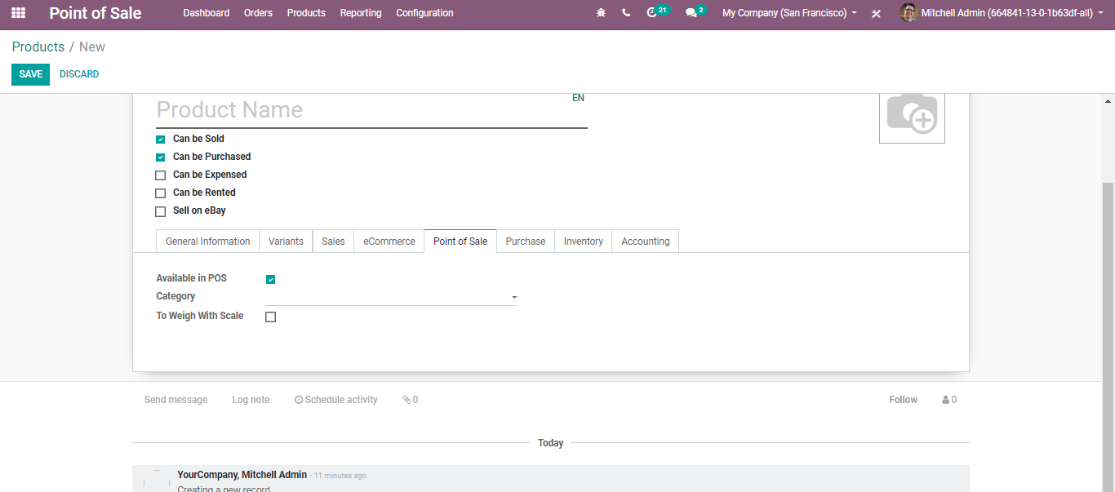
  - Available in POS: Tick the option if you want this product to appear at the point of sale.
  - To Weight with Scale: Check if the product should be weighed using the hardware scale integration.

  - Under Purchase Tab
  - 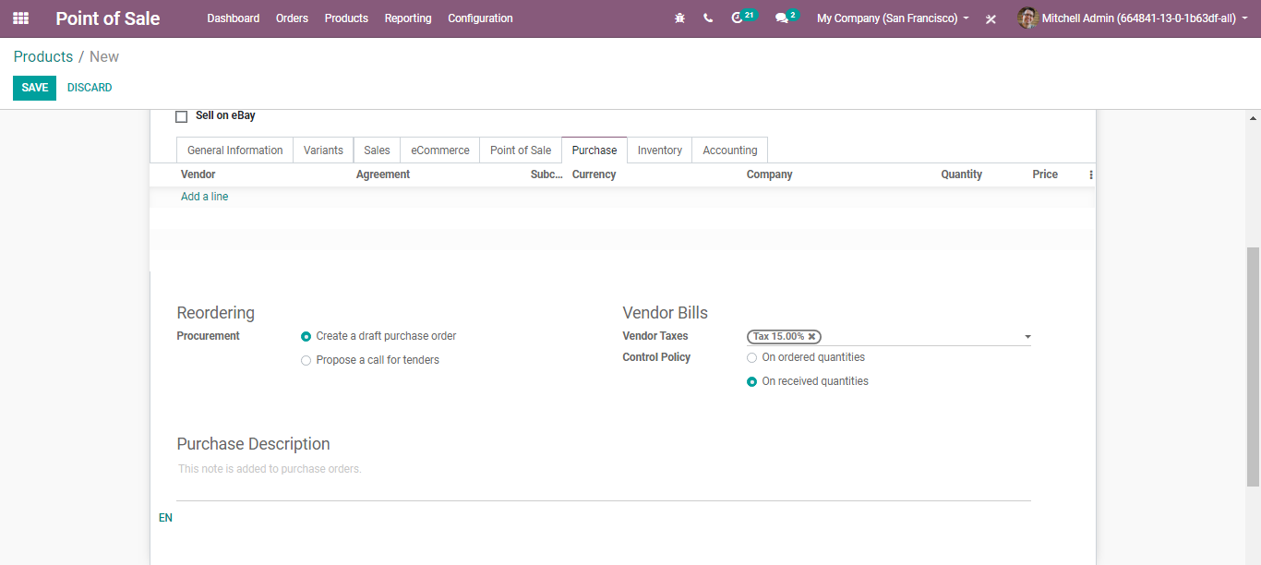
- Reordering: Procurement: Create a draft purchase order- Based on your product configuration, the system will create a draft purchase order. POS a call for tender-If the purchase requisition module is installed and this option is selected, the system will create a draft call for tender.
- Vendor Bills: Vendor Taxes- Default taxes used when buying the product.
- Control Policy: On ordered Quantities-Control bills based on ordered quantities. On received
- Quantities-Control bills based on received quantities.
- Purchase Descriptions: This note is added to purchase orders.

  - Under Inventory Tab
  - 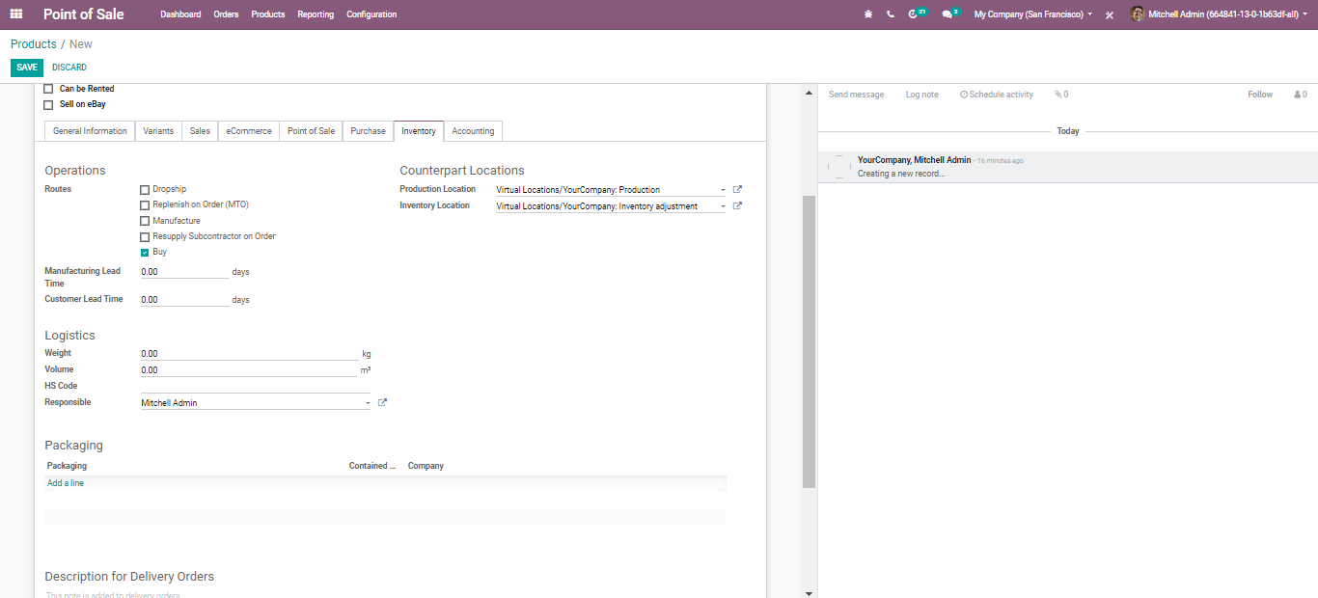
- Route: Depending on the module installed, this will allow you to define the route of the product. whether it will be bought, manufactured, replenished on order etc.
- Manufacturing Lead Time: Average lead time in days to manufacture this product. In the case of multi-level BOM, the manufacturing lead times of the component will be added.
- Customer Lead Time: Delivery lead time in days. It is the number of days, promised to the customer, between the confirmation of the sale order and the delivery.
- Product Location: The stock location will be used instead of the default one, as the source location for stock moves generated by manufacturing orders.
- Inventory Location: The stock location will be used instead of the default one, as the source location for stock moves generated when you do an inventory.
- Logistics: Here, you can give away the Weight, Volume, HS Code: Standardized code for international shipping and goods declaration. Now only used for FedEx Shipping Providers. Also, you can assign the Responsible: The user will be responsible for the next activities related to logistics operations for this product.
- Packaging: Gives the separate ways to package the same product.
  - 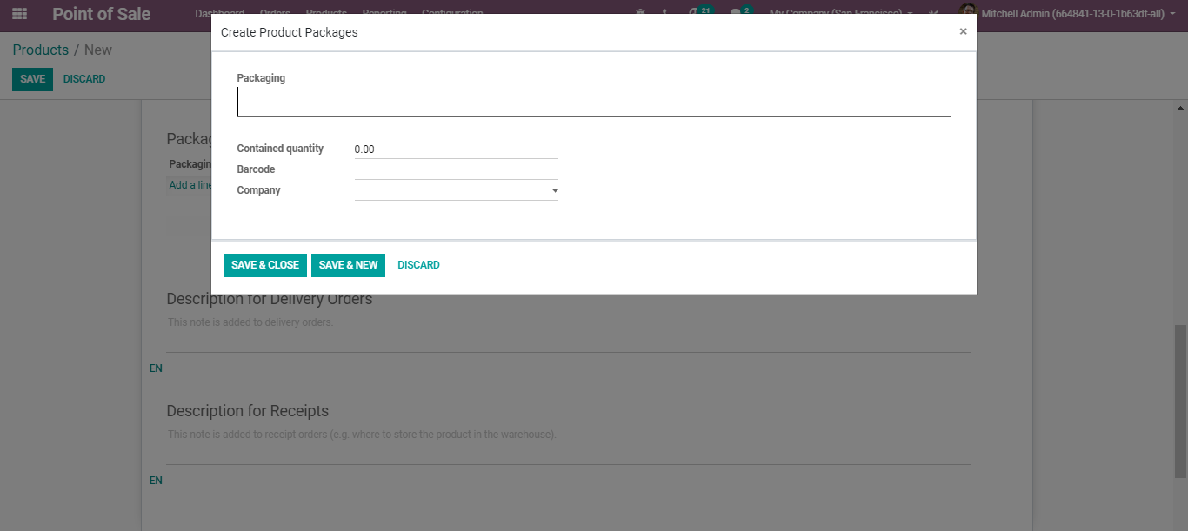
- Description for Delivery Orders: This note is added to Delivery Orders.
- Description for Receipts: This note is added to receipt orders.
  - 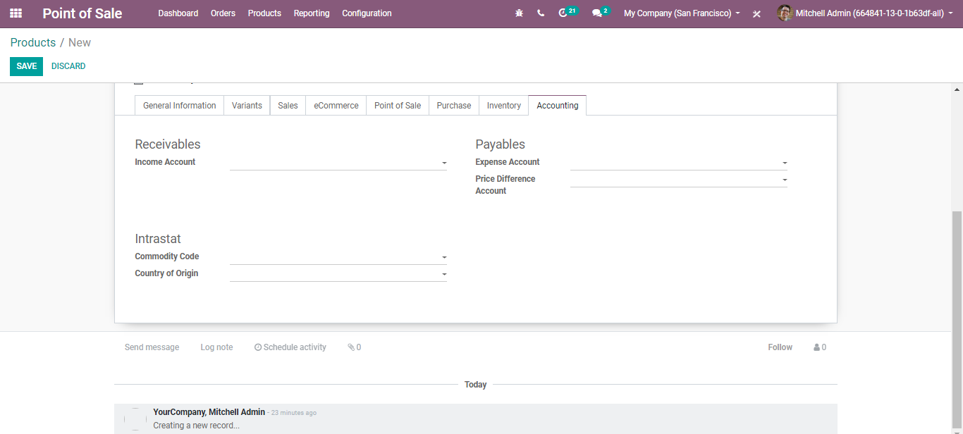
- Income Account: Keep this field empty to use the default value from the product category.
- Expense Account: Keep this field empty to use the default value from the product category. If anglo-Saxon accounting with an automated valuation method is configured, the expense account on the product category will be used.
- Price Difference Account: This account is used in the automated inventory valuation to record the price difference between a purchase order and its related vendor bill when validating this vendor bill.
  - PAYMENT METHODS
  - Once the desired set of products are configured for the POS, the next element to assemble is payment methods. To configure different payment methods for your point of sale, Go to POS> Configuration> Payment Methods.
  - You will be navigated to a new window like below:
  - 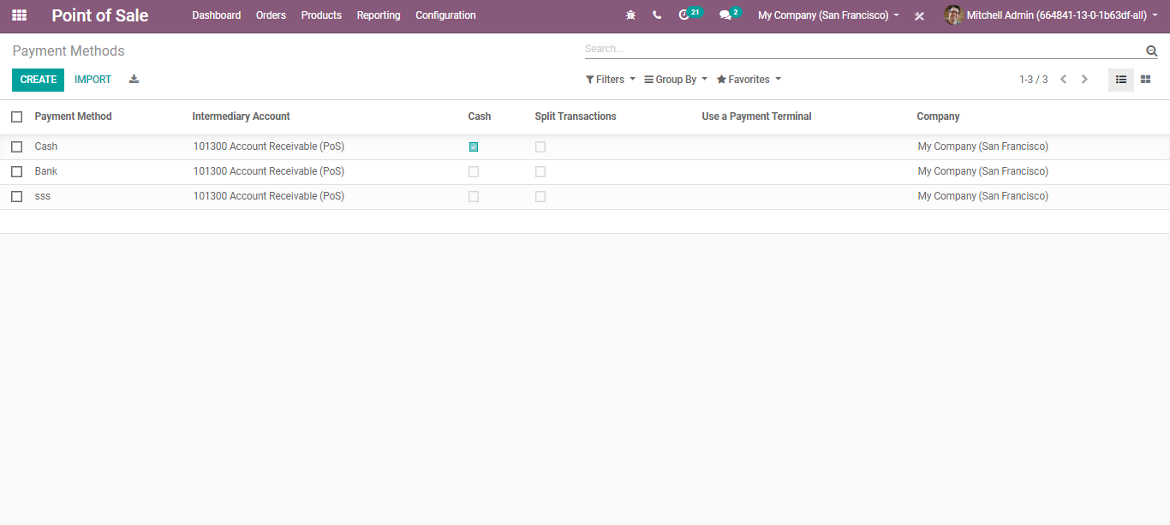
  - Upon clicking the CREATE button, you can configure a new payment method for your POS.
  - 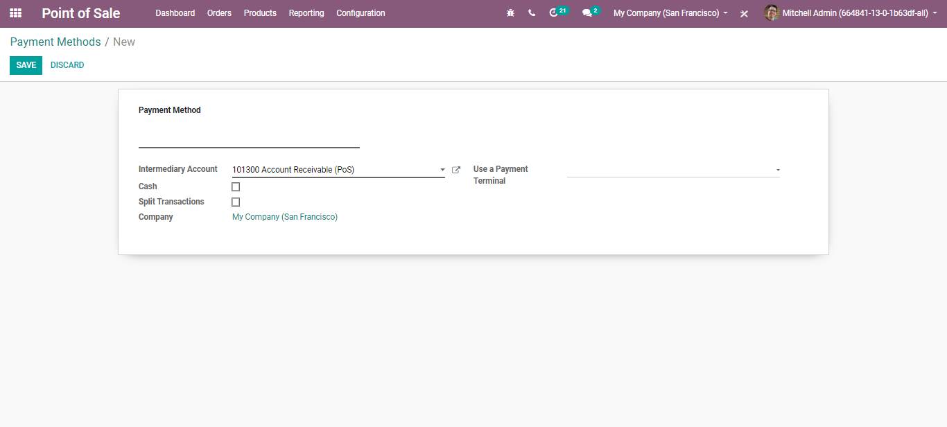
  - Here, you can name the new PAYMENT METHOD. Other fields include:
- Intermediary Account: Account used as counterpart of the income account in the accounting entry representing the POS sales.
- Split Transactions: If ticked, each payment will generate a separate journal item. Ticking that option will allow the closing of the POS.
- Payment Terminals: Record payments with a terminal on this journal.
  - If you go to point of sales configuration settings, underpayment terminals you can see different payment terminals. Upon selecting these payment terminals say Vantiv, Adyen, SIX, Ingenico, all your transactions will be processed through these terminals.
  - 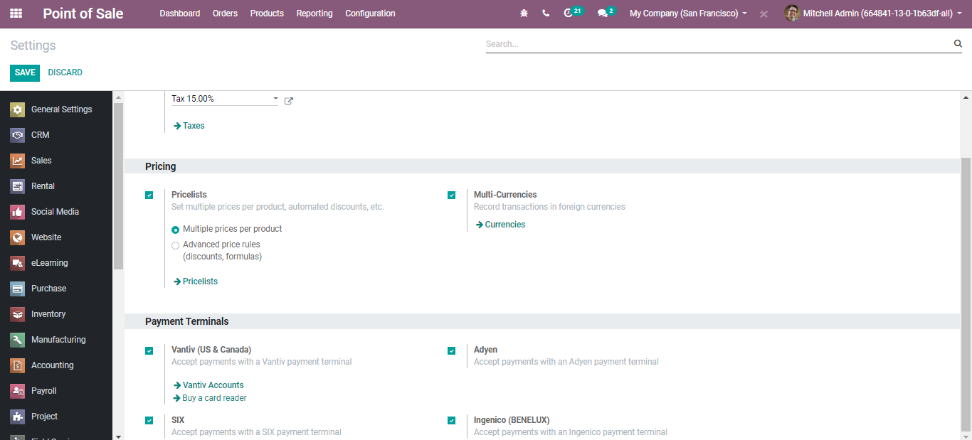
  - POS CONFIGURATION FOR RETAIL
  - Go to Point of Sale> Configuration > Point of Sale and select Point of Sale you want to configure.
  - 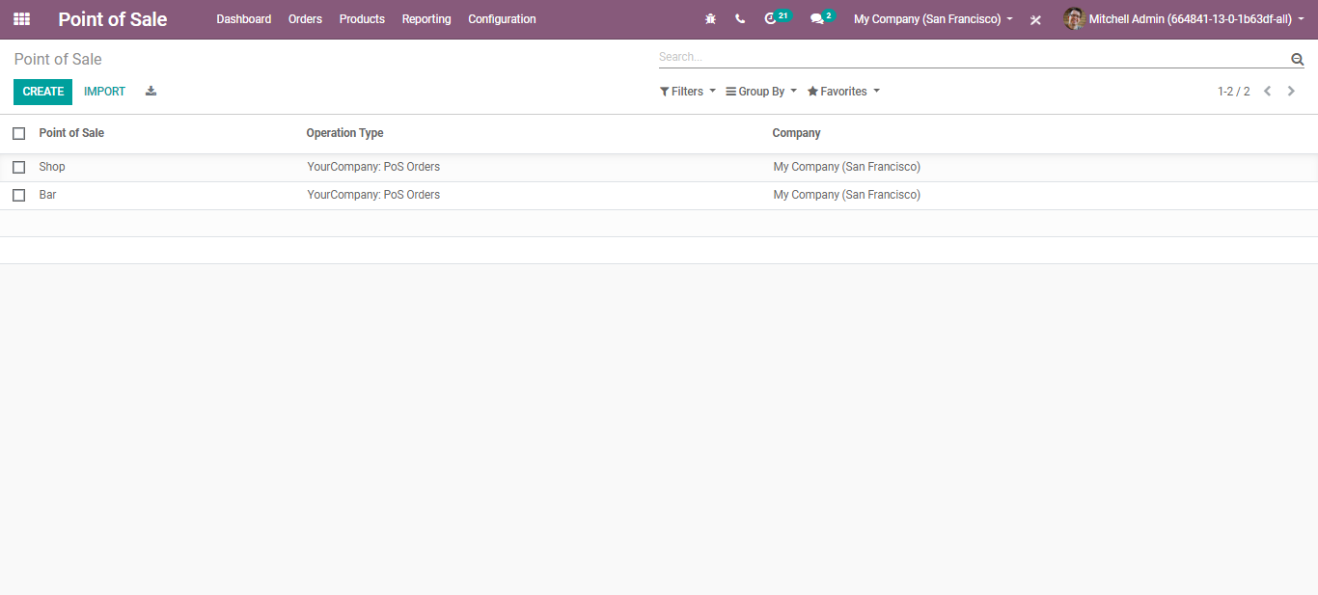
  - Since we are configuring point of sale for retail shops, select SHOP as your choice. And click CREATE button to configure your shop.
  - 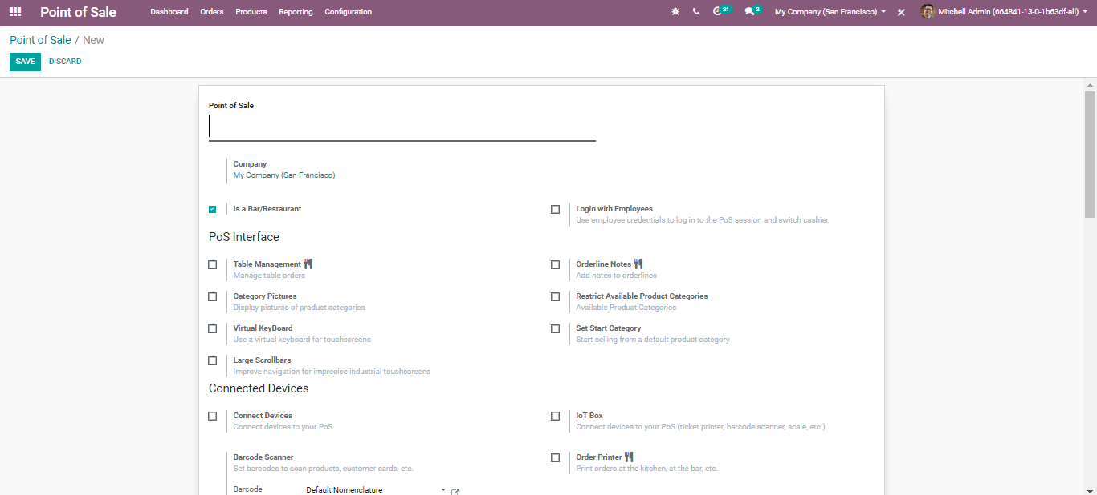
  - From this page, one can define all the settings for the shop. Let us look one by one.
  - Firstly, you can give an internal identification for your point of sale under the field Point of Sale Name.
  - 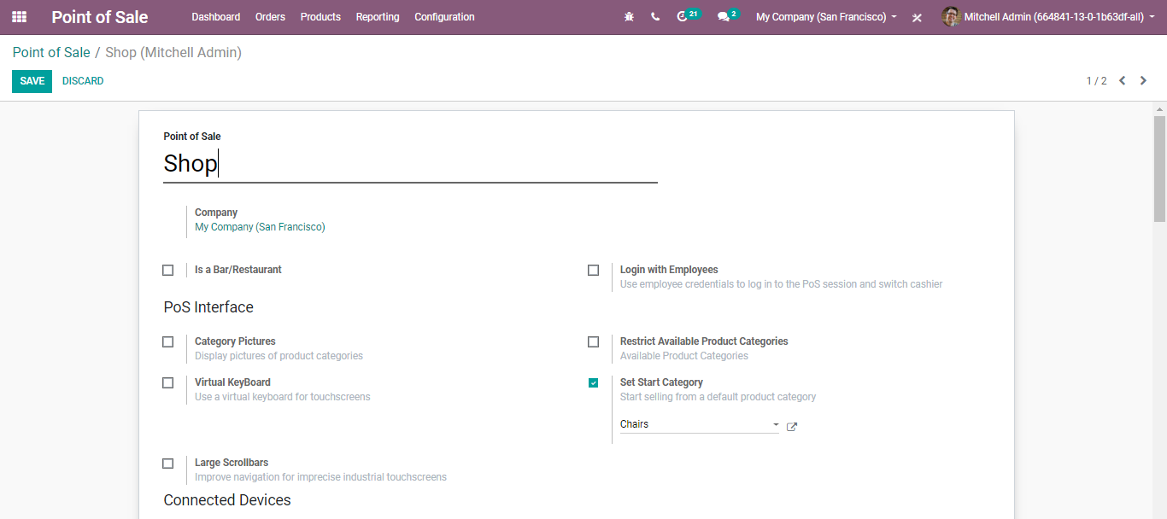
  - Later you can specify if it is a bar or restaurant via ticking the option.
  - 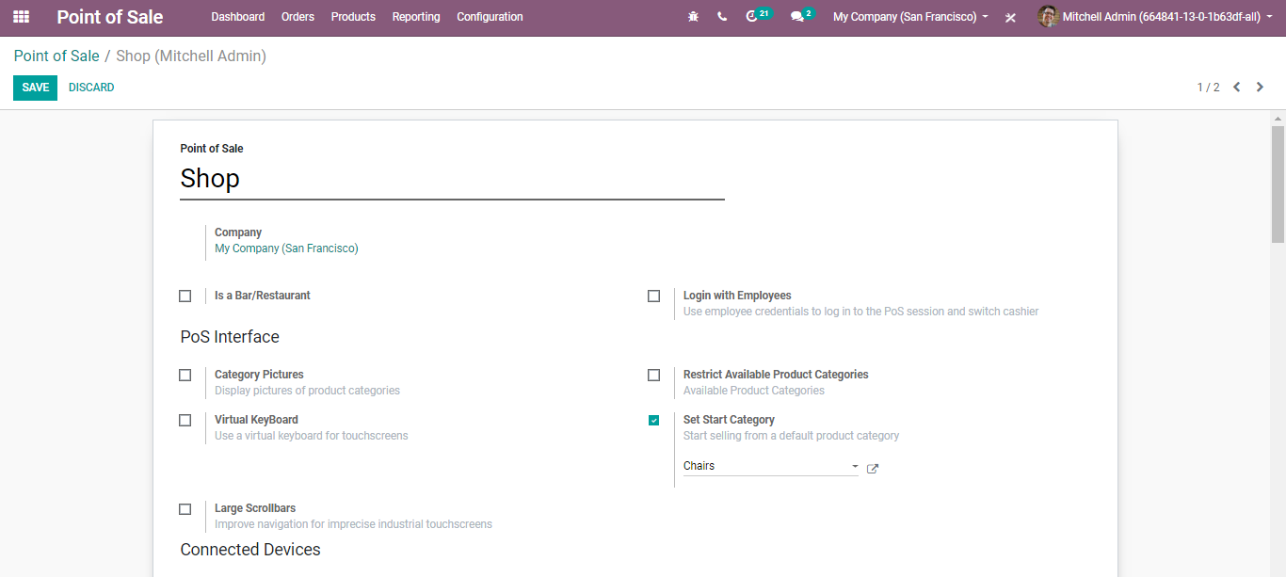
  - Login with Employees
  - 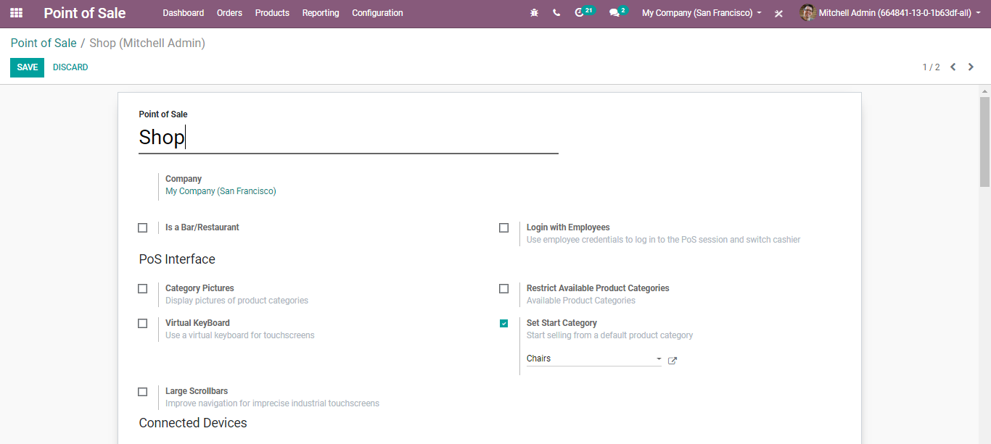
  - Via ticking this, Employees can scan their badge or enter a PIN to log in to a POS Session. These credentials are configurable in the HR setting tab of the employee form.

  - CONFIGURING YOUR ORDER INTERFACE
  - One can configure the POS shop according to their choice.
  - 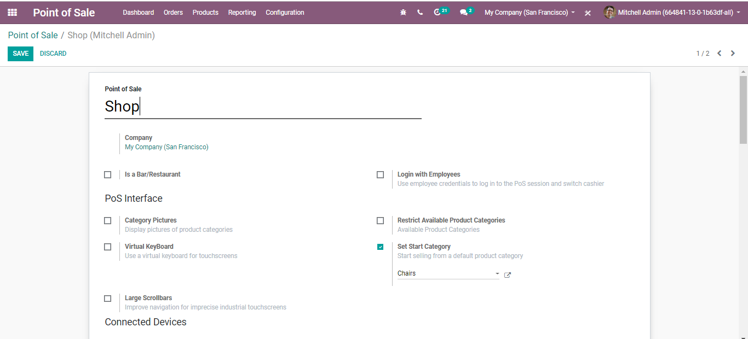
  - Category Pictures: In your shop, there may be a different category of products. To make your POS interface more user-friendly and attractive, you can add category images. Upon ticking the option, the product categories will be displayed with the pictures in POS.
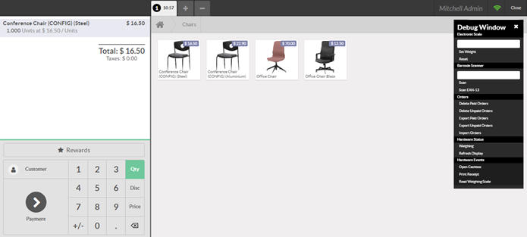

  - Virtual Keyboard: One can use a virtual keyboard for touch screens by enabling this option. Do not enable this option if you take orders on smartphones or tablets. Because the devices are already benefited from a native keyboard.
  - Large Scrollbars: This is used for the imprecise industrial touch screen. This helps in improving the navigation.
  - Restrict Available Product Categories: Upon selecting this option, the point of sale will only display products that are within one of the selected category trees. If no category is specified, all available products will be shown.
  - 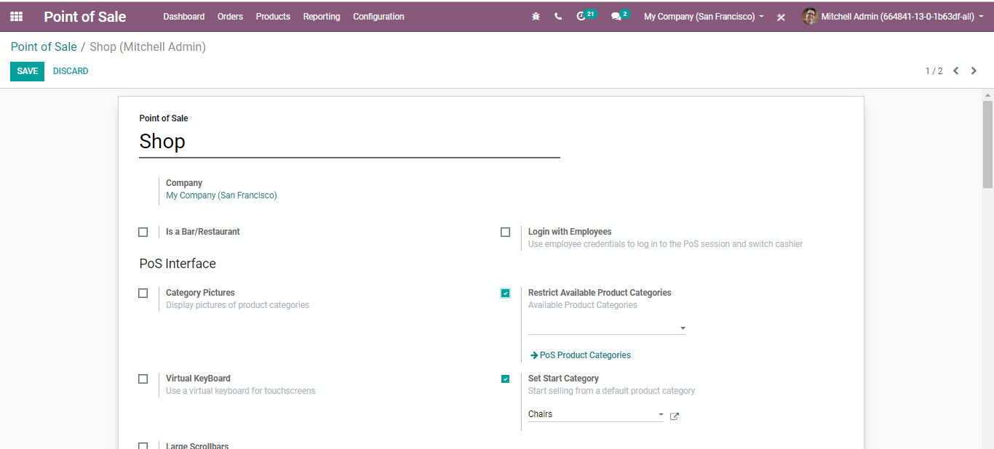
  - Set Start Category: In other words, initial category. The point of sale will display this product category by default. If no category is specified, all available products will be shown.
  - 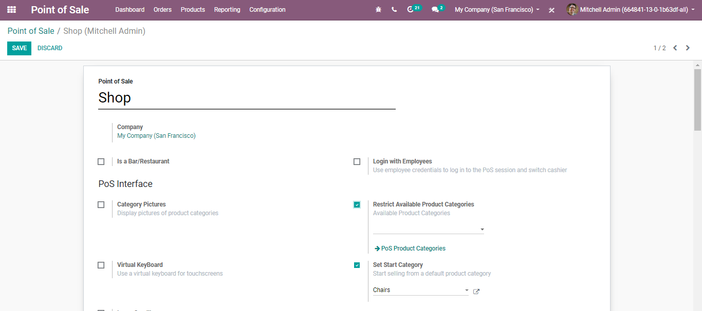
  - As soon as you open the session, you will see the chairs as the first option in the available products list.

  - CONNECTING TO EXTERNAL DEVICES
  - 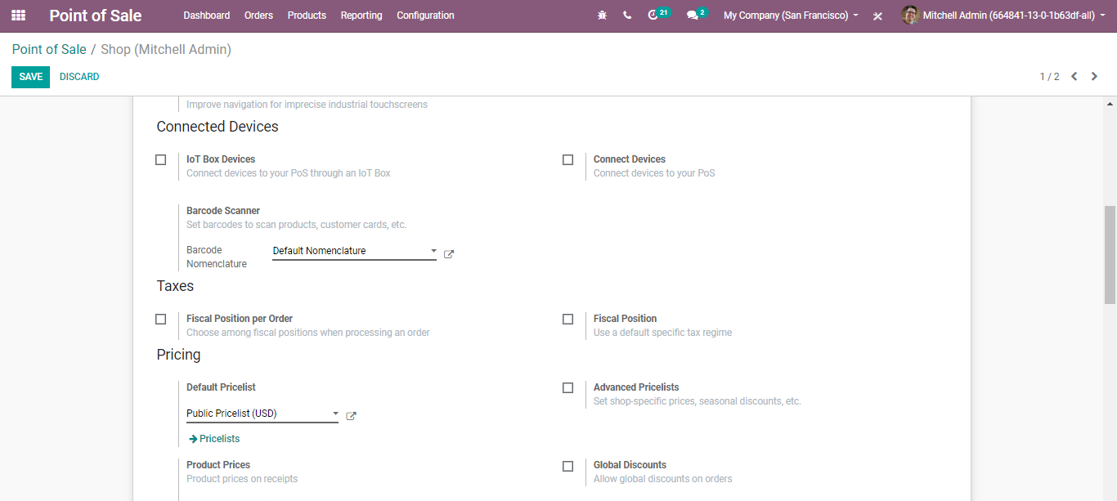
  - Via enabling the options underneath, your database can be connected to use hardware like the barcode scanner and IOT box devices.
  - 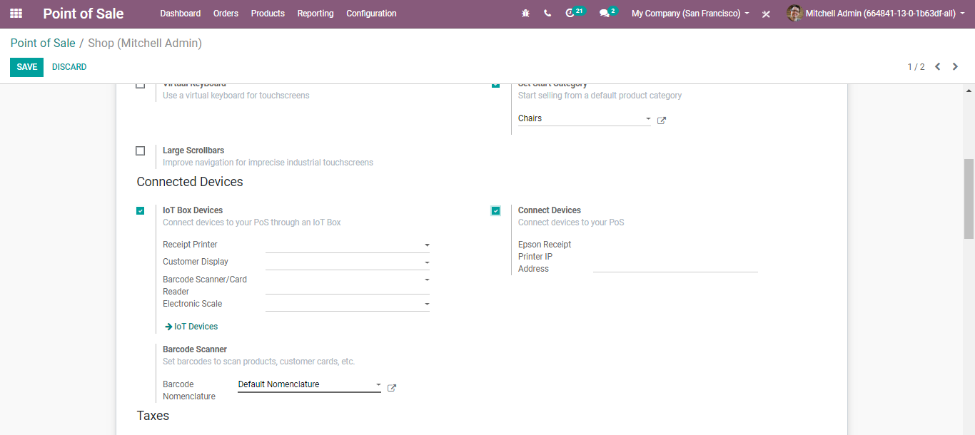
  - Using Barcode in POS
  - Using a barcode scanner to process point of sale orders improves your efficiency and helps you to save time for you and your customers.
  - Configuration
  - To use a barcode scanner, go to Point of Sale ‣ Configuration ‣ Barcode Scanner
  - 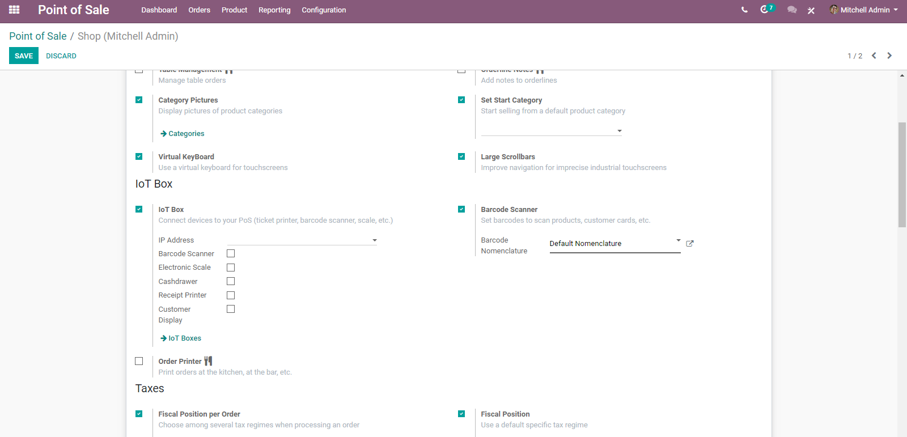

  - Adding barcodes to product
  - Under the general information tab, you can find a barcode field where you can input any barcode.
  - 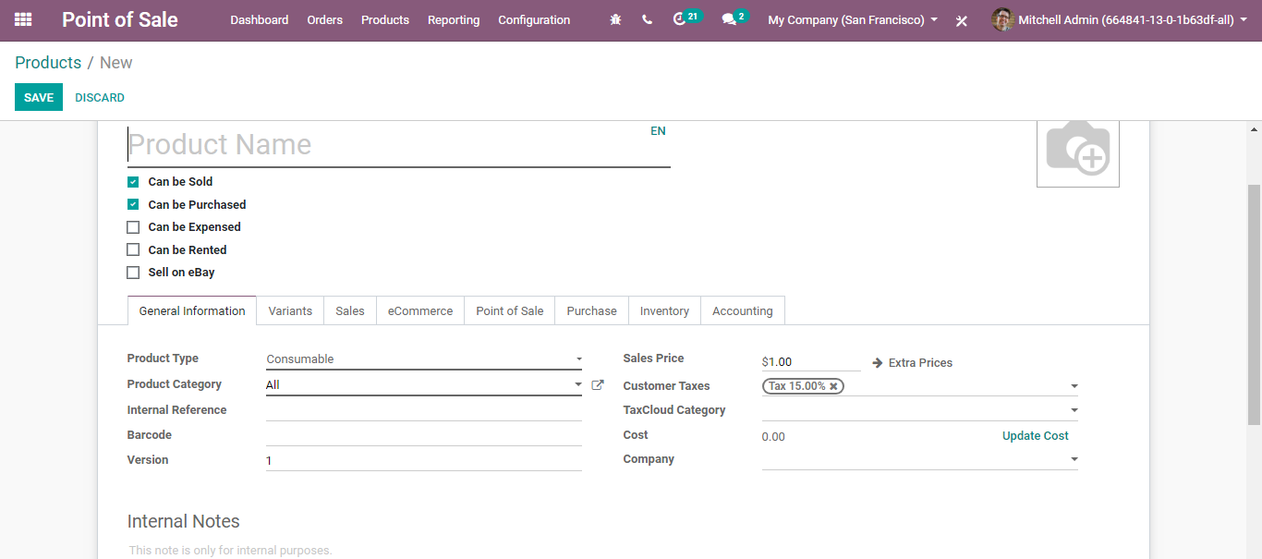
  - Scanning products
  - From your POS interface, scan any barcode with your barcode scanner. The product will be added; you can scan the same product to add it multiple times or change the quantity manually on the screen.
  - CONFIGURING TAXES
  - 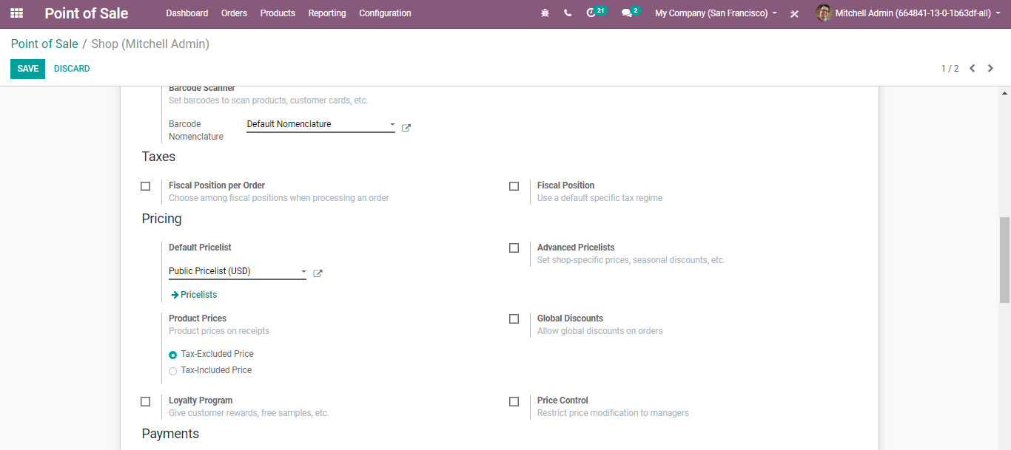
  - CONFIGURING PRODUCT PRICING
  - 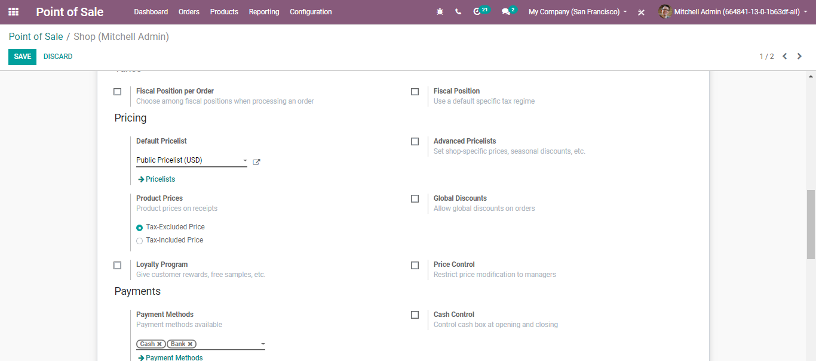
  - Default Pricelist: The price list is used if no customer is selected or if the customer has no sales pricelist configured.
  - Advanced Pricelist: If selected, one can set shop-specific prices, seasonal discounts, etc.
  - Product Prices: Here you can specify the product price on receipt should either be the tax-excluded price or tax-included price.
  - Global Discounts: If ticked the option, one can allow global discounts on orders.
  - 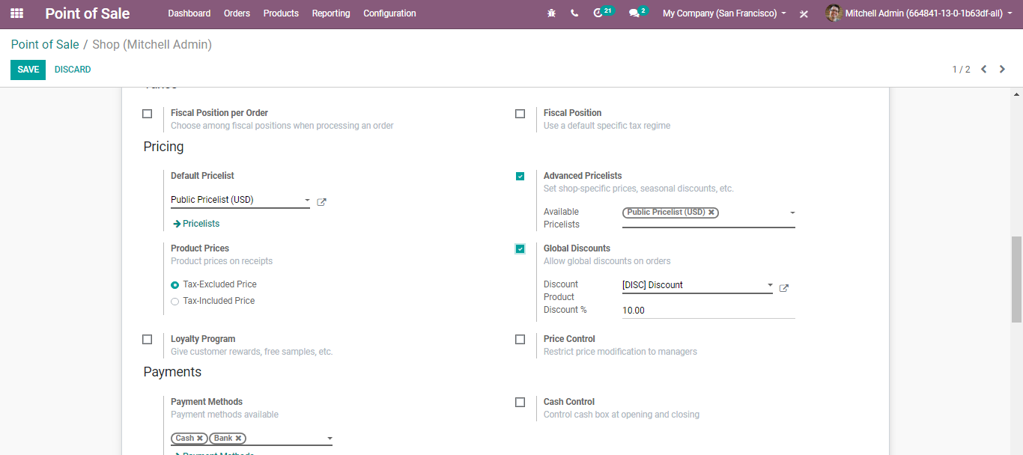

  - CONFIGURING LOYALTY PROGRAM
  - Loyalty Programs: Loyalty programs such as customer rewards, free samples to use for this point of sale.
  - Configuration
  - To activate the Loyalty Program feature, go to Point of Sale-> Configuration -> Pricing -> and loyalty program. Under the Pricing features, select Loyalty Program
  - 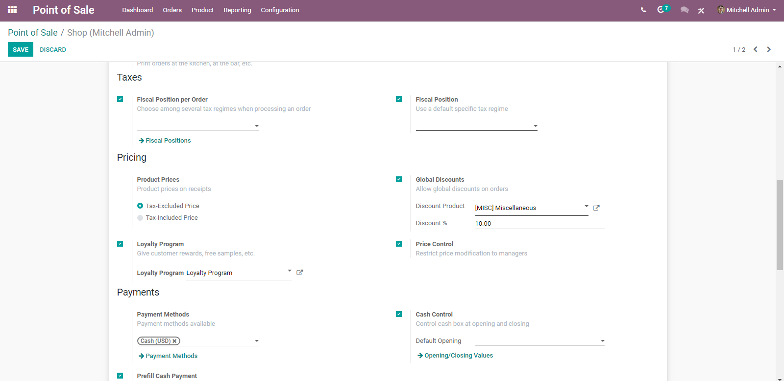
  - From there you can create and edit your loyalty programs via clicking the Loyalty Program.
  - A creation form will appear like below:
  - 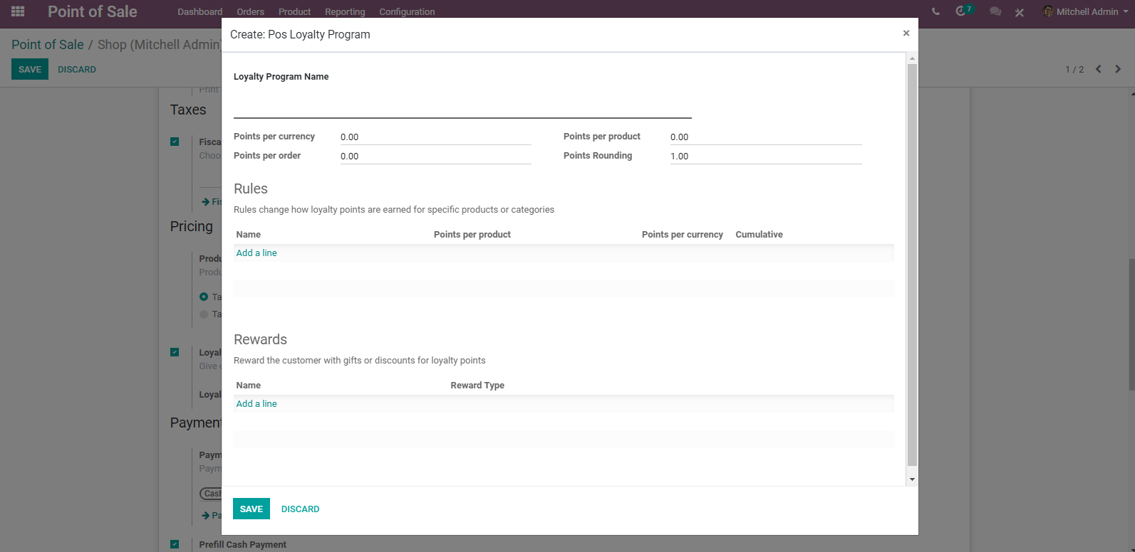
  - You can decide what type of program you wish to use, if the reward is a discount or a gift, make it specific to some products or cover your entire range. Apply rules so that it is only valid in a specific situation and everything in between.
  - The field includes:
  - Loyalty Program Name: An internal identification for the loyalty program configuration.
  - Points per currency: How many loyalty points are given to the customer by sold currency?
  - Points per order: How many loyalty points are earned for specific products/categories?
  - Points per product: How many loyalty points are given to the customer by-products sold?
  - Points rounding: The loyalty point amounts are rounded to multiples of this.
  - Rules: Rules change how loyalty points are earned for specific products or categories.
  - 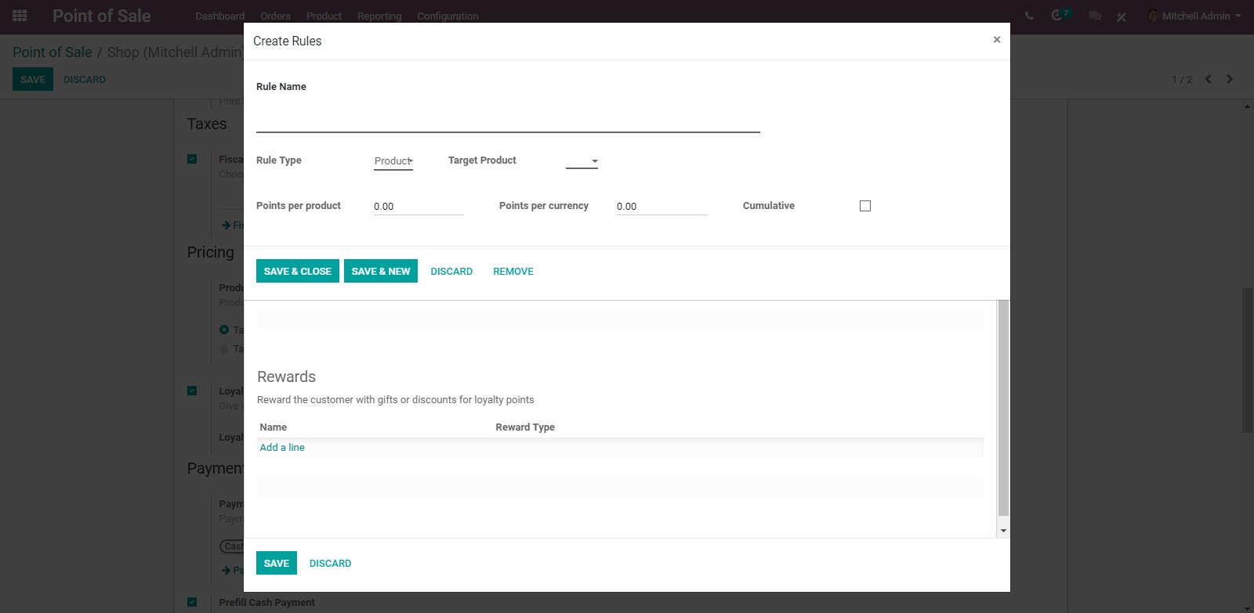
  - Rule Name: An internal identification for this loyalty program rule.
  - Rule Type: Does this rule affect products or a category of products.
  - Target Product: The product affected by the rule.
  - Points per Product: How many points the product will earn per product ordered.
  - Points per currency: How many points the product will earn per value sold.
  - Cumulative: The points won from this rule will be won in addition to other rules.
Rewards: Reward the customer with gifts or discounts for loyalty points.
  - 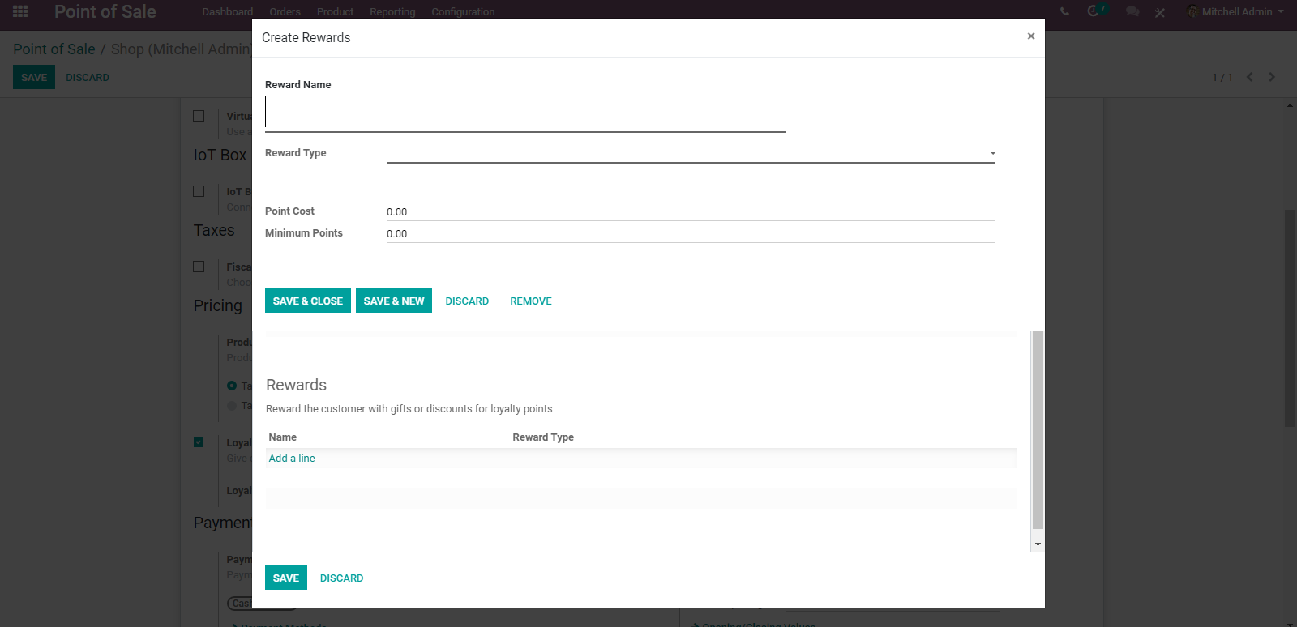
  - Reward Name: An internal identification for the loyalty reward.
  - Reward Type: The type of reward.
  - Point Cost: The cost of the reward.
  - Minimum Points: The minimum point of reward the customer must have for qualifying this reward.
  - When a customer is set, you will now see the points they will get for the transaction, and they will accumulate until they are spent. They are spent using the button Rewards when they have enough points according to the rules defined in the loyalty program.
  - 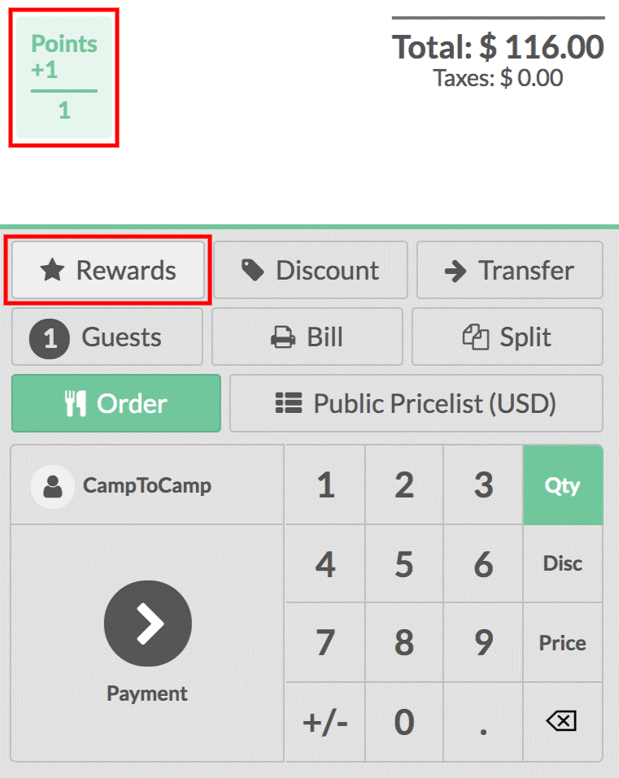
  - You can see the price is instantly updated to reflect the pricelist. You can finalize the order in your usual way.
  - Price Control: If selected, only users with manager access rights for the POS app can modify the product prices on orders.
  - CONFIGURING YOUR PAYMENT METHODS
  - To add a new payment method for a Point of Sale, go to Point of Sale ‣ Configuration ‣ Go to the Payments section and click on the link "Payment Methods".
  - 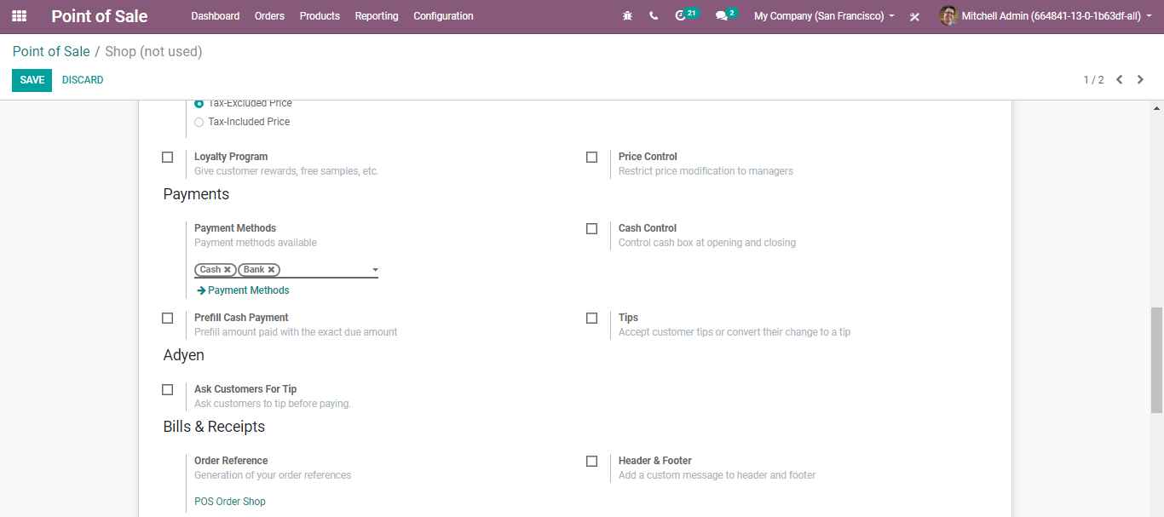
  - Upon clicking the payment method link, you will be directed to a new window like below:
  - 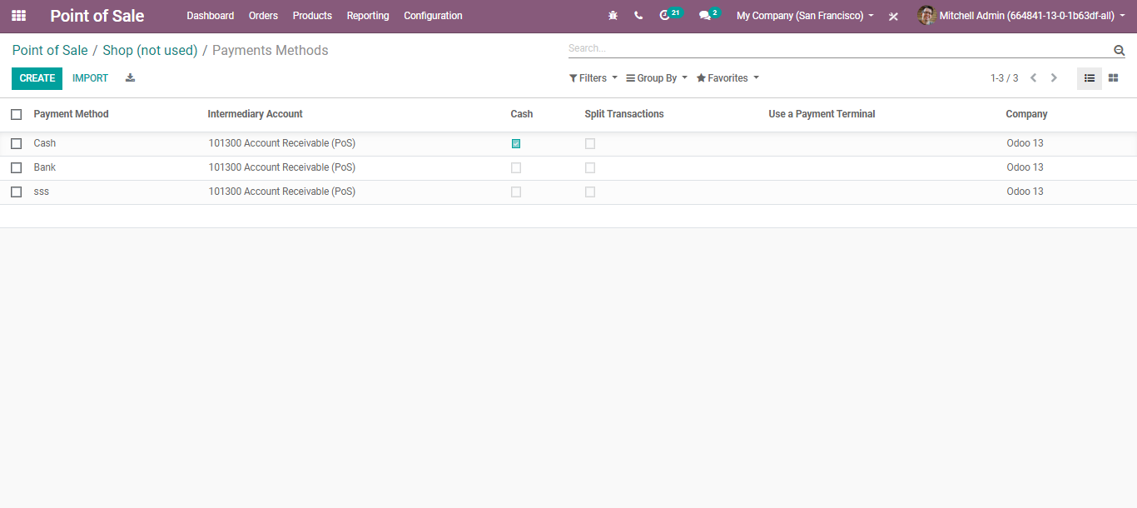
  - One can create a new payment method via clicking the CREATE BUTTON on top.
  - 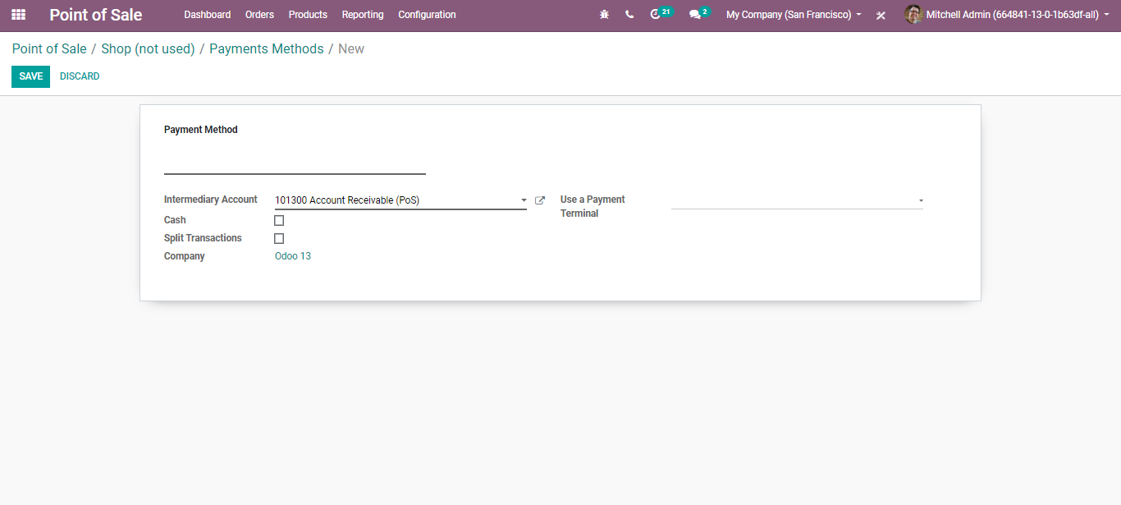
  - Intermediary Account: Account used as counterpart of the income account in the accounting entry representing the POS sales.
  - Split Transactions: If ticked, each payment will generate a separate journal item. Ticking that option will allow the closing of the POS.
  - Payment Terminals: Record payments with a terminal on this journal.
  - Cash Control
  - Cash control is a built-in option in BUSINESSBOXERP POS, which allows the user to check the amount in the cash box at the beginning and end of each session. As it is a default feature, there is no need for extra apps or plugins to install.
  - Configuration
  - Go to Point of Sale -> Configuration-> Payments section and click on the link "Cash Control".
  - 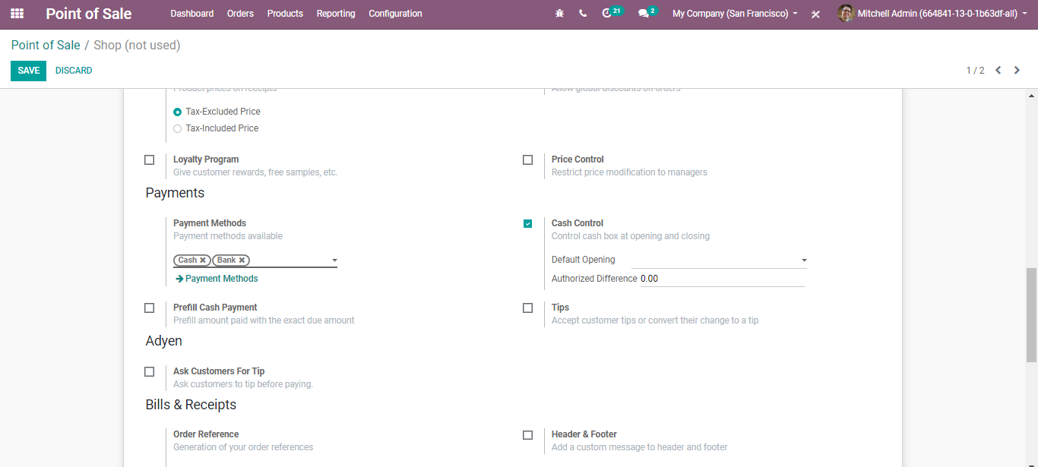
  - CREATE: DEFAULT BALANCE
  - Once you have enabled the ‘Cash Control’ option, a new section will appear under that option where you can provide the coins or bills in the cashbox. Click on CREATE to add a bill or coin. You need to provide the coin/bill value and the number of coins/bills. The subtotal will be automatically updated.
  - 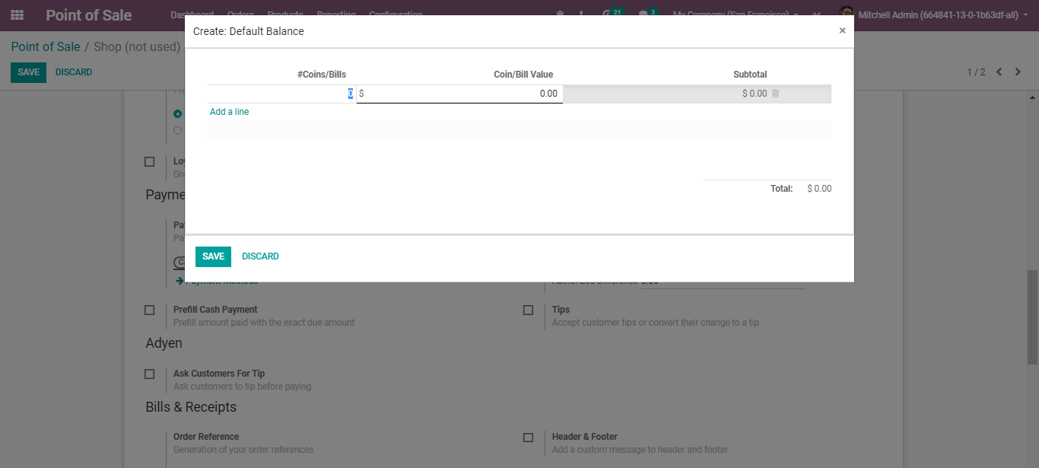
  - Based on the coins or bills we add; the opening balance will be updated automatically.
  - BILLS AND RECEIPTS
  - Use the Bill Printing feature to print the bill before the payment.
  - 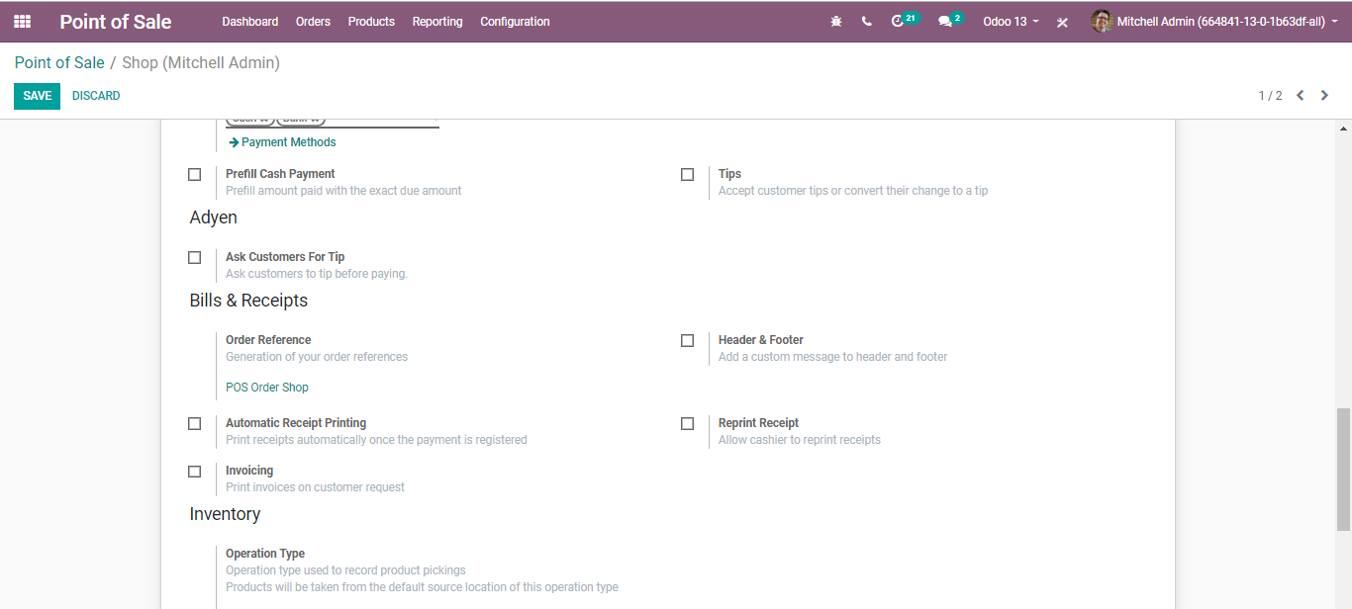
  - Order Reference: Order sequences are automatically created by BUSINESSBOXERP. However, using this feature one can customize the reference numbers of the orders.
  - 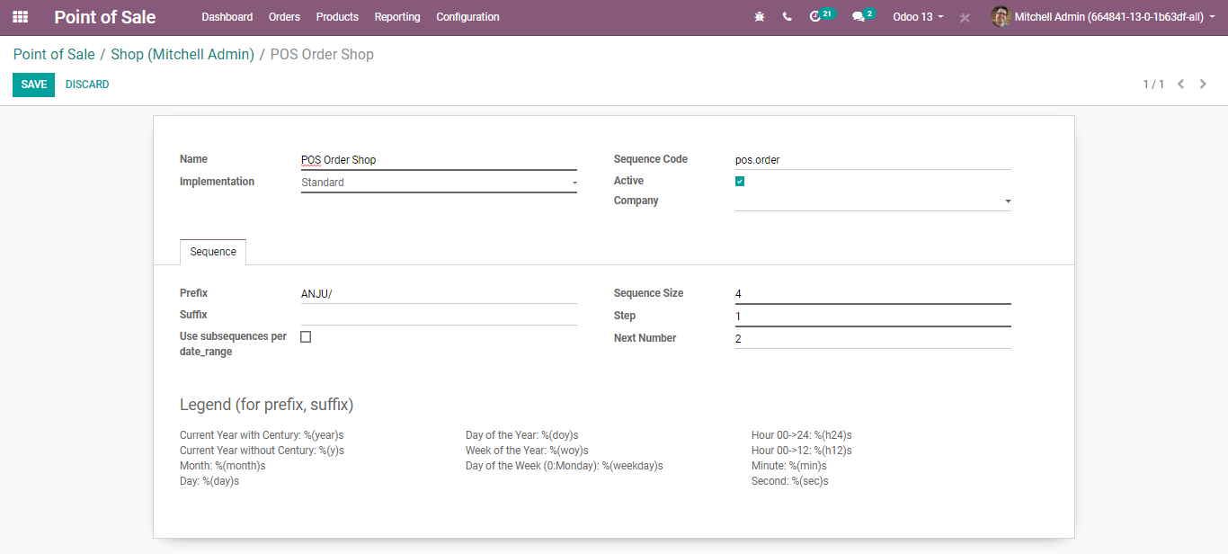
  - 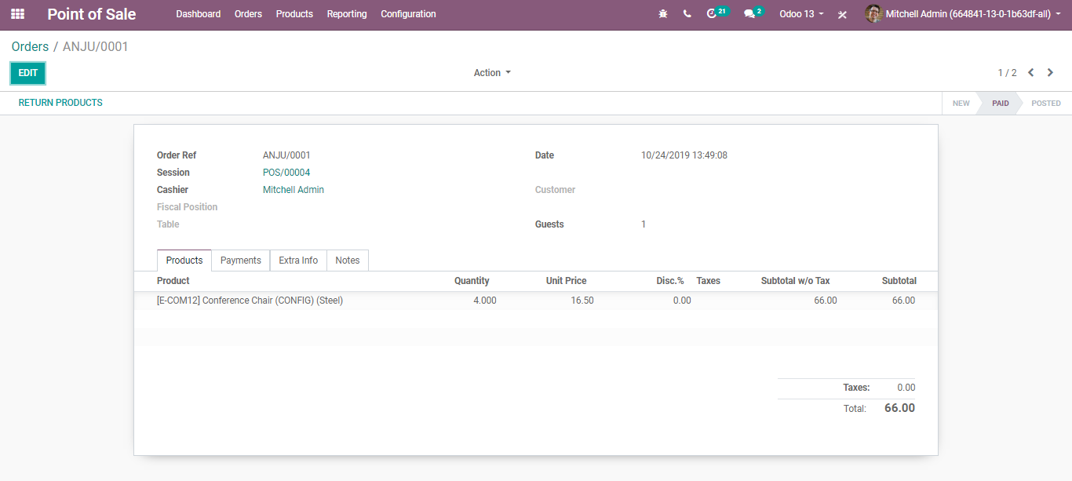
  - Header & Footer: Via clicking this option, one can add a custom message in the header and footer of the bills/receipts.
  - 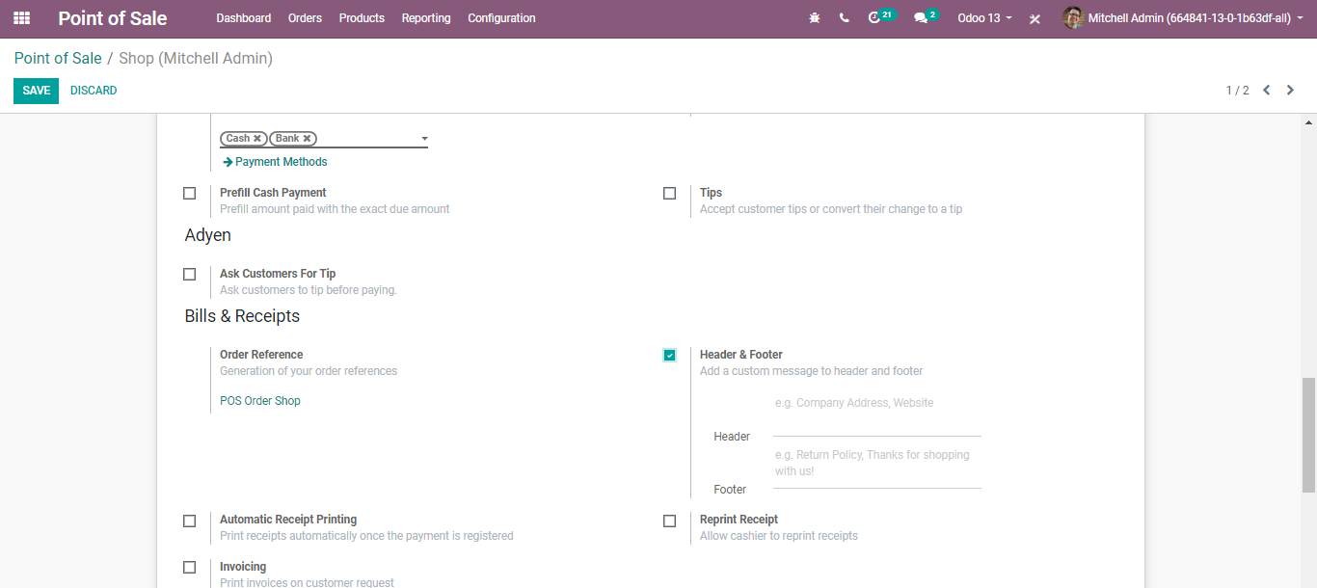
  - Automatic Receipt Printing: If an enabled option, the receipt will automatically get printed at the end of each order.
  - Reprint Receipt: If the option is enabled in the settings, it will allow cashiers to reprint the receipts.
  - Invoicing: If it is ticked, enables the invoice generation from the POS itself.
  - 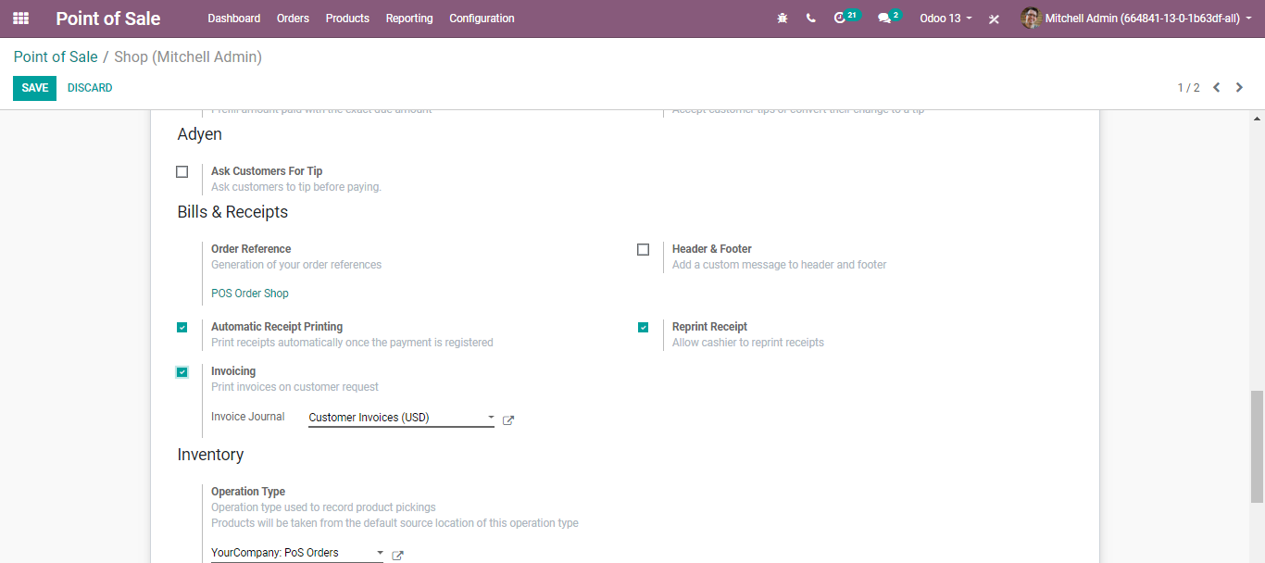

  - Invoice from POS interface
  - Firstly, select a customer. Then go to the session interface and use the customer button.
  - 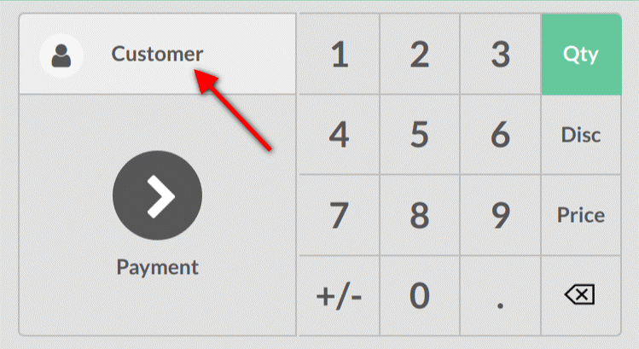
  - One can either select an existing customer or create a new one.
  - 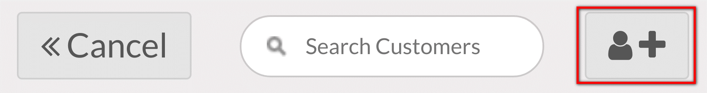
  - Upon selecting the customer, you will be provisioned to fill in the customer form.
  - Invoice your customer
  - From the payment screen, use the invoice button and validate it.
  - CREATE YOUR FIRST POS SESSION
  - YOUR FIRST ORDER
  - Once you are done with configurations, now you are ready to make your first sales through the POS. From the POS dashboard, you see all your points of sale and you can start a new session.
  - 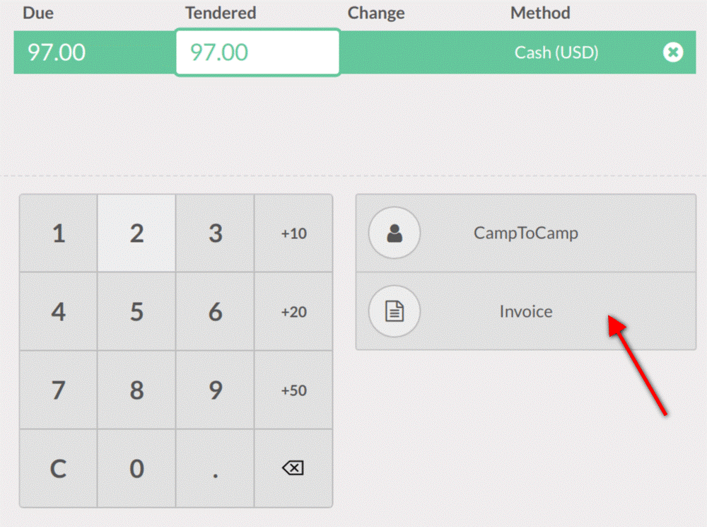
  - To start with, either you can click NEW SESSION OR RESUME.
  - This is your POS interface.
  - 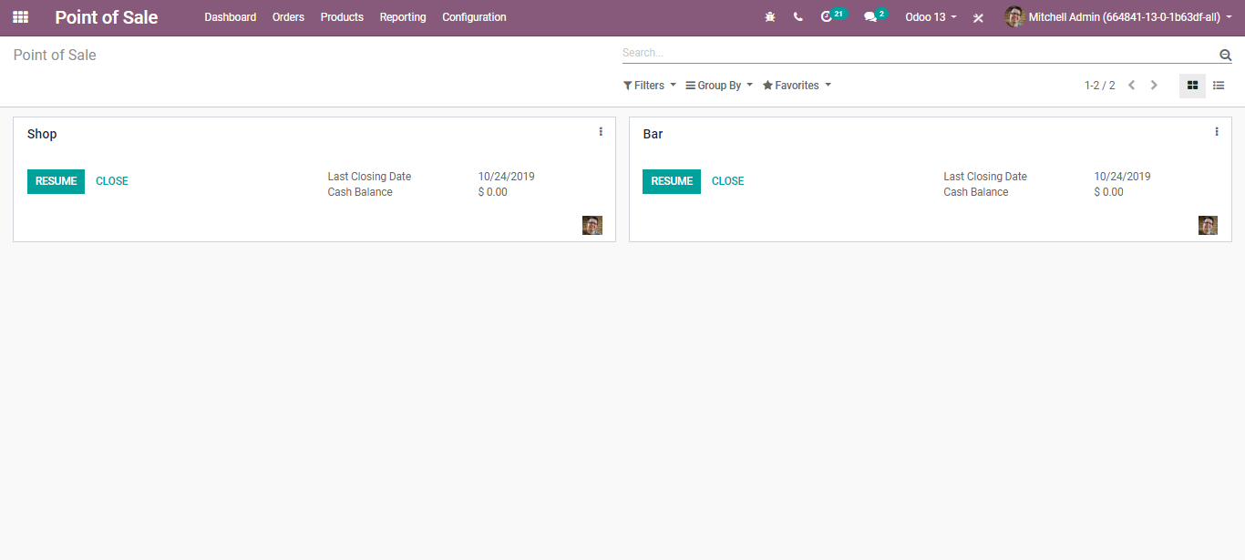
  - Via clicking the desired products, you can add them to your cart.
  - 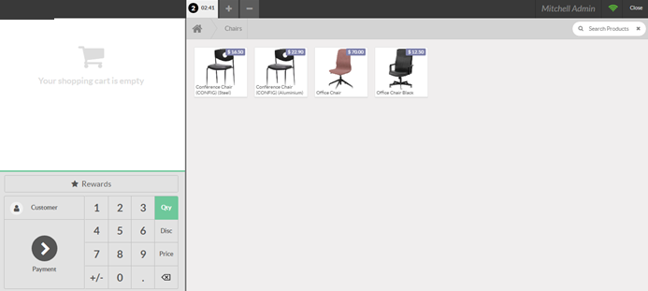
  - If the customer does not need a particular product he ordered, the seller can delete the order via clicking the backspace button.
  - Click the PAYMENT for paying the order.
  - 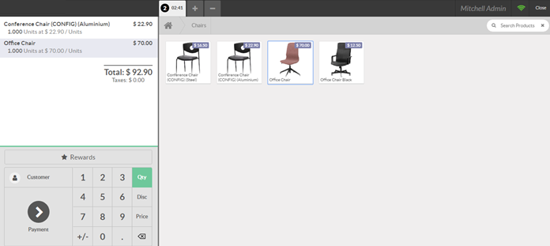

  - Adding customer name
  - Upon clicking the customer button, you add the regular customer’s name from the database list.
  - 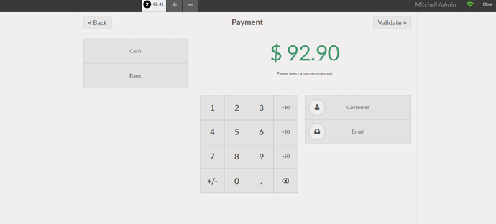
  - Via clicking the edit button, you can add a new customer name.
  - 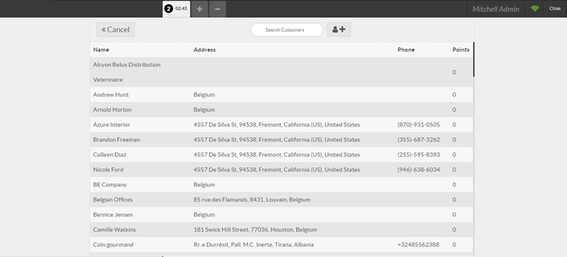
  - You can fill out the customer form with relevant information.
  - 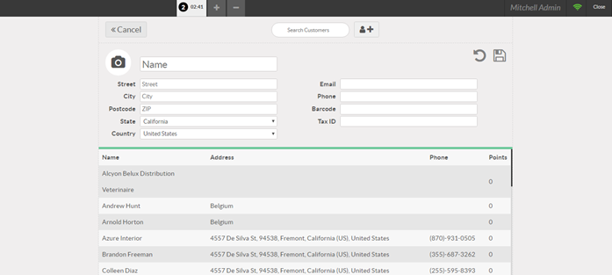
  - Click the SAVE button to mark changes.
  - Once you are done with your order, you can proceed to pay. The payment methods will appear on the left of the screen. Select the payment method, also enter the received amount.
  - 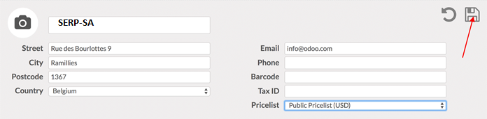
  - Validate the payment.
  - 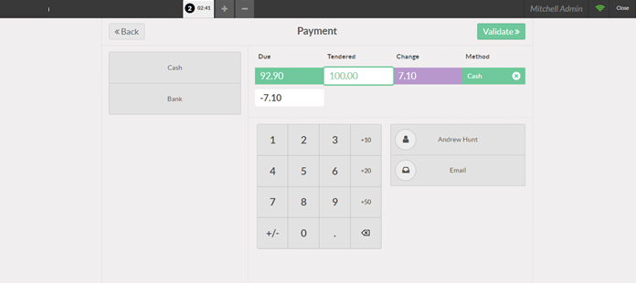
  - You get the receipt without any moments delay.
  - Now you can register the next order.
  - CLOSE THE POS SESSION
  - At the end of the day, you will close your POS session. For this, click on the CLOSE button that appears on the top right corner and CONFIRM.
  - 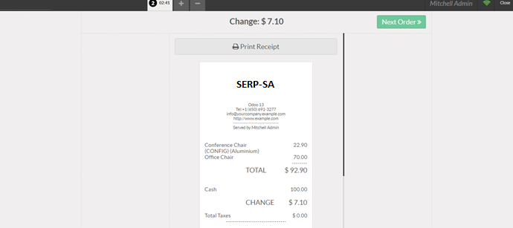
  - You can now close the session from the dashboard.
  - 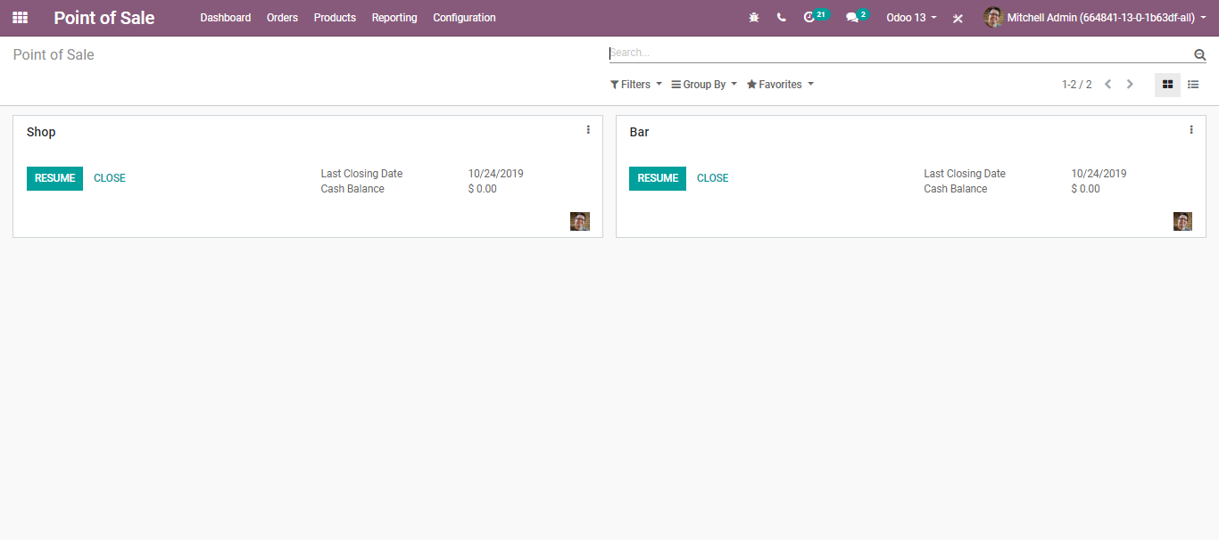
  - Now if you click on close, you can see the summary of all transactions per payment method.
  - If everything is right, you can validate the POS session. Also, Post the closing entries.

  - 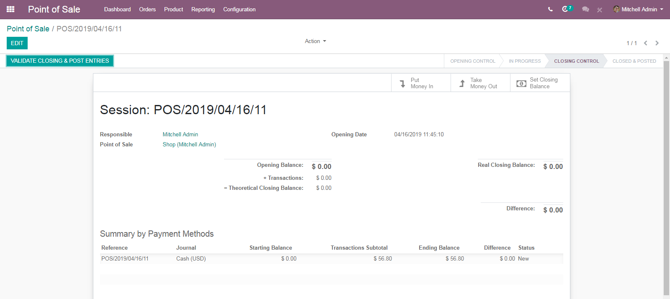
  - Via clicking the VALIDATE CLOSING & POST ENTRIES BUTTON, you get your session CLOSED AND POSTED.
  - 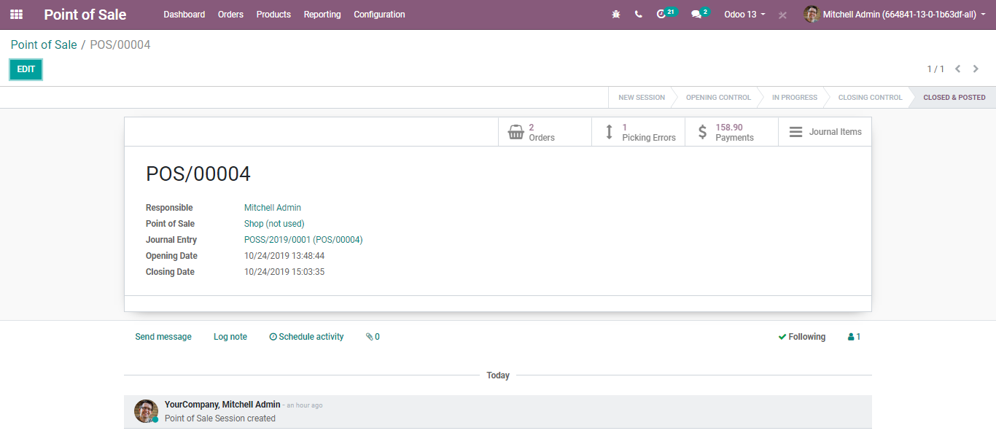
  - 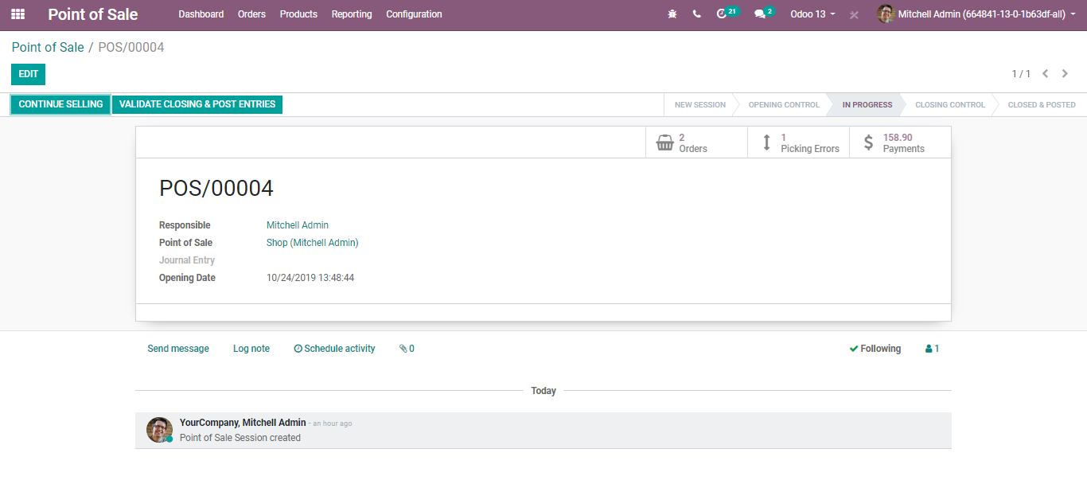
  - PRODUCT RETURNS AND REFUNDS
  - From the POS interface, select the product that needs to be returned. Now use the +/- button.
  - Enter the quantity to be returned. In case there is a return of multiple products, you need to repeat the process.
  - 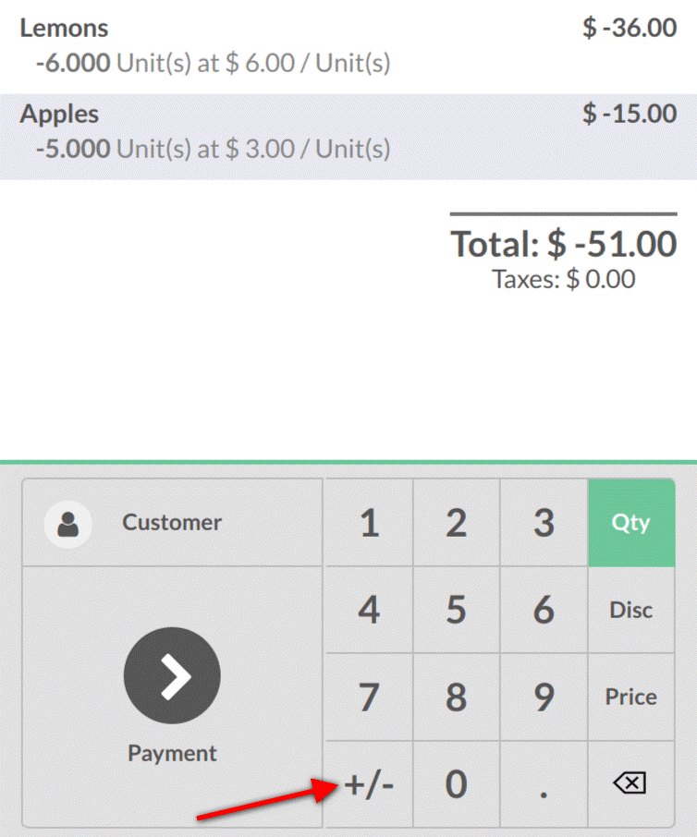
  - You can view the total is in negative. To refund, process the payment.
  - 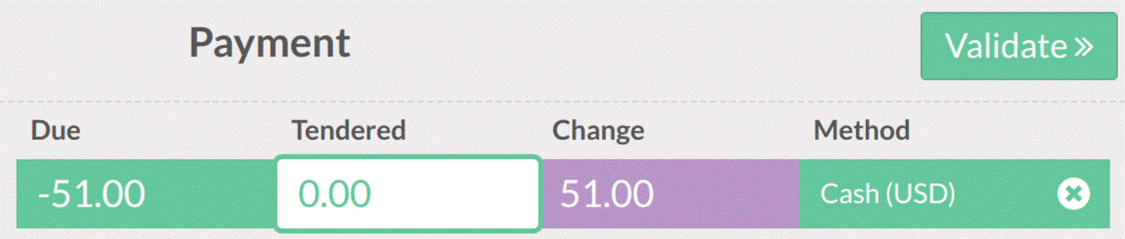
  - Returning from backend
  - For that go to POS>Orders>Orders
  - Select the order from which you want to return the products.
  - 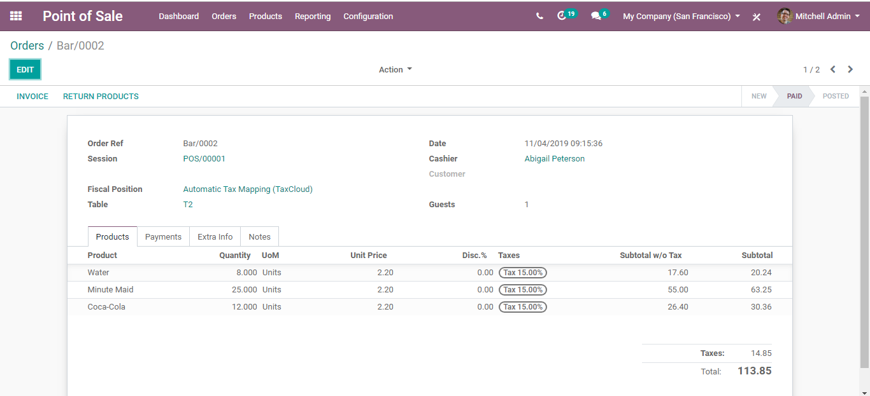
  - Upon clicking the RETURN PRODUCTS option,
  - 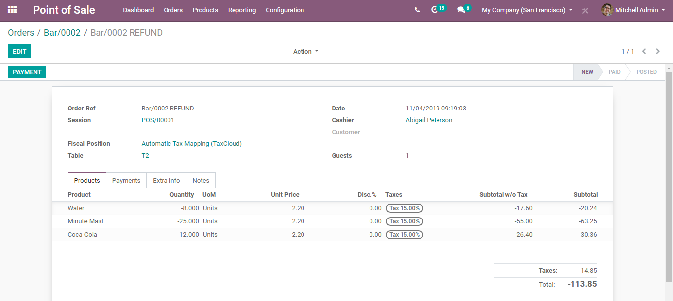
  - You can see the product quantity in - sign.
  - Now click the PAYMENT button,
  - 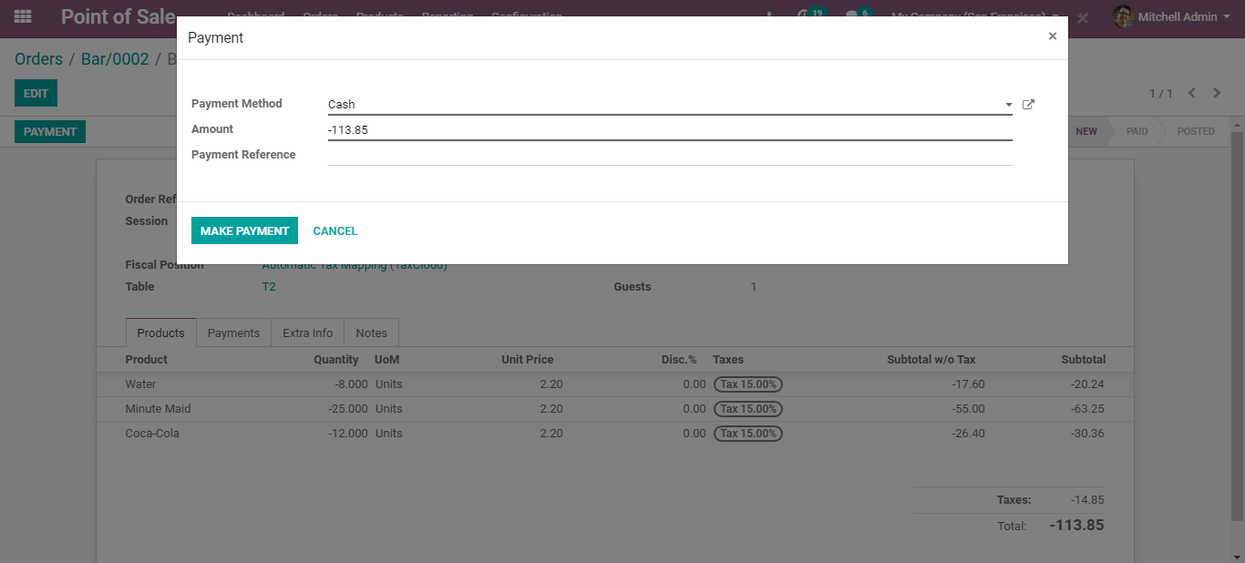

  - Your return will be initiated.
  - 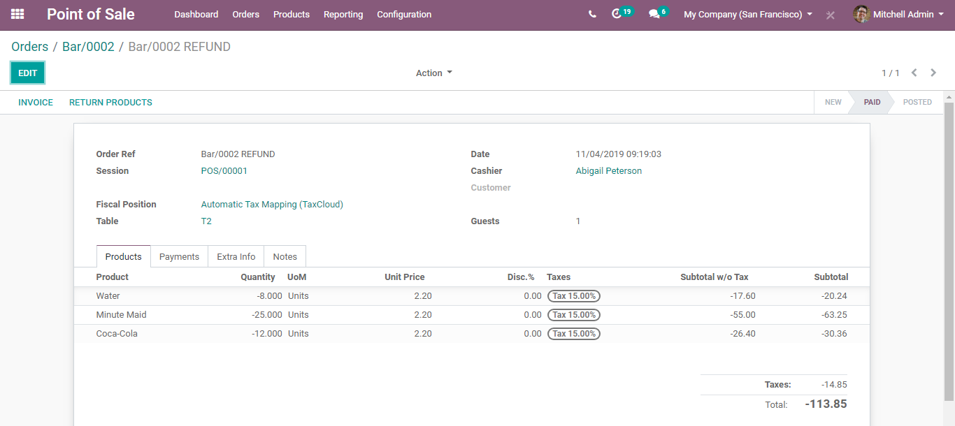
  - CREATE YOUR FIRST POS SESSION
  - BUSINESSBOXERP Restaurant lets you quickly overview your restaurant and jump from floor to floor to your table's orders. The floor plan will tell you exactly where your customers are, where are the free tables, who is still waiting for food, how much room do you have left and many more.
- Fully customizable floor plan
- Supports multiple POS
- Floor plan entirely optional
- Can be configured on a POS basis
- General Configurations
  - Go to configuration->Point of Sale->Bar
  - 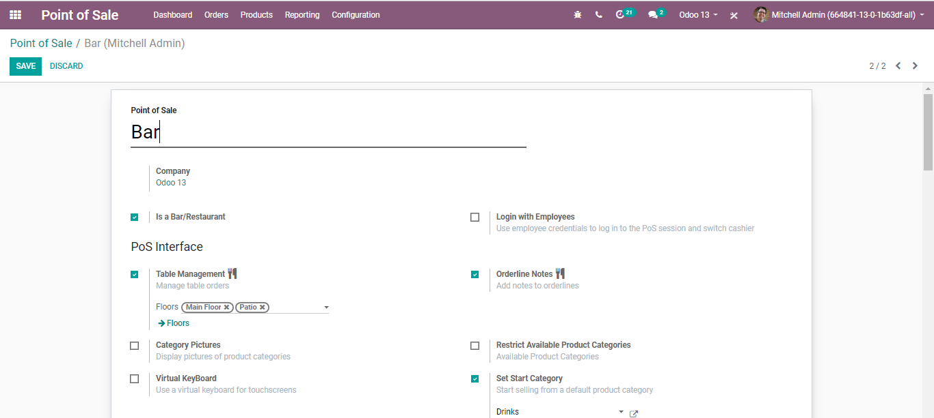
  - Point of Sale Name: An internal identification of your point of sale. You can name your restaurant under this field.
  - Enable the option Is a Bar/Restaurant for configuring your POS.
  - 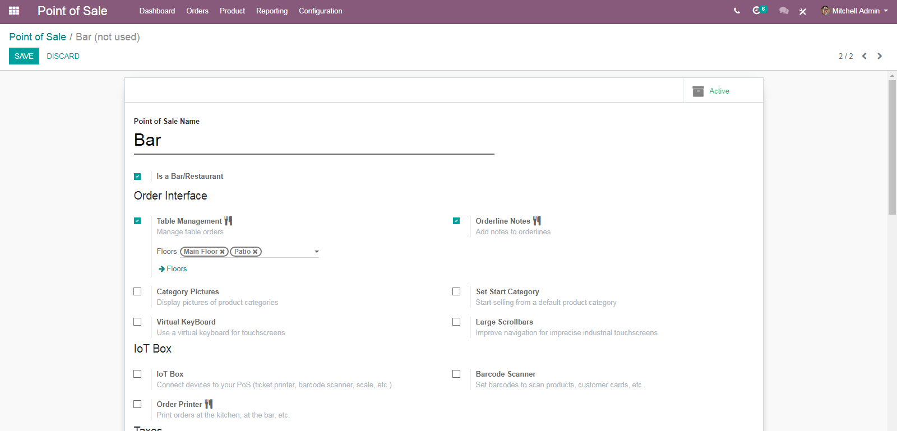
  - Login with Employees
  - 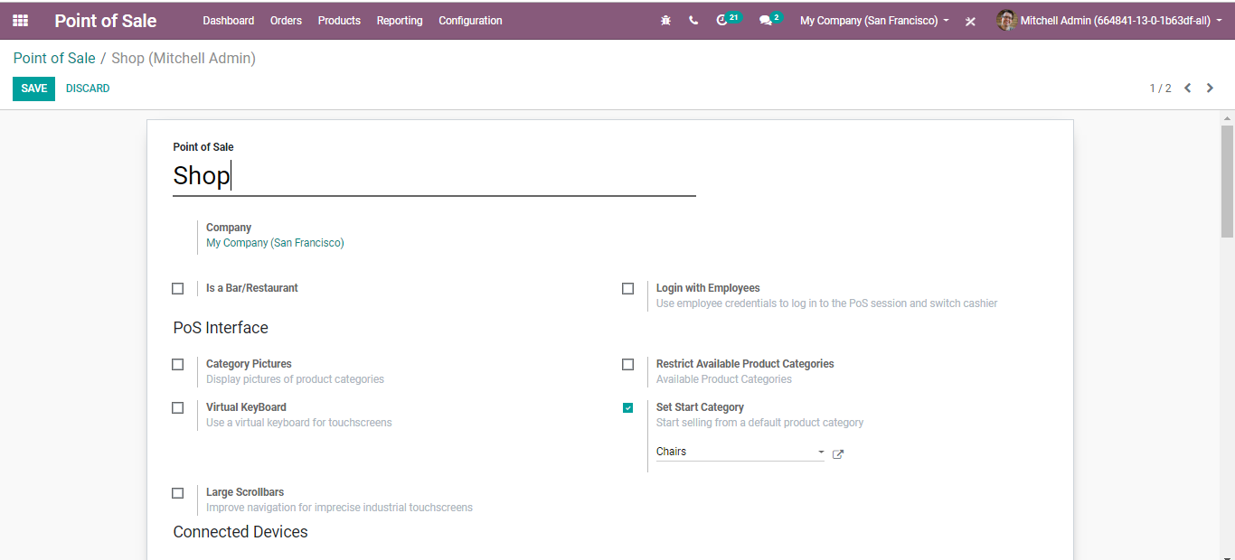
  - Via ticking this, Employees can scan their badge or enter a PIN to log in to a POS Session. These credentials are configurable in the HR setting tab of the employee form.
  - CONFIGURING YOUR ORDER INTERFACE
  - One can configure the POS bar according to their choice.
  - 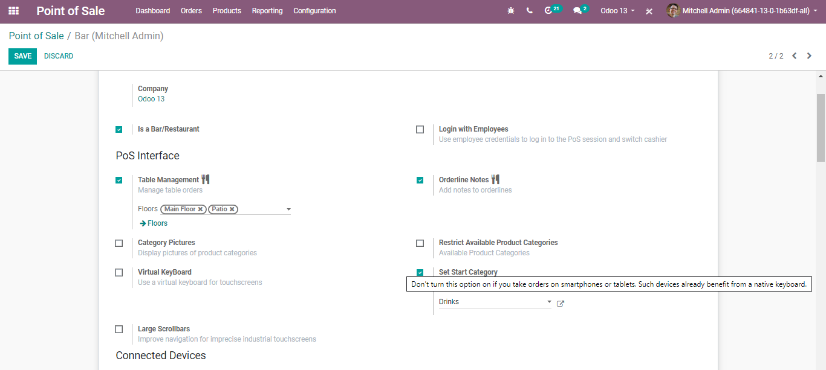
  - Table management: If your Shop is a bar/ restaurant you can activate this option to easily manage your shop floor and tables. Once you enable the option, the POS interface will look like the below image.
  - 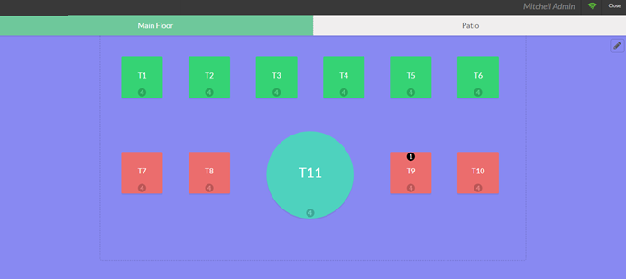
  - 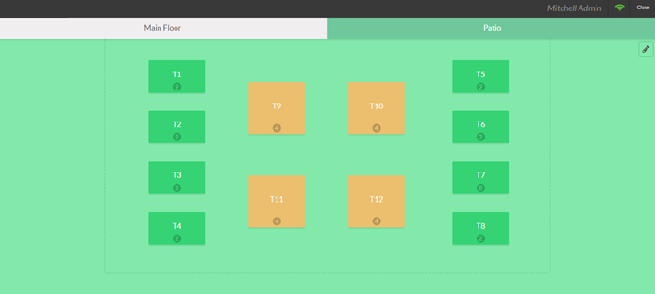
  - You can manage different floors and tables, seamlessly order them.
  - Order Line Notes: Order Line Notes is a unique feature in BUSINESSBOXERP POS that enables the end-user to give specifications to his orders. For example, if an end-user gives an order and wants some further additional or extra ingredient, he can use his functionality in BUSINESSBOXERP POS. By enabling this option, you can easily manage the order taking. Now we can see a new button in POS named Note.

  - If one has taken an order and the customer needs some more ingredients, he/she can make use of the Note button for this purpose.
  - 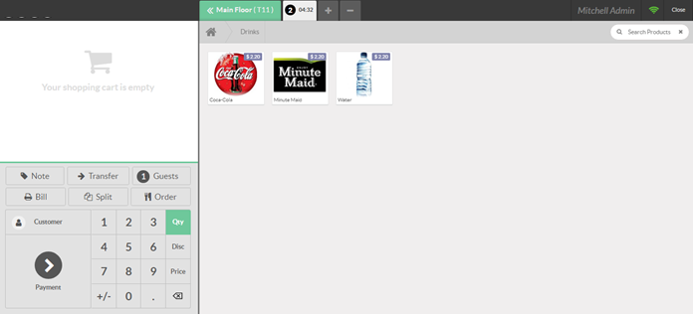
  - You can add a note for each order line. After the addition of notes, the order will look like
  - 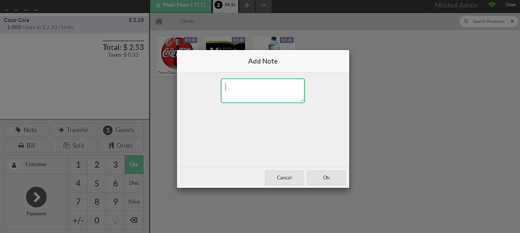
  - Category Pictures: In your shop, there may be a different category of products. To make your POS interface more user-friendly and attractive, you can add category images. For that enable the option Category pictures, this will display pictures of product categories in POS.
  - 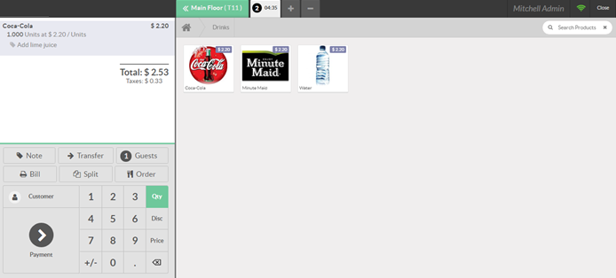
  - Restrict Available Product Categories: Upon selecting this option, the point of sale will only display products that are within one of the selected category trees. If no category is specified, all available products will be shown.
  - 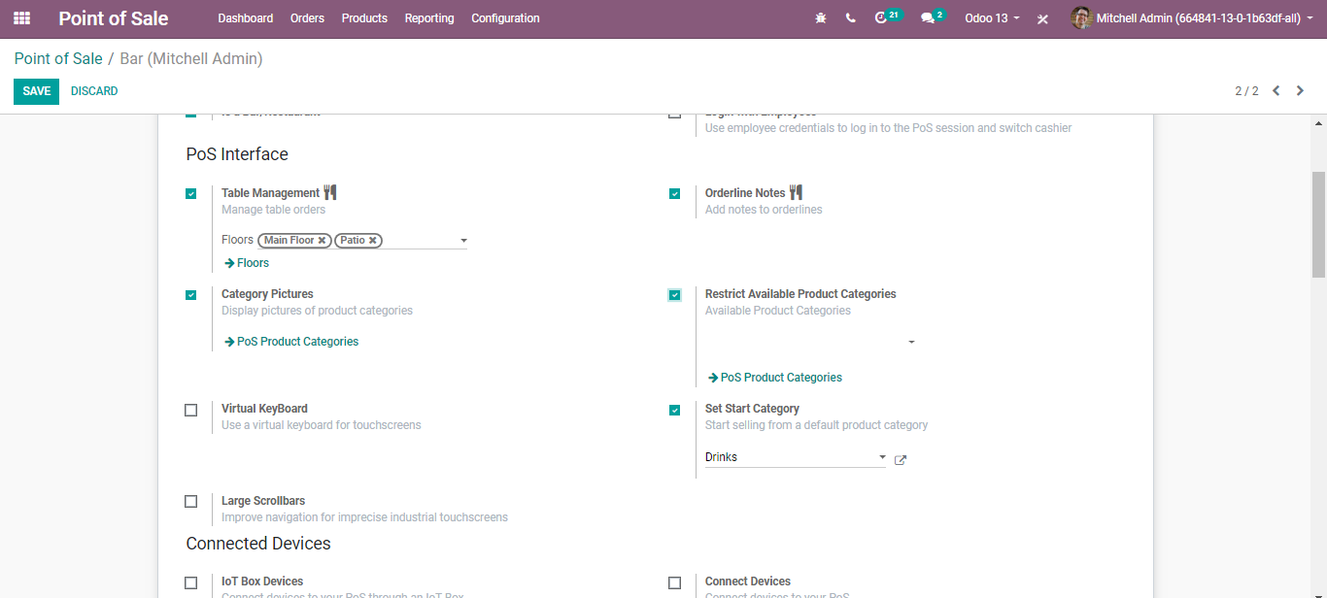
  - Virtual Keyboard: One can use a virtual keyboard for touch screens by enabling this option. Do not enable this option if you take orders on smartphones or tablets. Because the devices are already benefited from a native keyboard.
  - Large Scroll Bars: This is used for the imprecise industrial touch screen. This helps in improving the navigation.
  - Set Start Category: In other words, initial category. The point of sale will display this product category by default. If no category is specified, all available products will be shown.
  - 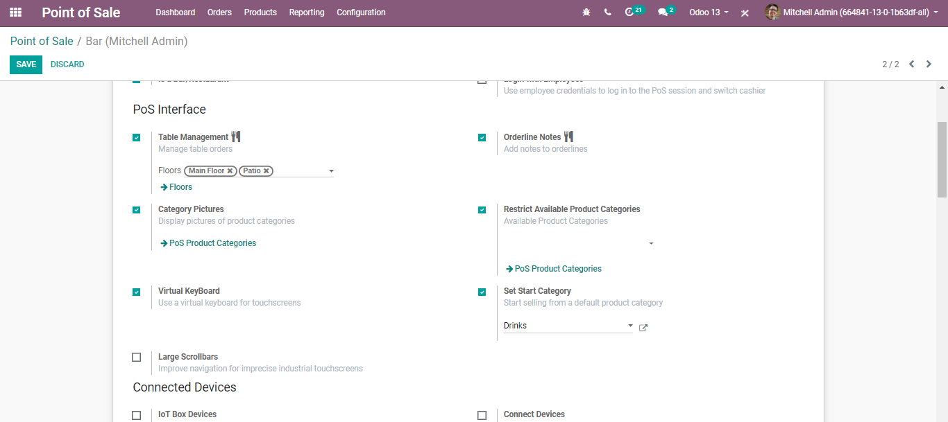
  - Since we have set chairs as our initial/start category, as soon as you open the session, you will see the chairs as the first option in the available products list.
  - 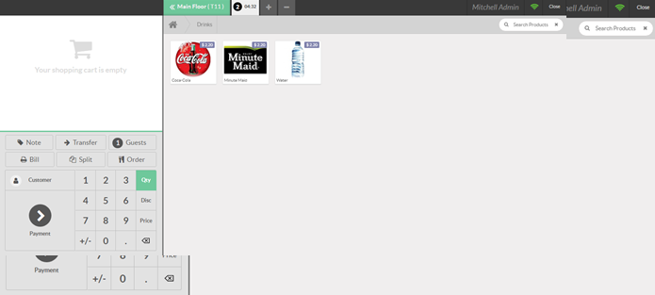
  - CONNECTING TO EXTERNAL DEVICES
  - Via enabling the options underneath, your database can be connected to use hardware like the barcode scanner and IOT box devices.
  - 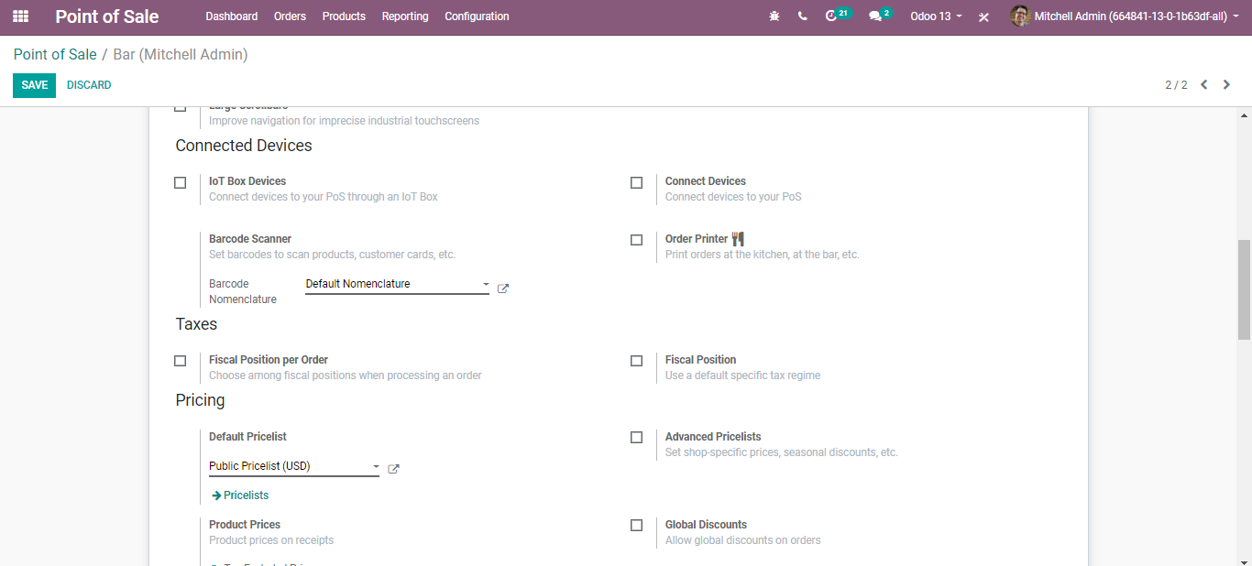
  - Using Barcode in POS
  - Using a barcode scanner to process point of sale orders, improves your efficiency, and helps you to save time for you and your customers.
  - Configuration
  - To use a barcode scanner, go to Point of Sale ‣ Configuration ‣ Barcode Scanner
  - 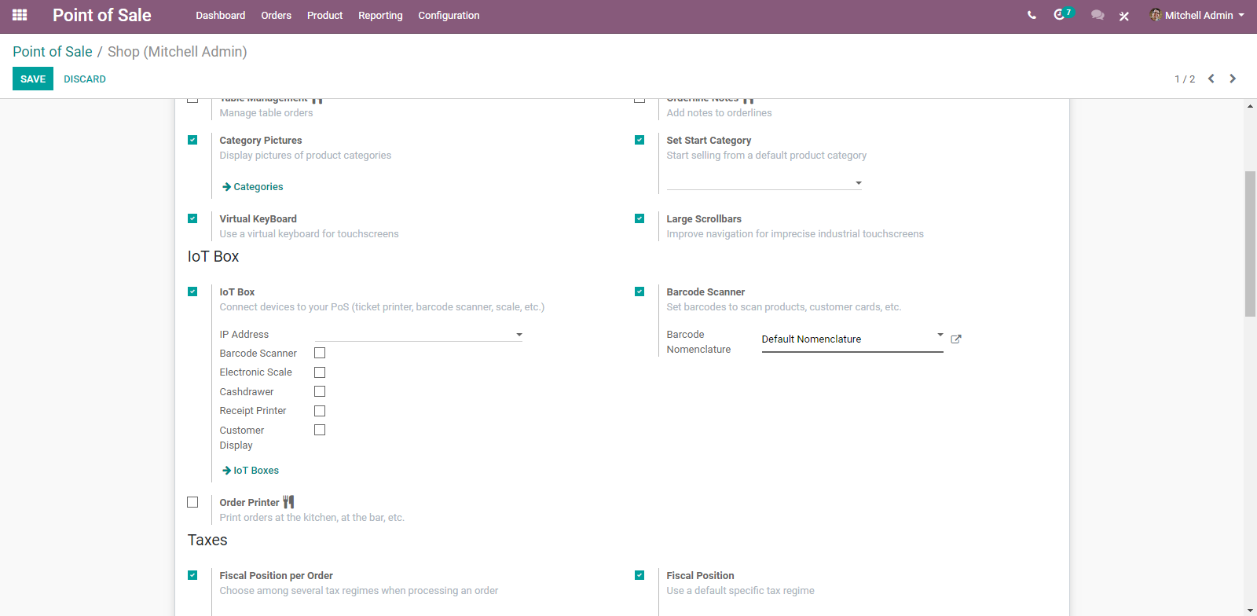
  - Under the IoT Box / Hardware category, you will find Barcode Scanner select it.
  - Add barcodes to the product
  - Go to Point of Sale ‣ Catalog ‣ Products and select a product.
  - Under the general information tab, you can find a barcode field where you can input any barcode.
  - 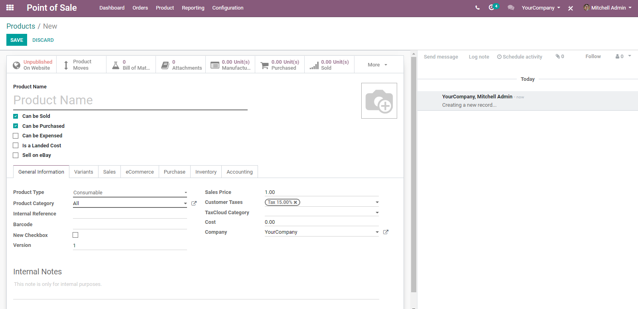
  - Scanning products
  - From your POS interface, scan any barcode with your barcode scanner. The product will be added; you can scan the same product to add it multiple times or change the quantity manually on the screen.
  - Order Printer
  - To ease the workflow, printing the orders taken on the POS interface right in the kitchen or bar can be a tremendous help. Order printers are used by restaurants and bars to print the order updates in the kitchen/bar when the waiter updates the order.
  - 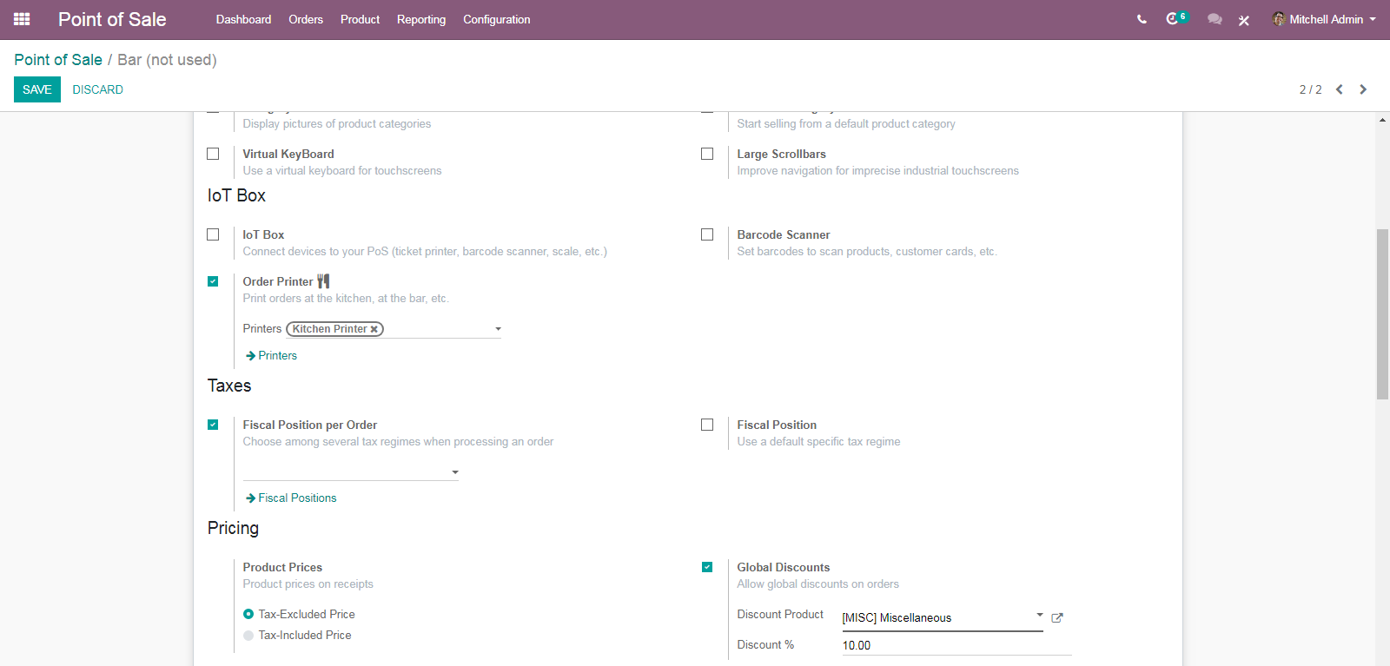
  - Each order printer has an IP address that defines the POS Box/Hardware Proxy where the printer can be found, and a list of product categories. An order printer will only update for products belonging to one of its categories.
  - 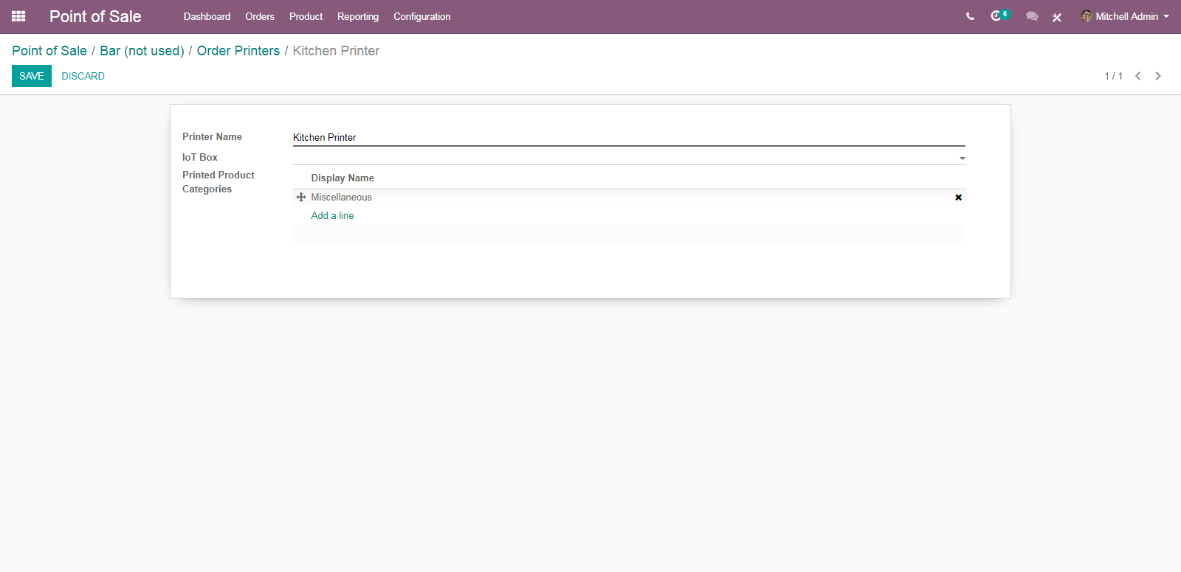
  - Print the order in the kitchen/bar
  - On your POS interface, you now have an ORDER button.
  - 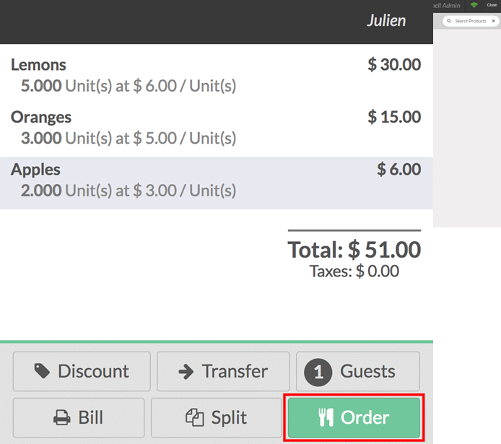
  - When you press it, it will print the order on your kitchen/bar printer.
  - CONFIGURING TAXES
  - 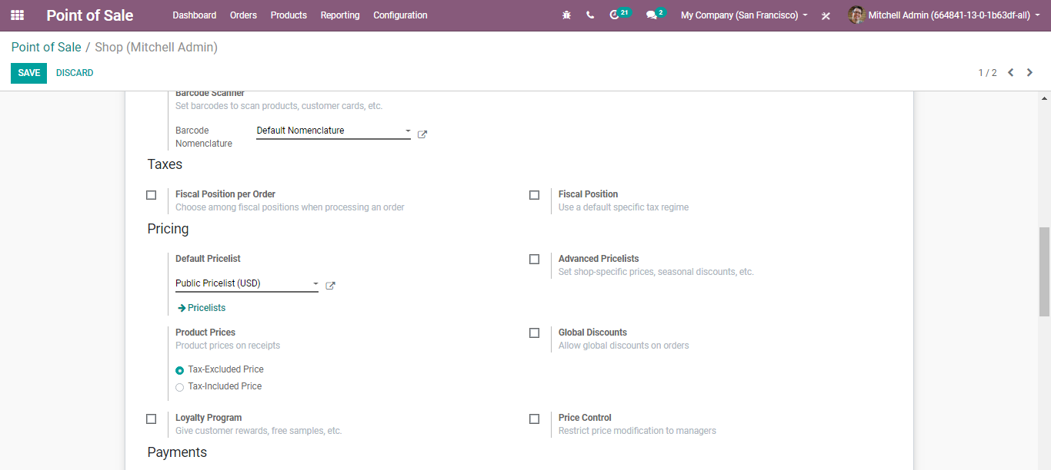
  - CONFIGURING PRODUCT PRICING
  - 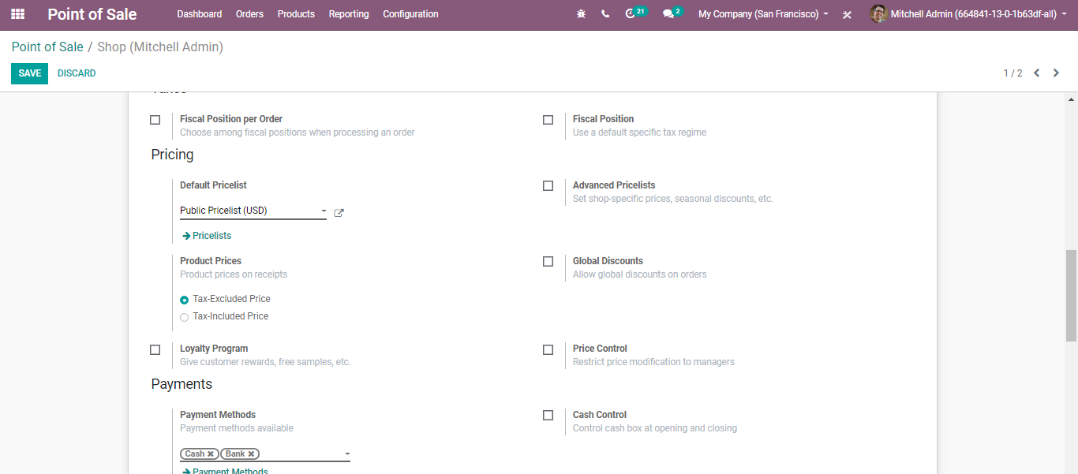
- Default Pricelist: The price list is used if no customer is selected or if the customer has no sales pricelist configured.
- Advanced Pricelist: If selected, one can set shop-specific prices, seasonal discounts, etc.
- Product Prices: Here you can specify the product price on receipt should either be the tax-excluded price or tax-included price.
- Global Discounts: If ticked the option, one can allow global discounts on orders.

  - CONFIGURING LOYALTY PROGRAM
  - To activate the Loyalty Program feature, go to Point of Sale-> Configuration -> Pricing -> and loyalty program. Under the Pricing features, select Loyalty Program.
  - 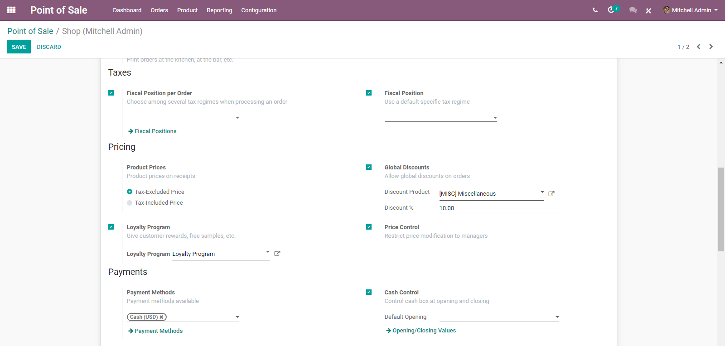
  - From there you can create and edit your loyalty programs via clicking the Loyalty Program.
  - A creation form will appear like below:
  - 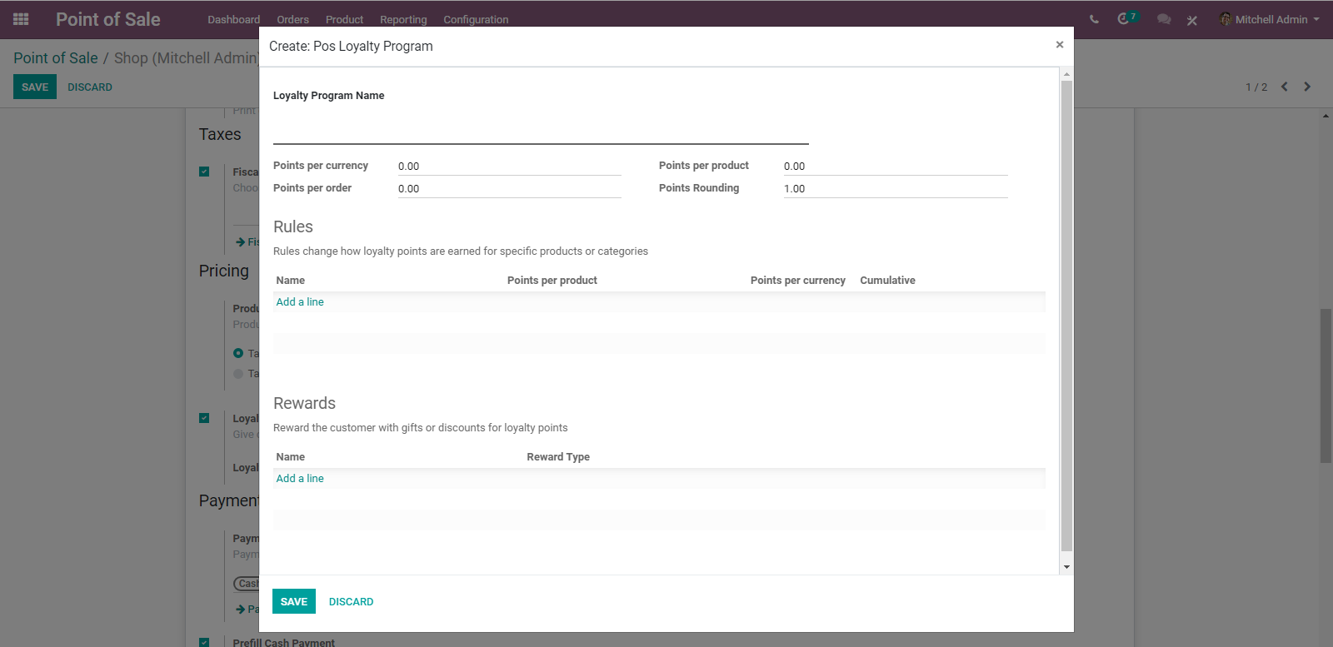
  - You can decide what type of program you wish to use, if the reward is a discount or a gift, make it specific to some products or cover your entire range. Apply rules so that it is only valid in a specific situation and everything in between.
  - The field includes:
- Loyalty Program Name: An internal identification for the loyalty program configuration.
- Points per currency: How many loyalty points are given to the customer by sold currency?
- Points per order: How many loyalty points are earned for specific products/categories?
- Points per product: How many loyalty points are given to the customer by-products sold?
- Points rounding: The loyalty point amounts are rounded to multiples of this.
- Rules: Rules change how loyalty points are earned for specific products or categories.
  - 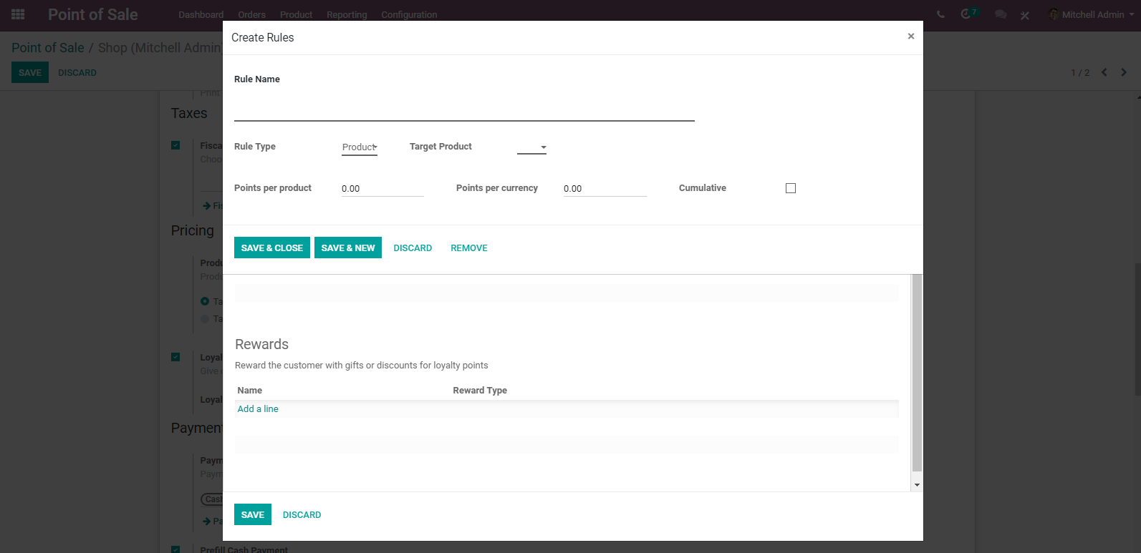
  - Rule Name: An internal identification for this loyalty program rule.
  - Rule Type: Does this rule affect products or a category of products.
  - Target Product: The product affected by the rule.
  - Points per Product: How many points the product will earn per product ordered.
  - Points per currency: How many points the product will earn per value sold.
  - Cumulative: The points won from this rule will be won in addition to other rules.
  - Rewards: Reward the customer with gifts or discounts for loyalty points.
  - 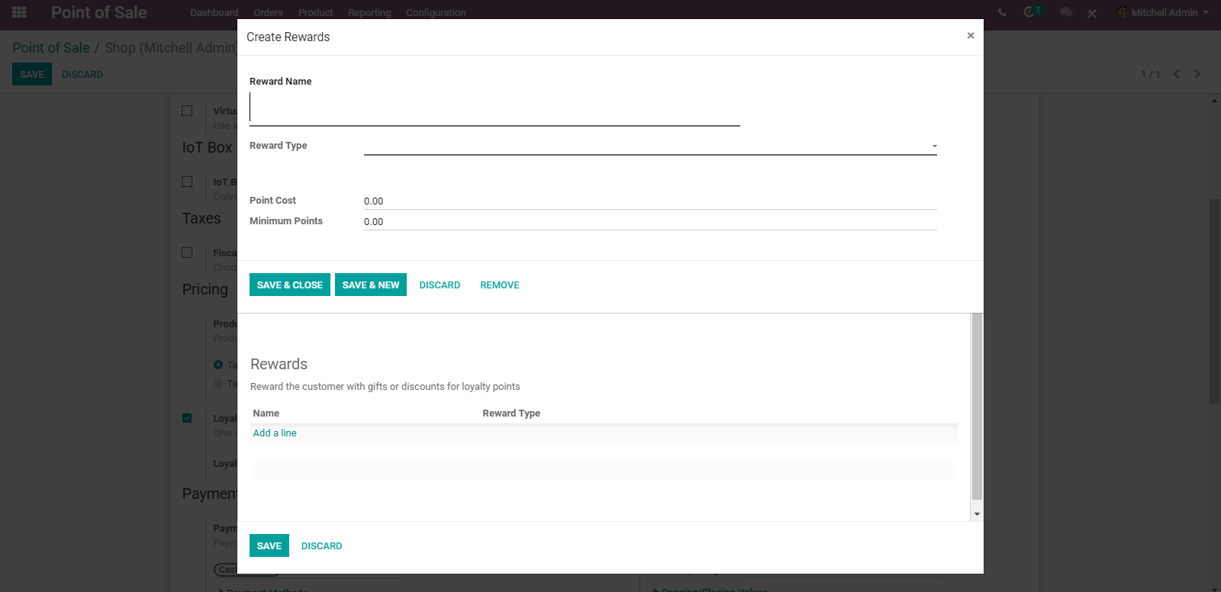
  - Reward Name: An internal identification for the loyalty reward.
  - Reward Type: The type of reward.
  - Point Cost: The cost of the reward.
  - Minimum Points: The minimum point of reward the customer must have for qualifying this reward.
  - Use the loyalty program in your POS interface
  - When a customer is set, you will now see the points they will get for the transaction, and they will accumulate until they are spent. They are spent using the button Rewards when they have enough points according to the rules defined in the loyalty program.
  - You can see the price is instantly updated to reflect the pricelist. You can finalize the order in your usual way.
  - Price Control: If selected, only users with manager access rights for the POS app can modify the product prices on orders.
  - CONFIGURING YOUR PAYMENT METHODS
  - To add a new payment method for a Point of Sale, go to Point of Sale ‣ Configuration ‣ Go to the Payments section and click on the link "Payment Methods".
  - 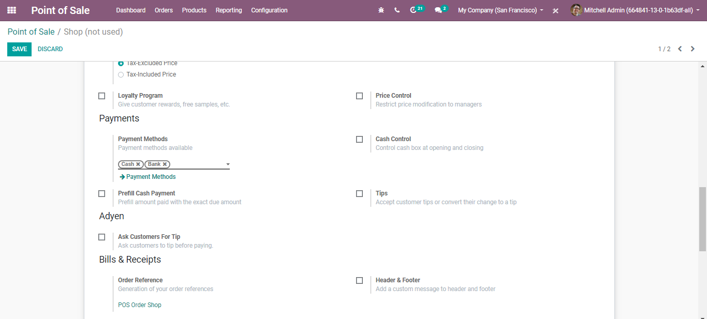
  - Upon clicking the payment method link, you will be directed to a new window like below:
  - 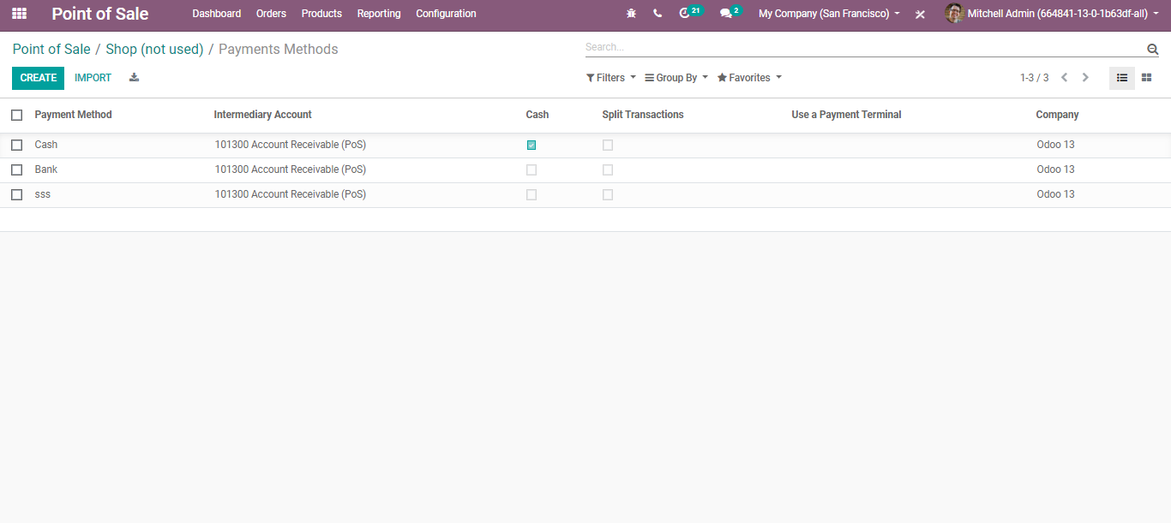
  - One can create a new payment method via clicking the CREATE BUTTON on top.
  - 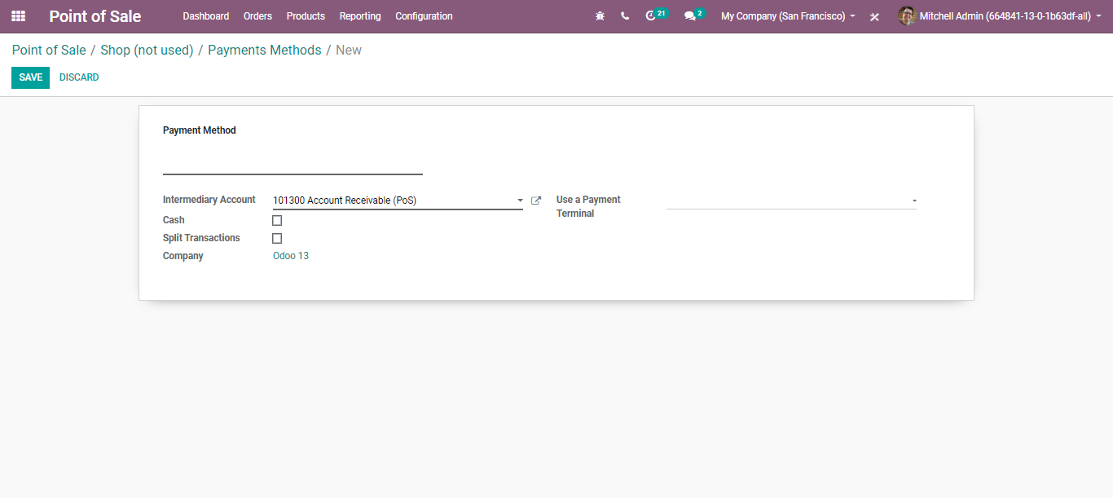
- Intermediary Account: Account used as counterpart of the income account in the accounting entry representing the POS sales.
- Split Transactions: If ticked, each payment will generate a separate journal item. Ticking that option will allow the closing of the POS.
- Payment Terminals: Record payments with a terminal on this journal.
  - Cash Control
  - Cash control is a built-in option in BUSINESSBOXERP POS, which allows the user to check the amount in the cash box at the beginning and end of each session. As it is a default feature, there is no need for extra apps or plugins to install.
  - Configuration
  - Go to Point of Sale -> Configuration-> Payments section and click on the link "Cash Control".
  - 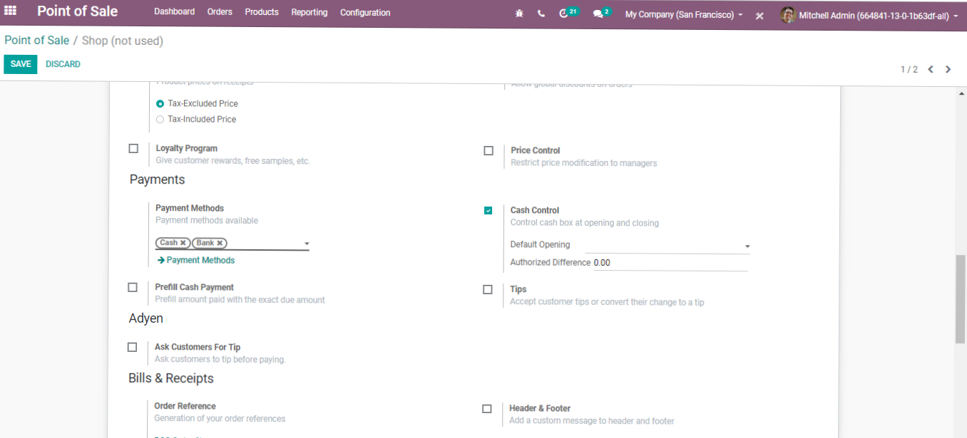
  - CREATE: DEFAULT BALANCE
  - Once you have enabled the ‘Cash Control’ option, a new section will appear under that option where you can provide the coins or bills in the cashbox. Click on CREATE to add a bill or coin. You need to provide the coin/bill value and the number of coins/bills. The subtotal will be automatically updated.
  - 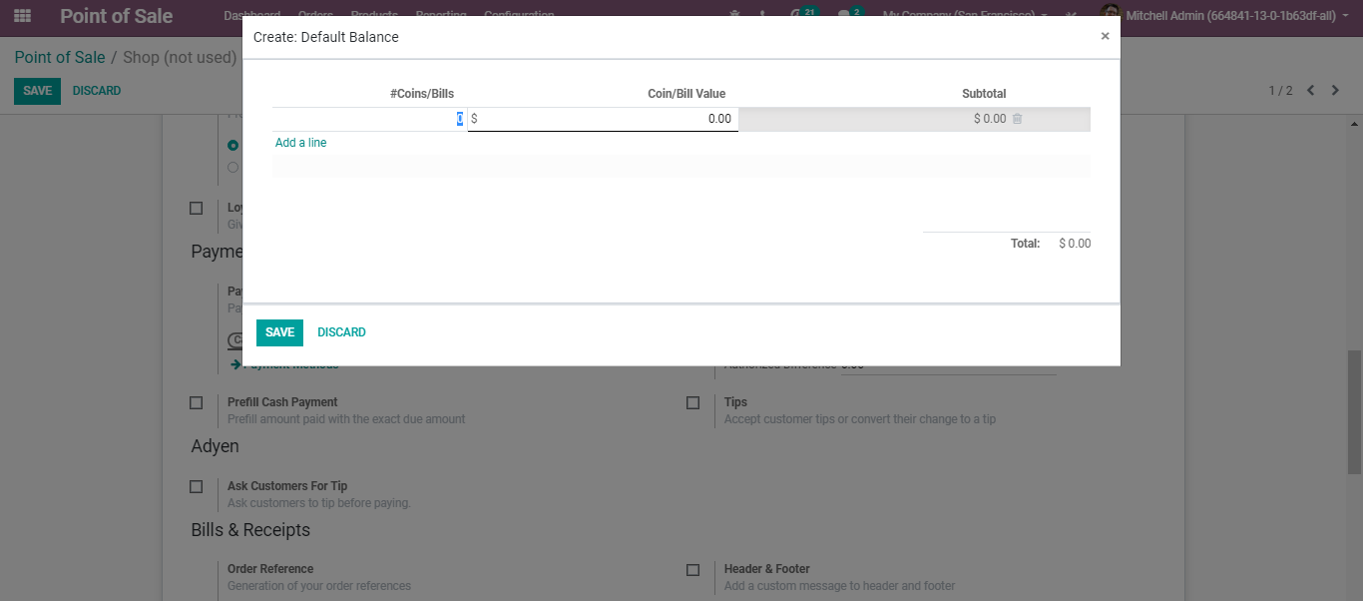
  - Based on the coins or bills we add; the opening balance will be updated automatically.
  - BILLS AND RECEIPTS
  - Use the Bill Printing feature to print the bill before the payment.

  - Order Reference: Order sequences are automatically created by BUSINESSBOXERP. However, using this feature one can customize the reference numbers of the orders.
  - 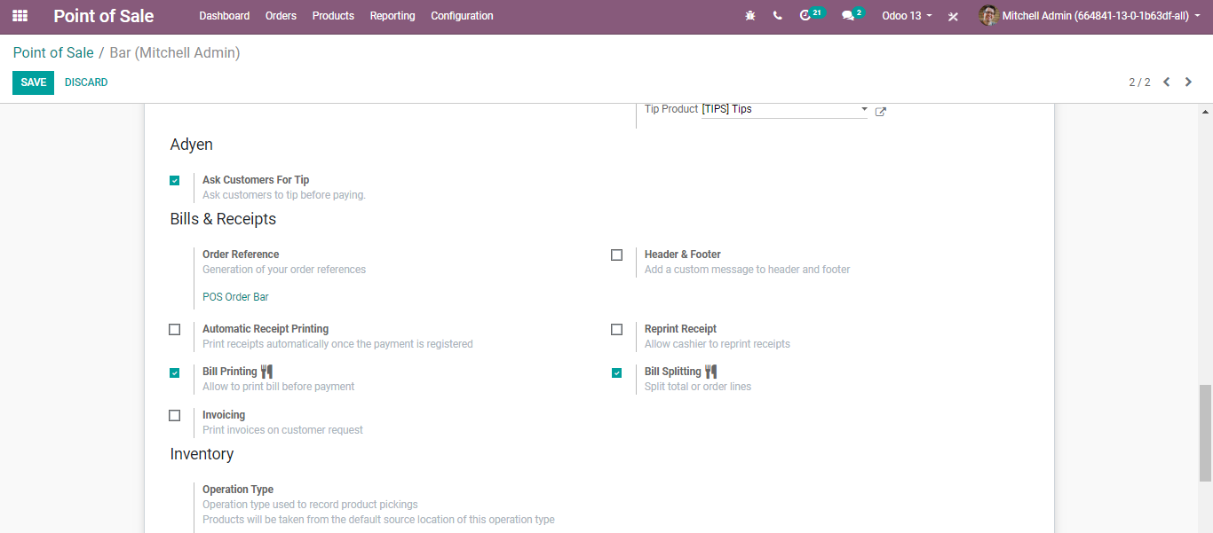

  - Header & Footer: Via clicking this option, one can add a custom message in the header and footer of the bills/receipts.
  - 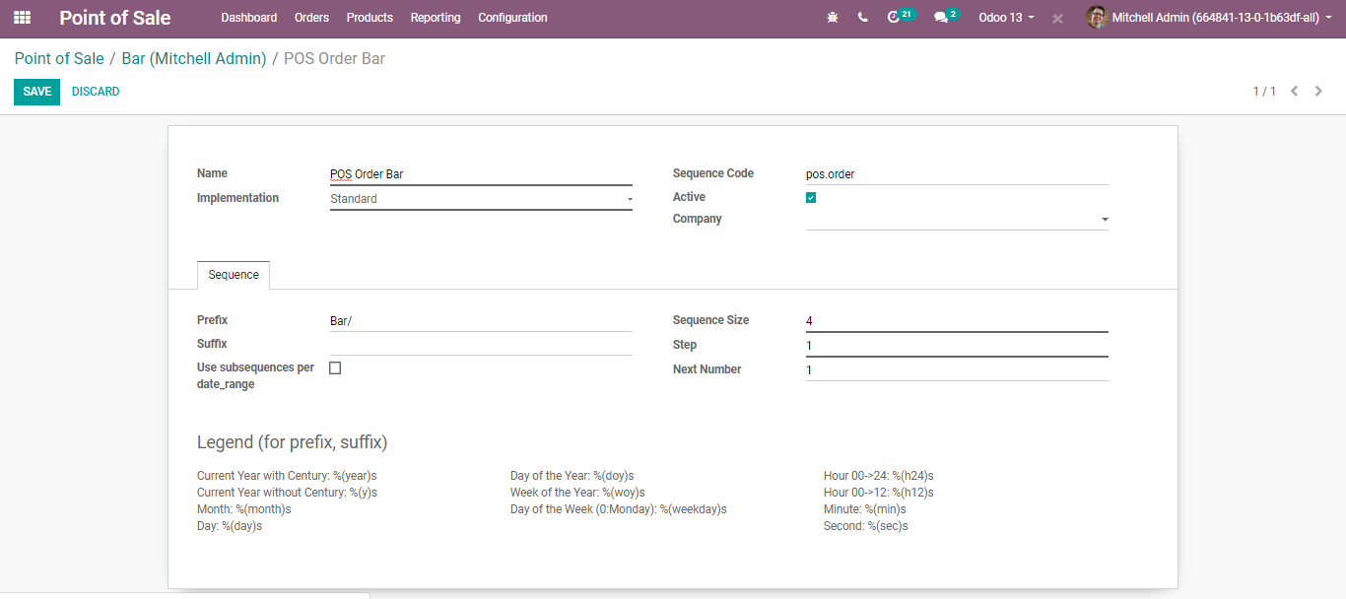
  - Automatic Receipt Printing: If an enabled option, the receipt will automatically get printed at the end of each order.
  - Reprint Receipt: If the option is enabled in the settings, it will allow cashiers to reprint the receipts.
  - Bill Printing: Allow to print the bill before payment.
  - 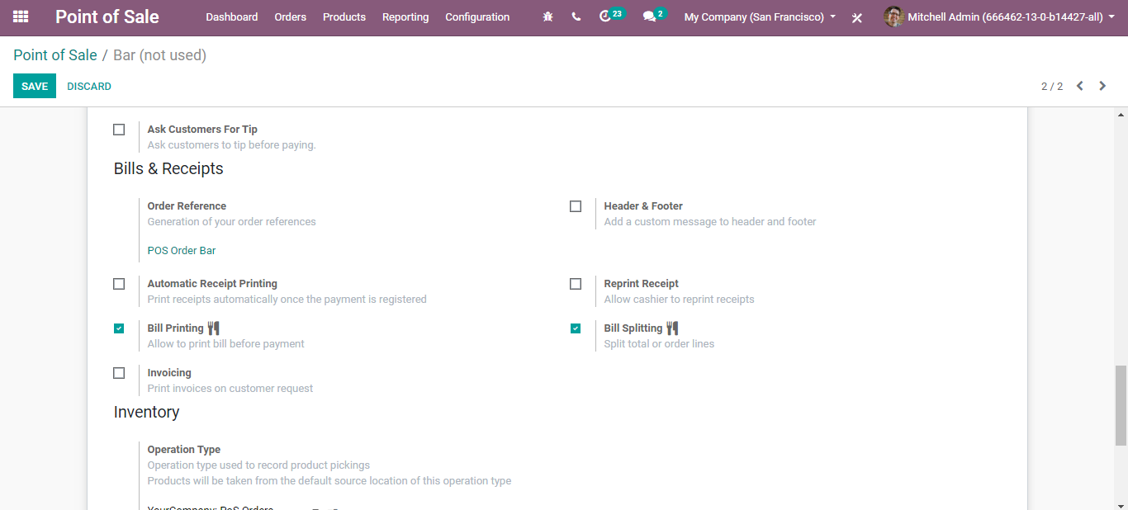
  - You get a BILL button in the POS. Upon clicking it you can print the bill.
  - 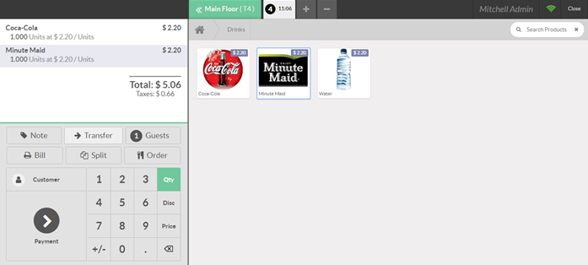
  - 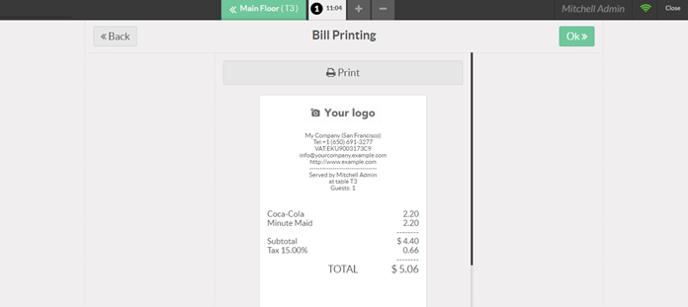
  - Bill Splitting: Enables the bill splitting at the point of sale.
  - 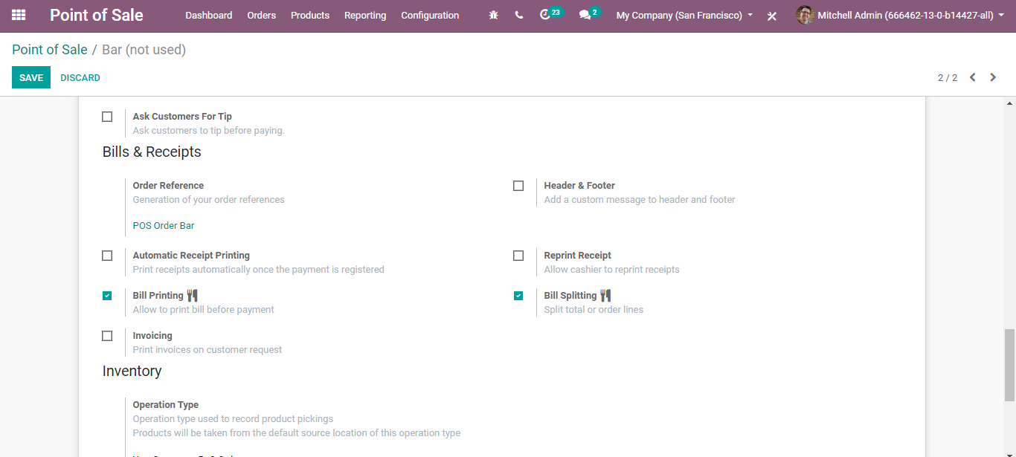

  - Split a Bill
  - On your POS interface, you now have a SPLIT button.
  - 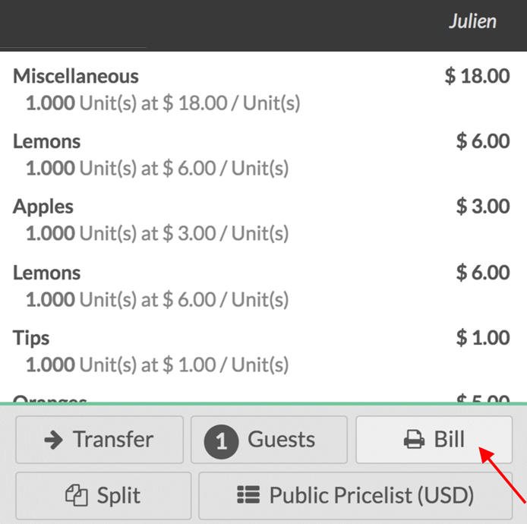
  - 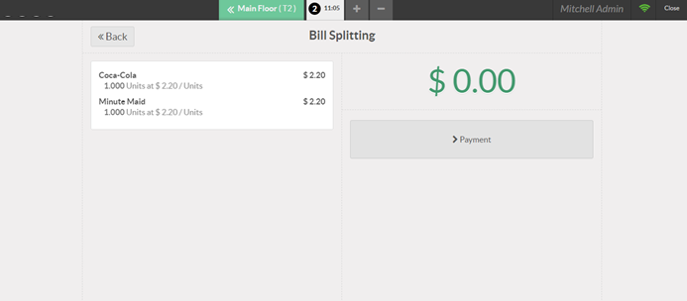
  - CONFIGURING TABLE MANAGEMENT
  - ADD A FLOOR
  - Upon selecting the Table management option under the POS Configuration Settings, you can manage your floors via clicking the option FLOOR.
  - 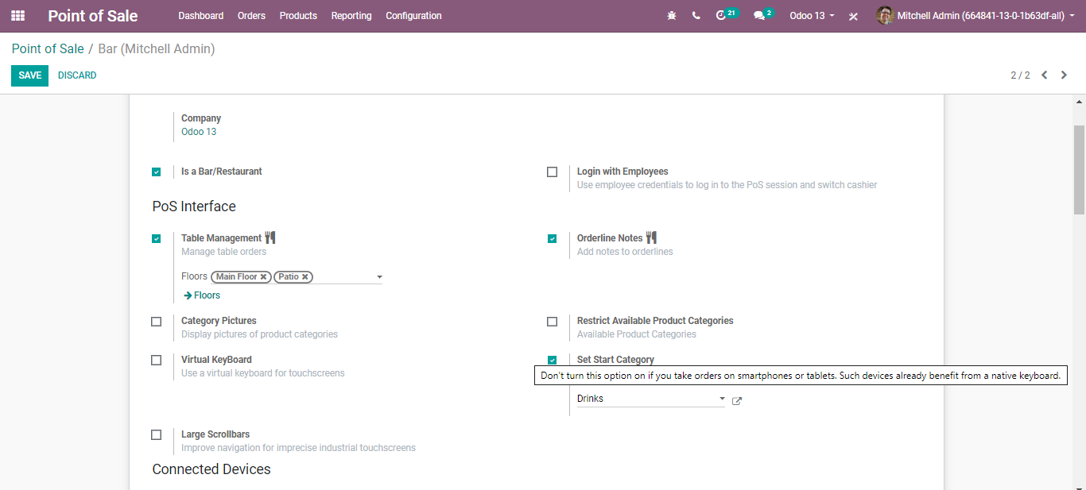
  - Here, we have configured two floors: Main Floor and Patio. So now you can go to the POS dashboard and start a new session under POS Bar.
  - 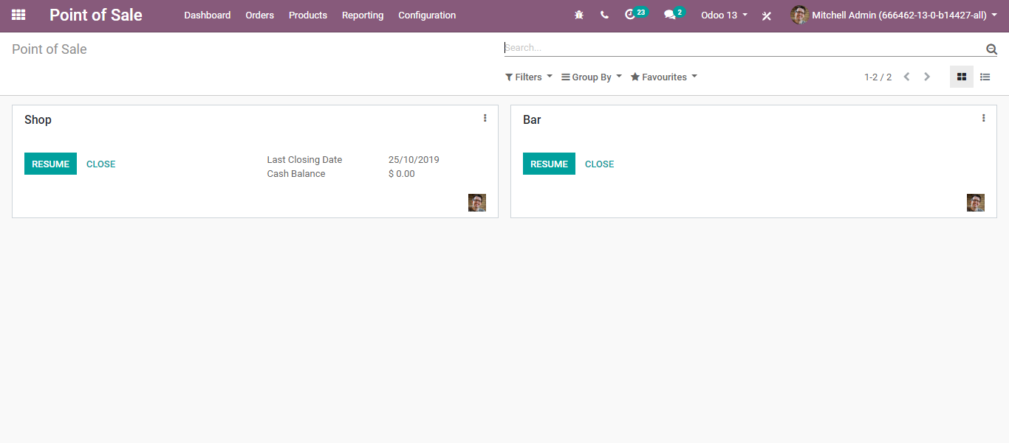
  - Upon clicking the NEW SESSION, you will be navigated to Restaurant/Bar POS. You can see two floors here: MAIN FLOOR and PATIO
  - 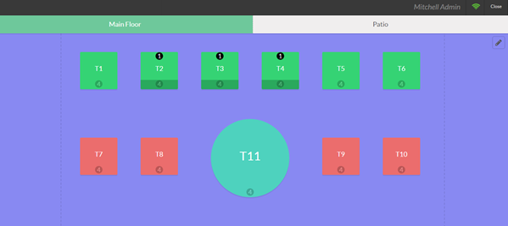
  - 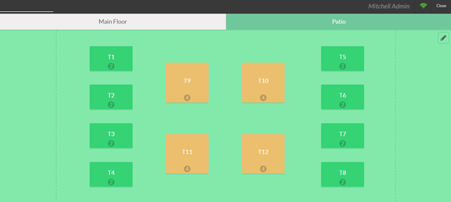
  - Both the main floor and patio are designed a bit differently. Here from this page, one can customize it further deeply.
  - ADD A TABLE
  - From your POS interface, you can see the floor. Next, you can customize the floor by adding tables. When you click on the pencil you will enter edit mode, which will allow you to create tables, move them, modify them,
  - 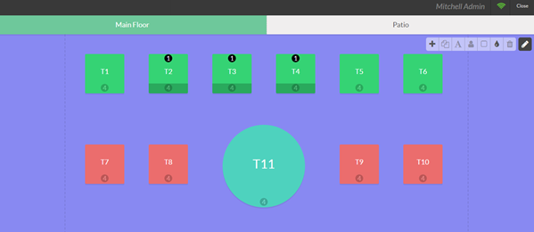
  - Using the pencil tool,
  - - one can rename the table
  - 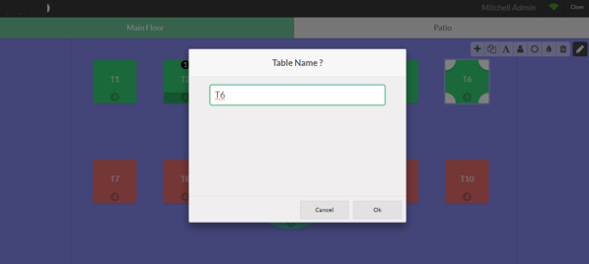
  - - change their shape
  - 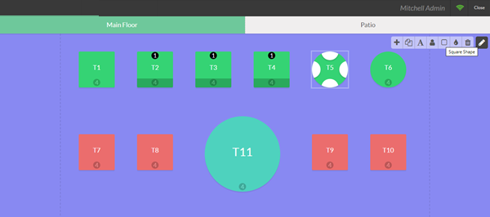
  - - size, the number of people they hold as well as duplicate them with the handy toolbar.
  - 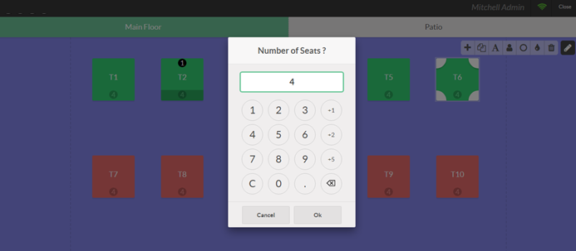
  - Once the floor plan is set, you can close the edit mode and start taking orders.
  - REGISTER YOUR TABLE(S) ORDERS
  - Upon selecting a table, you will be brought to the usual interface for registering the order and making payment.
  - You can quickly go back to your floor plan by selecting the floor button and you can also transfer the order to another table.
  - 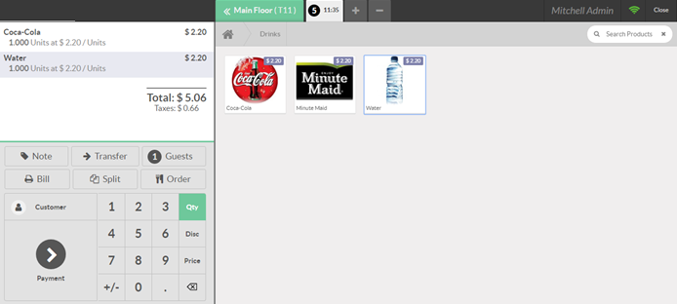

  - TRANSFER CUSTOMERS BETWEEN TABLES
  - If your customer(s) need to change table after they have just put in an order, BUSINESSBOXERP can assist you with transferring the clients and their request to their new table, keeping your clients glad without making it muddled for you.
  - To transfer customer(s), firstly select the table your customer(s) is/are sitting.
  - 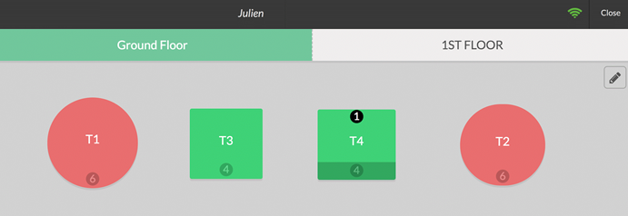
  - Now to transfer the customers, simply click the transfer button and select a new table.
  - 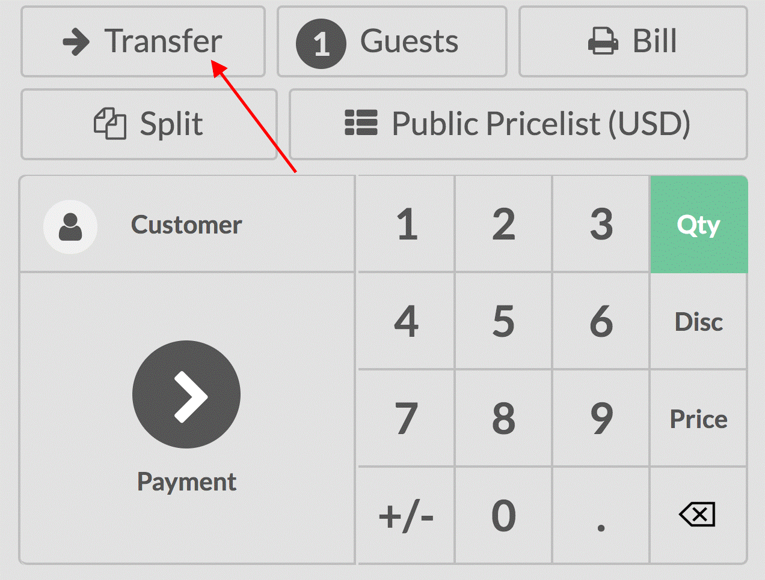

  - REGISTER MULTIPLE ORDER
  - The BUSINESSBOXERP Point of Sale App enables you to enlist various/multiple requests simultaneously.
  - Register an extra order
  - To register an additional order, you can utilize the + button in the interface.
  - You would then be able to move between every one of your orders and proceed with the payment when required.
  - 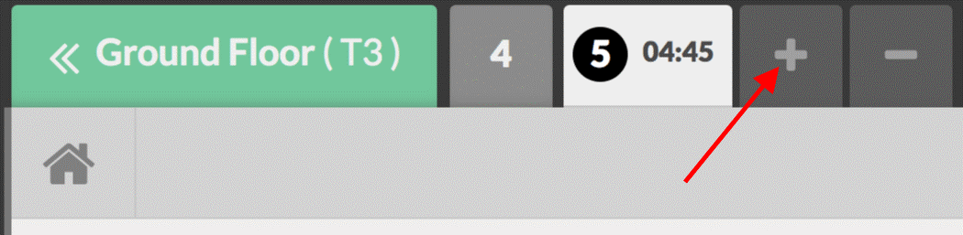
  - By using the - button, you can remove the order you are currently on.
  - PRINTING ORDERS AT KITCHEN
  - Configuration:
  - Activate the bar/kitchen printer
  - To activate the Order printing feature, go to Point of Sales ‣ Configuration ‣ Point of sale and select your POS interface.
  - Under the IoT Box / Hardware Proxy category, you will find Order Printers. Note that you need an IoT Box to connect your Printer to the POS
  - Add a printer
  - In your configuration menu, you will now have the Order Printers option where you can add the printer.
  - 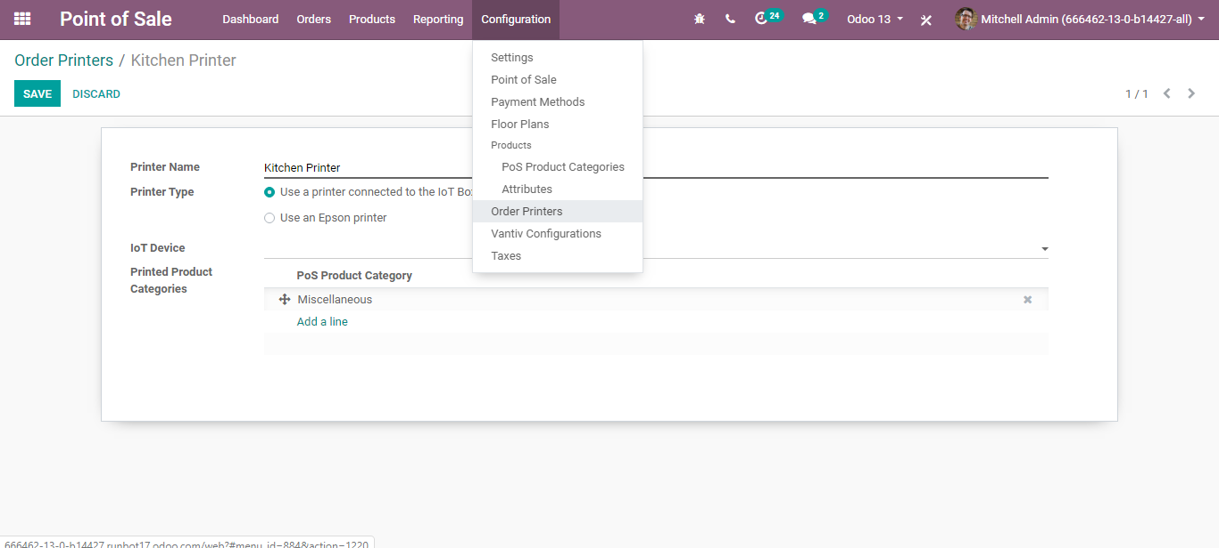
  - Select or create a printer
  - 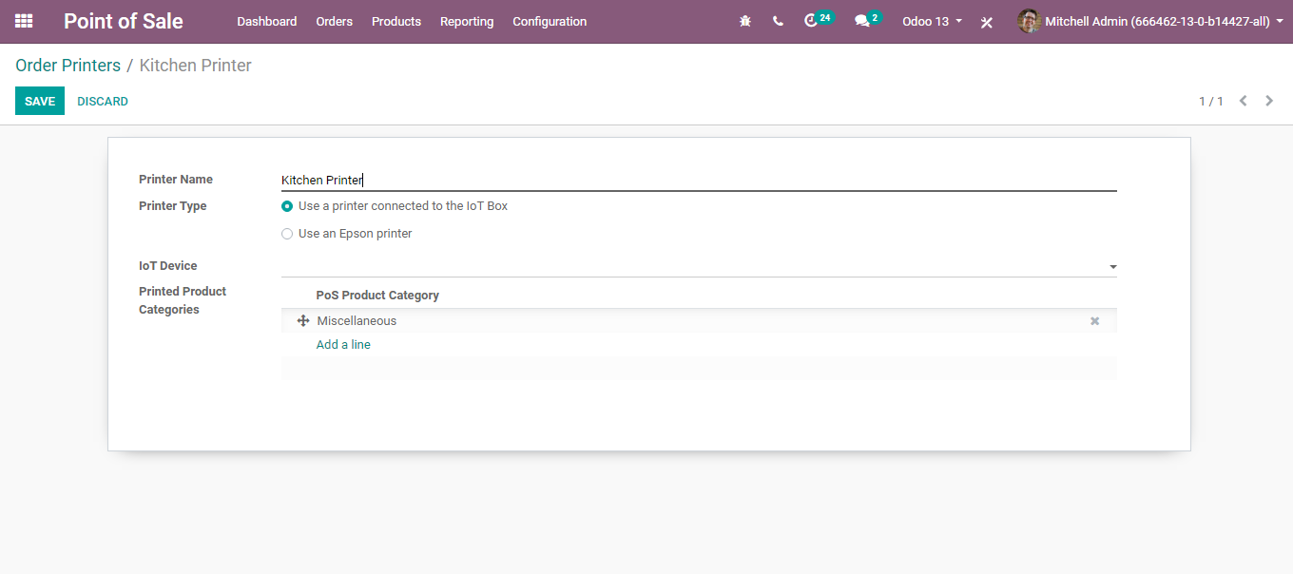
  - Print the order
  - You have an Order button in your POS interface.
  - 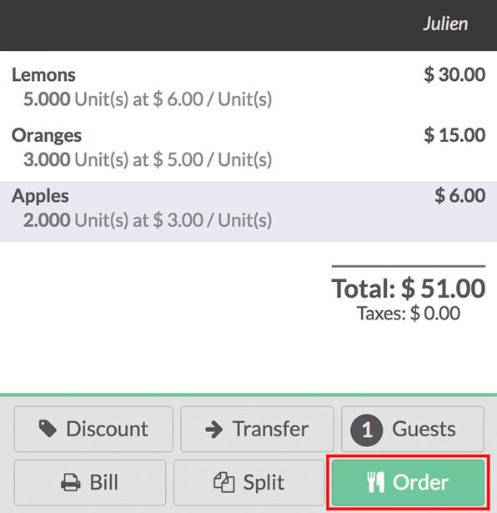
  - Upon pressing the ORDER button, it will print the order on your kitchen/bar printer.

