**Project Management**

BUSINESSBOXERP Project Management is a Kanban view management system, like the whiteboard concept we look for. It is a time-saving tool that can give us a visual overview of all our ongoing projects. Thanks to the BUSINESSBOXERP apps that it will be easy to know what has been worked on, who is working on it and how far they have gotten.

So, let us go ahead and check this out in BUSINESSBOXERP

**PROJECT DASHBOARD**

As soon as you enter the project management module, you see is the dashboard. The dashboard gives you a glimpse of every project that currently the company has in its store. From here, one can get a complete overview of the project also the tasks underneath every project.

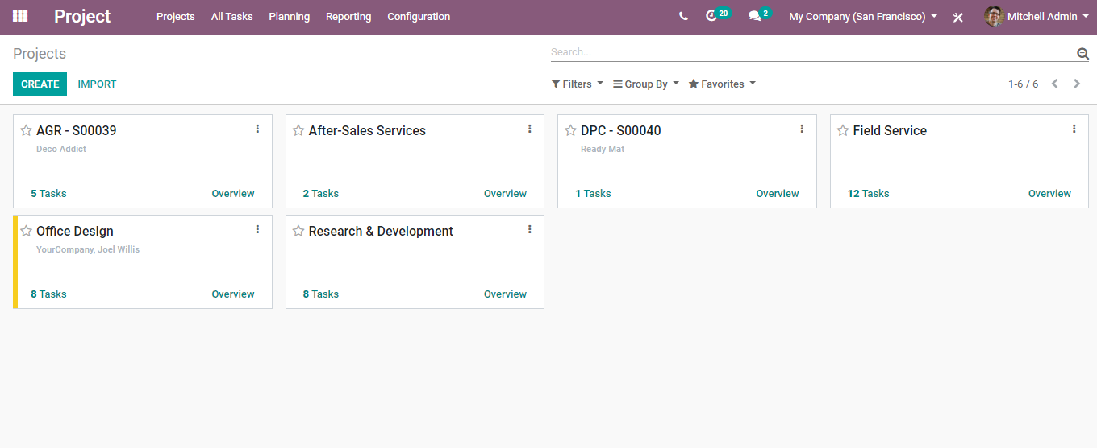

To view the tasks, click on the TASK icon.

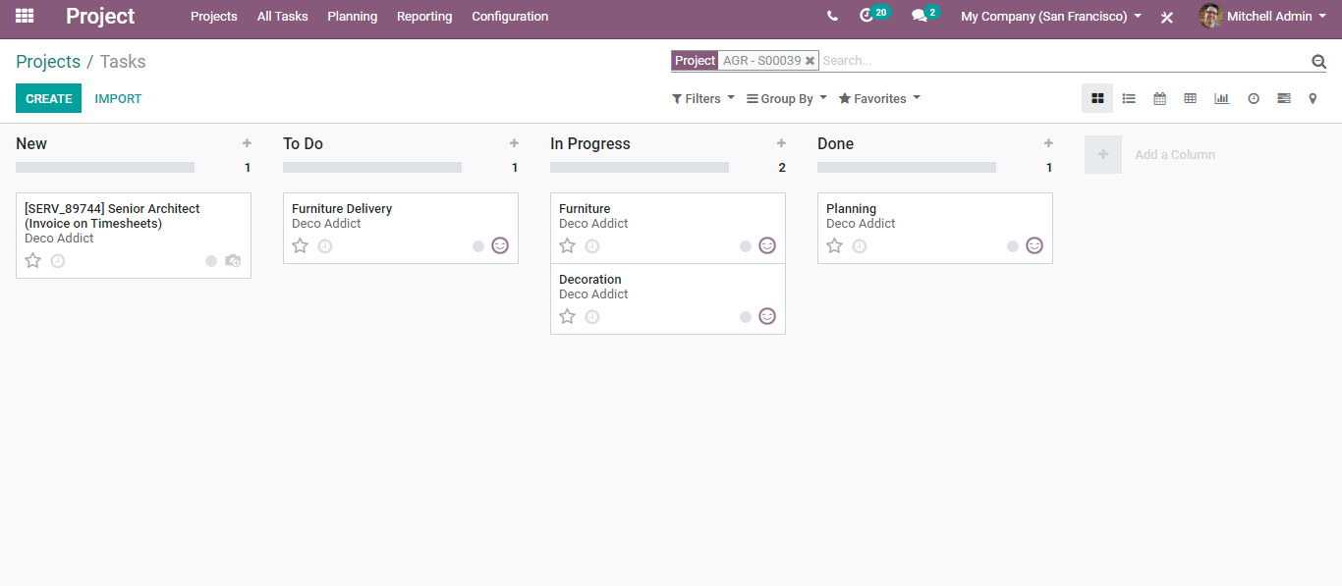

Here you can see the various tasks under a project, also which stage they belong to.

To get the overview of the project, click the OVERVIEW icon. Upon, clicking you will be navigated to a new window like below:

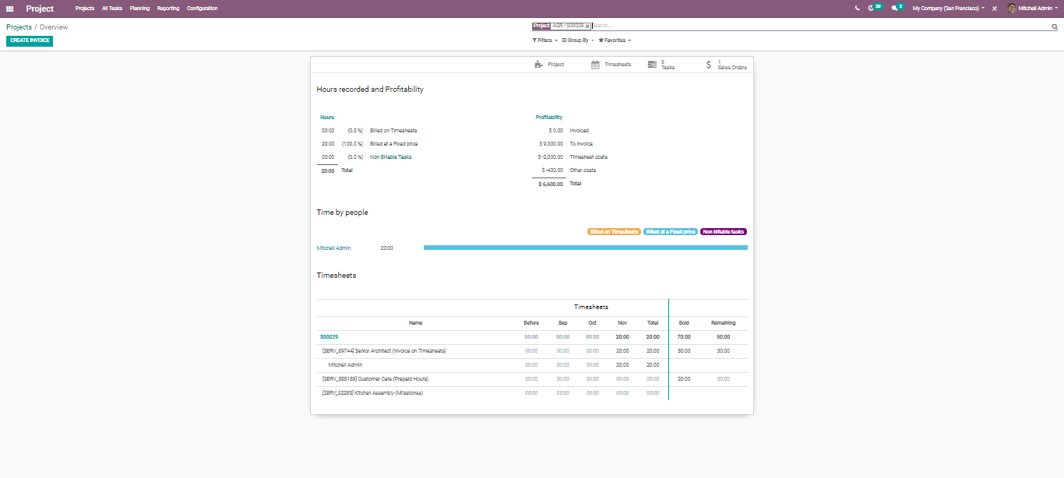

Here as you see, you get the complete overview of the project such as the recorded hours, tasks, timesheet, sale order created. If you want to create a new invoice for the project, you can click the CREATE INVOICE button.

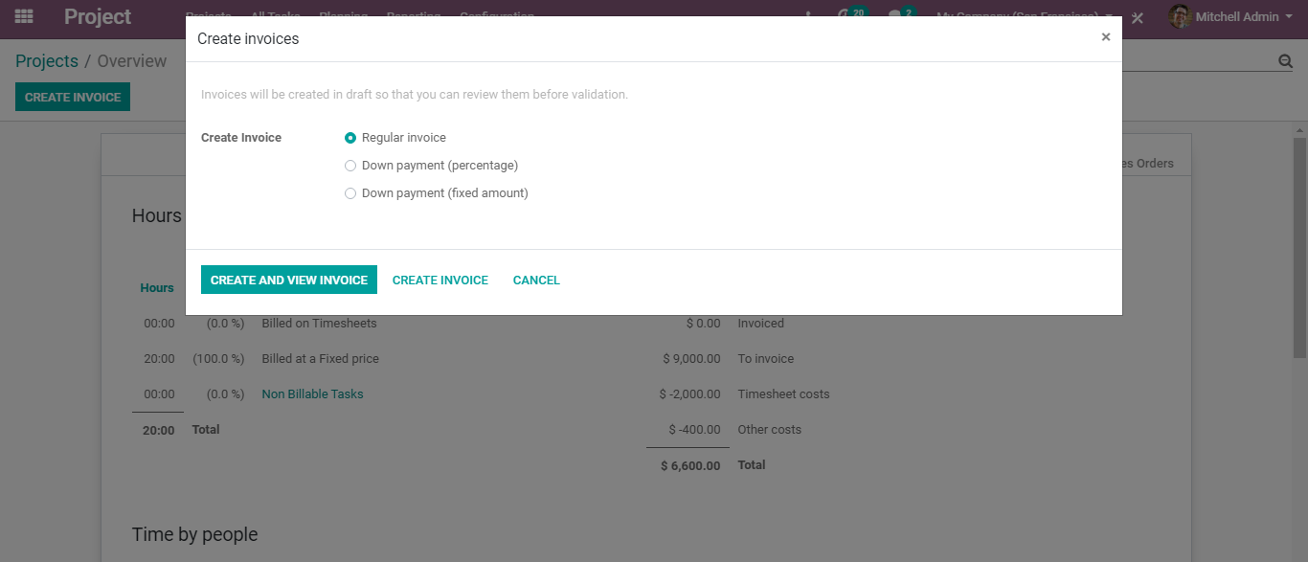

**CREATING NEW PROJECT**

To create a new project, you can click on the CREATE button in the dashboard.

Upon clicking the button, you are navigated to a new screen like the below image.

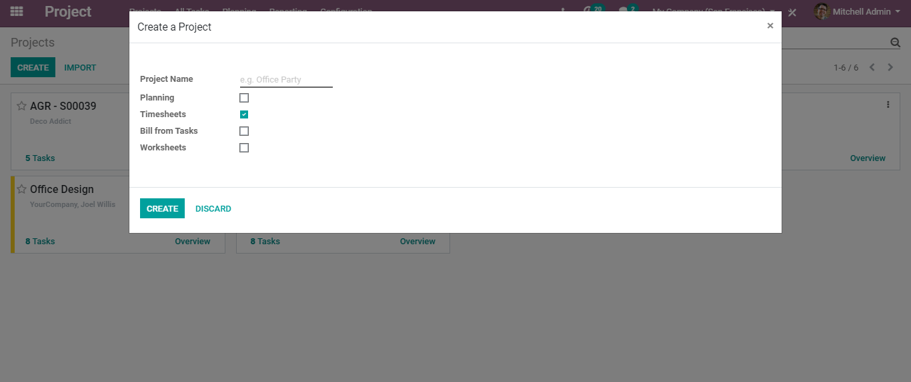

Here you can add the project name and select the following options.

* Planning to enable planning tasks on the project.
* Timesheet to enable timesheets on the project.
* Bill form Tasks to enable billing from tasks.
* Worksheets to enable customizable worksheets on Tasks.

Later click CREATE button.

**TASK STAGES**

Upon clicking the create button, you will be redirected to a new page like below.

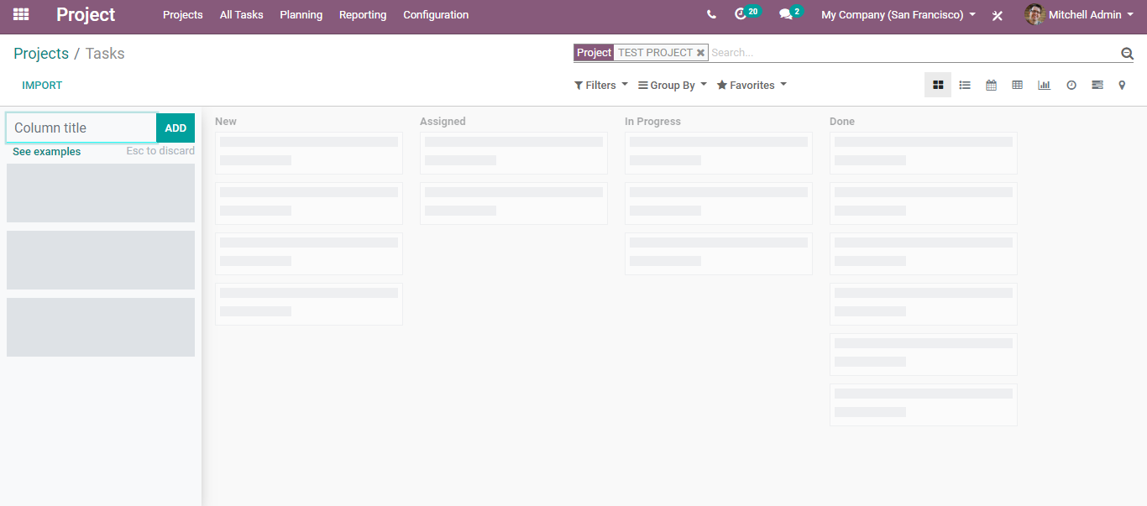

Here, you can add certain columns to your project. They will function as different stages for your project tasks. You can name the tasks in chronological order based on your project. Add as many columns as you need.

BUSINESSBOXERP helps you with certain examples for different use cases. For that click, the EXAMPLES button.

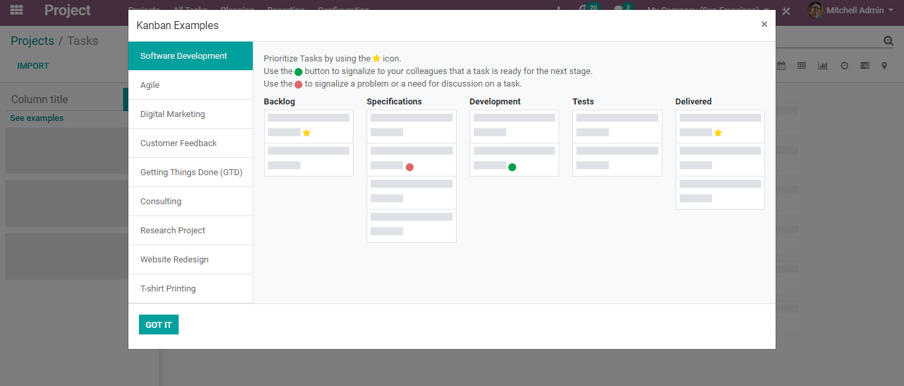

BUSINESSBOXERP has set different examples for different projects for instance- Software Development, Digital Marketing, getting things done, Research Project and more.

To close the window, click the button GOT IT.

And now you can add your titles. Once you add your desired columns and create a few tasks via clicking on CREATE button.

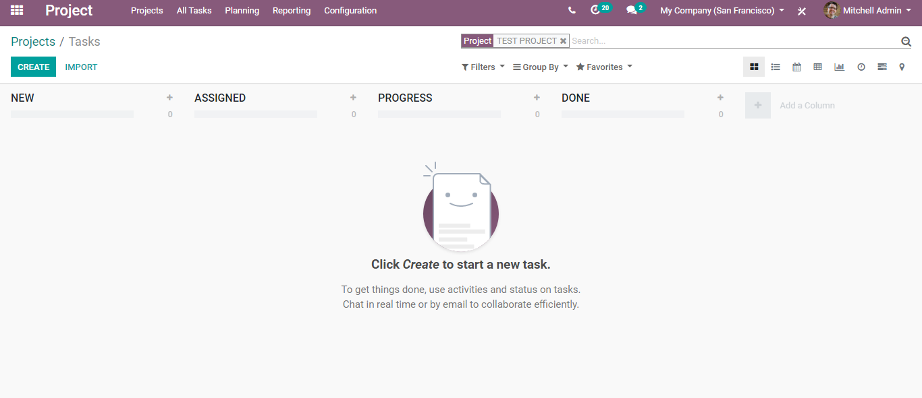

Now you have a new window, where you can add the Task Title and Individual to whom the task is assigned.

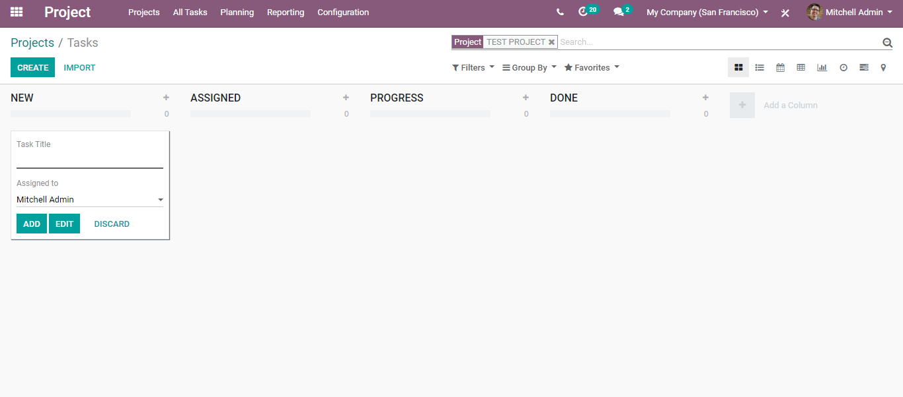

One can also edit this task created via clicking on the EDIT button.

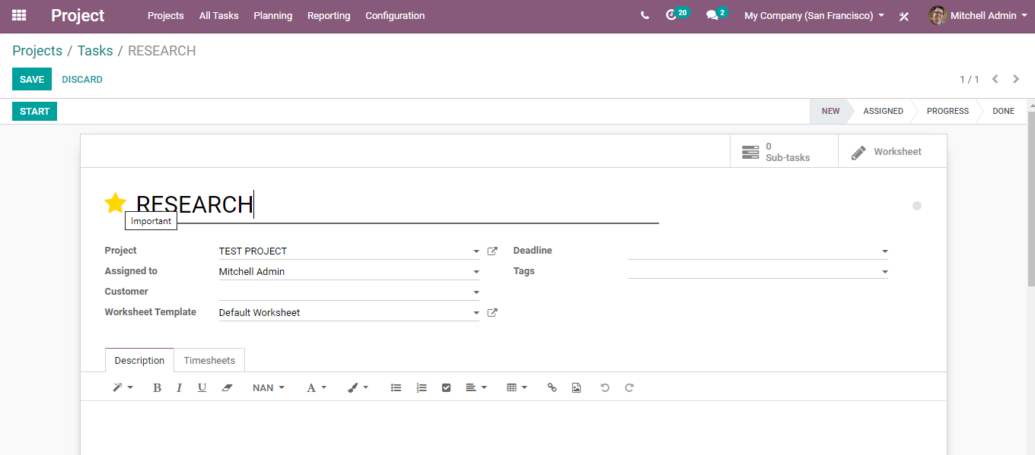

Here you get the task page, of course, you can change the task title if you need to, you can even assign someone, and can also change the project under which the task belongs to. This can be helpful if you have multiple teams working on multiple projects and you want this task to be transferred to another team. Therefore, in that case, from the task page itself, you can change the name of the project under which the task has to be scheduled. One can also add deadlines for tasks and tags for quick identification.

Tags can be helpful, as it helps you in quickly identifying the tasks in the Kanban view or the task overview.

One can also create a new tag via simply typing the text, this is shown in the below image.

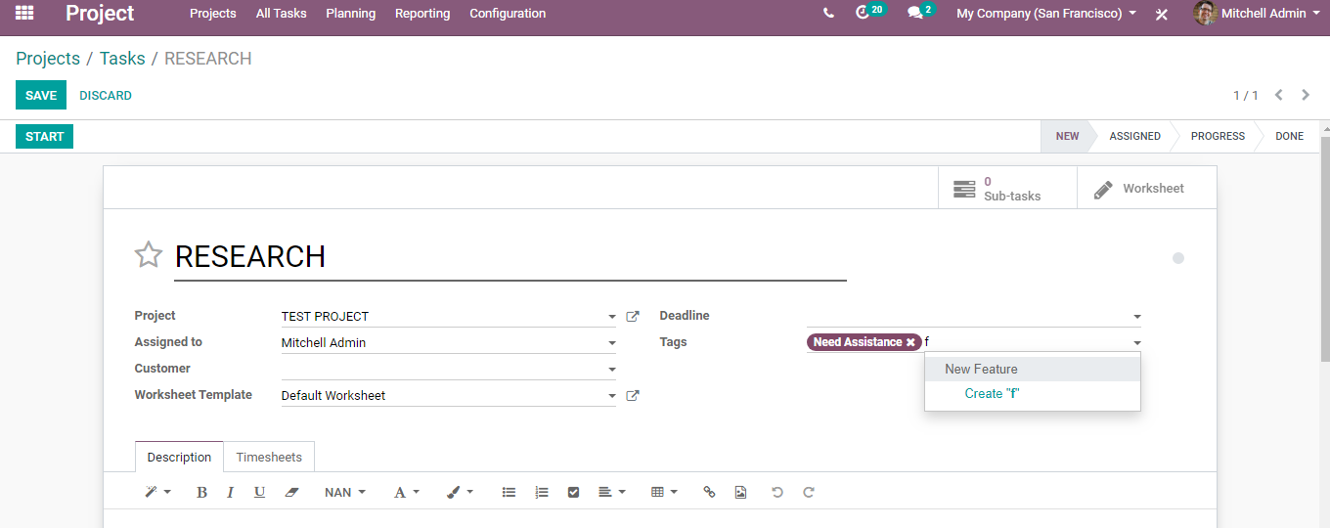

One can also add the descriptions, timesheets, and extra information underneath the task to communicate with the customer.

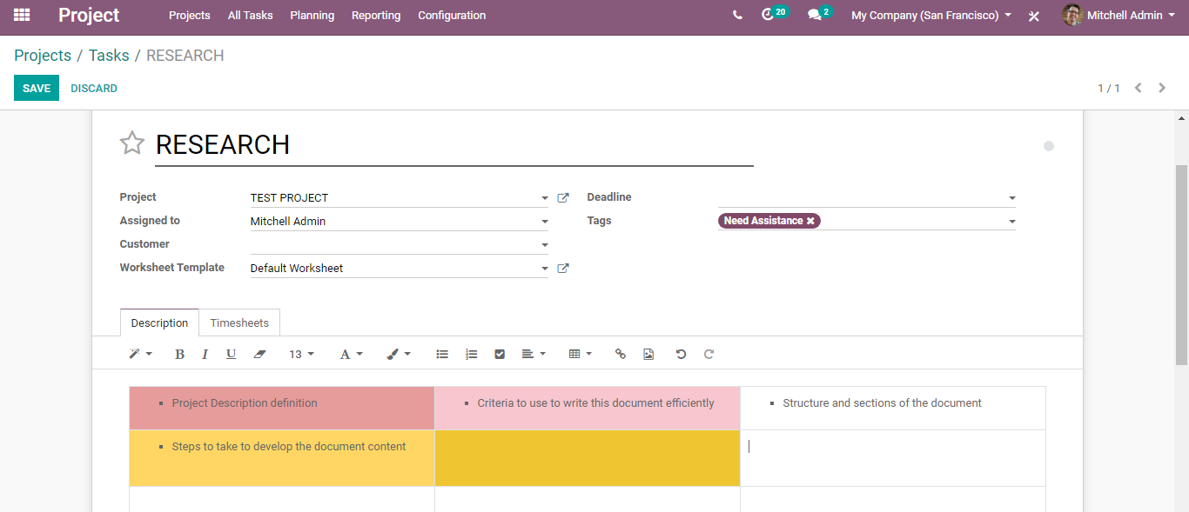

Click the SAVE button to mark the changes.

From the task dashboard, one can also do some cool activities.

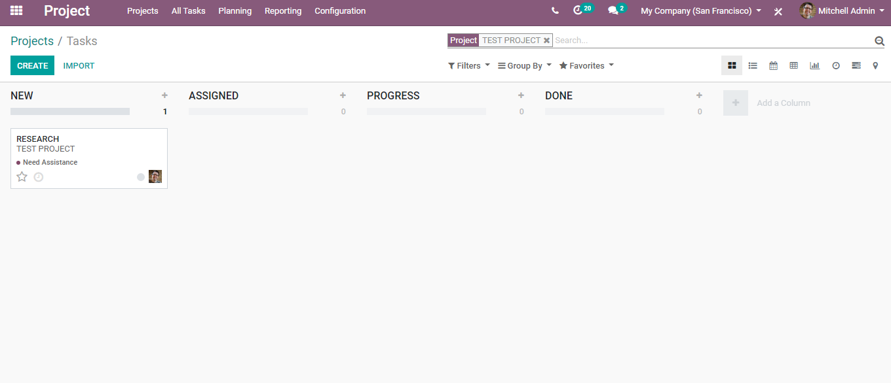

The colour dots and star icons are customizable markers. You can apply them to your tasks for identification. For instance, to know which task requires attention. One can give any such significations depending on the task.

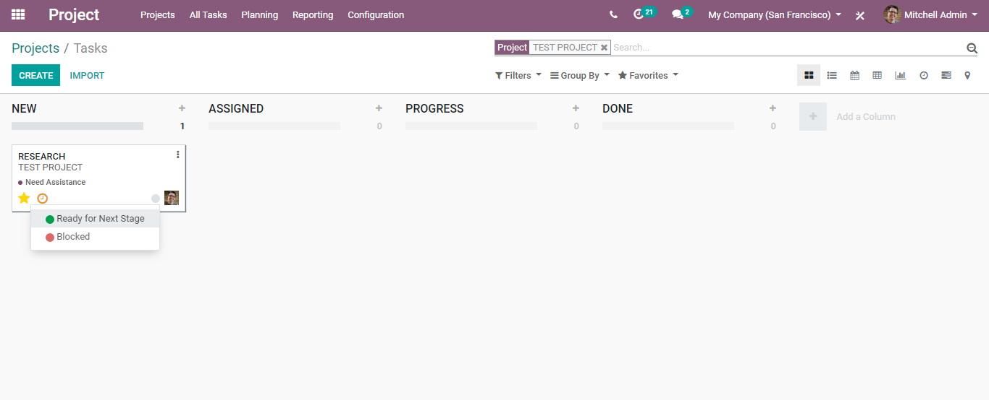

From the task dashboard, one can also see the planning/activities scheduled under each task. Also, can schedule certain new activities underneath it.

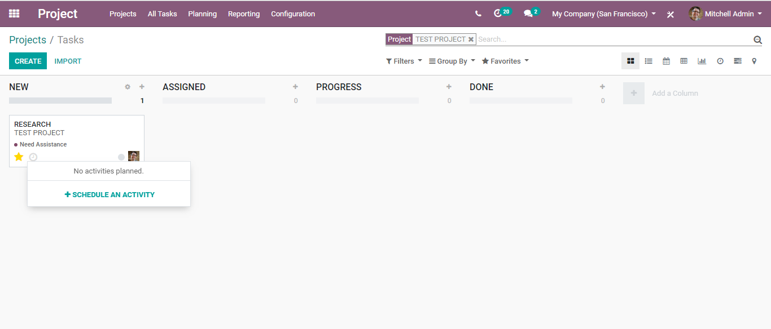

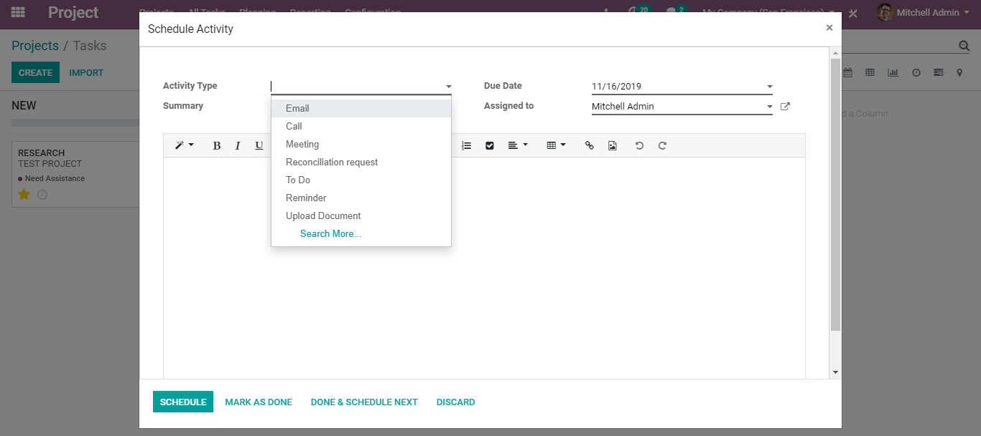

Click SCHEDULE to mark the changes.

**REARRANGE TASK STAGES**

From the Kanban view of the project, one can add as many stages as they want, also they can be rearranged via simply dragging and dropping the column to the desired location. One can also fold/ unfold the stages via using the setting icon on your desired stage.

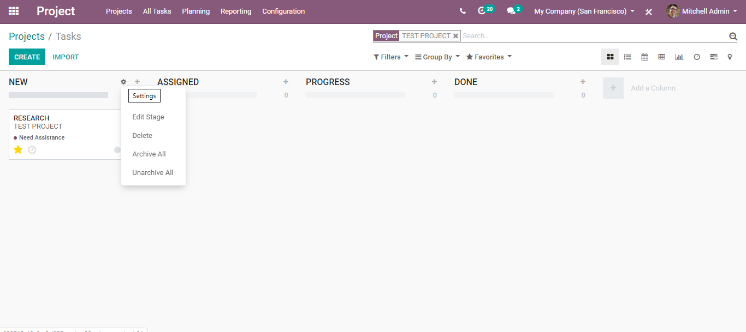

One can edit the stages, delete it, archive/unarchive the task.

**PLAN AND TRACK EMPLOYEE TASKS**

With the BUSINESSBOXERP project, it is quite easy and simpler the follow and planning of employee tasks. Under general settings of project management, upon enabling the option Manage time estimation on tasks, it creates a progress bar in the form view of your tasks.

And when each time the salesperson records his work hours in the timesheet, the bar gets automatically updated based on the initially planned hours.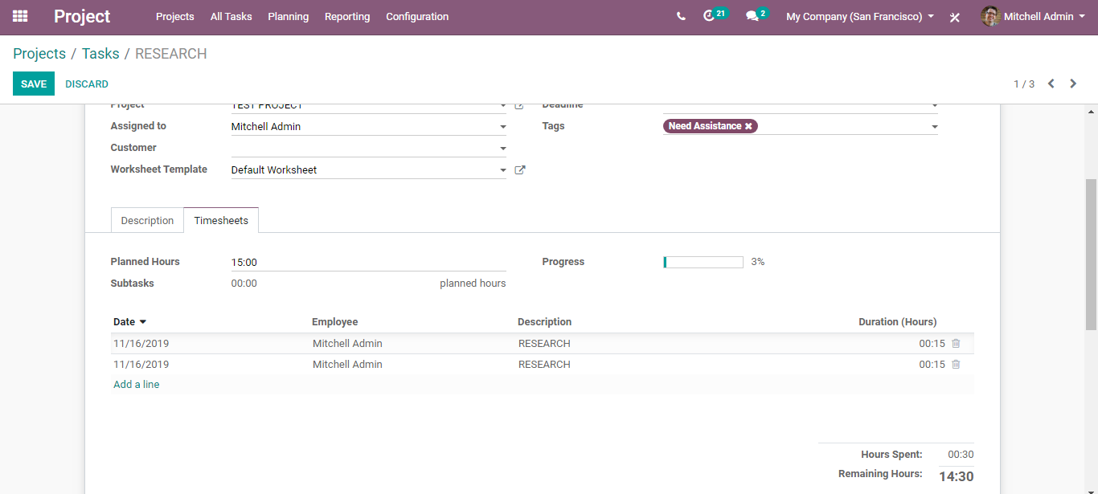

Also, from the multiple views within BUSINESSBOXERP, one gets to know the overview of different tasks created. These views help the manager to plan and follow up their employees’ tasks.

For instance, from the Kanban view of the project, one gets to see the view on the stages your tasks having the higher priorities.

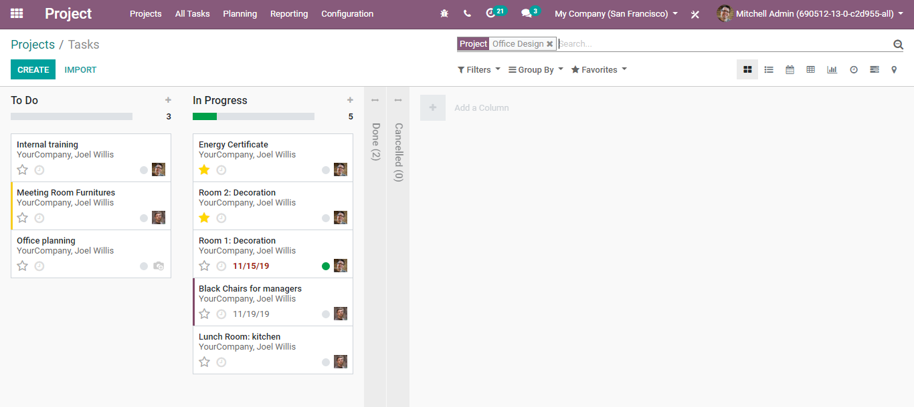

**Sort tasks by priority**

Under each column, one can sort the tasks by their priority. Tasks with higher priority are always placed on top of the column. Upon clicking the star in the bottom left of a task, you can prioritize the task. For the tasks that are not tagged, BUSINESSBOXERP classifies them based on deadlines. Note: dates that passed their deadlines will appear in red.

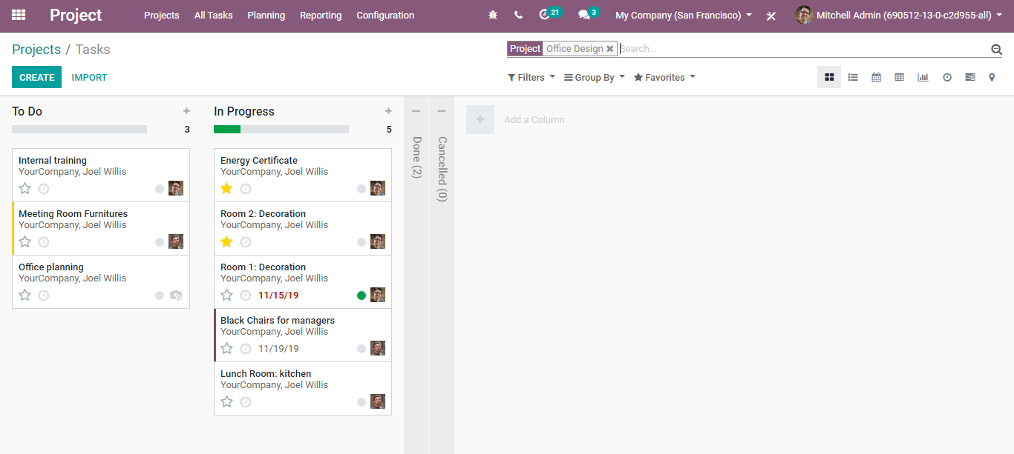

Track the progress of each task from the list view

The managers get a glimpse of time spent on tasks for all employees using the list view.

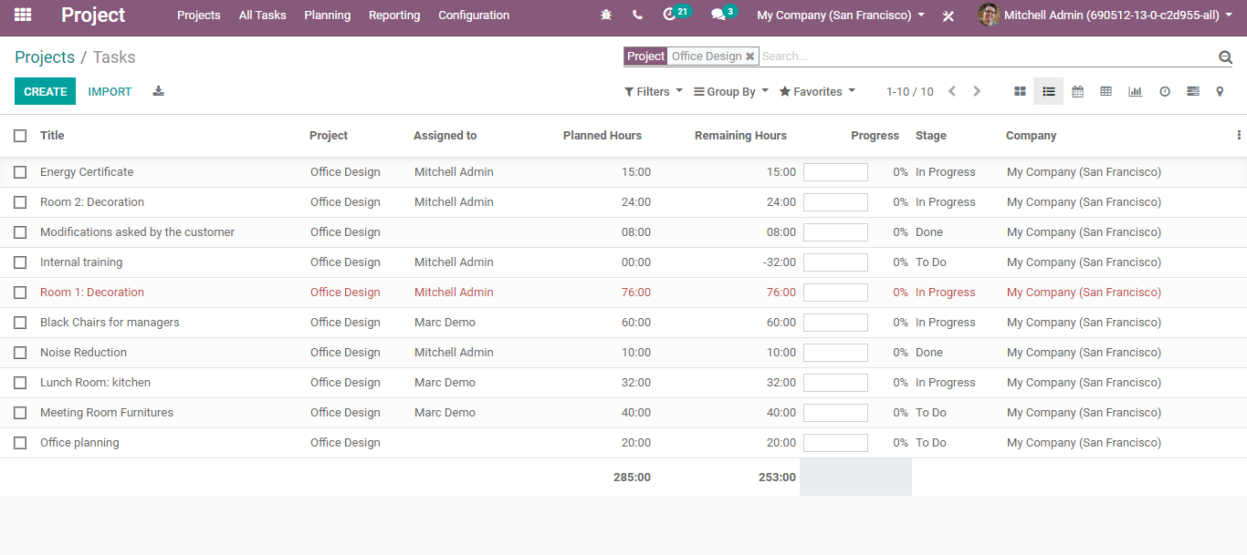

From calendar view managers can quickly get to know the deadlines set if any.

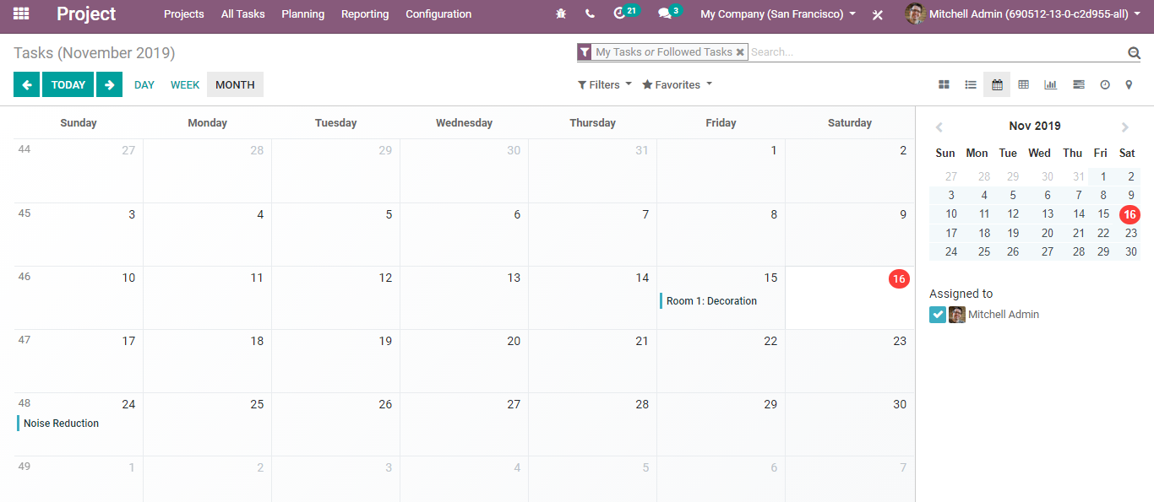

Pivot view

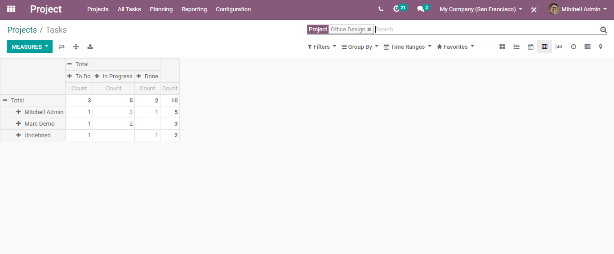

**NOTIFY TASK**

BUSINESSBOXERP project enables you to notify the co-workers of the status of your tasks from Kanban view. As said, you can make use of the little dot beside each task.

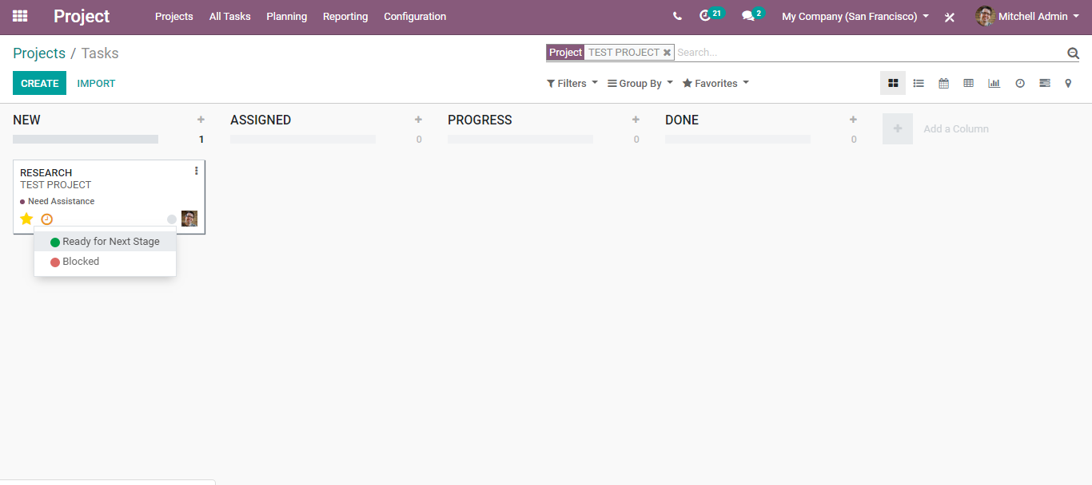

The green button, upon clicking it, you can mark this task as ready for the next stage and red to block it from further proceedings. These dots will notify the task follower if the task is ready or not.

**SUBTASKS**

**Configuration**

**Go to Projects> Configuration>Settings**

Under Settings, you will find a couple of options under Task Management. You can activate the option sub-tasks. Click the SAVE button to mark the changes.

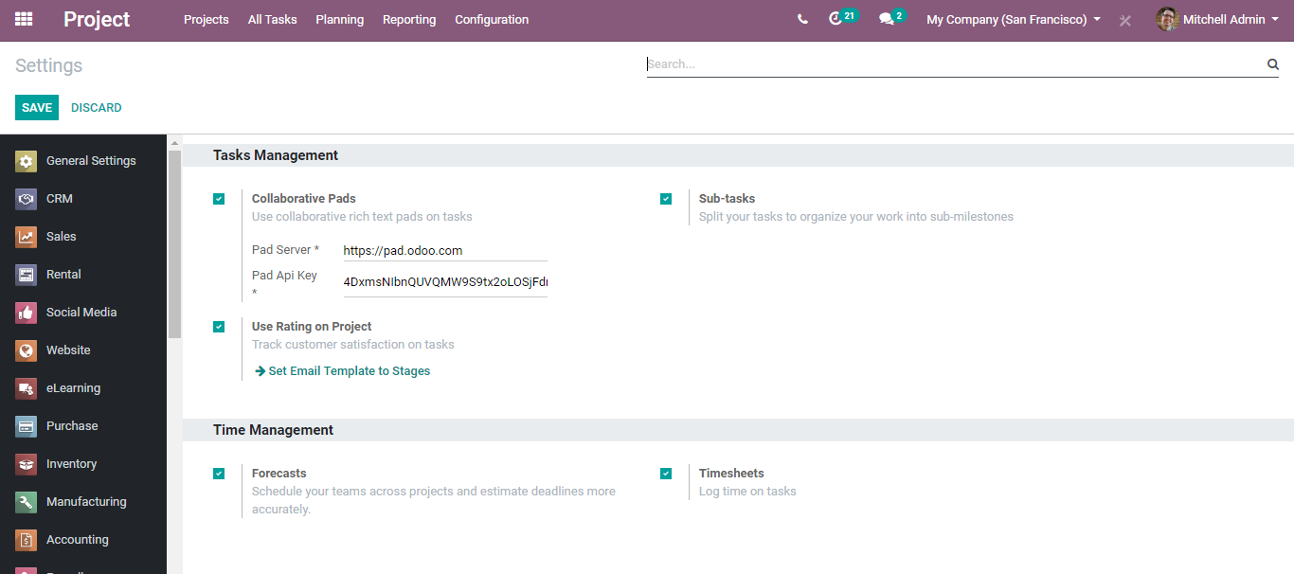

Later go to the project and select any task. One can find the new option subtask on top of the window.

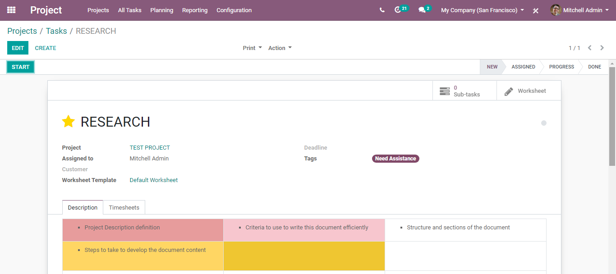

Upon clicking the sub task button, you will be navigated to a new window where you can create a new subtask for the parent task.

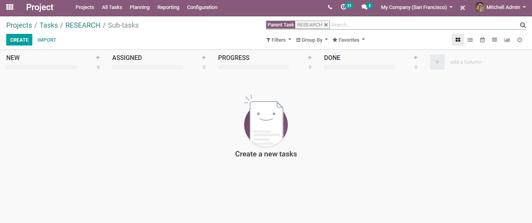

There you can find the task title and the person to whom the subtask is assigned. Later click on the Add button. One can also modify the subtask via clicking on the edit button.

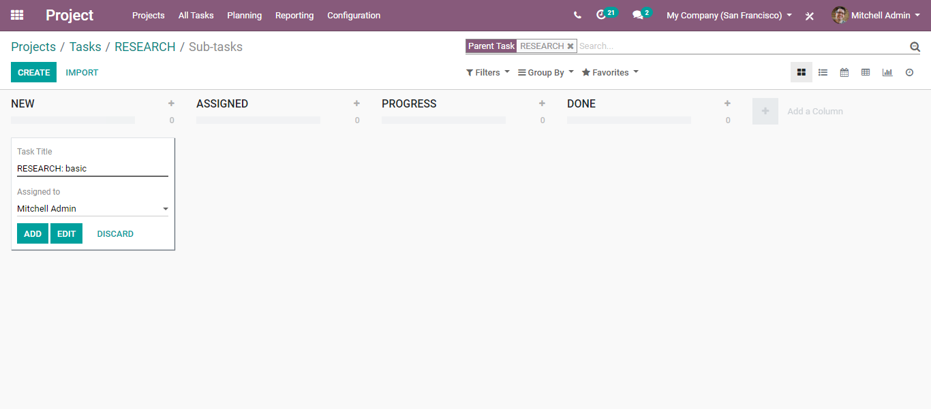

One can access the parent task from here itself.

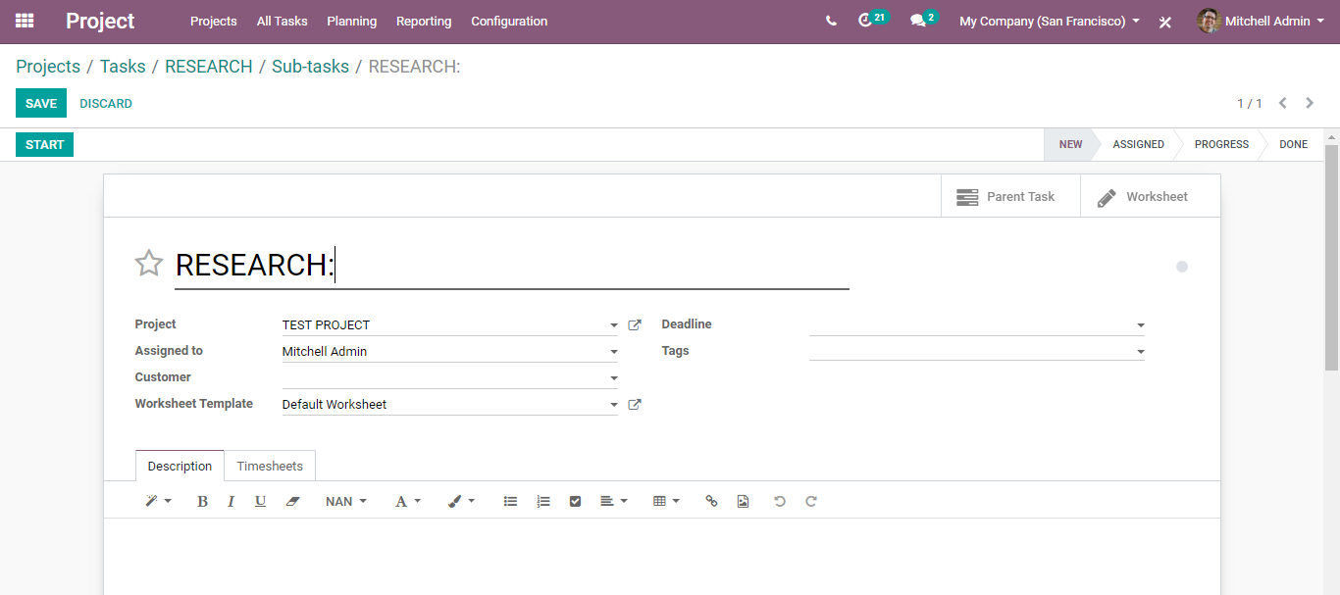

**RECORDING TIME SPENT ON TASK**

With the help of the BUSINESSBOXERP project management module, one can easily record the time spent by an individual employee on a particular project/ task. This can help create valid project reports as well as for direct invoicing to the customer.

**Configuration**

To record the time spent on projects, firstly activate the feature timesheets under the time management option.

**Project> Configuration >Settings>Time management> Timesheets**

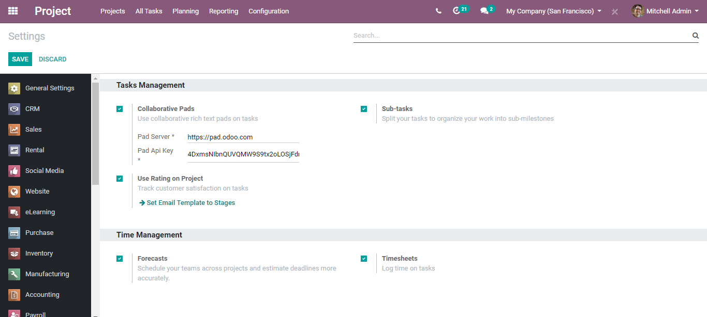

**Recording timesheets**

Go to the corresponding project and thereby the task you want to record timesheets for.

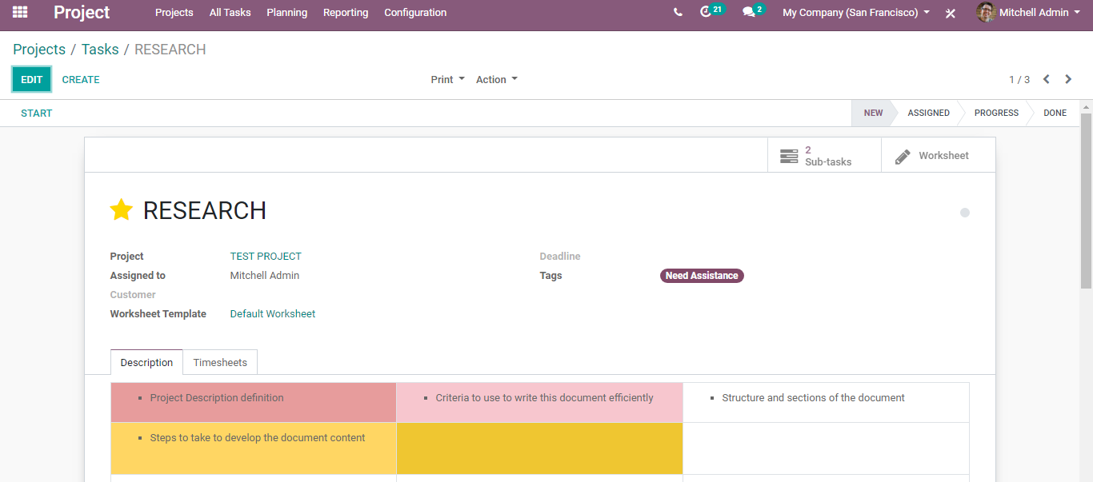

Click the START button to record the time.

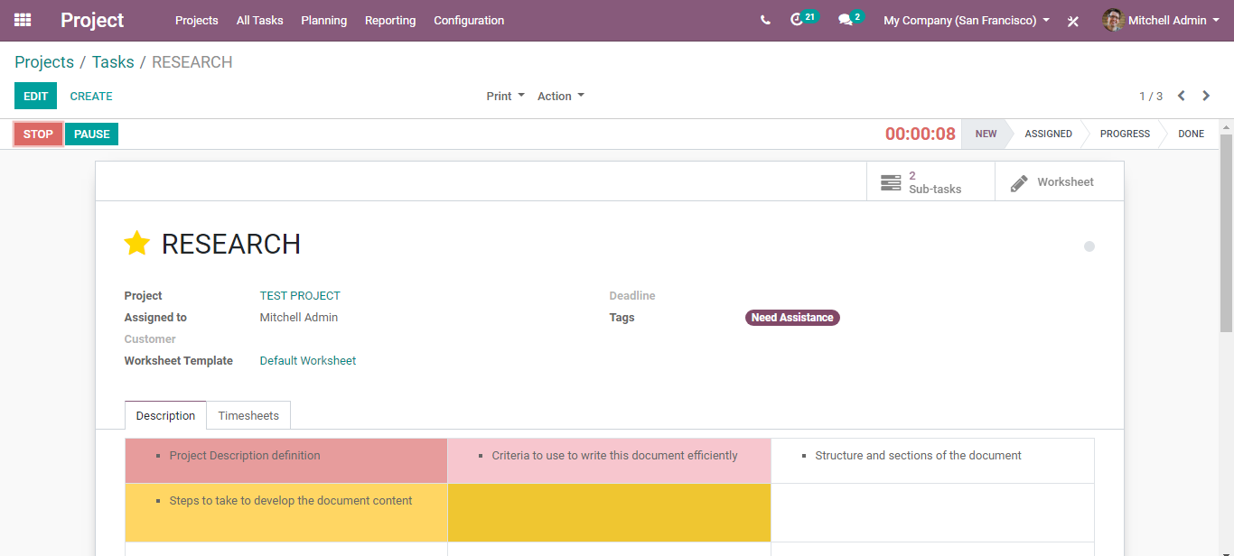

You can see the time getting recorded on top.

To stop the recording, click STOP and to pause click PAUSE.

Upon clicking stop. You get to a new window where you can confirm the time spent on the project task. Click SAVE to record the time.

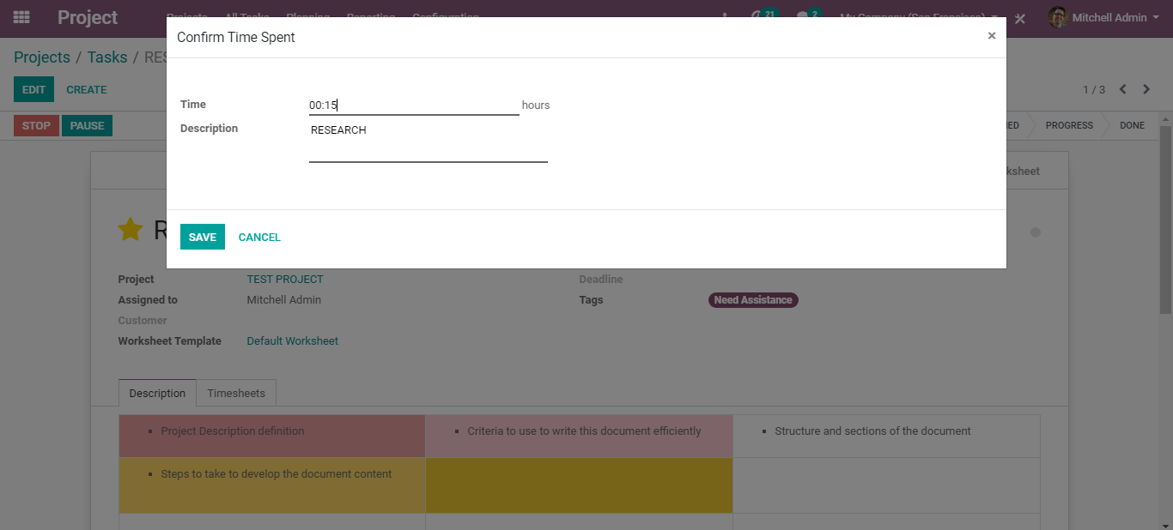

Now under the timesheet menu of the task, you can see the time spent by an employee on this task. You get to see the date, employee name, description of the task and the duration of time spent.

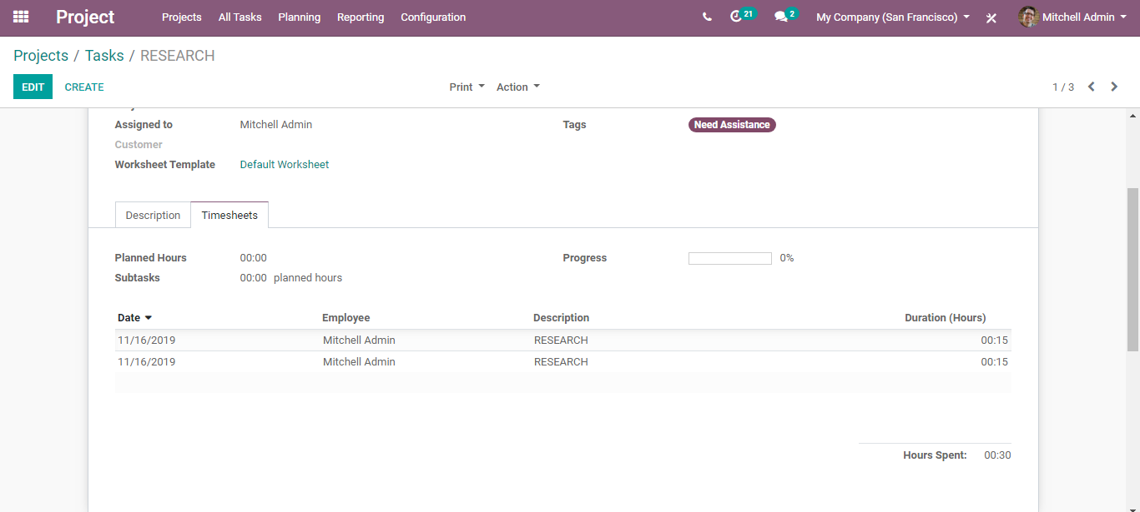

Via clicking EDIT, you can mark necessary changes in the timesheet.

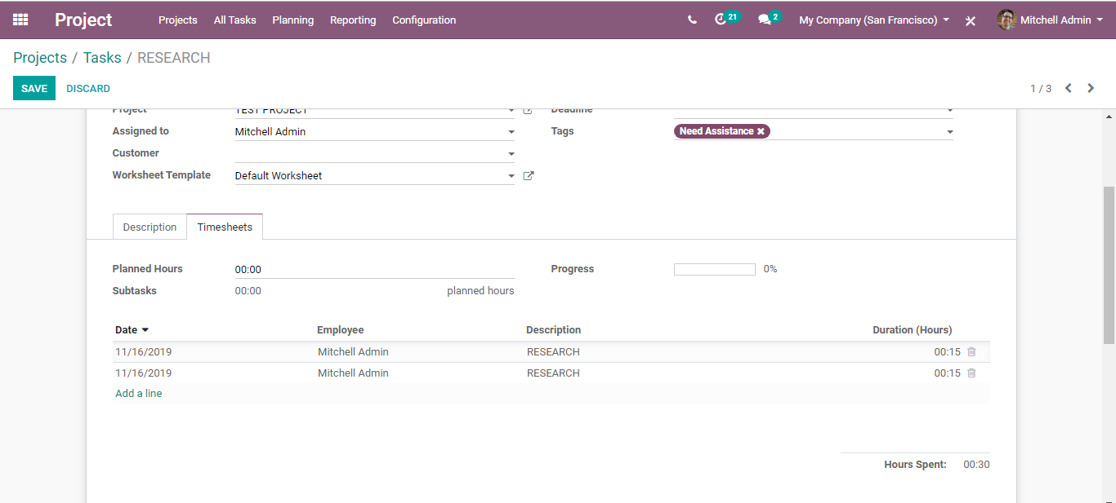

You can set here the planned hours- the time planned to archive this task. Upon setting it, you get to see the progress of the task in the progress bar, also the remaining hours available to complete the task.

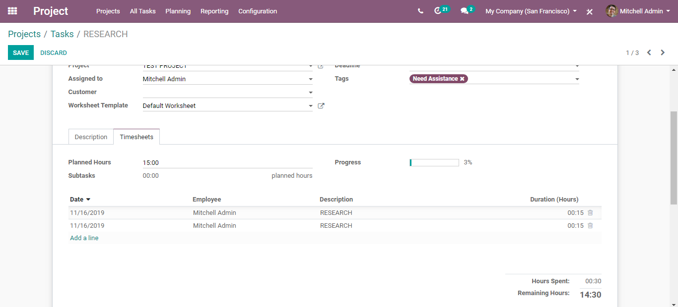

**PLANNING TASKS**

Under the planning feature of BUSINESSBOXERP, one gets access to the Gantt chart enabling better planning and organizing of the workload and human resources.

**Configuration**

**Project> Planning**

Under BUSINESSBOXERP, one can either plan by project or plan by the employee.

Upon clicking planning by the employee, you get the following Gantt Chart.

[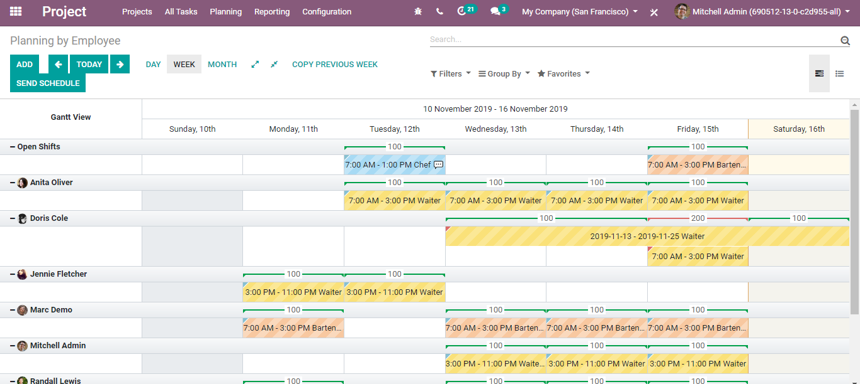](https://www.images.cybrosys.com/images/odoo-book-13/odoo-book-v13-pm-38.png)

One can see easily see from here in the Gantt chart, which people are assigned or who has been involved assignment.

In case any alterations are needed in the current schedule, one can do them from here. One can seamlessly allocate the resources effectively.

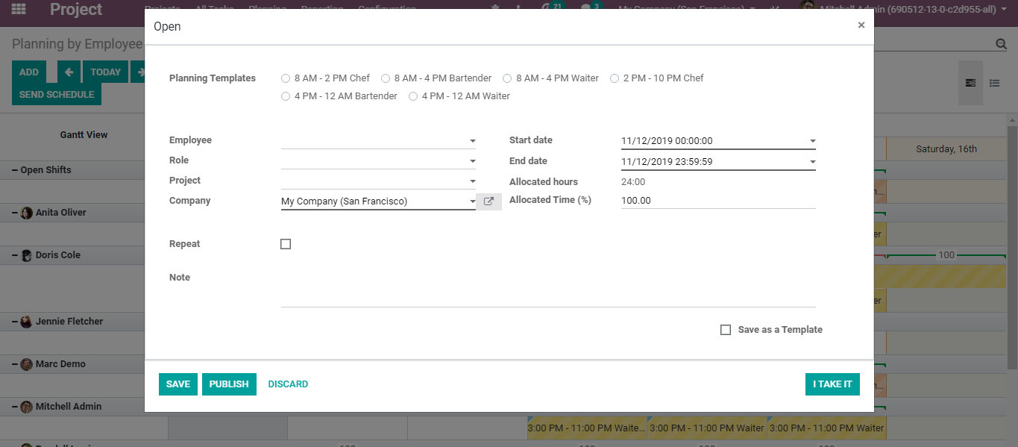

One can choose the suitable planning template, employee, role, project, start and end date, allocated hours, allocated time for the new plan.

After making the changes, you can send the updated schedule to the employees. For that click, the SEND SCHEDULE button.

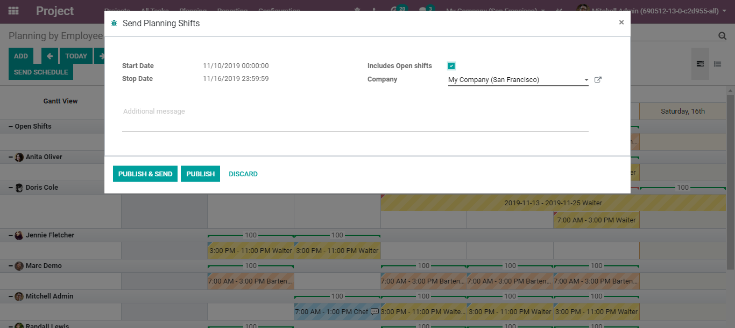

**Planning by Project**

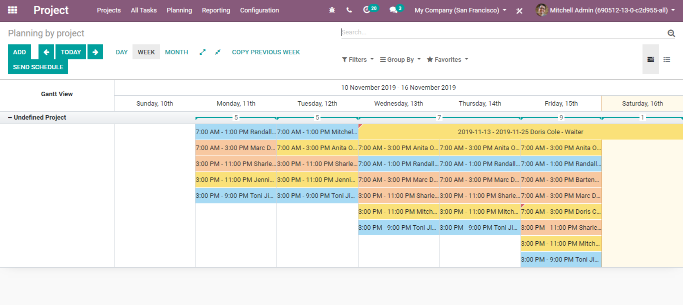

To make changes in the shift, click the corresponding.

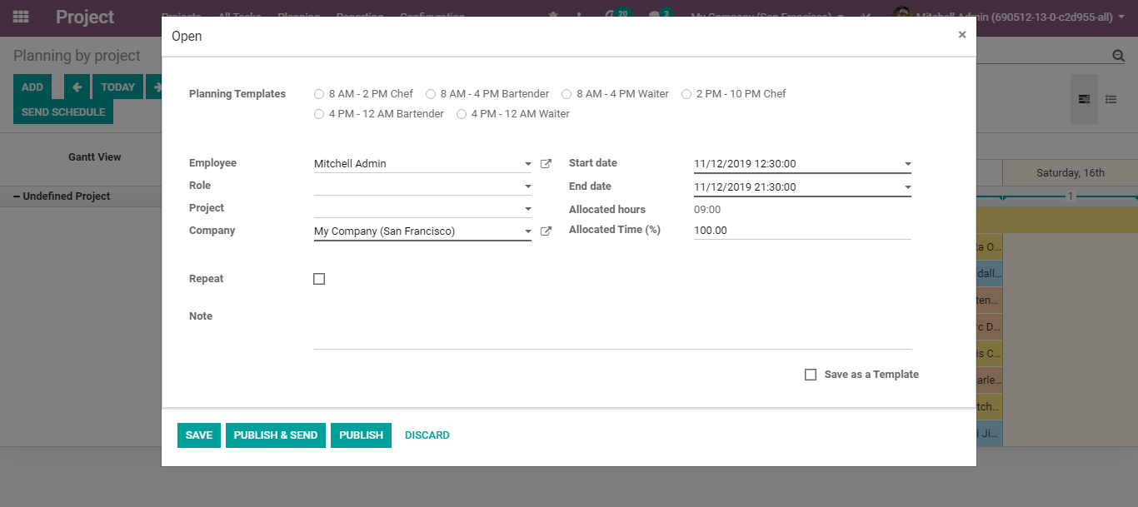

**INVOICING PROJECT**

Under the BUSINESSBOXERP Project Management module, the invoice is done on three elements.

* Timesheet
* Ordered quantity
* Milestones

To configure different service invoicing policies, go to the sales module, create a product with product type as service. Under the sales tab of the product, select the Service Invoicing Policy option: Timesheets on Tasks, Milestone, Ordered Quantities.

Here, one can also enable different service tracking options. For instance: Do not create a task, create a task in an existing project, create a new project but no task.

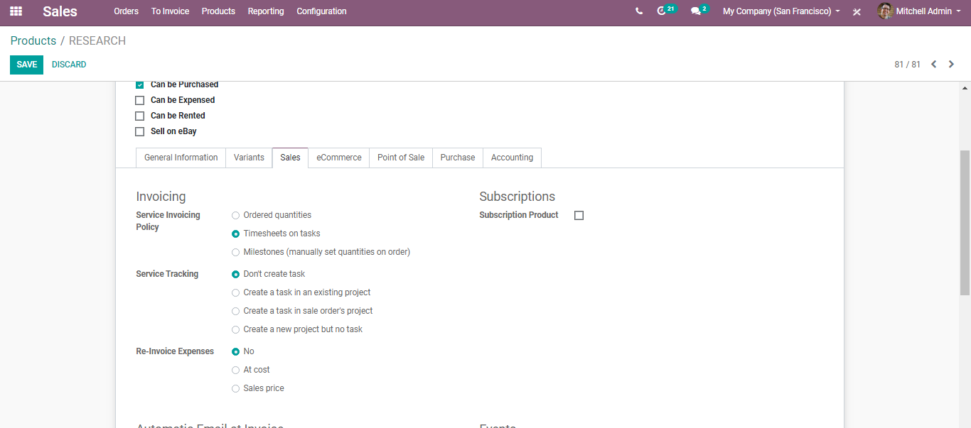

Click save to mark the changes.

Each project will have more than one task that is managed by different employees. Therefore, each employee’s timesheet cost will be different. Timesheet cost is the service cost of an employee per hour on a project. Invoice based on the timesheet is one invoicing method that helps to invoice the exact working hours of the employees on a project.

Now after configuring the product under sales, go to Projects.

Here you can see all projects with the respective project manager alongside the valid contacts.

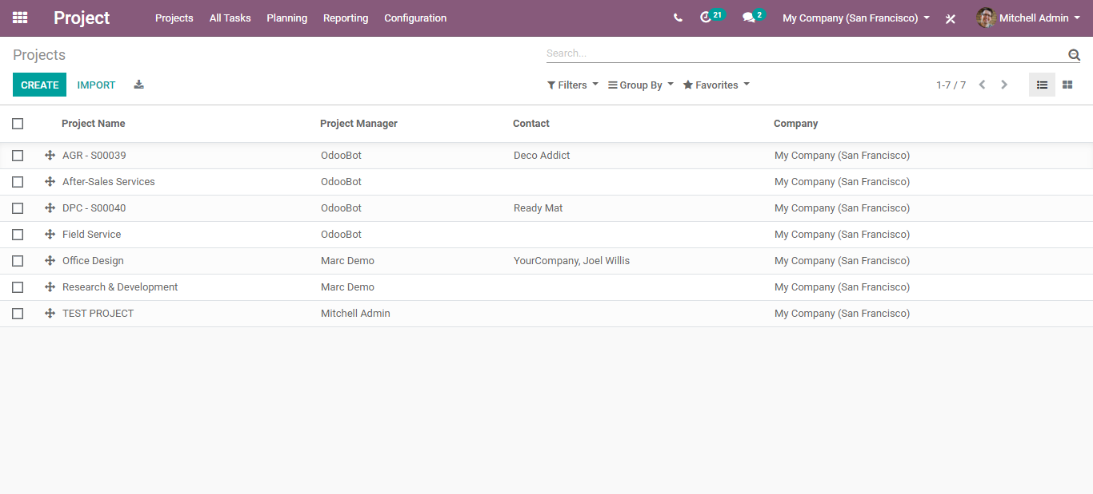

Next, open a project for creating the sales order.

Here you can edit the project if you want to or else click the CREATE button.

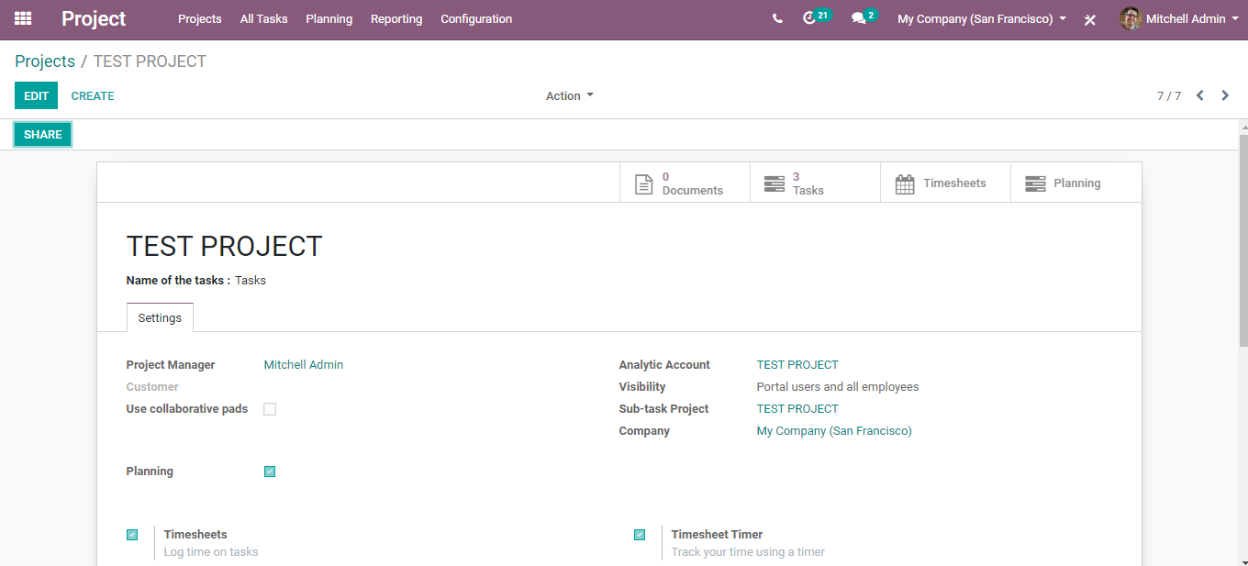

Upon clicking the CREATE button, you get to the following window, from where you can create the sale order for that project.

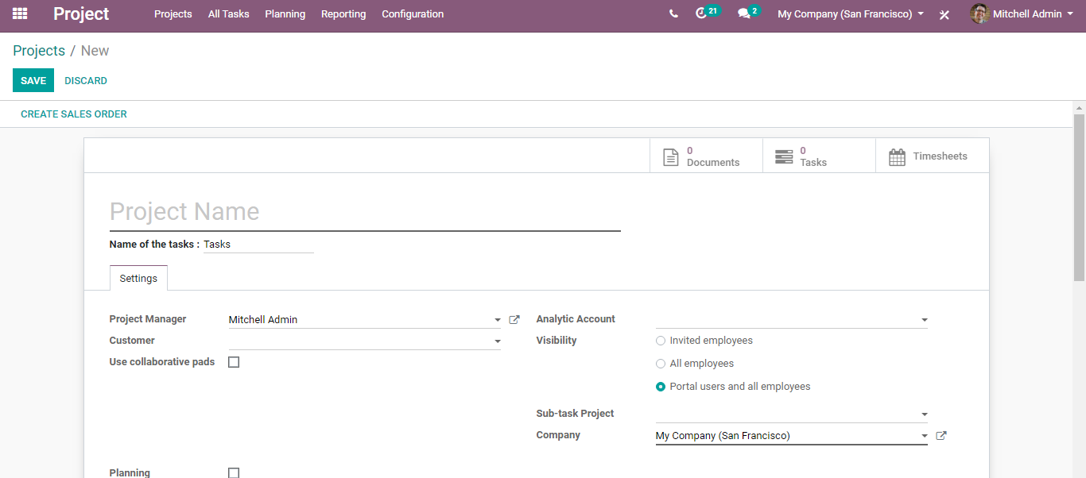

One can find here, the relevant details such as project manager, analytical account, customer, project visibility settings and many others.

Upon clicking the CREATE SALE ORDER button, a pop-up window will appear like below.

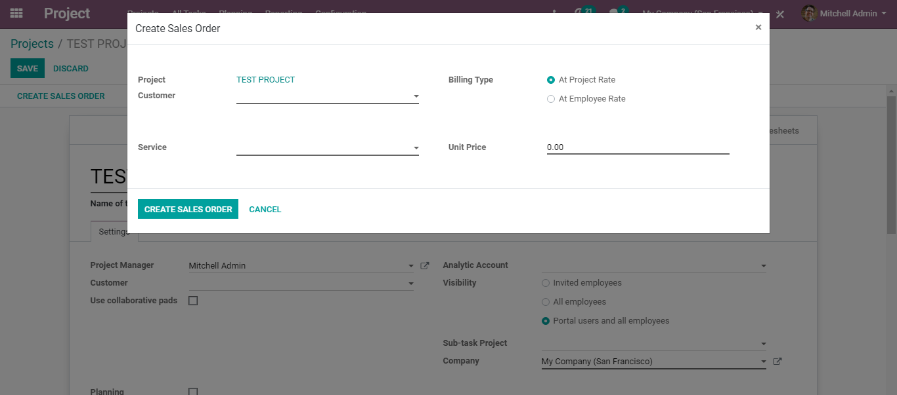

From here one can select the customer, the service, the unit price, and the billing type. By default, there are two types of billing in BUSINESSBOXERP:

* At employee rate
* At project rate

Under the Employee rate, the bills are calculated based on the timesheet cost of the employee. However, under the project rate, the cost amounts to the fixed cost of the project.

Click CREATE SALES ORDER button after entering all the details.

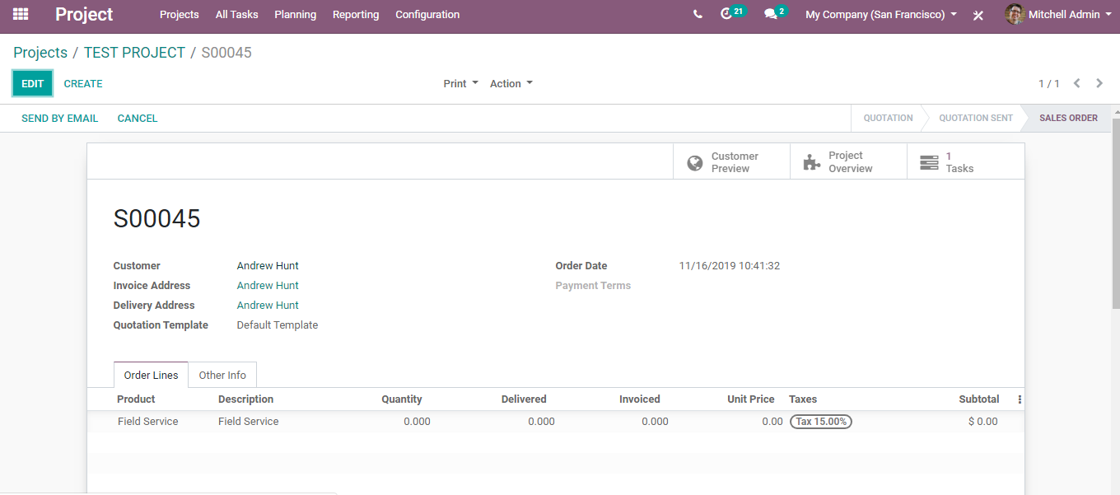

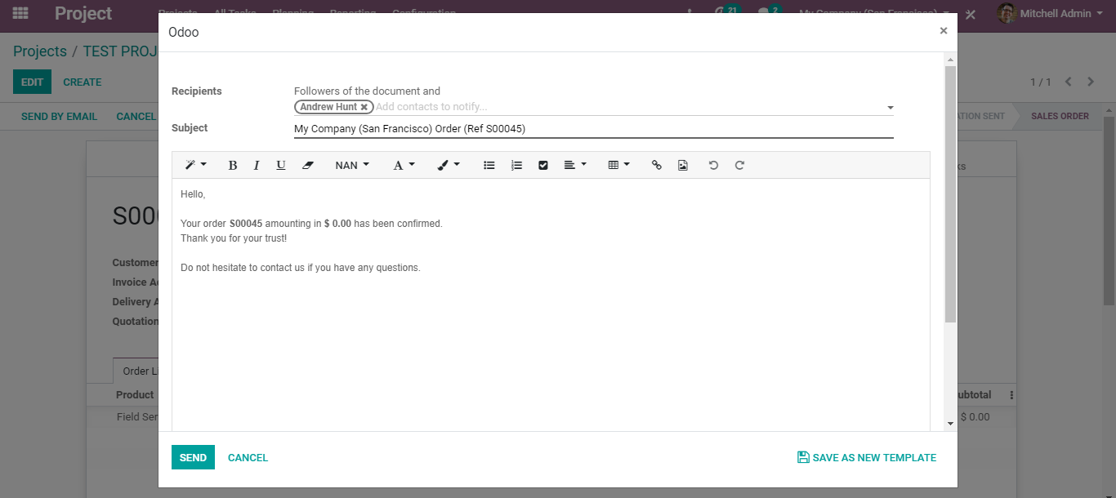

You can see the created sales orders under Configurations> Project.

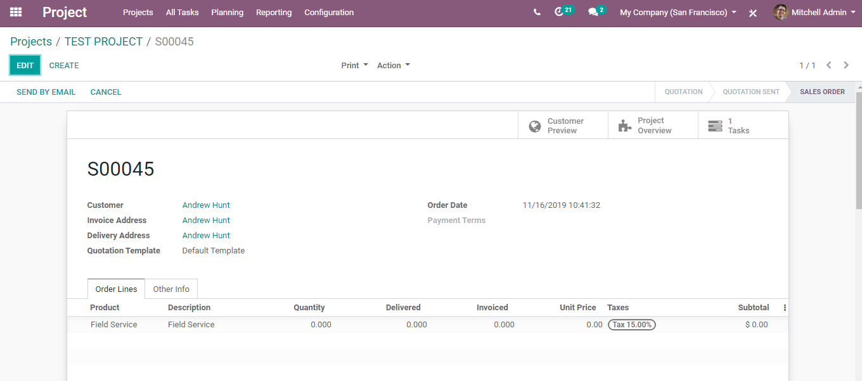

**PROJECT PROFITABILITY**

For a business firm, it is highly essential to know the profitability of each project. BUSINESSBOXERP Project, provisions easier tactics to acquire project profitability in a single click. One can also analyse the projected revenue and expenses using the analytic accounting enshrined in the module.

Open Project Module

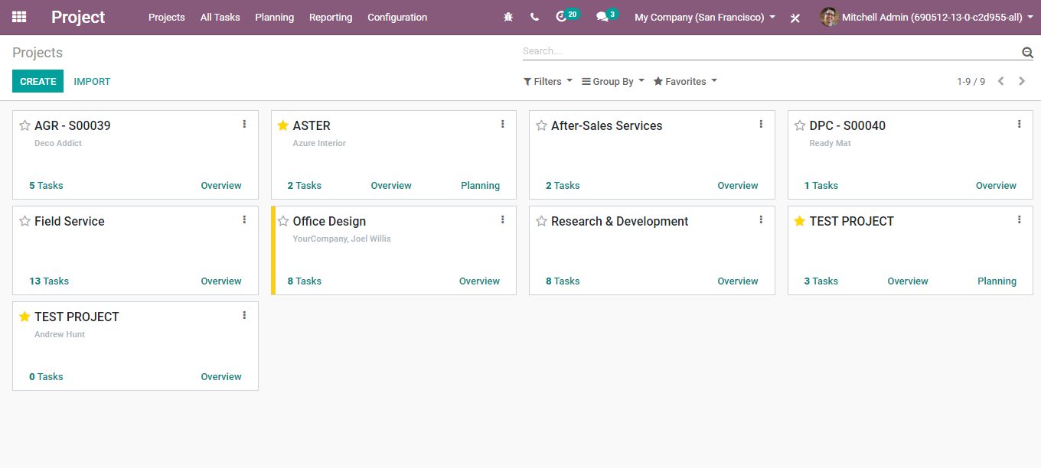

Under the Project Overview, BUSINESSBOXERP displays the current profitability status of a project.

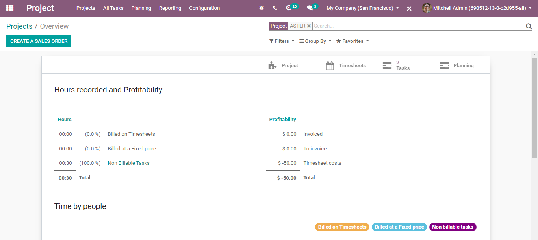

The profitability of a project is calculated based on three elements.

* Invoiced: A project has a sales order, and it may be fully invoiced when the invoicing policy is set based on the ordered quantity or partially invoiced in case of invoicing policy based on timesheet of tasks. Here the invoiced amount is displayed as invoiced.
* To Invoice: A project has a sales order, and the timesheet is updated with an employee, which means service is delivered to the customer, but not invoiced.
* Timesheet Cost: Timesheet cost = Delivered Quantity * Employee Timesheet cost. Timesheet cost is the amount that a company has spent on a project.

Profitability calculation:

Total = Invoiced + To invoice - Timesheet cost

Profitability Using Analytical Accounts

One can analyse a project using Analytical accounts. Upon creating a new project, BUSINESSBOXERP creates an analytic account with the same name of the project.

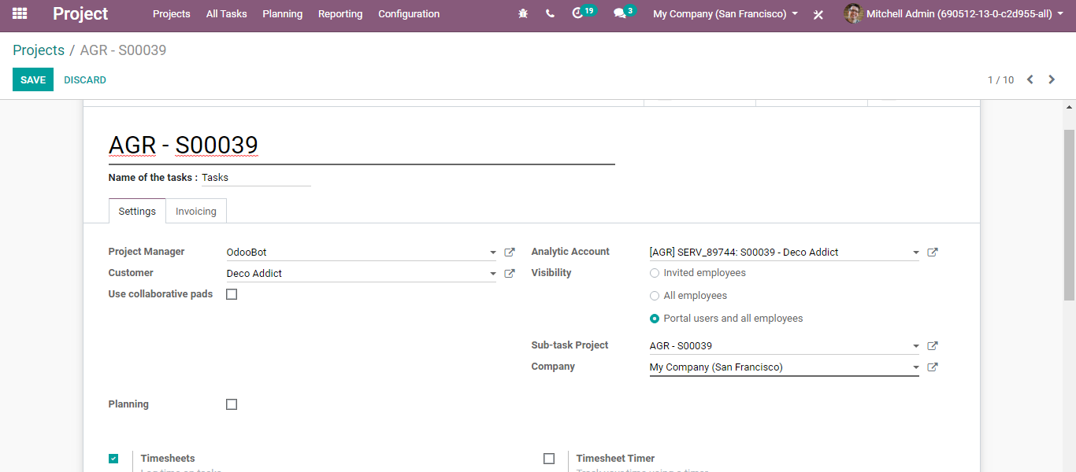

To get the detailed report of this project,

**Go to Accounting >Management > Analytic Items**

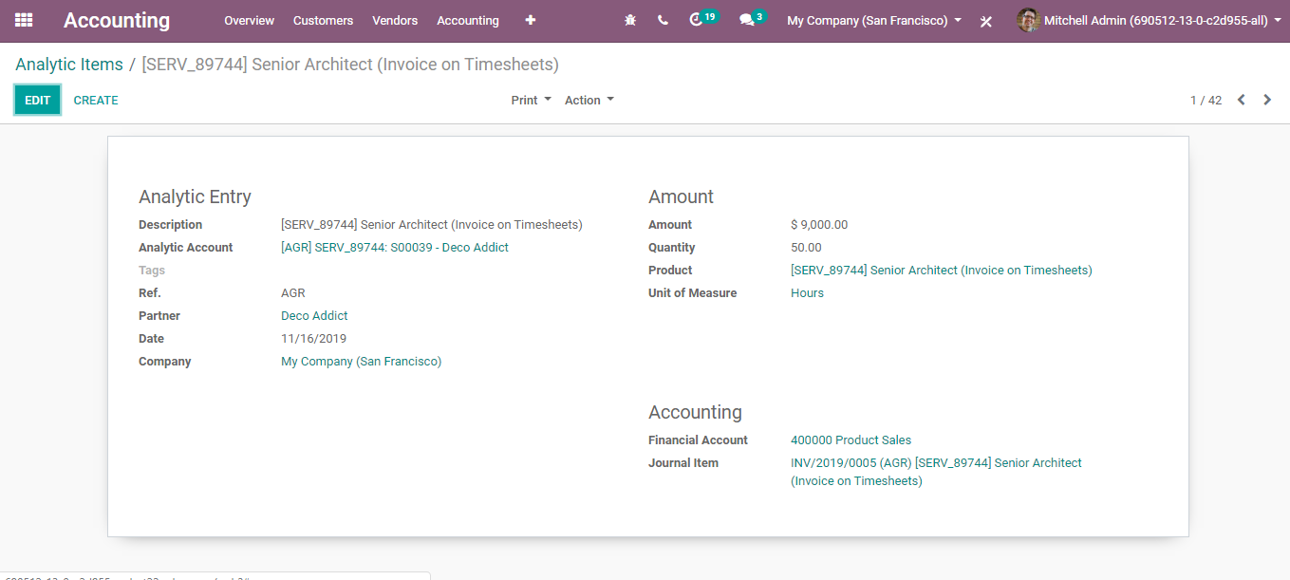

**PROJECT PRIVACY**

Privacy is always an upheld factor in project management. However, one can seamlessly manage the privacy settings in BUSINESSBOXERP. BUSINESSBOXERP comes with different features in the Privacy setting under Project management. There are three types of Privacy features in BUSINESSBOXERP, and they are as follows-

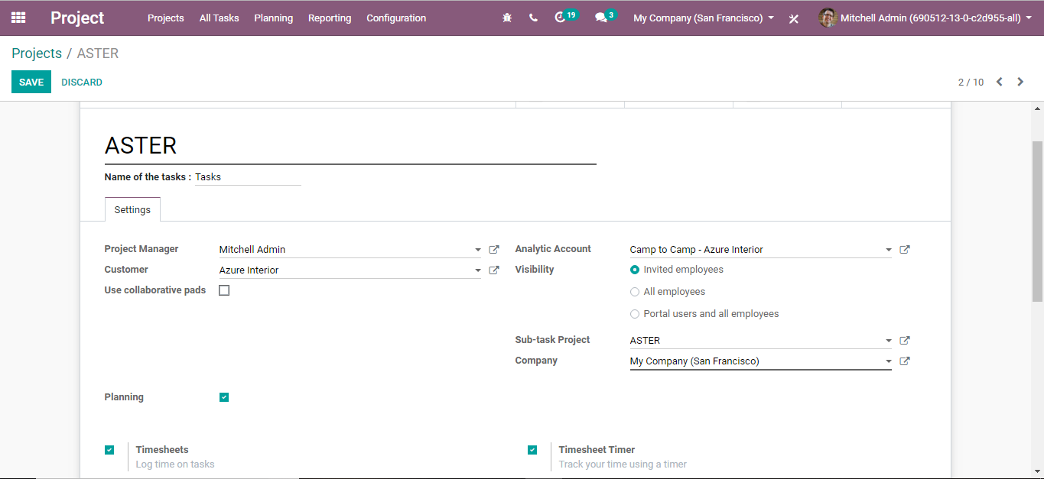

* Visibility to Invited Employees: Upon selecting the option “Invited Employees,” the privacy changes and the corresponding project, tasks, and issues can be viewed only by the internal users who are followers of the project.
* Visibility to All Employees: Upon selecting the option, the privacy changes and the project, corresponding tasks, and issues could be viewed by all the employees.
* Visibility to Portal Users and all employees: Upon selecting the option, one can add the portal user as the follower. the project, corresponding tasks, and issues could be viewed by all the employees.