**SMS Marketing**

SMS Marketing is a fantastic way to boost conversion rate. The SMS Marketing strategy has a high percentage of penetration to people as people who use smartphones do not keep unread SMSs!

With BUSINESSBOXERP’s SMS Marketing application, one can you can plan, organize, schedule, and keep track of the mailings in a better way. The easy-to-use interface helps in easy management of the previously mentioned functions.

Install SMS Marketing App from BUSINESSBOXERP Apps.

As soon as you enter the application, you are welcomed with an easy-to-use interface of BUSINESSBOXERP SMS Marketing.

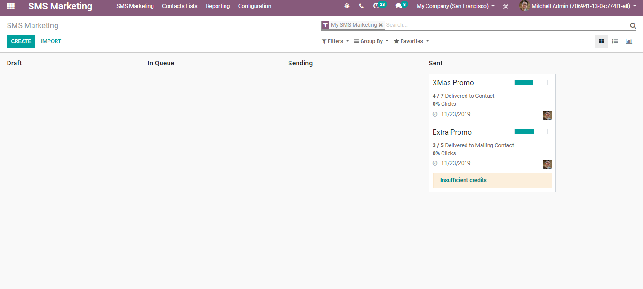

**Create SMS Mailings**

To create SMS mailings, go to SMS Marketing> Create.

You will be navigated to a new window like below:

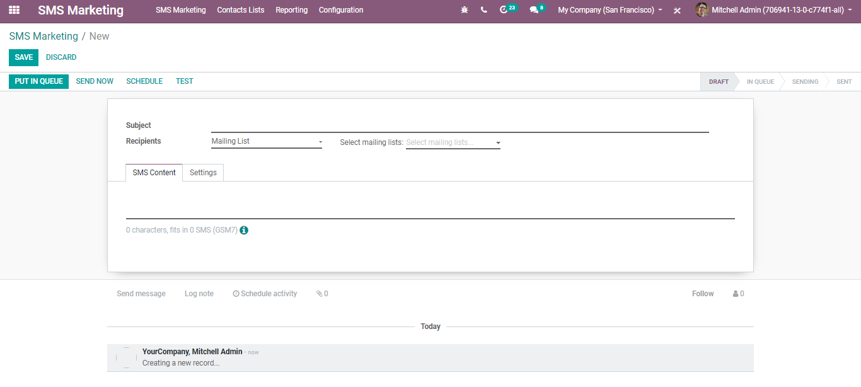

Under the create form one can specify a subject name (what the mailing is about).

Secondly under recipients, one can choose to whom you would like to send the SMS.

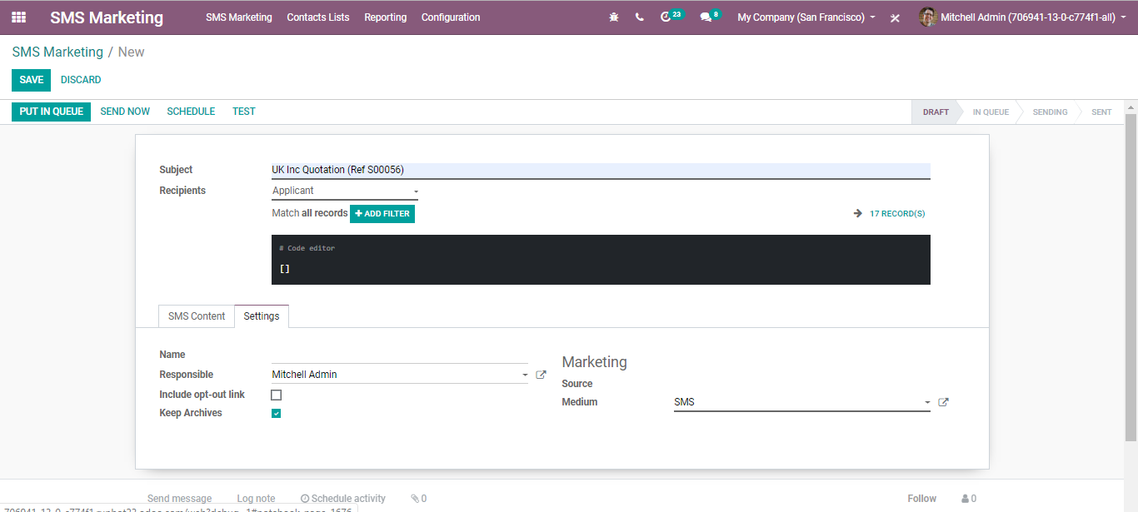

Depending on the recipient one can add filters for our records.

Under the SMS Content tab, one can add the contents.

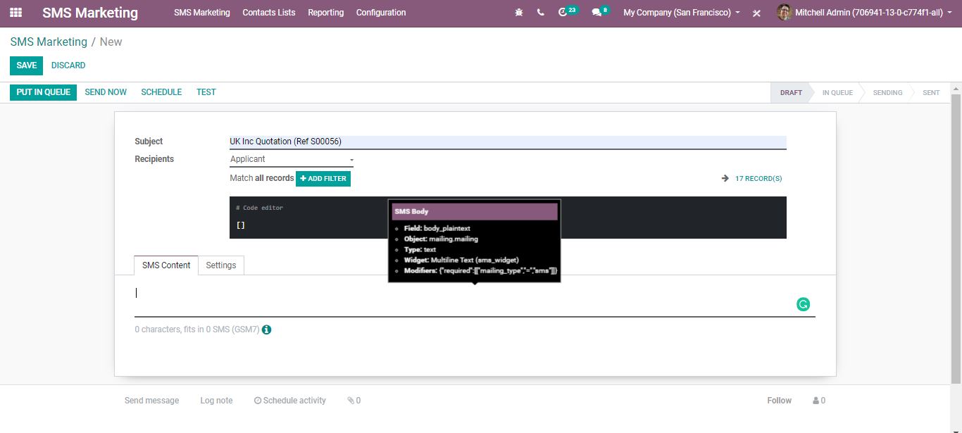

With the information icon, one can easily check for the prices to send an SMS to your country.

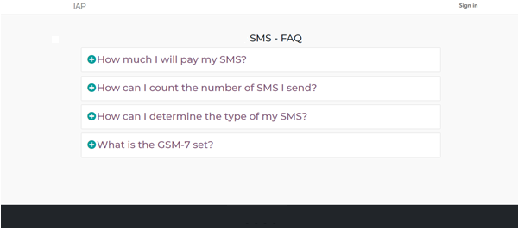

On Settings

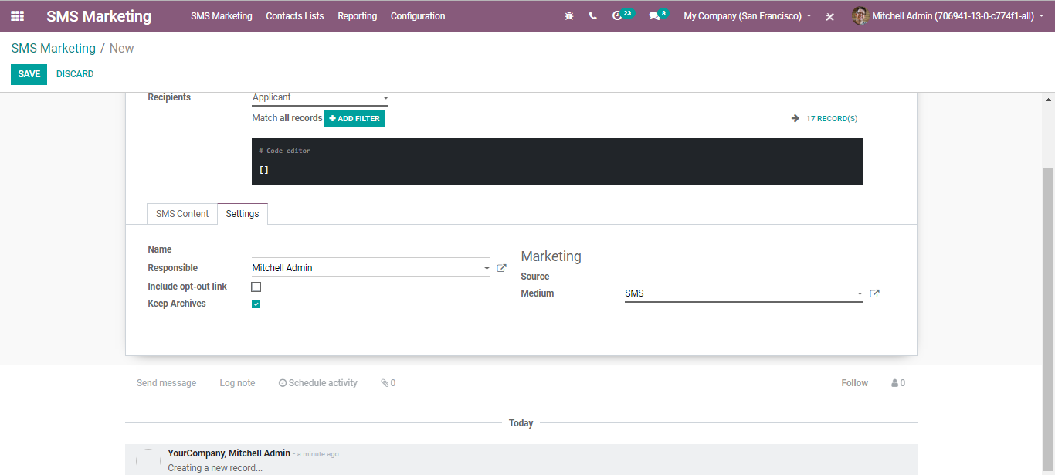

One can include an opt-out link. If activated, the contact will be able to unsubscribe from the mailing list he is not interested in anymore.

If you go to the Link Tracker menu under SMS Marketing configuration, one can see the history of sent links.

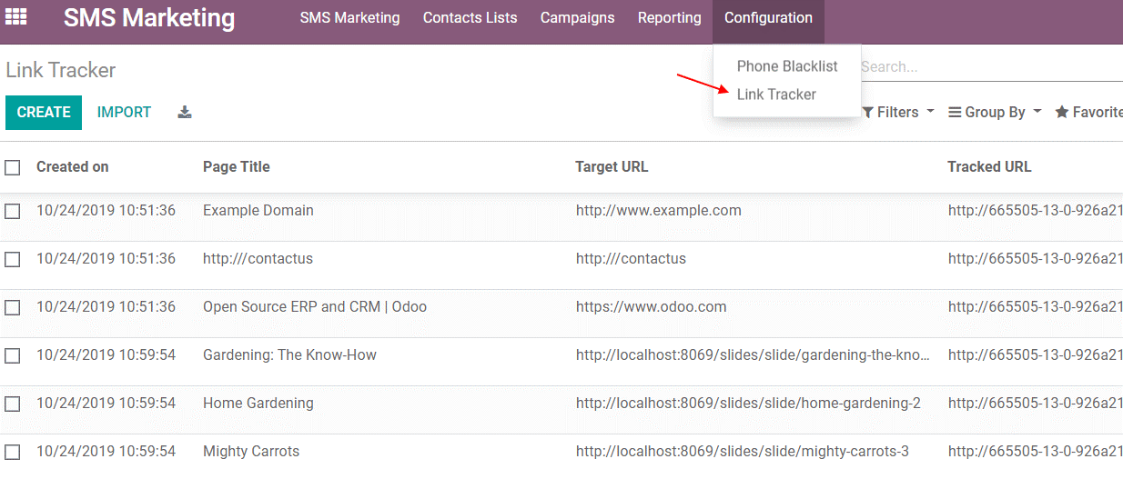

**Sending my mailing**

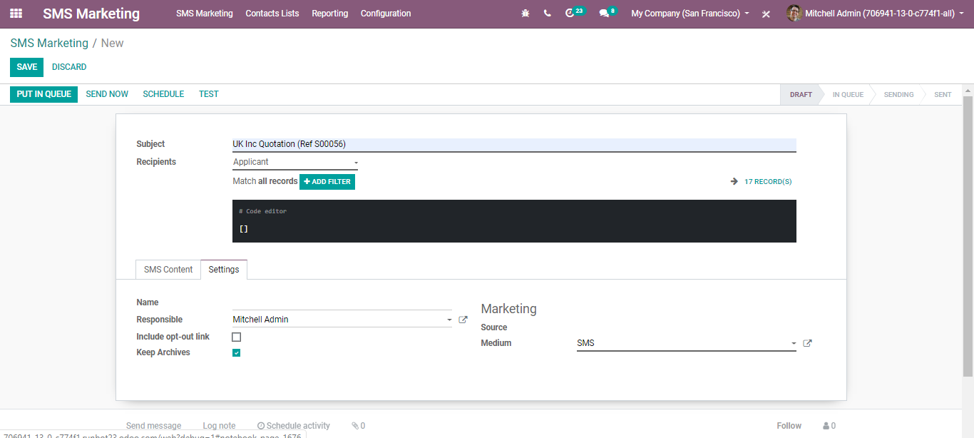

As you see you have the following options here.

odoo-sms-marketing

Put in queue: Triggers mailing in the next automatic run.

Send now: To immediately send the message. Advised when there are not many recipients.

Schedule: Access to choose day and time for sending SMS.

Test: Sending SMS for testing purposes.

**Visualize reports**

Via going to SMS Marketing> Reporting one can analyse the performance of SMS mailings. Also, you can make use of the filters to get more intrinsic analysis.

