## Social Marketing

The greatest test of an organization is to connect effectively with their locale. BUSINESSBOXERP Social Marketing helps you to meet your group of audience with the assistance of a few backings: social media, pop-up messages, or live chats.

As the module name, BUSINESSBOXERP Social Marketing better manages your social profile.

Let us check it out. Firstly, install the BUSINESSBOXERP Social Marketing App from BUSINESSBOXERP Apps.

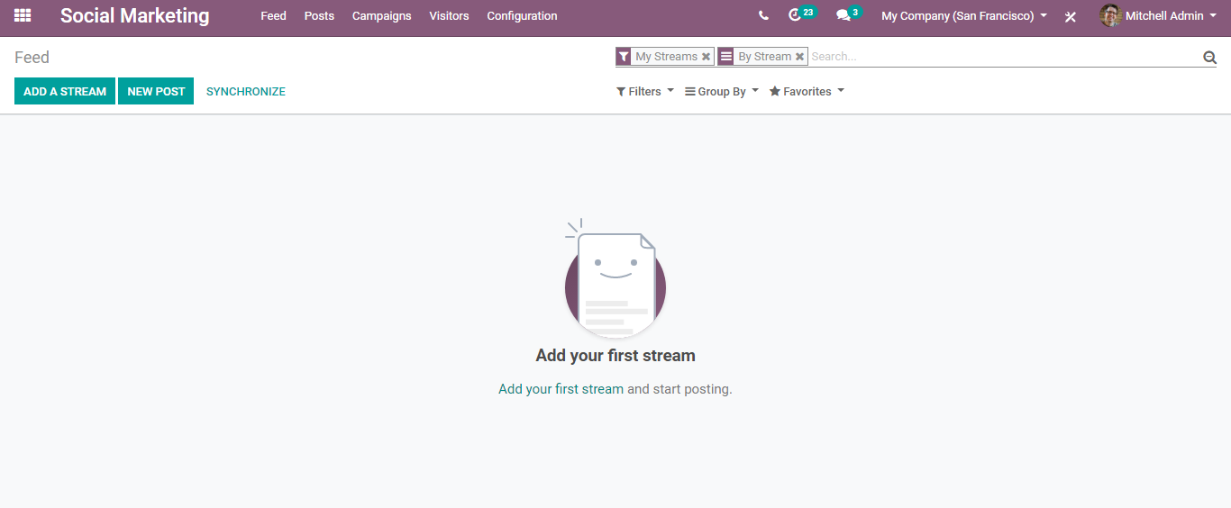

#### **Adding social media and creating feed**

To start with, firstly you need to add your social media accounts. For that, click ADD A STREAM button on top of the dashboard.

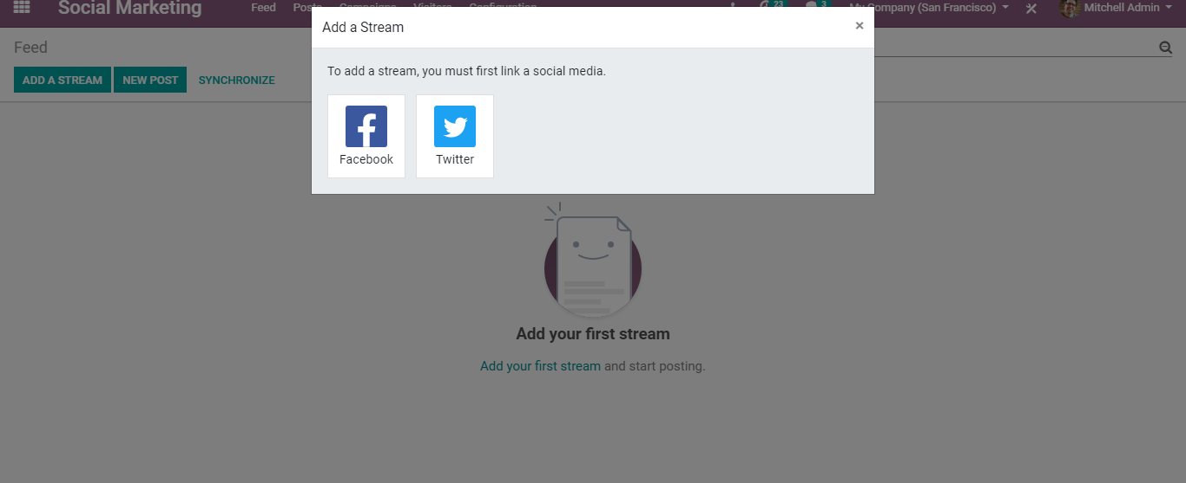

Once it is fixed, next the user shall be redirected to the feed.

Automatically a column gets added with the publications of your added account.

The user can now add streams to their feed. Also, customize the Kanban view as desired.

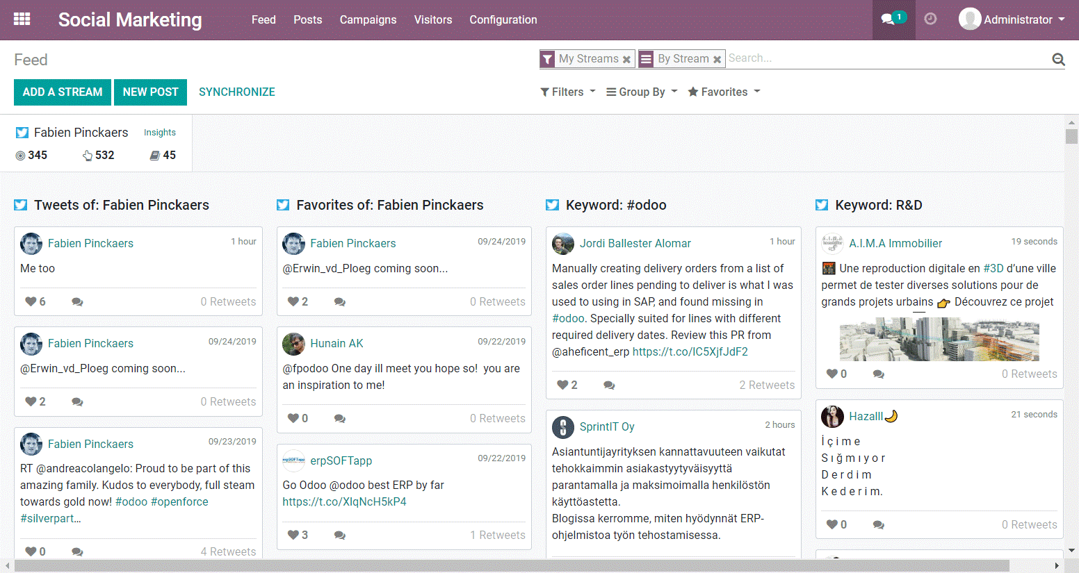

Adding social media accounts to the Feed automatically adds KPIs to it.

Audience: Channel Followers.

Engagement: How many times did people get engaged with the posts?

Stories: How many times do people get engaged with channels and share or retweet your posts?

###### **Publish content**

To publish any kind of content or push any kind of notifications to your subscribers, you can go to Social Marketing> Feed> New Post.

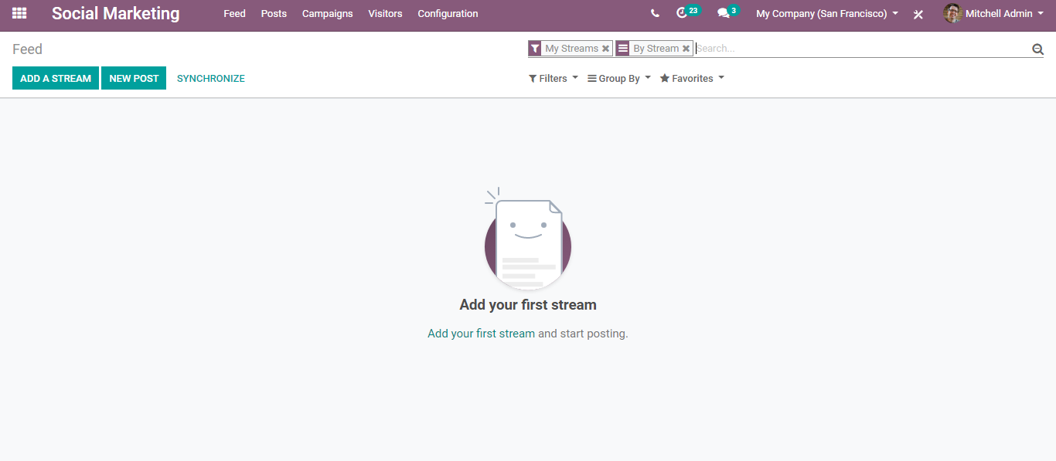

Upon clicking a new post, you will be redirected to a new window like below:

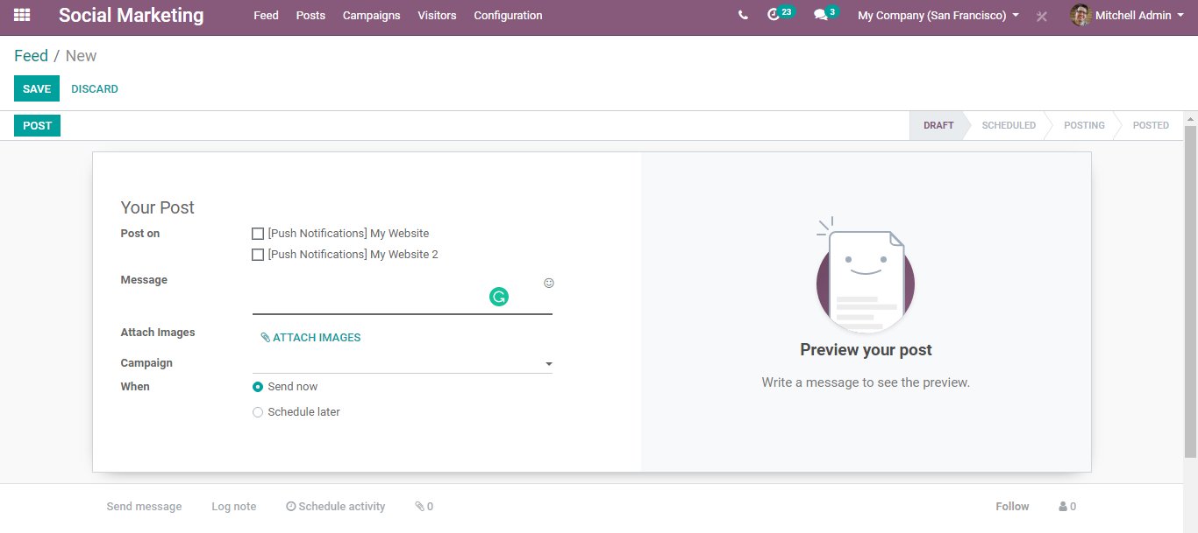

Here you can select the account in which you want to post the content, write messages, attach images if any, decide when to post whether now or schedule for later.

Via clicking the PREVIEW YOUR POST, you get with instant preview of how it will look when published.

Upon selecting PUSH NOTIFICATIONS, you get entitled to additional fields like below.

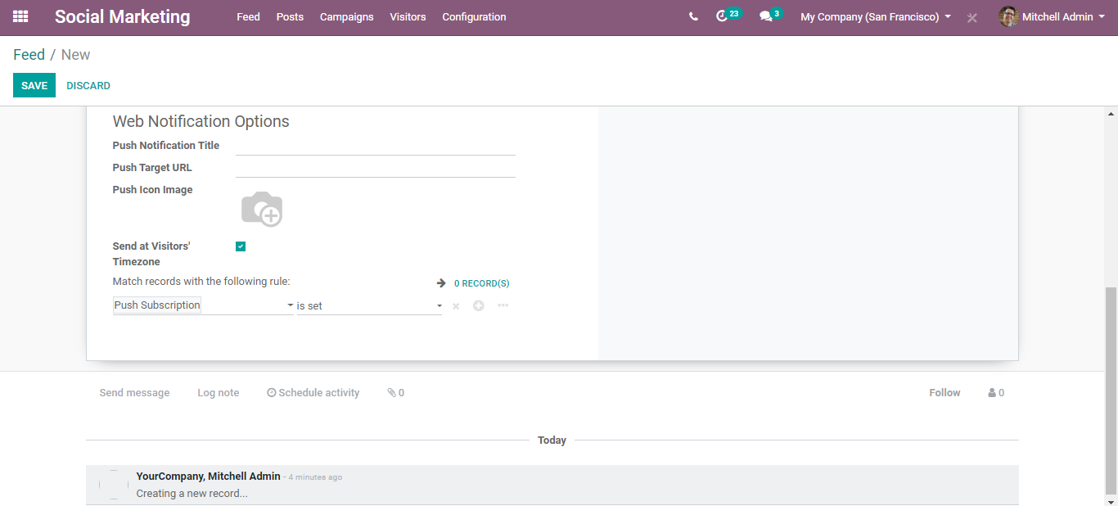

Via filling this in, one can complete the push notifications configuration.

#### Enabling push notifications on the website

By default, the push notifications system uses a Firebase account. It enables you to send push notifications to your subscribers.

**Configuration:**

**Website> Settings.**

Configure the notifications permission request.

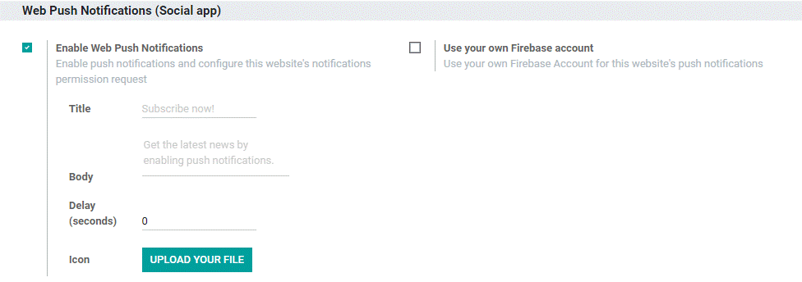

When it is set, a popup will appear to your site's guests, requesting that they permit message pop-ups. When they SUBSCRIBE to it, you can begin sending them message pop-ups through the Visitors menu. You can either send it independently or focus on a greater portion by choosing different guests in the list view.

#### **Interacting with online visitors**

One can seamlessly monitor online visits by making use of the Visitors menu. From here, one could see each visitor that got landed on the tracked page.

One can contact the visitors via sending emails /messages/ push notifications (if they have subscribed to it)/live chat requests.

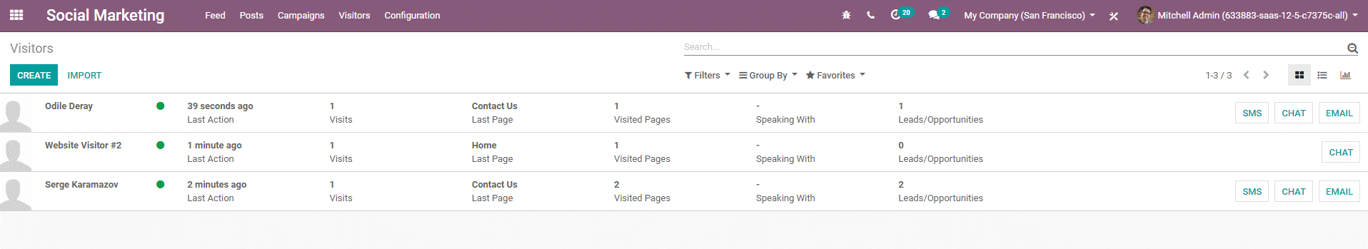

#### **Configuring social media accounts**

By default, the BUSINESSBOXERP Social Marketing is already configured with Facebook and Twitter accounts, however, one can configure a new account if needed. For that firstly activate the developer mode. Later go to Configuration > Settings and enter the API keys.

