**Subscription**

BUSINESSBOXERP comes savvy to all kinds of business communication platforms and the business models such as subscription are no exception with BUSINESSBOXERP. Often the subscription model comes into play when a customer must pay a certain subscription price to have the right access to the product or service. BUSINESSBOXERP Subscription app initiates excellent subscription management to efficiently handle the subscription business models.

To start with, firstly install the BUSINESSBOXERP subscription app from the BUSINESSBOXERP app store.

As soon as you enter the dashboard, you see the subscriptions in different stages.

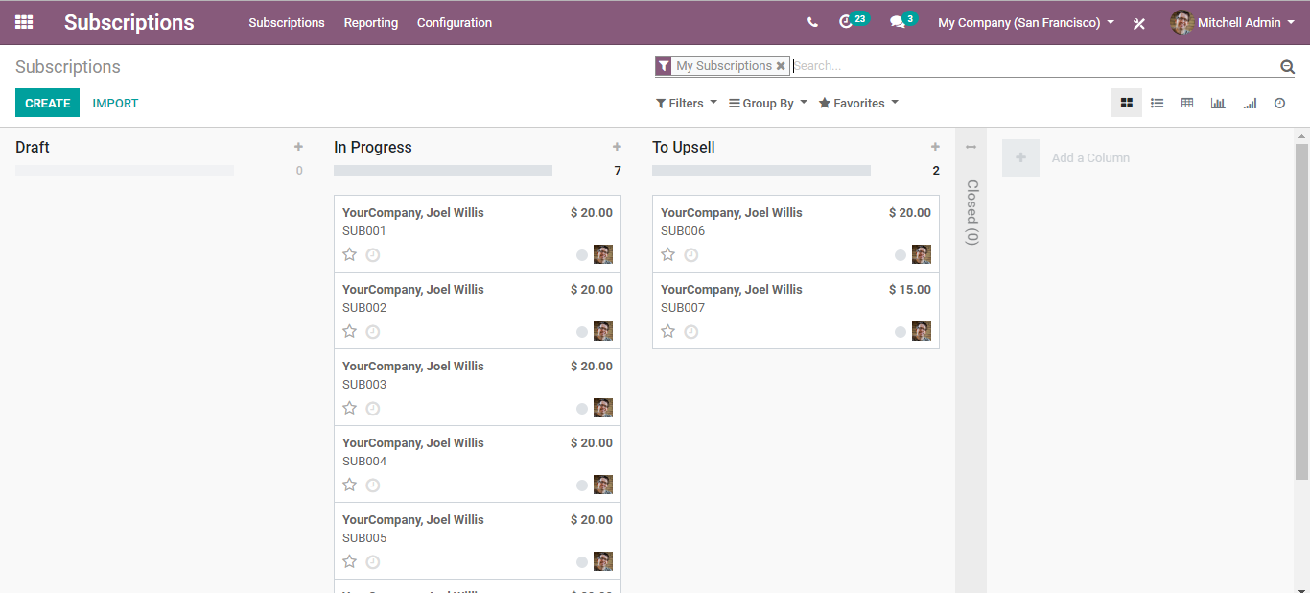

To activate a subscription, firstly create a ‘Subscription Template’ and a Subscription Product’.

Once you fix the template, assign the template to your subscription product.

To bind everything and sell the subscription, create the quotation templates under sales.

**Create Subscription Template**

To create subscription template, go to Subscriptions> Configuration> Subscription Templates

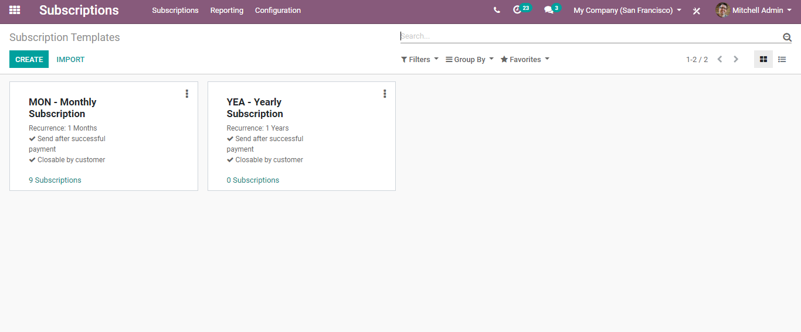

You can see the already created templates here. To edit the existing templates, click the three dots on the right end.

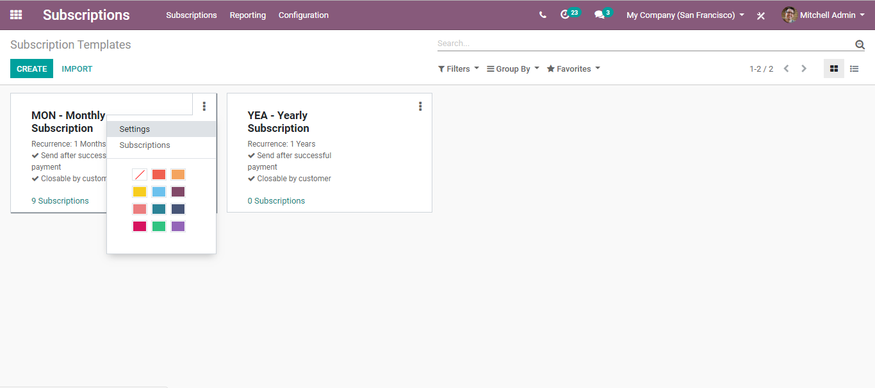

To create a new one, click on the CREATE button.

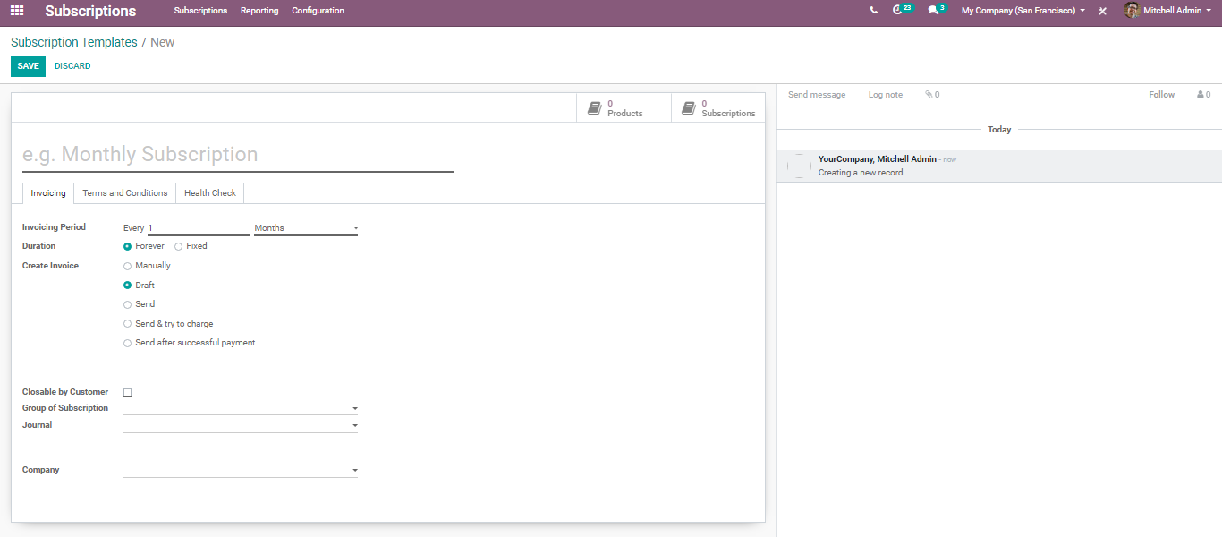

Here, one can add the following information:

Subscription name: Name of the subscription template.

Invoicing Period: Repeat Every Day/Week/Month/Year. It denotes whether your subscription is weekly, monthly, yearly and or so on.

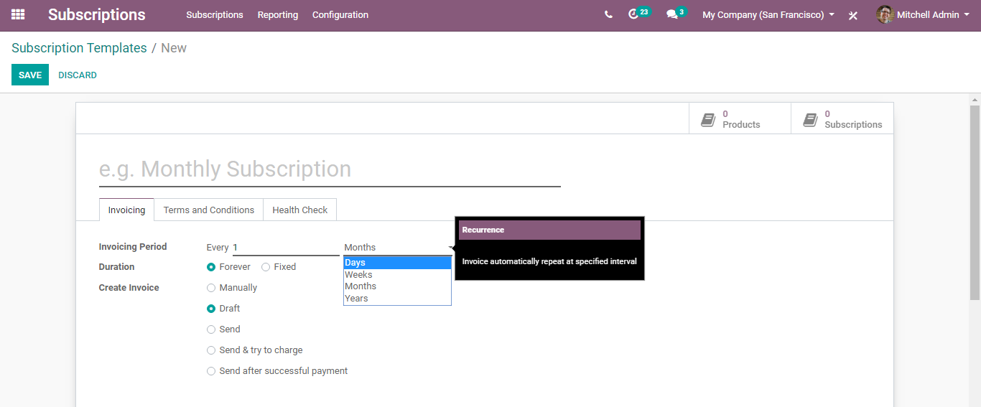

Duration: Duration of the subscription whether it is forever or fixed. Via clicking Forever, the subscription runs forever until it is manually closed. On the other hand, if it is ticked as Fixed, you get an additional field like below, where you can specify manually the time.

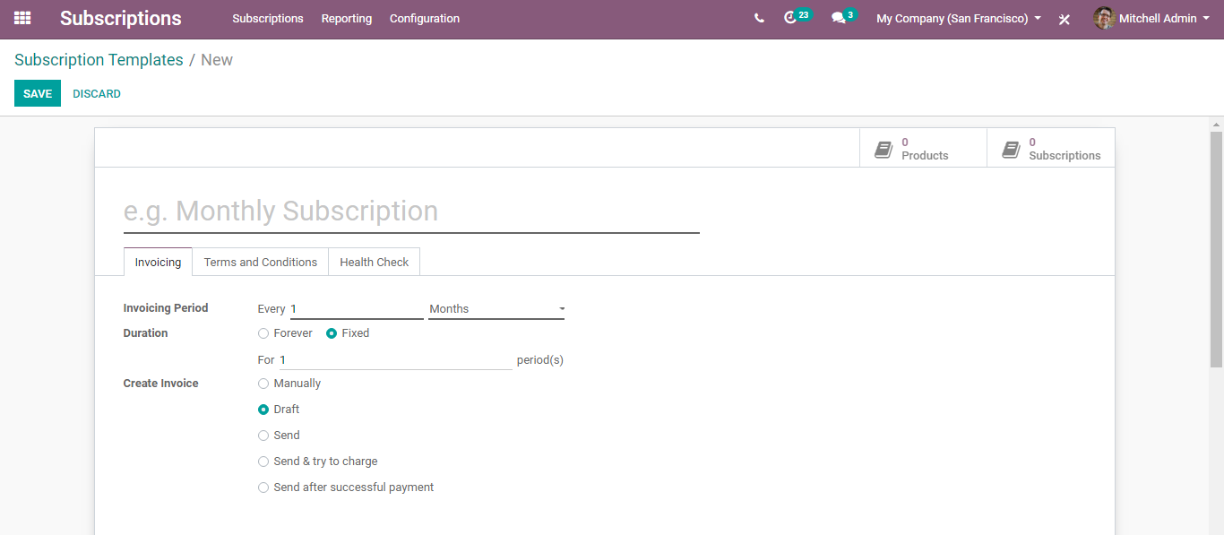

Next, we have several options for creating Invoices, say manually, draft, send and try to charge and so on.

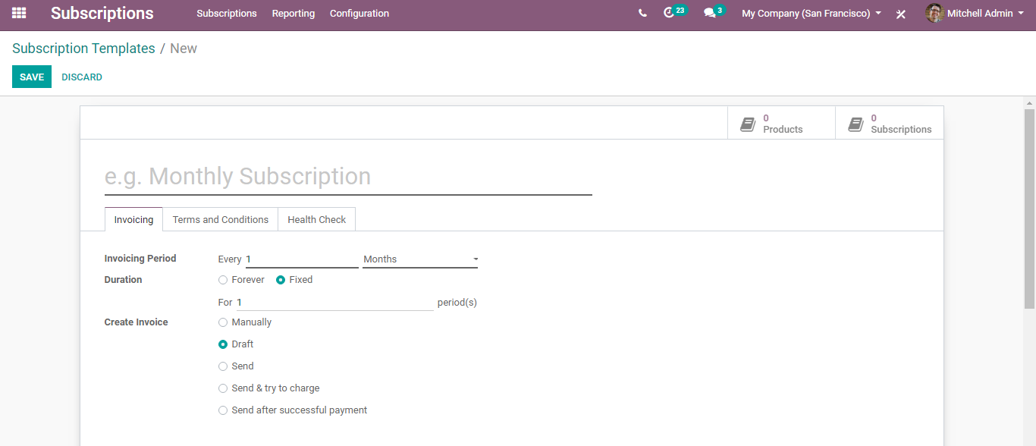

Closable by the customer: If checked, the user can close his payment from the Website.

Journal: If set, the subscription with this template will invoice in this journal; otherwise, the sales journal with the lowest sequence will be used.

Under the terms and conditions tab, one can add the terms for this template.

Health Check: Here one can modify the rules.

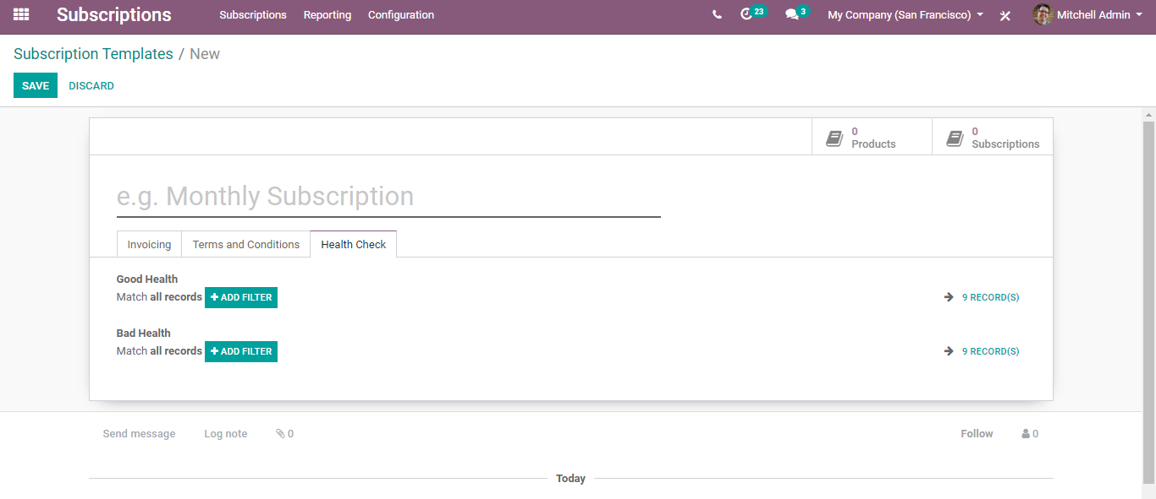

Enter all. Click SAVE to mark the changes.

Now we can assign this Subscription Template to different subscription products as discussed above.

**Create Subscription Product**

To create a new subscription product, go to Subscriptions> Subscriptions> Subscription Products> Create.

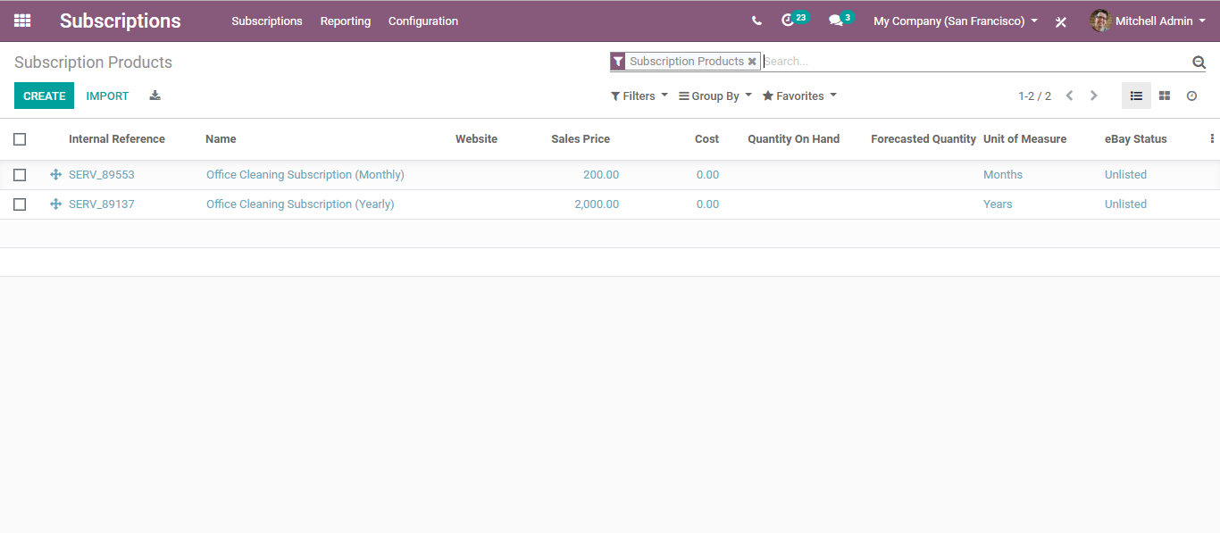

Click CREATE button,

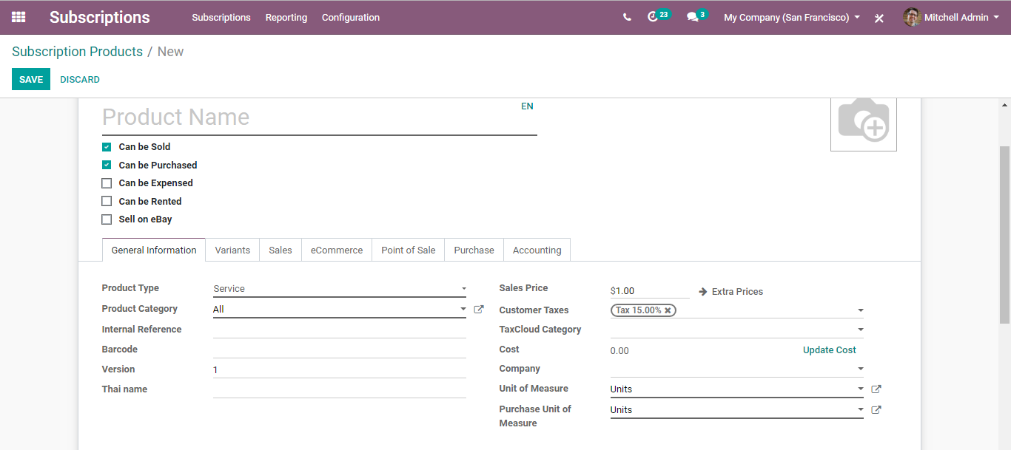

You will be navigated to the product create a form just as we saw in the sales and other modules.

Here, one needs to specify the product type as SERVICE. Enter the product category, internal reference, and other valid details.

Via going to the variants tab, one can also add the product variants.

Next move to the SALES TAB,

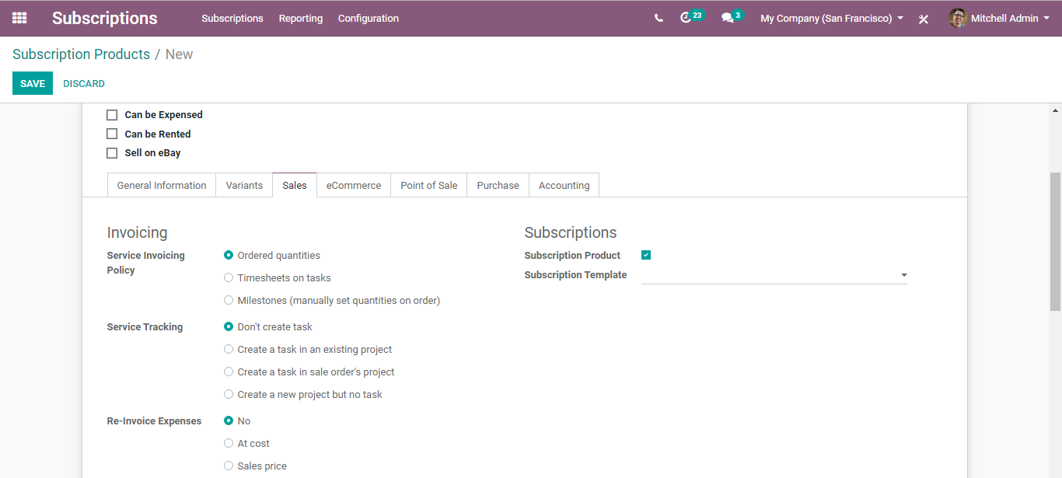

You can find here the subscription section. Tick the option subscription product to facilitate with subscriptions and under the field Subscription Template, select the desired template created by you.

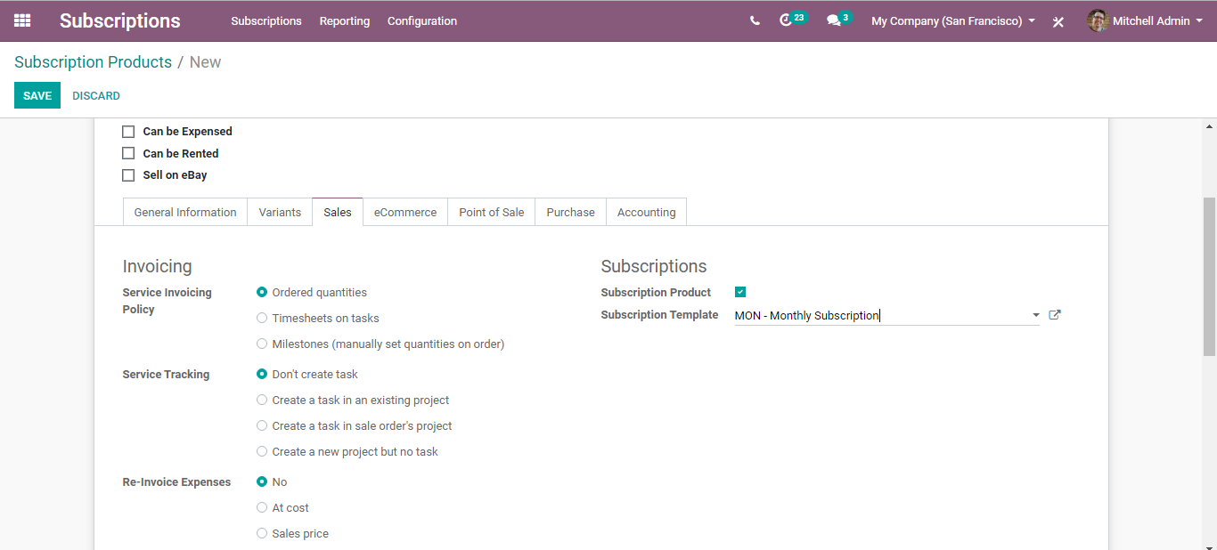

Enter all the details and click save to mark the changes.

**Create Quotation**

For that go to the sales application,

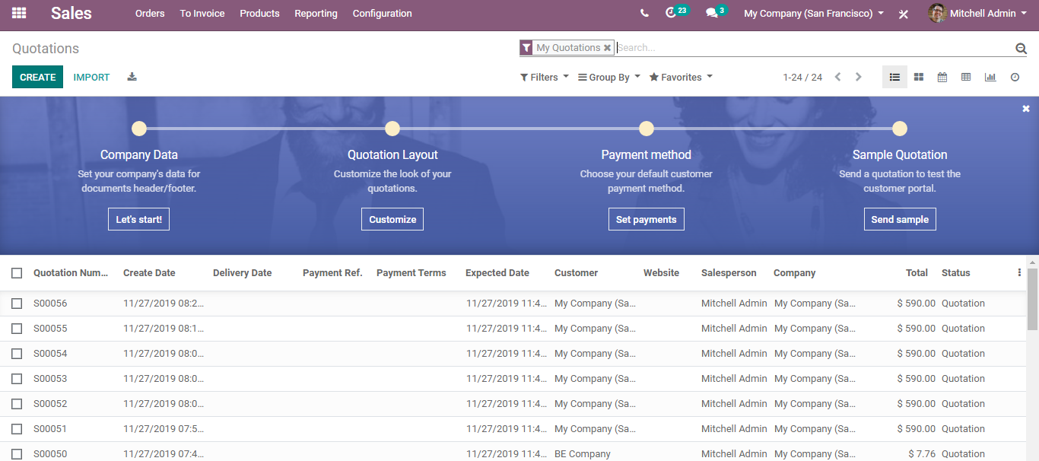

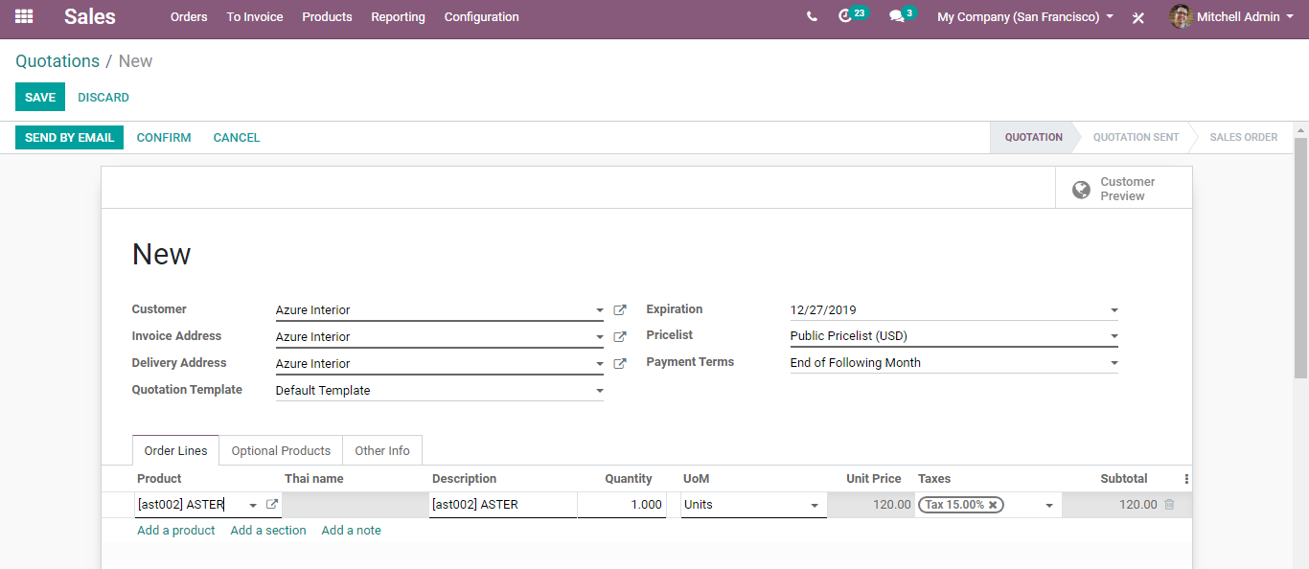

Send the quotation and confirm.

You can see the subscription on the top right end.

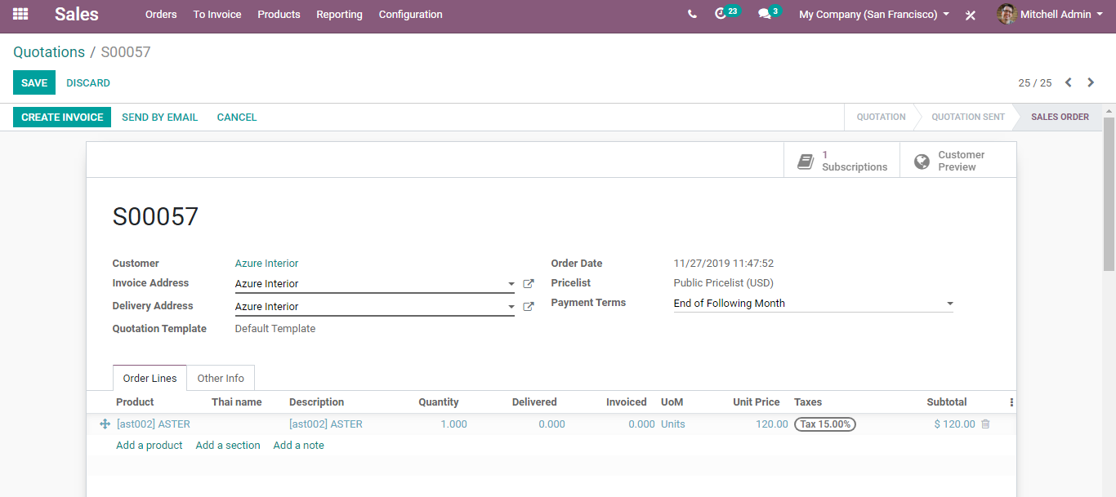

You can see the subscription in PROGRESS.

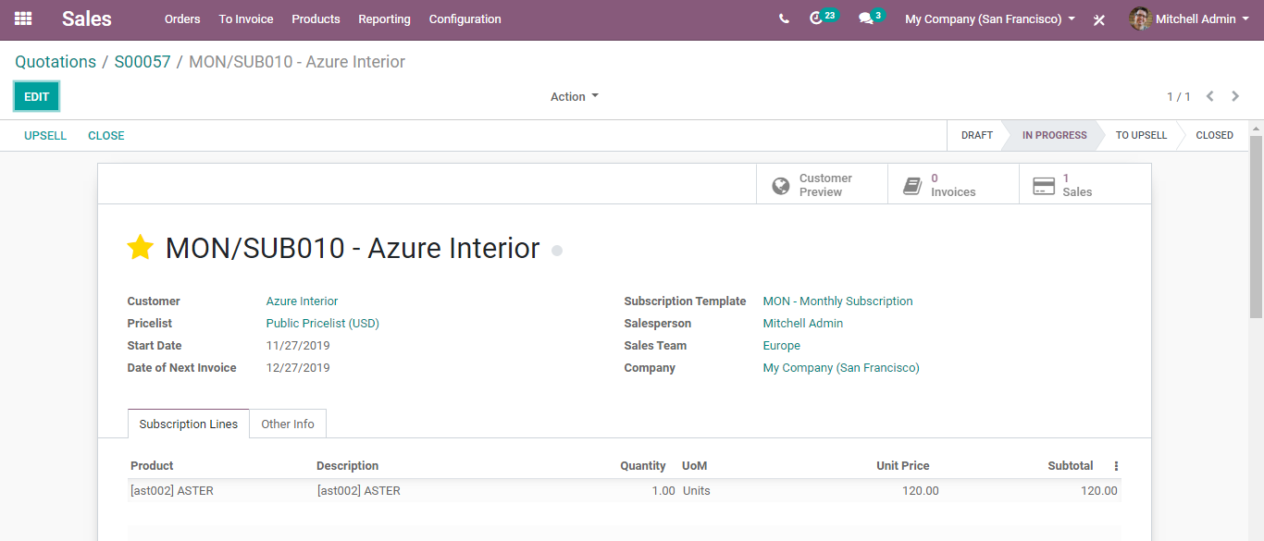

Via clicking on the EDIT button, you can make changes to the subscription.

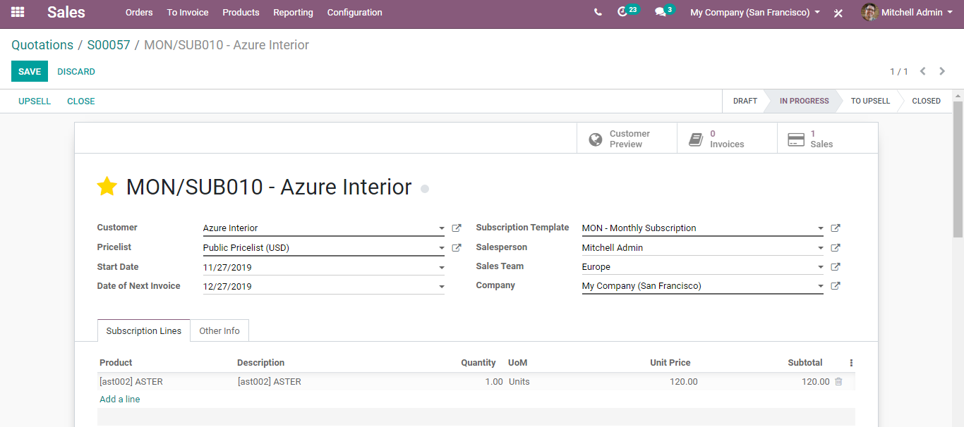

You can either UPSELL or CLOSE the subscription.

Via clicking upsell,

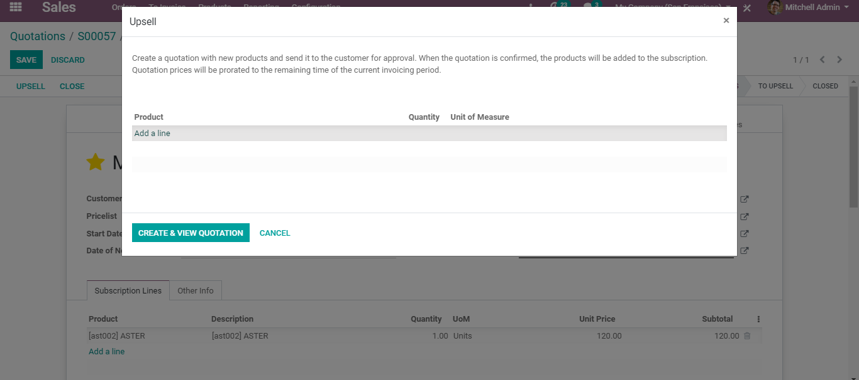

You can create a new quotation with new products and it to the customer for approval. When the quotation gets approved, the products will be added to the subscription.

Via clicking CLOSE, you can close the quotation.

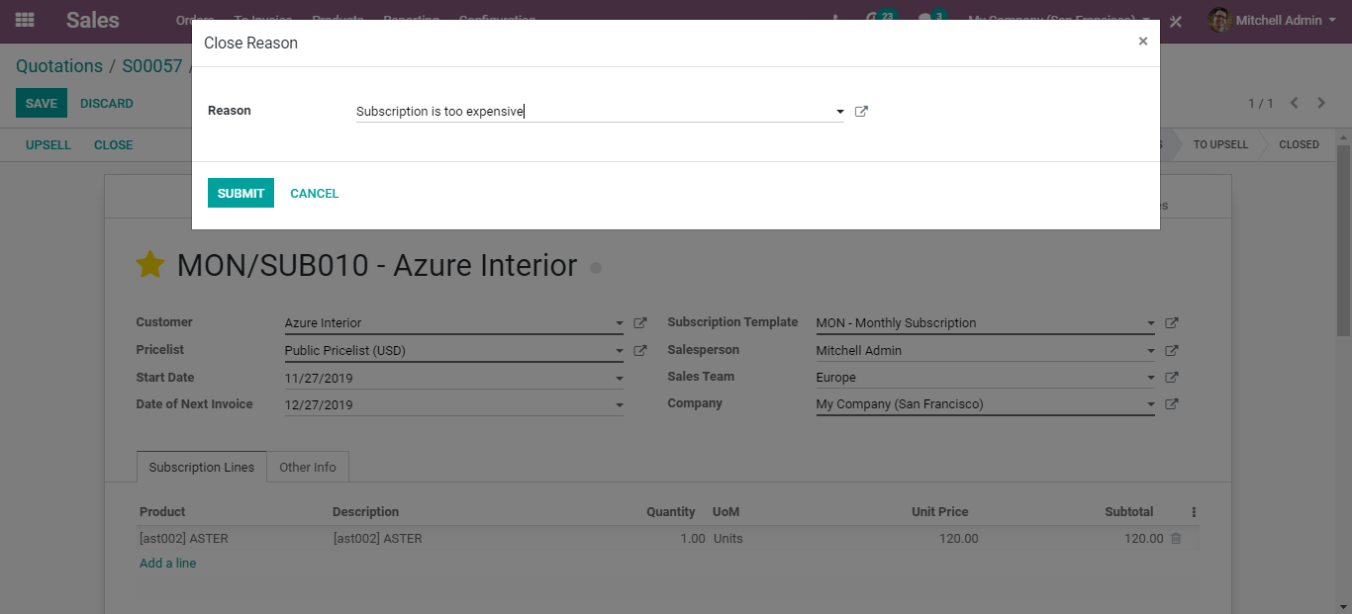

You can give here, the reason for closing the quotation.

Now if you go back to the subscription module, you can straight away see the subscription status as closed.

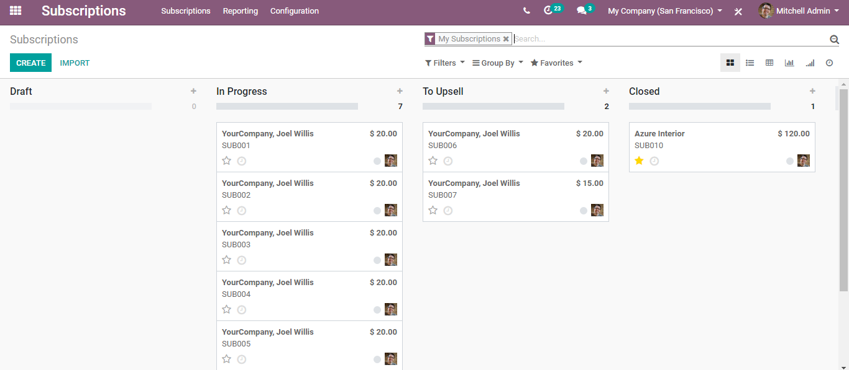

Revenue KPIs

