**BUSINESSBOXERP E-commerce**

This feature makes BUSINESSBOXERP more powerful than any other competitor. BUSINESSBOXERP E-commerce App supports you to sell your products online. One can seamlessly add the products, configure their payment and delivery methods. Also, let the public access your website without much strain. Since BUSINESSBOXERP E-commerce comes integrated with other modules like CRM, Sales, and Inventory it simply enhances the business efficiency. One can install the eCommerce application from the BUSINESSBOXERP apps store. To further enhance the system capabilities, you may install eCommerce delivery and eCommerce optional products.

BUSINESSBOXERP E-commerce module displays competitive features when compared to CMS service providers like Magento and Shopify. The most promising thing is that many add-on features in other CMS service providers are built-in components in BUSINESSBOXERP. BUSINESSBOXERP enjoys the advantage of features like Product Inline Page Builder, Drag and Drop Page Builder, Buy Without Sign Up, Inline SEO Suggestion, Link tracker etc. comparing to Magento. And over Shopify, BUSINESSBOXERP has the advantage of options like Stock Available, Drag and Drop Page Builder, Integrated A/B testing, Inline SEO Suggestion, Multi-Store Support, Advanced Taxes and more.

Some of the useful features of BUSINESSBOXERP are given below.

**Design & configure**

Inline Editing, create product pages utilizing BUSINESSBOXERP's unique 'edit inline' approach. Here there is no need for code, what you see is what you get.

**Building blocks system**

Create your product page from scratch by dragging and dropping pre-made, fully customizable building blocks. Describe products in a table to give a maximum number of specifications.

**Sell digital products**

You can now add digital products like eBooks to your online catalogue.

**Word processor text editing**

Easily create and update your text content through an editor designed to replicate the word processor experience.

**Product variants creation**

Create a product available in several variants, like size, colours, or other attributes.

**Pricelists, products, and stores**

Create flexible pricelists, add variants to add to products options, and create multiple stores under one environment. Display available stock on products.

**Integrated tools**

Cross-selling and Upselling, suggest optional products related to items to increase your revenues.

**Promotional or coupon codes**

Encourage potential customers to use promo codes and coupons.

**Options to boost sales**

Define product categories, use attribute search, focus on promotions, coupons, or gift certificates, and push best products to the top of your page to multiply your sales.

**Shopping experience**

Easy search system, make finding products easier by setting attributes on products (size, colour, power, etc.).

**Customer onboarding**

Set up step by step instructions to help customers go to checkout with no blocking issues.

**Guest & registered user**

Customers can choose to create a user profile or as guests. Registered users can retrieve their contact information upon check out and access a portal including related messages, orders, invoices, registered claims, etc.

**Skip shipping address**

Shipping address is no more required when providing only services.

**Live chat embedded**

Provide your visitors with information in real-time directly on your website and secure your sales.

**Easy checkout process**

Simple checkout to avoid losing clients.

**Customer portal**

Access tracking of orders, advanced shipping rules and return management through the customer portal.

**Order review**

See details of your order at the end of the process.

**Payment methods**

Fully integrated, allow customers to pay with Payments Connect, PayPal, Ogone, Adyen, Buckaroo, Authorize.net and SIPS Worldline. Online payment methods redirect customers to a 'Thank you' page on your website.

**Billing & Accounting**

Calculate & Bill Shipping Costs, get delivery costs computed automatically using BUSINESSBOXERP's embed Delivery Method configurator.

**Integrated Accounting package**

BUSINESSBOXERP’s chart of accounts contains national taxes, fiscal positions, accounts.

**Tax rates**

Fiscal positions allow you to adapt tax rates to the whereabouts of your customers.

**Chart of accounts**

Use the Custom package template to build your chart of accounts. It embeds a set of generic pre-set accounts, taxes and more.

**Reporting**

Sales data analytics, Highlight the best product in terms of quantity sold. Find the best customer in terms of revenue. Display a graph with your monthly sales per product and add it to your Dashboard. Group your Sales by Partner and display the products in the column header.

**System Users**

By default, there are two types of users in Website related modules.

Editor and Designer: Like the manager in other modules, he can access both the front end and back end of the website. He can configure your website and change its settings

Restricted Editor: - Front end (i.e., portal) designer. Generally, he can alter only the portal view of the site and products with some restrictions etc.

Firstly, install the BUSINESSBOXERP e-commerce module- Website from the Apps List.

**E-commerce Dashboard**

E-commerce dashboard offers better data visualization, helping managers with real-time access and interpretation of data. The managers get to know in real-time the average order value, the average delivered quantity, average invoiced quantity and more, helping them improve their e-commerce strategy.

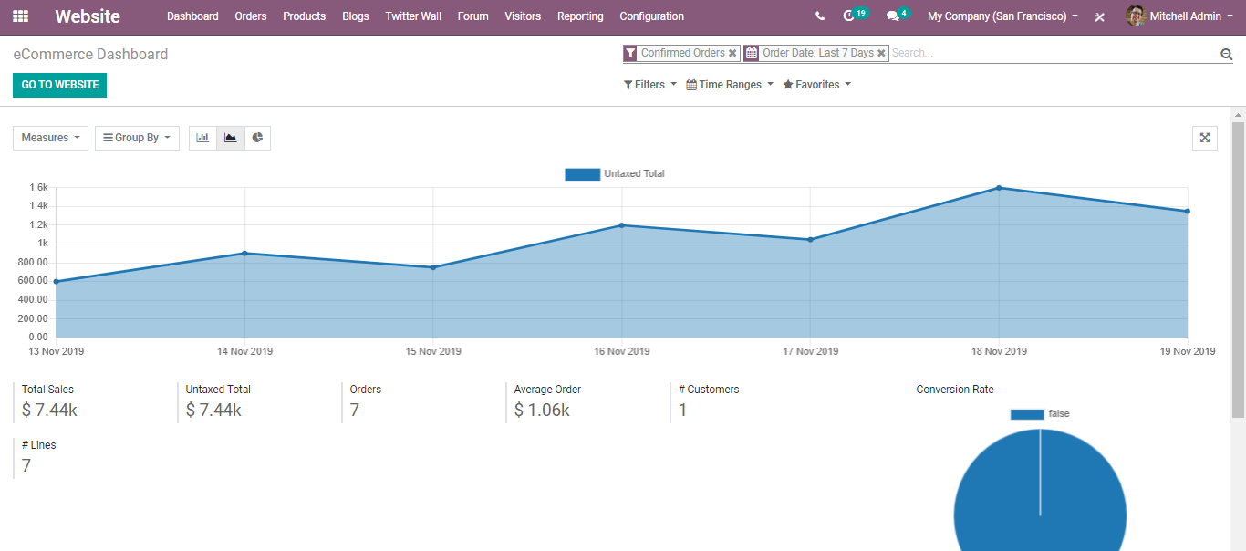

Under the dashboard, you have one more Option-Analytics.

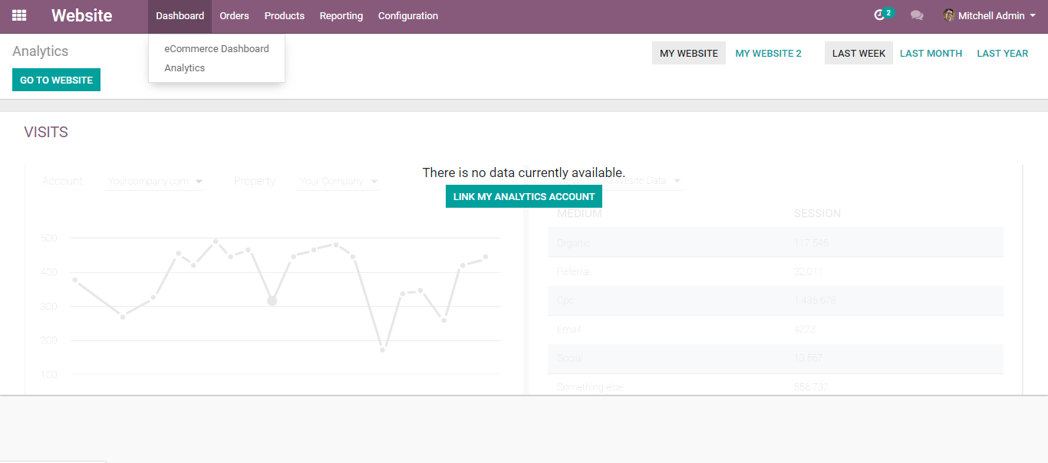

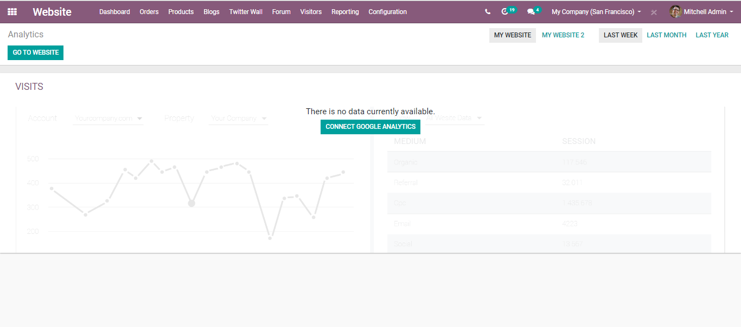

It helps you in getting the analytics of your website visits. You can connect google analytics to track your website traffic.

**Connecting BUSINESSBOXERP with Google Analytics**

Create a google analytics account.

Accept conditions to get the tracking ID.

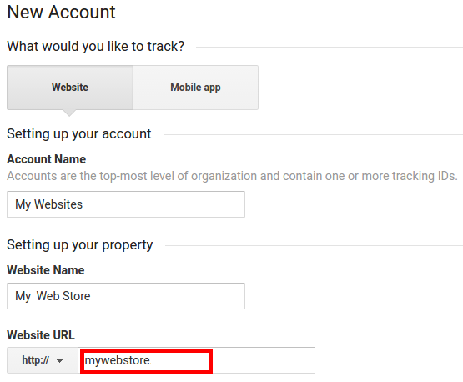

Copy the tracking ID for inserting them in BUSINESSBOXERP.

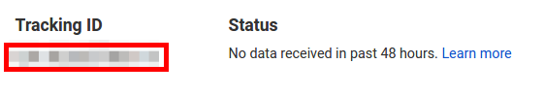

Go to the Configuration menu of BUSINESSBOXERP’s Website and turn on Google Analytics. Paste the tracking ID. Save it.

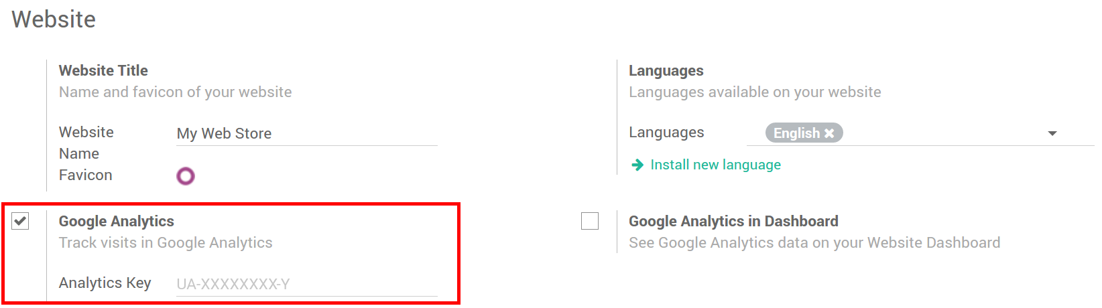

**Order Tracking**

View Order

One can view all the confirmed sales orders via going to

**Website Admin > Orders > Orders**

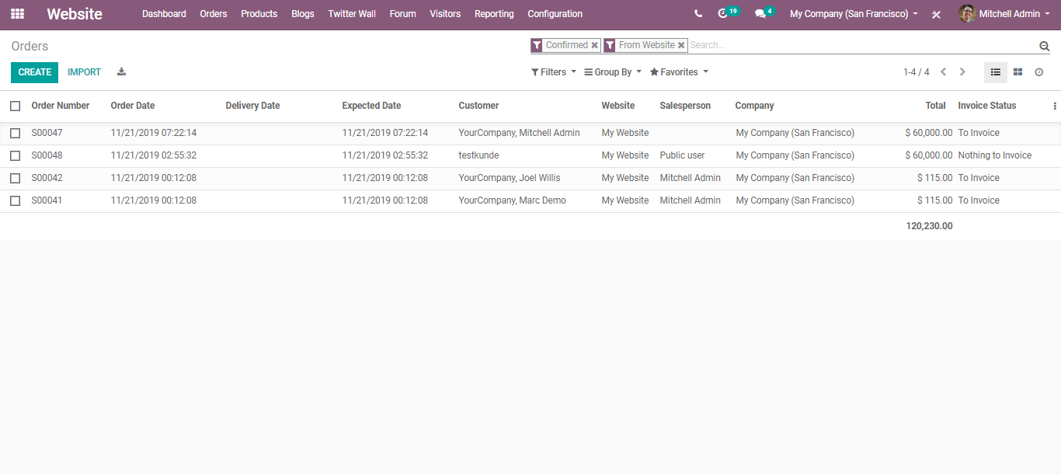

Also, upon clicking the CREATE button, one can create an order manually if needed.

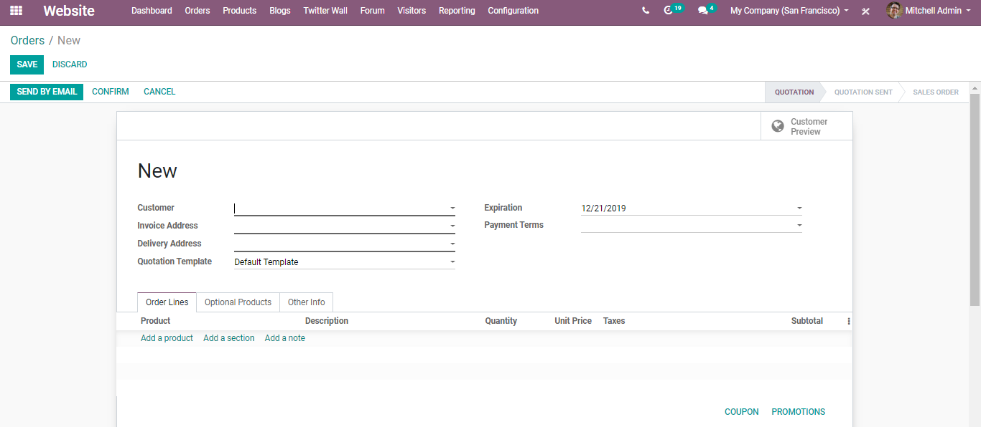

**View Unpaid Order**

To see the sales order awaiting payment validation, go to Website Admin > Orders > Unpaid Orders.

**Abandoned Carts**

While doing a purchase on E-commerce, the client may move to some different exercises and may have neglected to do the checkout procedure. Abandoned carts are the carts wherein the client left without doing the checkout.

In E-business, over half of the carts are left deserted. For this situation, we are losing deals with that client. In this way, for bringing back those clients to proceed with the buy, BUSINESSBOXERP empowers you to send a mail reminding the client to return and proceed with the purchase. The procedure is known as abandoned carts recovery.

We can likewise save the carts waiting for the clients. It is essential to remind the client to re-proceed with the buy-in BUSINESSBOXERP E-commerce. One can set an email layout for Abandoned Carts. To activate the feature**, go to Website Admin> Configuration> Settings> Orders Follow up**.

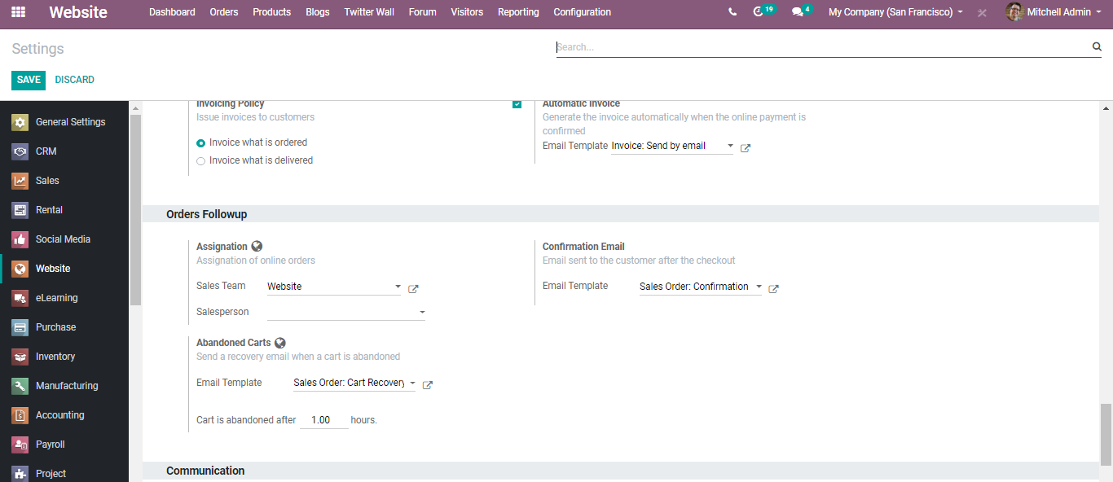

One can either select the template from the drop-down menu or create a new one. Here you can edit the cart recovery email and other related settings.

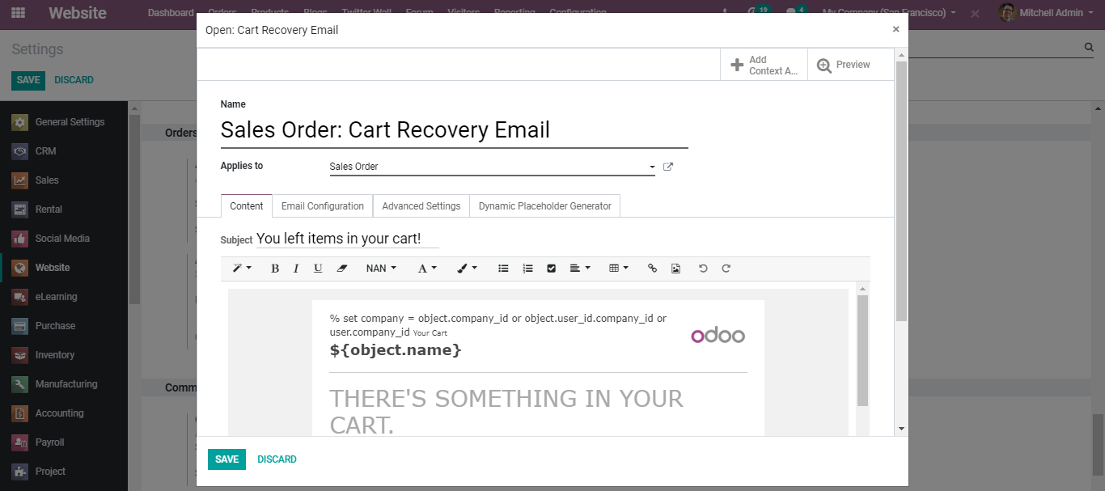

One can also set under the configuration -the number of hours after which the cart is abandoned.

**Customers**

To view your regular customers and create new customers,

**Go to Website Admin > Orders > Customers**

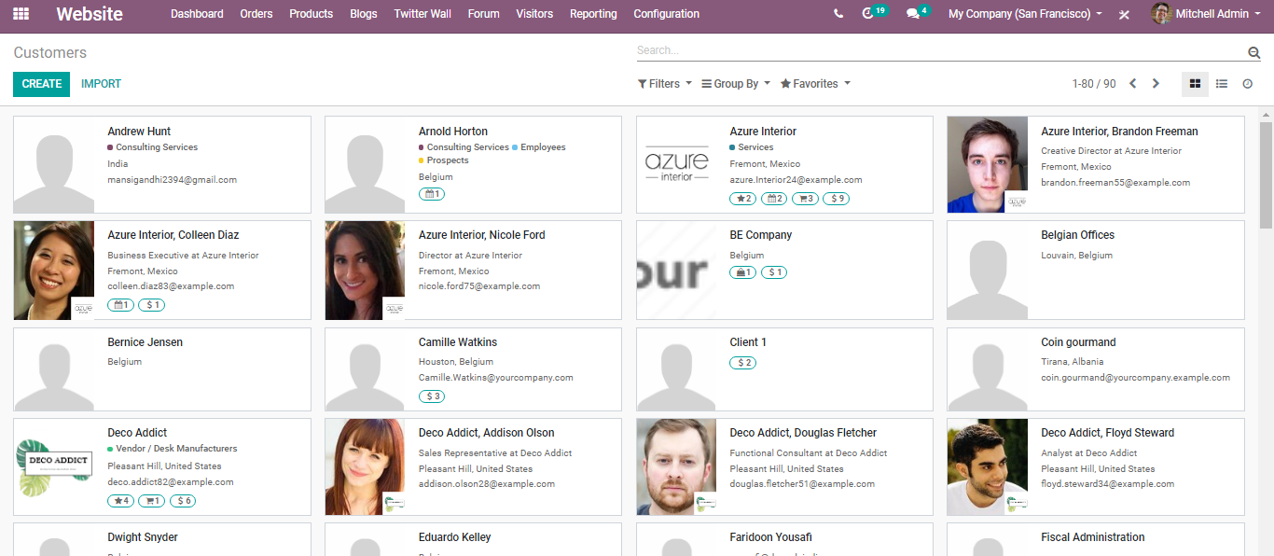

Via clicking the create button, one can create a new customer.

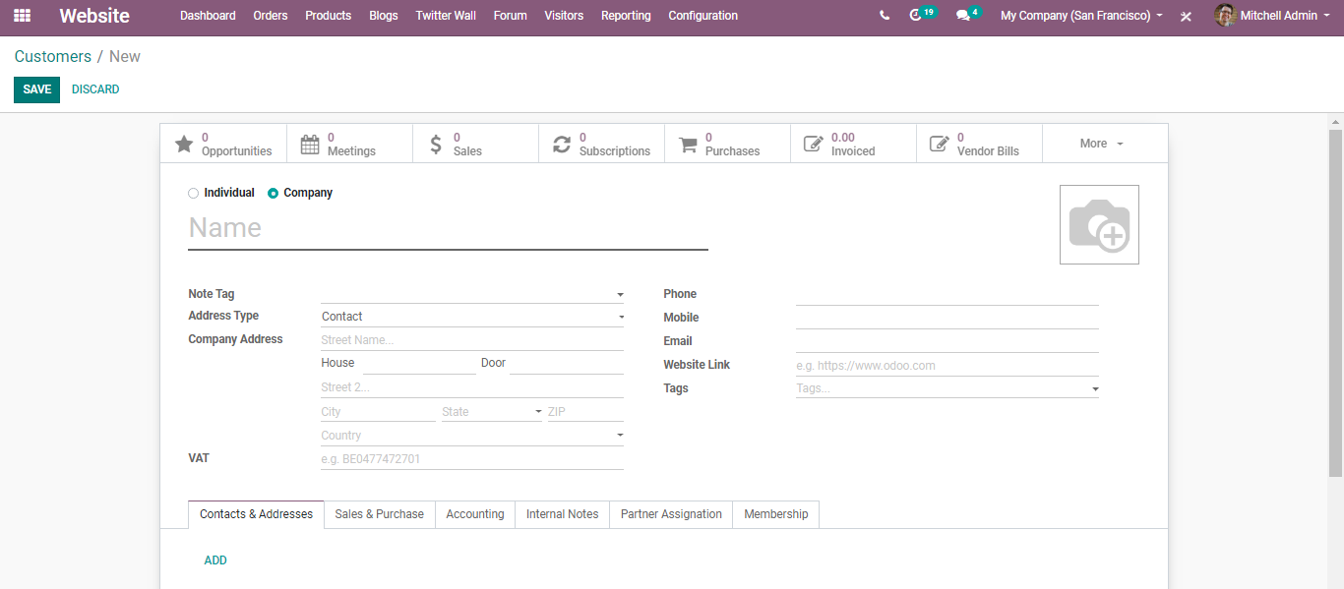

Under the create form, one can add all details of the customer such as his name, address, phone number, mobile, email, whether he is a vendor, customer, account details, payment terms, delivery methods and much more.

**Product Management**

**Add new Product**

To add a new product, go to

**Website Admin > Products > Create**

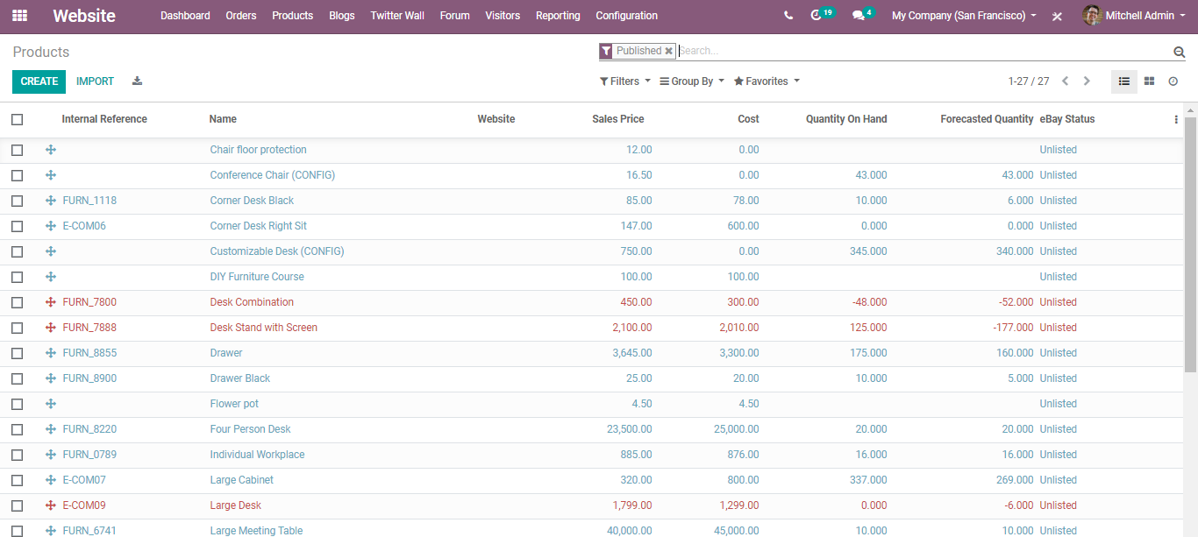

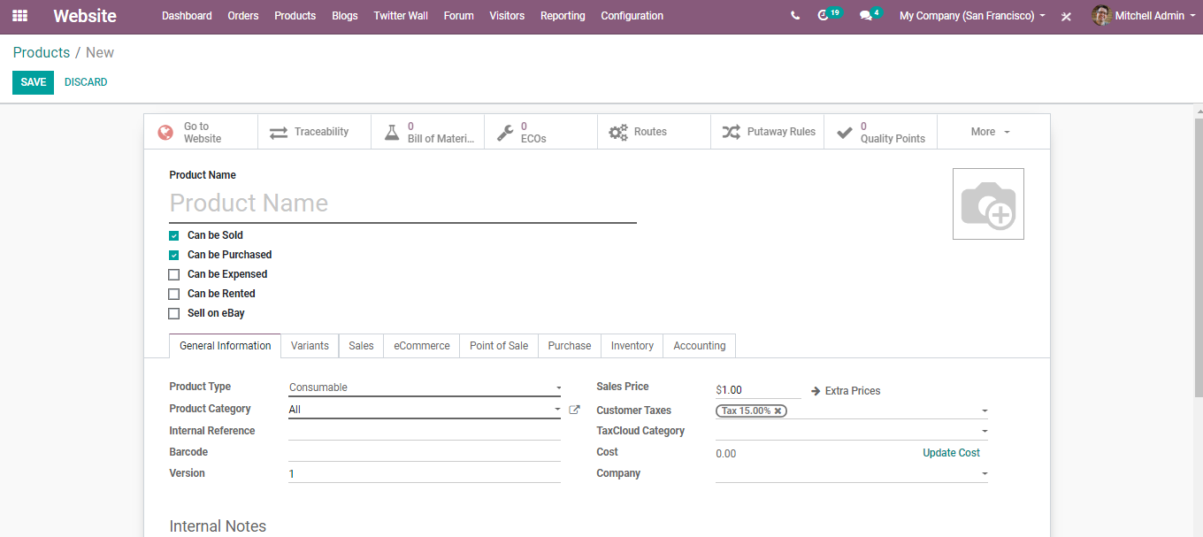

Fill all necessary fields by switching to ‘inventory’, ‘sales’, ‘variants’, ‘invoicing’, tabs, and the product. It will automatically get added to your website.

**Edit Product Details**

One can Update/Edit a product detail just by clicking on the product image from Website Admin > Products

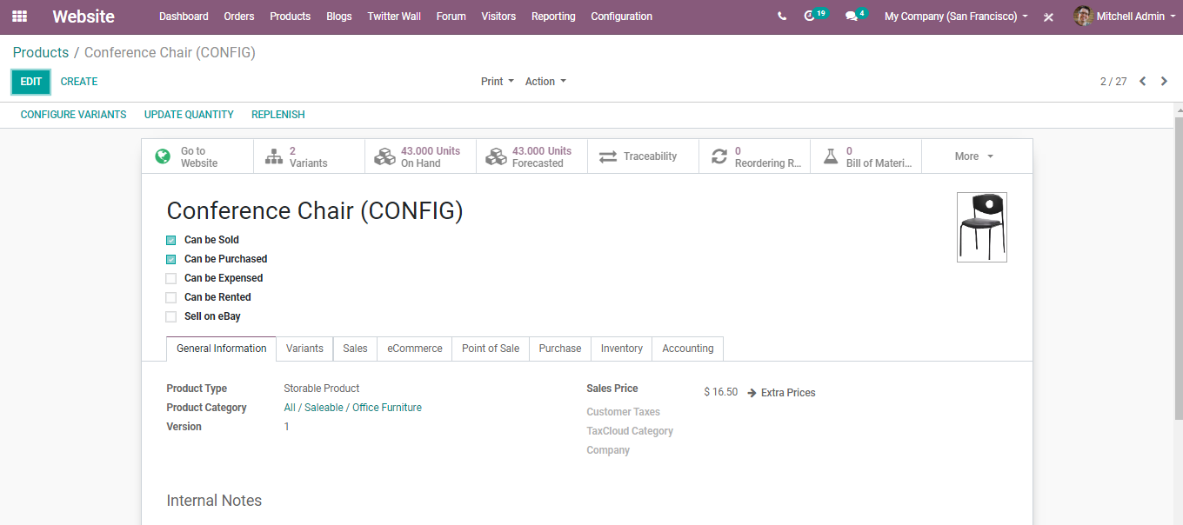

Click the "Edit" button to edit product info "Update Quantity in Hand" to update quantity manually. One can also configure product variants via clicking CONFIGURE VARIANTS.

Or else one can configure the product variants via going to the **Website Admin > Configuration> Settings>Products**

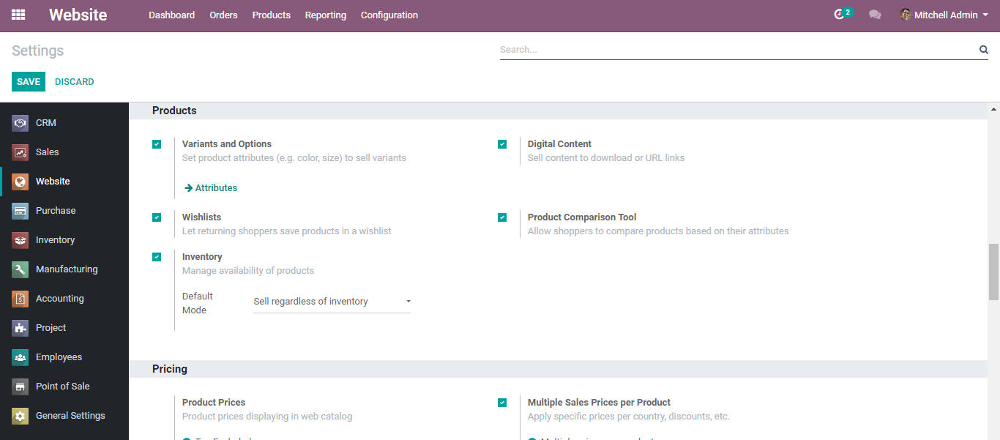

If you click on the attributes button, you are navigated to a new window like below:

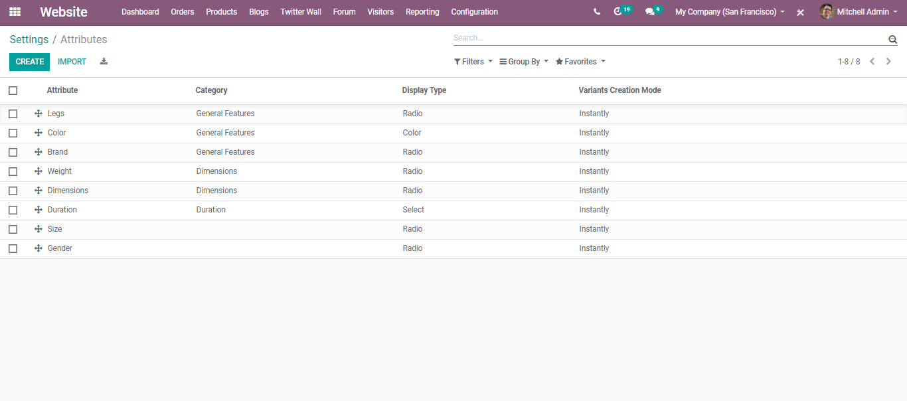

Here you can see the already created attributes. However, to create a new attribute, click CREATE button.

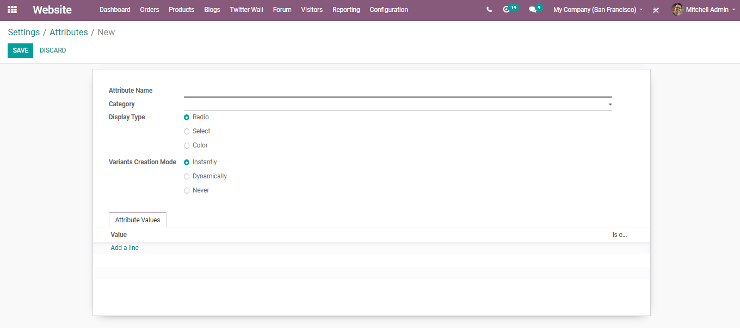

Here you can give off the Attribute name, category (to regroup similar attributes under the same section in the comparison page of eCommerce), Display Type (the display type used in the product configurator)

[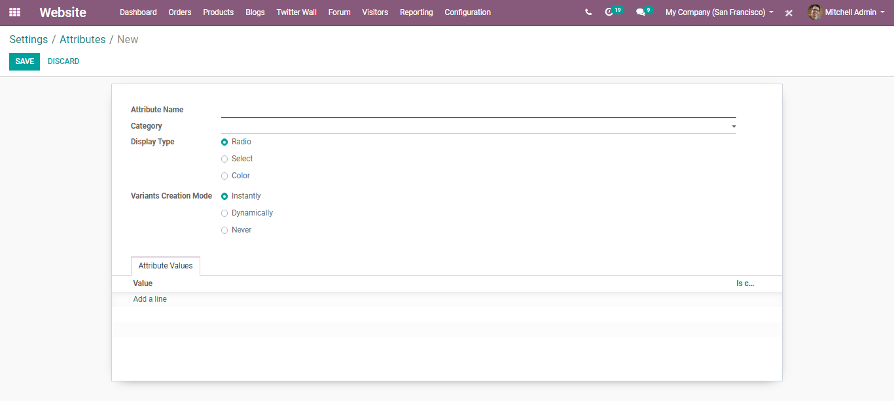](https://www.images.cybrosys.com/images/odoo-book-13/odoo-book-v13-ecommerce-19.png)

Variants Creation Mode:

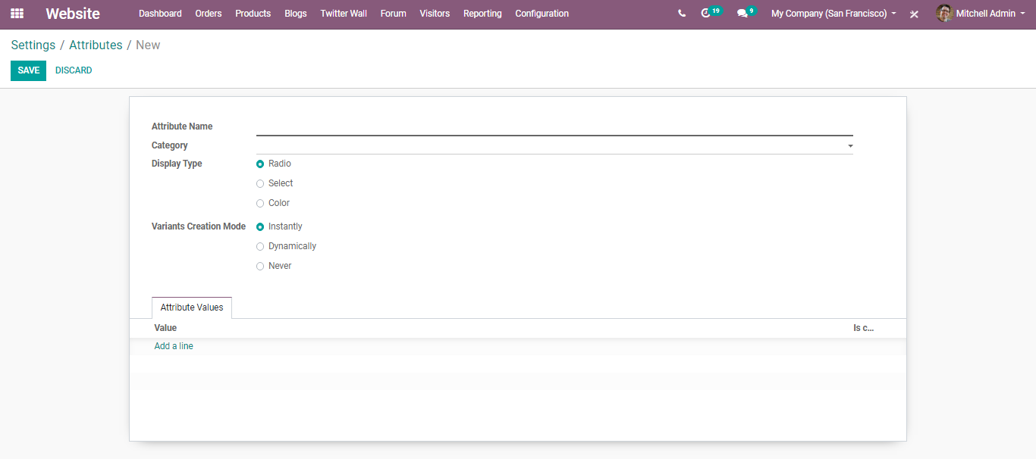

Instantly- All possible variants are created as soon as the attribute and its values are added to a product.

Dynamically- Each variant is created only when its corresponding attributes and values are added to a sales order.

Never- Variants are never created for the attribute.

**Pricelists**

BUSINESSBOXERP embeds with powerful pricelist features to support the pricing strategy needed for your E-commerce business. A price list is a list of prices or price rules that BUSINESSBOXERP searches to determine the suggested price. One can seamlessly create a specific pricelist or a price rate for a specific customer. The price list or price rate can be for a specific product or a group of products.

One can set several criteria’s in BUSINESSBOXERP to use a specific price: It can be: Periods, Quantity, Quality, Service, Economic environment, Competition, Product demand. By using BUSINESSBOXERP pricelist, one can easily manage the product pricing depending on the company needs. As pricelists only suggest prices, they can be overridden by users completing sales orders. One can choose the pricing strategy from Sales ‣ Settings.

One can choose the pricing strategy from E-commerce settings.

Go to the **Website Admin>Configurations>Settings>Pricing,** enable the option Multiple Sales Prices per product via ticking the checkbox. Save changes.

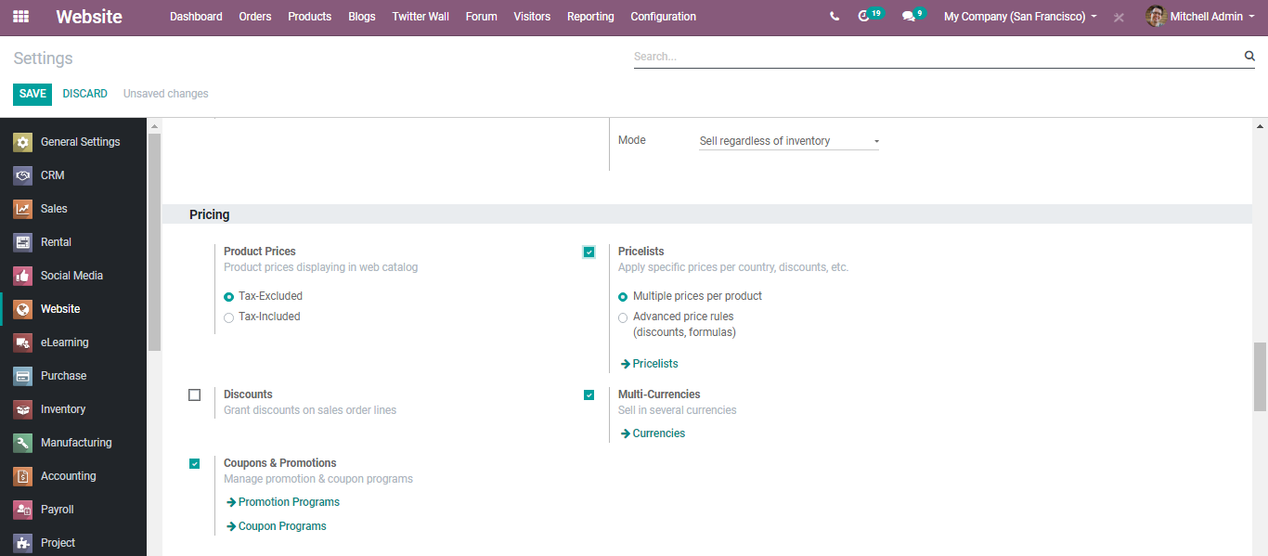

There are 2 types of sales pricelists in BUSINESSBOXERP.

**1) Multiple prices per product (e.g., customer segments, currencies)**

The option can be used for creating pricelists for your customer segments or to set different pricelists with different currencies.

**2) Advance price rules (discounts, formulas)**

The option allows setting price change rules. Changes can be relative to the public price, product cost price, or to another pricelist. Calculation of changes is made upon the surcharges and discounts making it fit the minimum and maximum margin set by the user. Further, BUSINESSBOXERP enables the rounding of prices to the nearest cent or dollar or even the multiple of both.

To choose the option that you desire, or to know the working of both options, one needs to first select multiple prices per product (e.g., customer segments, currencies) and later go to the Products tab and choose Pricelist. There you can see the available list of pricelists.

Via going to the Products tab, one can see the different Pricelists created.

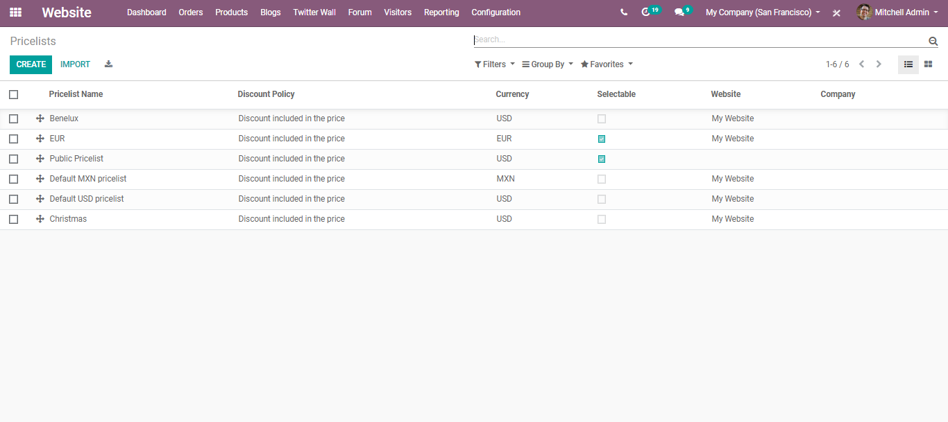

Also, one can create a new price list by clicking on the CREATE button.

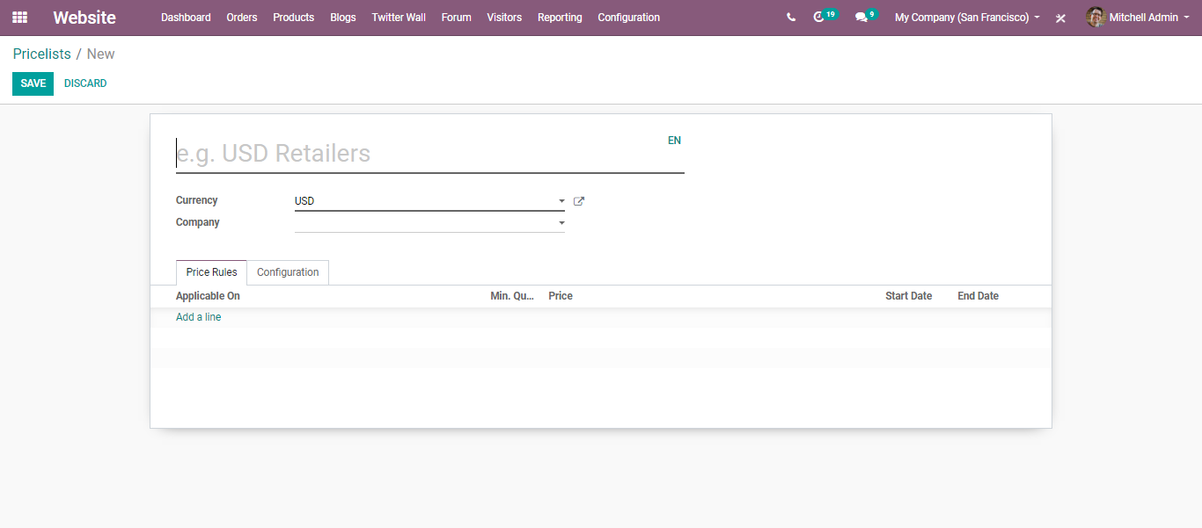

Here you can define the name, select the Currency (also can create a new currency), Country groups. Via clicking add a line, you can mark where to apply on the pricelists, minimum quantity (for the rule to apply, bought/sold quantity must be greater than or equal to the minimum quantity specified in this field.), starting date for the pricelist item validation and end date for the pricelist item validation. One can also select here the price computation mode whether it is fixed price, percentage, or formula.

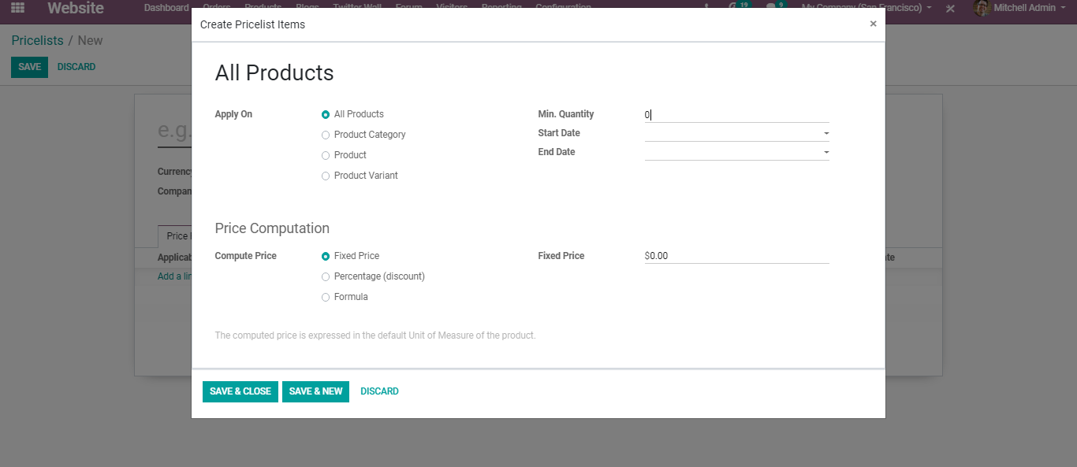

**Promotion & Coupon programs**

To ensure the business profit, there should always be a backup or an alternative plan to hold and attract the customers at large. BUSINESSBOXERP E-commerce allows you to manage your sales most efficiently. BUSINESSBOXERP enables “Promotion and Coupon Programs” which helps the end-user to create the promotion for their products as per the current needs. Promotional programs can be used as a marketing tool where you can target a specific audience and can implement a loyalty program.

To enable the Promotion and Coupon Programs, go to Website Admin>Configuration>Settings> Pricing.

Tick the option Coupons and Promotions. Click SAVE to mark the changes.

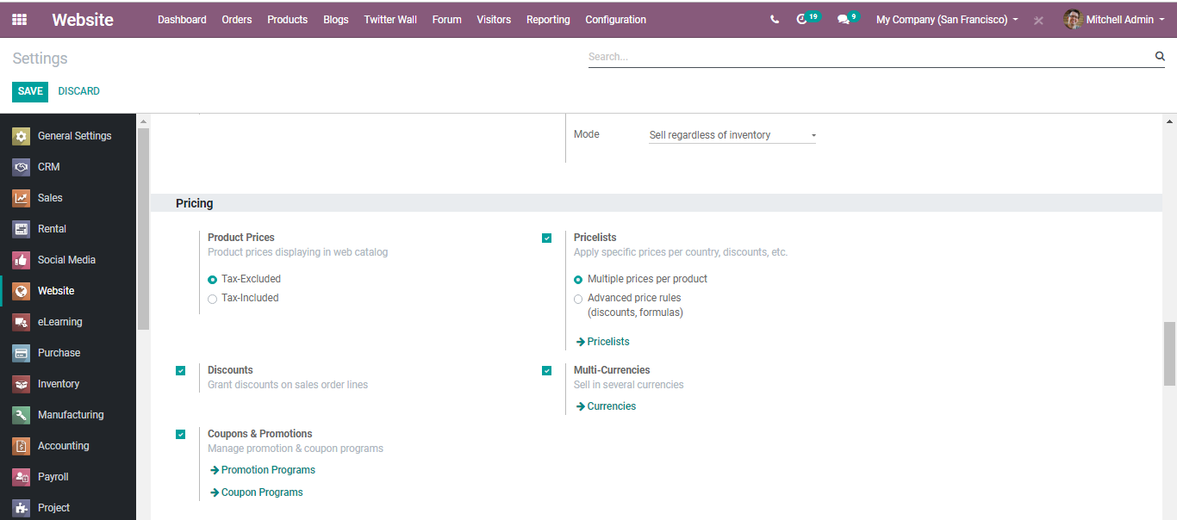

Upon clicking the promotion programs and coupon programs, one can create new loyalty programs to attract the customer.

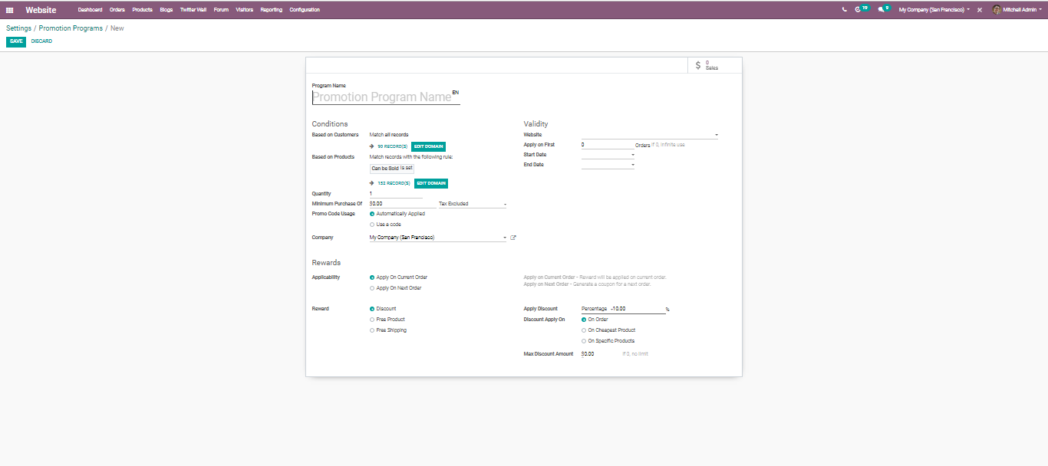

In the

promotion programs, there are different fields in BUSINESSBOXERP

* **Program Name**
* The name for the promotion program
* **Conditions**
* Based on customers
  + This coupon program will be applied to the selected customers only.
  + One can filter the customers according to the need.
  + By default, all the customer records will be taken
* Based on Products
* On purchase of these selected products rewards will be given.
* We can filter products according to our needs.
* By default, all products records that can be sold will be taken.
* Quantity
  + Minimum required product quantity to get rewarded
* Minimum purchase Of
  + Minimum required amount to get rewarded
* Promo code Usage
  + Automatically Applied: No code is required. If the rule is met, the reward is applied (Except global discount)
  + Use code: If the program rule is met the valid code needs to add the reward.

**Rewards**

* Applicability
  + Apply on current order: A reward will be applied to the current order.
  + Apply on next order: Generate a coupon for the next order.
* Reward
  + Discount: The reward will be given as a discount
    - Apply discount: give the discount in two methods Percentage  
      Amount: Fixed amount discount will be provided
    - Discount Apply on  
      On order  
      Discount will be given on the whole order  
      On cheapest product  
      Discount on the cheapest product on the order  
      On specific Product
    - Discount will be given to the selected specific product
    - Max Discount amount: A maximum amount of discount that should be provided.
  + Free product: The reward will be given as the product

**Validity**

* Apply On: Maximum number of sales orders in which reward can be applied
* Start date & End date: Coupon program start date and end date

Coming to coupon programs, you have the following fields.

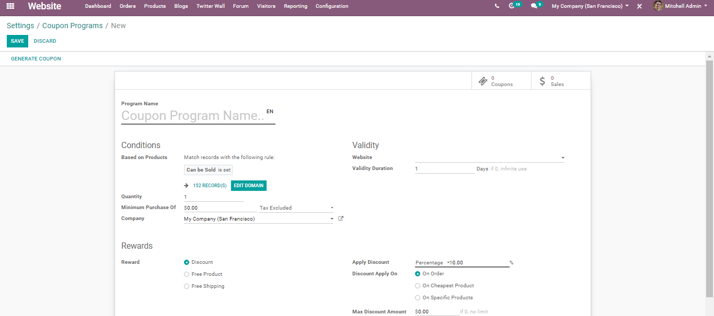

Coupons are used to generate limited discounts. A coupon is a one-time use code that will generate a discount for the customers.

**Payment Acquirers**

A business is ultimately dependent on its income generation or investment return. Every business collects money from their customers in return for the products/services they offer. In BUSINESSBOXERP Enterprise, the transactions are made easier and quicker via some built-in Payment Acquirers.

One can find all built-in payment Acquirers from

**Website Admin > Configuration > ecommerce > Payment Acquirers**

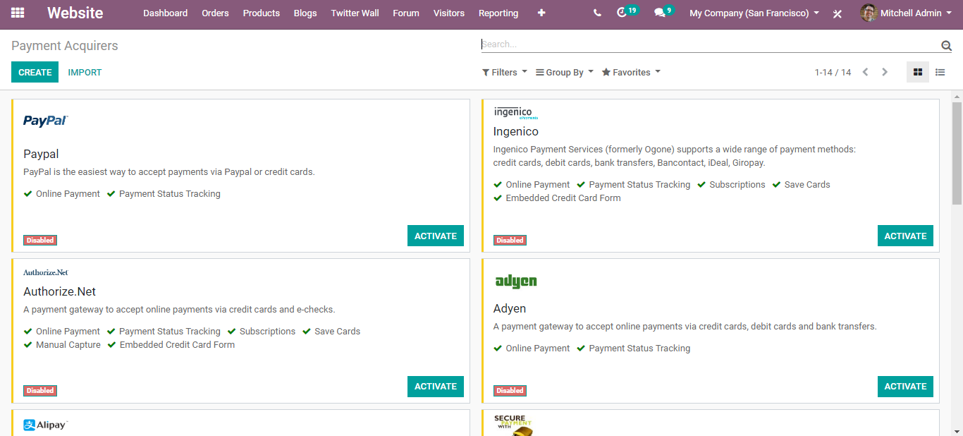

Click ACTIVATE to configure your payment acquirers.

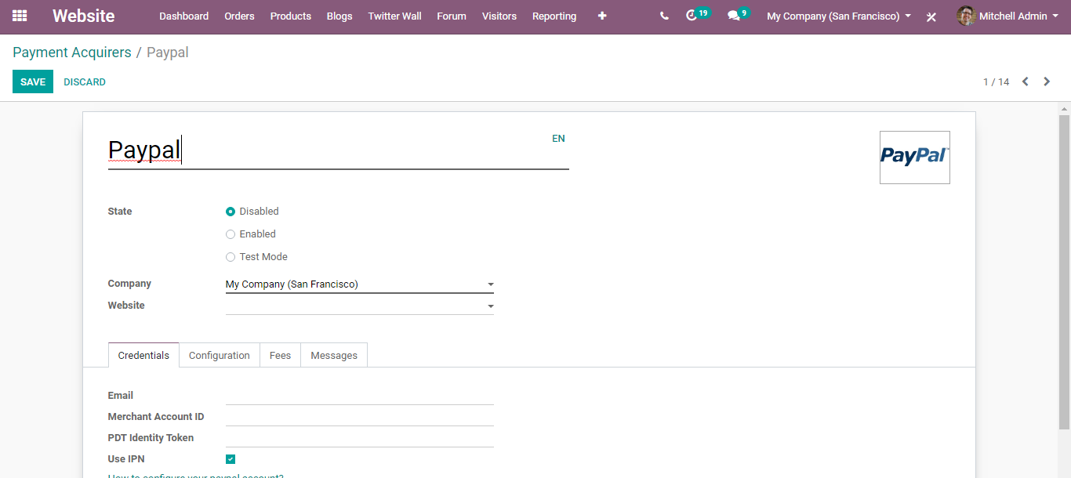

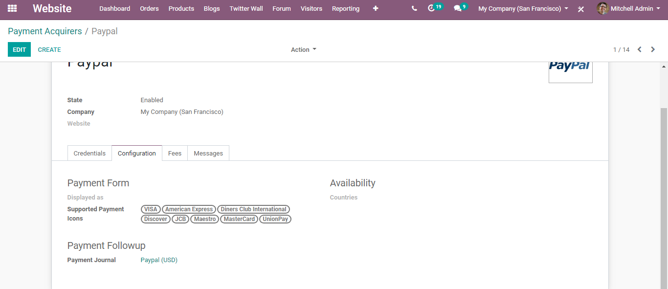

Once you configured the settings, Publish the same on Web site to make it available for users.

**Shipping Methods**

BUSINESSBOXERP can deal with different shipping methods, however, it is not activated by default. BUSINESSBOXERP ERP gives the alternative to arrange different shipping techniques in it. It will rearrange the tasks like transportation mode, conveyance cost figuring, shipment tracking and so forth. BUSINESSBOXERP shipping integration is accessible for DHL, FedEx, Temando, UPS, USPS and the sky is the limit from there. Shipping Methods enable you to deal with the transportation company, the cost, and the destination. You can even integrate BUSINESSBOXERP with outside shippers to compute the genuine cost and the packaging.

**Configuration**

**Website Admin > Configuration > ecommerce > Shipping Methods**

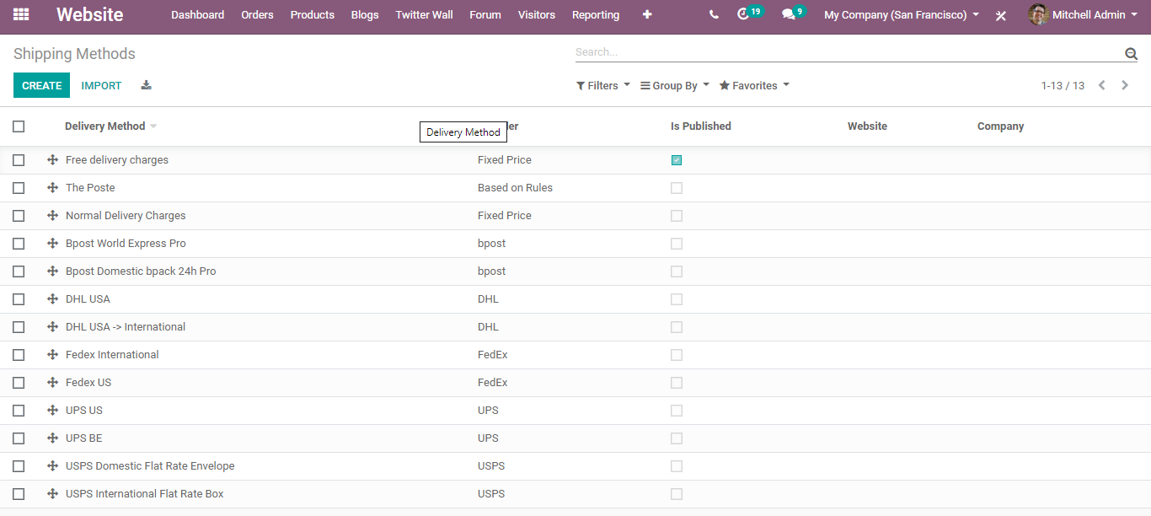

Right off the bat, name the new delivery method. Next is the provider field, which can be either fixed-price or based on Rules. On the off chance that we set the fixed price, at that point the delivery cost will be a fixed sum (Or it very well may be without invalid conveyance). On the other hand, if it is based on rules, it enables you to set the expense dynamically. Given rules, it is for processing the conveyance cost based on certain guidelines. The conditions, for example.

* Weight
* Volume
* Weight *volume
* Price
* Quantity

**E-commerce Categories**

To show the product category wise on the website we need to set a category for each product. One can set different Categories of products by going to

Website Admin > Configuration > Products> e-Commerce categories

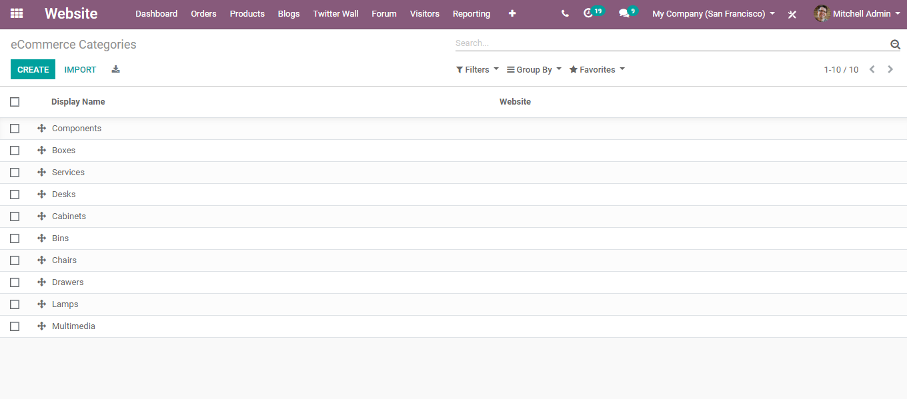

Upon clicking CREATE button, you will be navigated to a new window, where you can create new eCommerce Categories.

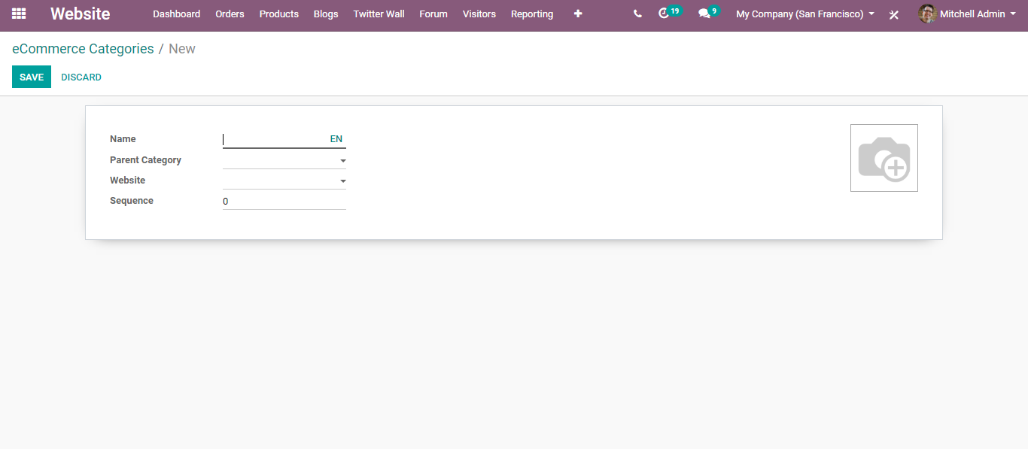

Choose the parent category (if applicable) and save

Edit Product Category

**Delete or edit a product category**

**Website Admin > Configuration > Product> e-Commerce category**

Click on any of the listed categories to update or delete it.

[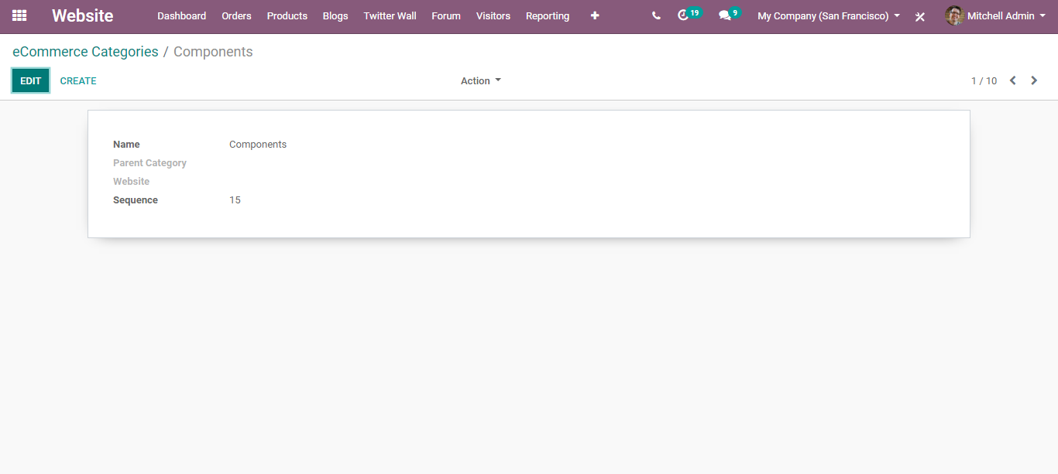](https://www.images.cybrosys.com/images/odoo-book-13/odoo-book-v13-ecommerce-34.png)

Later go to the website and click on Customize, there you can see different options. Enable Product Categories options to view products category wise.