**eLearning**

eLearning module in BUSINESSBOXERP ERP gives a chance to frame courses on the web, further empowering the visitors to join and finish their course as per the standards designed while making the course. This module additionally gives an interesting dashboard to the user who is presently signed into the website. He is displayed with several details such as status of the courses which he joined, identifications he gained, rank and other profile data.

To install the BUSINESSBOXERP eLearning module go to BUSINESSBOXERP Apps.

As soon as you enter the dashboard, you can see the already created courses. However, to create a new course, you can click the CREATE button provided on top.

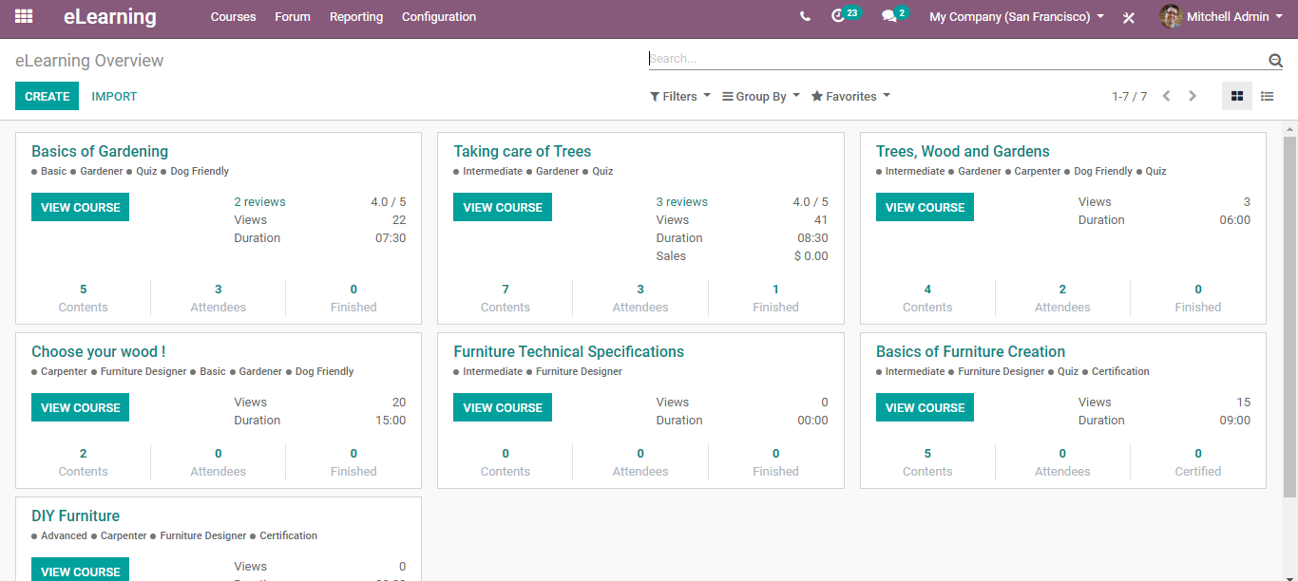

If you go to configurations, you can see menus for configuring channels, tags categories etc.

**Create Course**

To configure a new course, **go to eLearning> Courses> Create**.

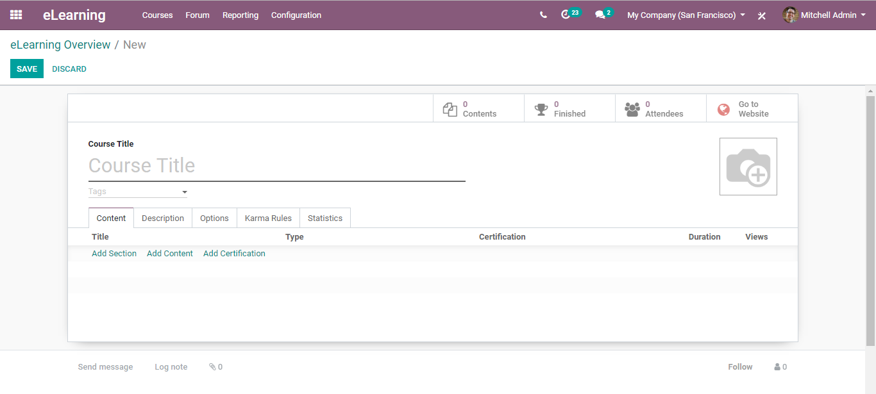

The course creates form will have the following fields:

* Under the course title field, you can name your course,
* Tags: Tags are used to categorize, and filter displayed channels/ courses.

One can either select the tags from the drop-down menu or create a new one.

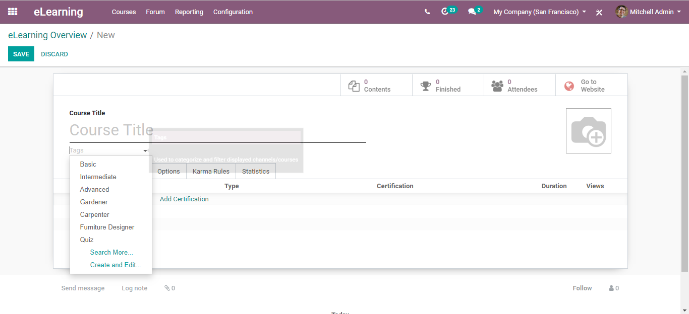

To create a new one, click CREATE AND EDIT option.

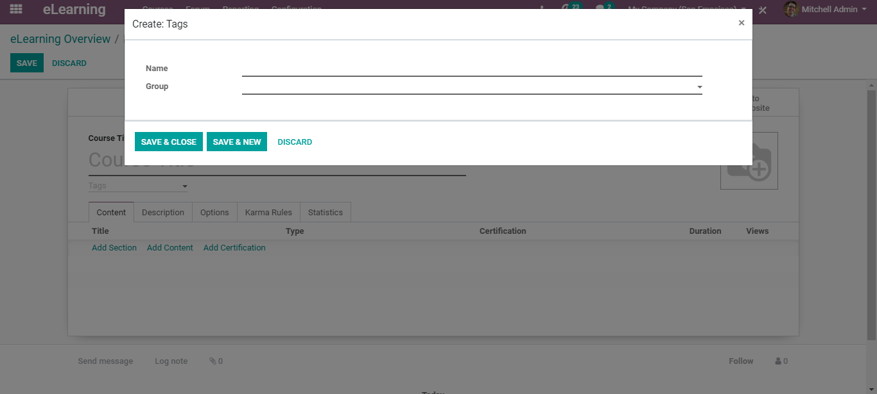

One can name and group the tag (to which the tag belongs to).

Contents:

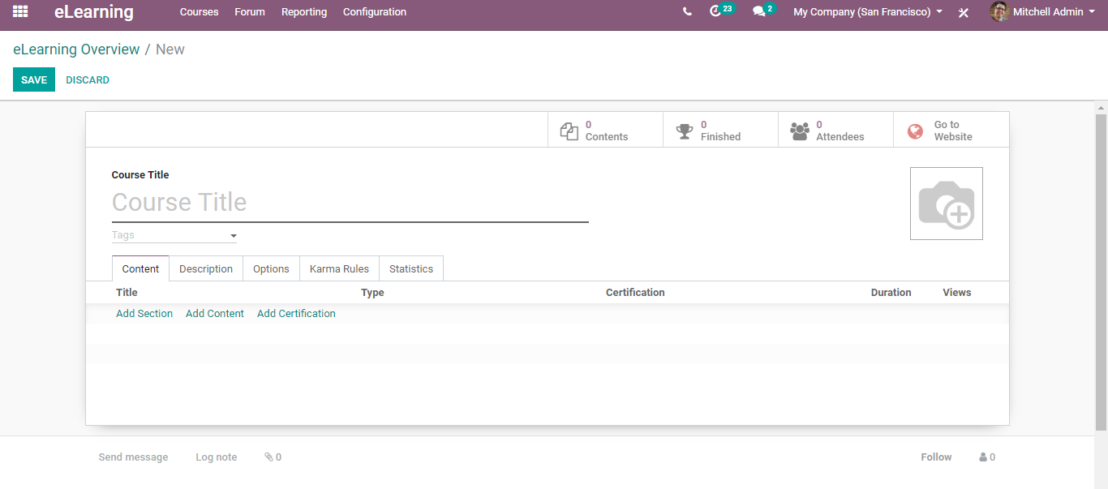

**Under the contents tab,**

One can add the section, content, certification for the course.

Upon clicking content, you are navigated to a new window like below:

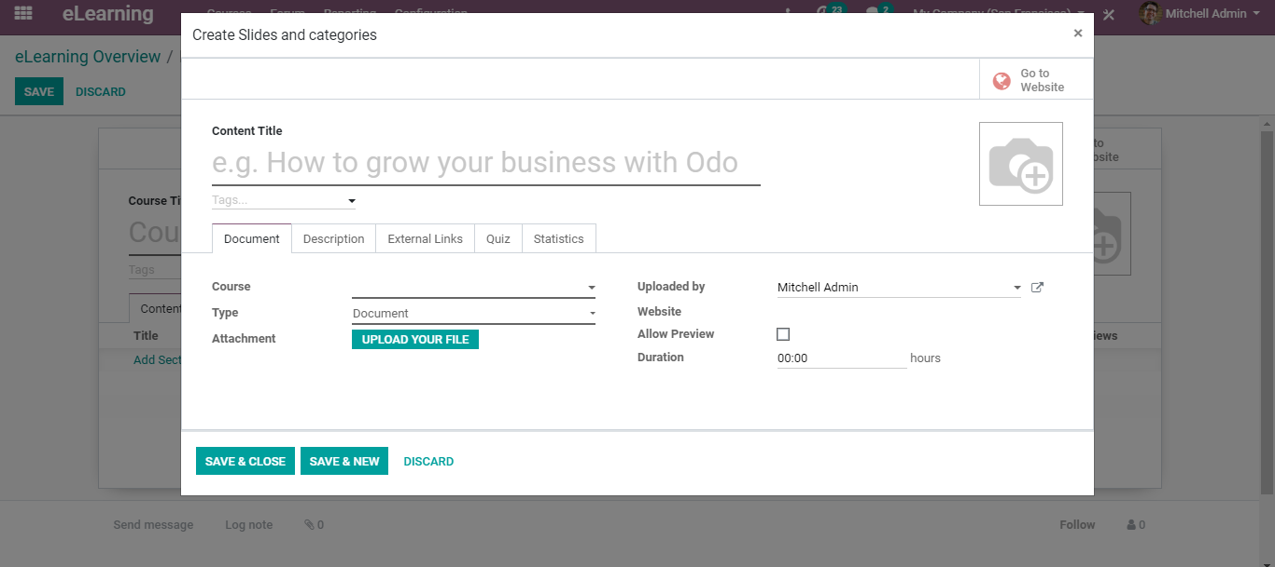

Here, you can add:

* Course Title
* Course Tag
* Course

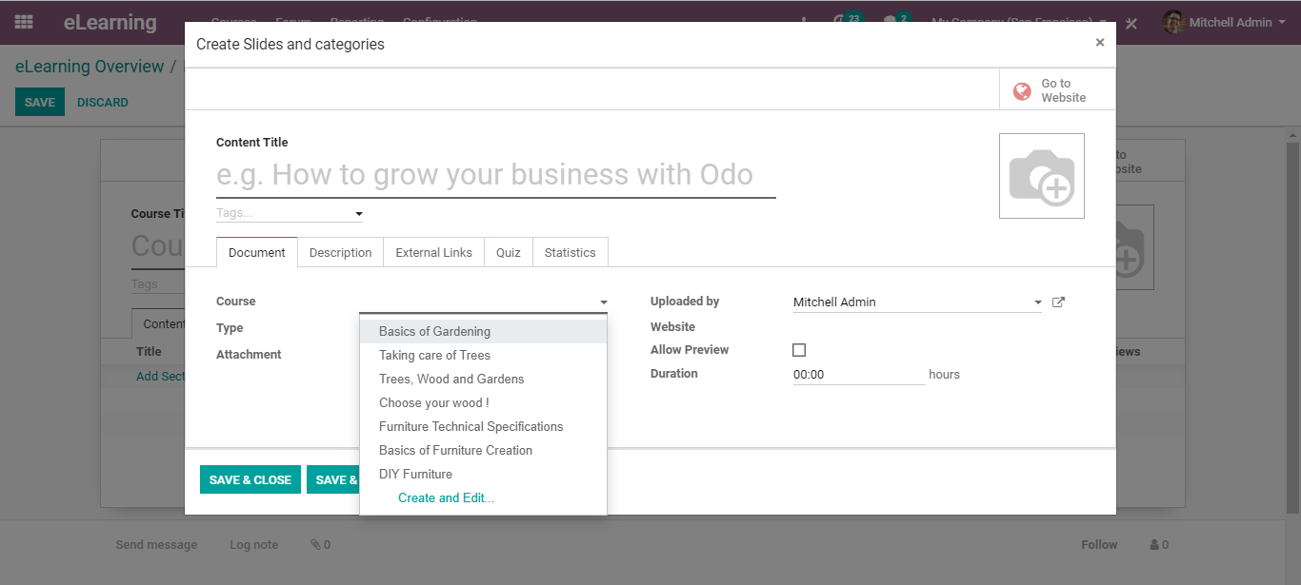

One can either select from the drop-down menu or create a new one. To create a new course, click CREATE and EDIT menu.

Course Type

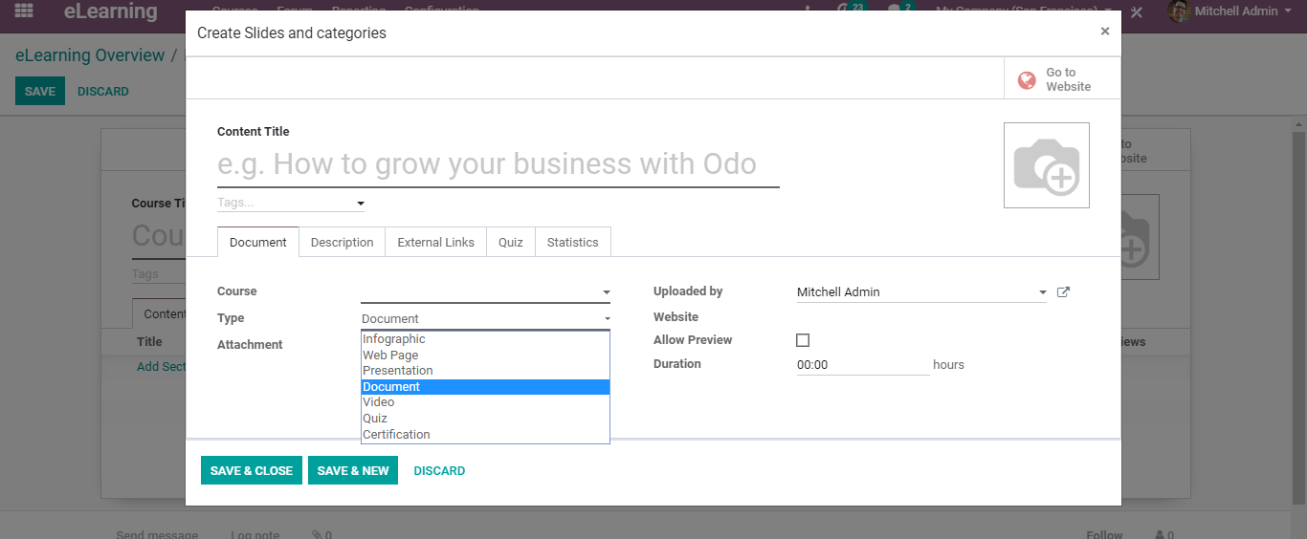

Whether it is an Infographics, Webpage, Presentation, Document, Videos, Quiz, Certificate etc.

* Attach documents under the content if needed.
* Website: Via selecting the website, you can restrict publishing the content to this website.
* Allow Preview: Via clicking the course gets accessible to anyone, the users need not join the channel to access the course content.
* Duration: The estimated completion time for this slide.

**Under options tab**

Under the options tab of the course creation form, you have the following fields.

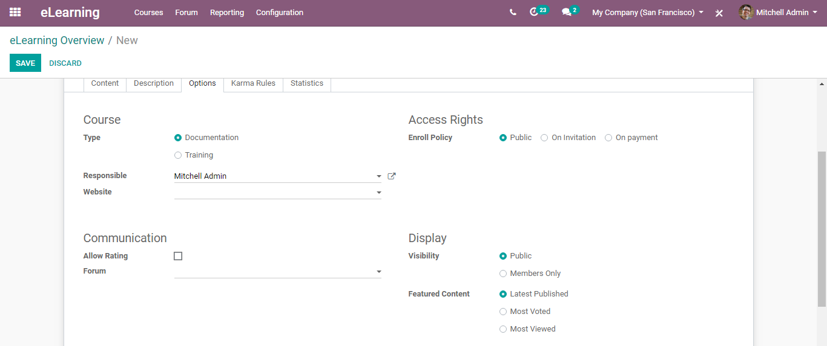

Here, you can define whether the course type is documentation or a kind of training.

Secondly, set the responsible for this course.

Access Rights: Under access rights, you can set conditions to enrol- whether it is for the public, on invitation, upon payment.

Display: Set visibility. Allow hiding channels and their content for non-members.

Featured content: Display featured content.

**Karma Rules:**

Using Karma Rules, one can set rules and points for acquiring karma for those individuals who join and attend the course.

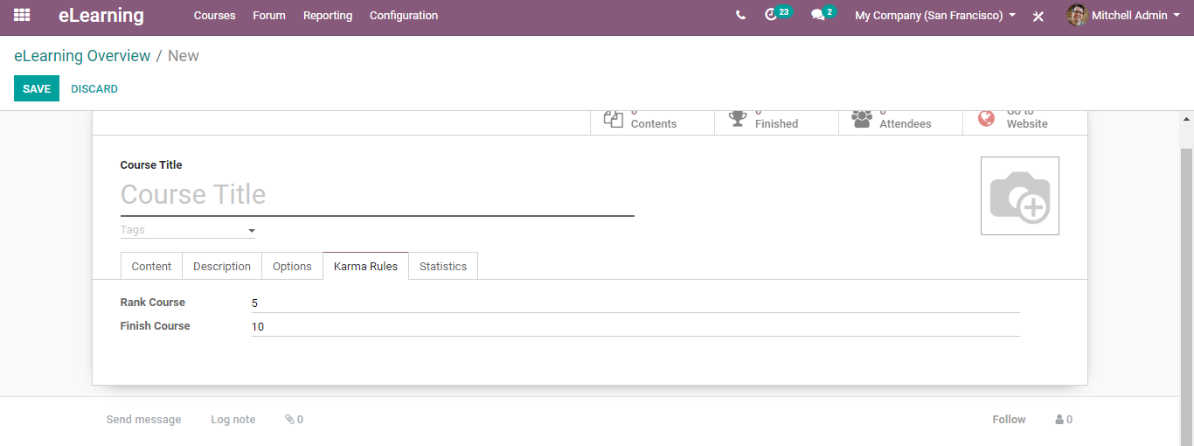

**Statistics:**

Under the tab, you get to know the course statistics, how many presentations, documents, videos, infographics, etc under the course.

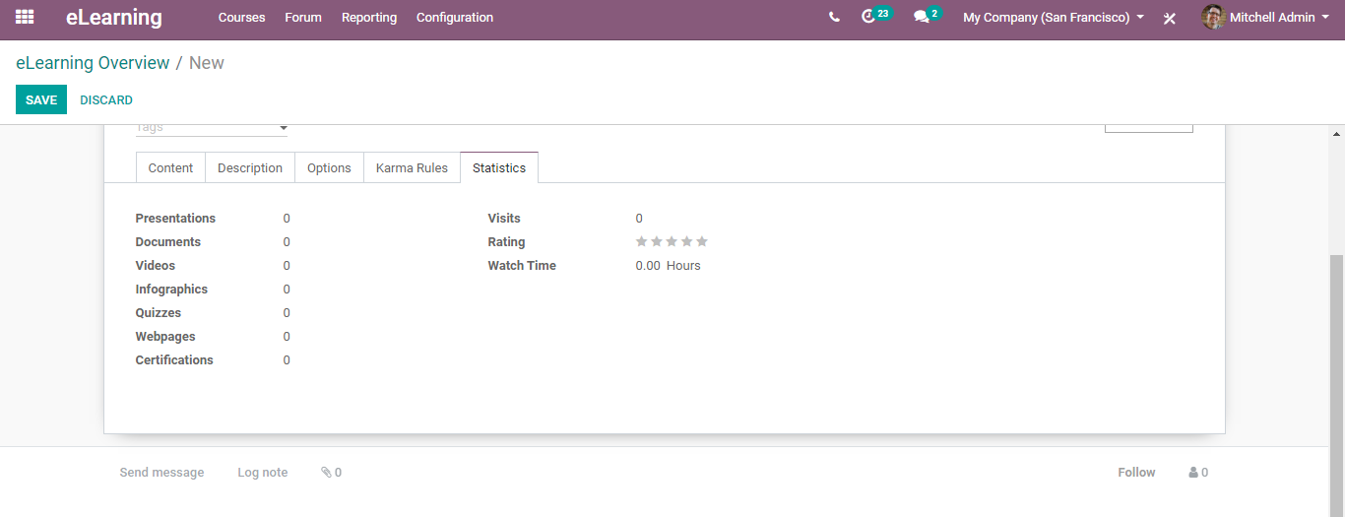

**Create Forums**

The forum invites the interplay of a large number of people. One can attain maximum participation of the people via creating forums.

To create a forum in the eLearning module of BUSINESSBOXERP, go to eLearning> Forums> Create.

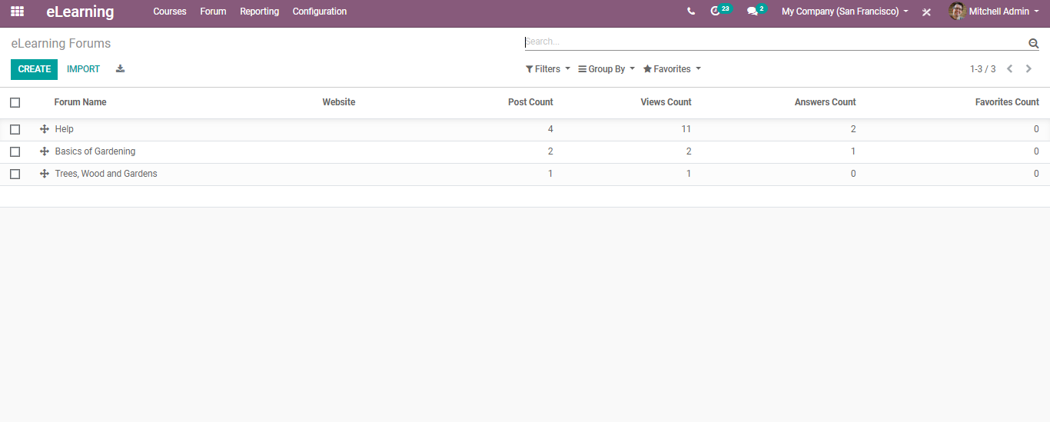

From the dashboard, you can see the already created forums. Alongside you can see their Post Count, Views Count, Answer Count etc.

To create a new forum, click CREATE button.

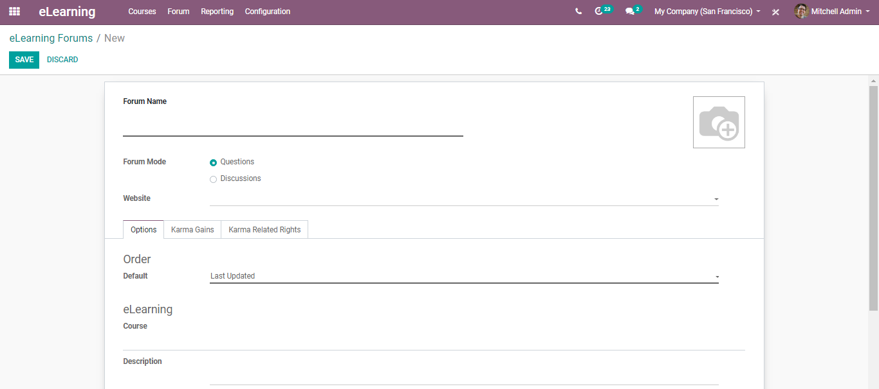

Under the form, you can define the forum mode whether it is questions or the discussions, secondly the website in which it will be started, karma gains (rules).

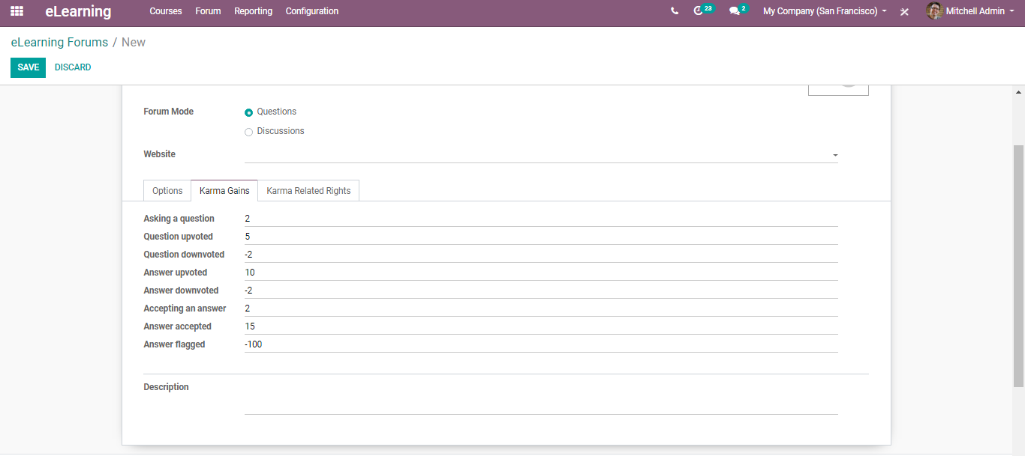

Karma Related Rights: Specifics of Karma Rules.

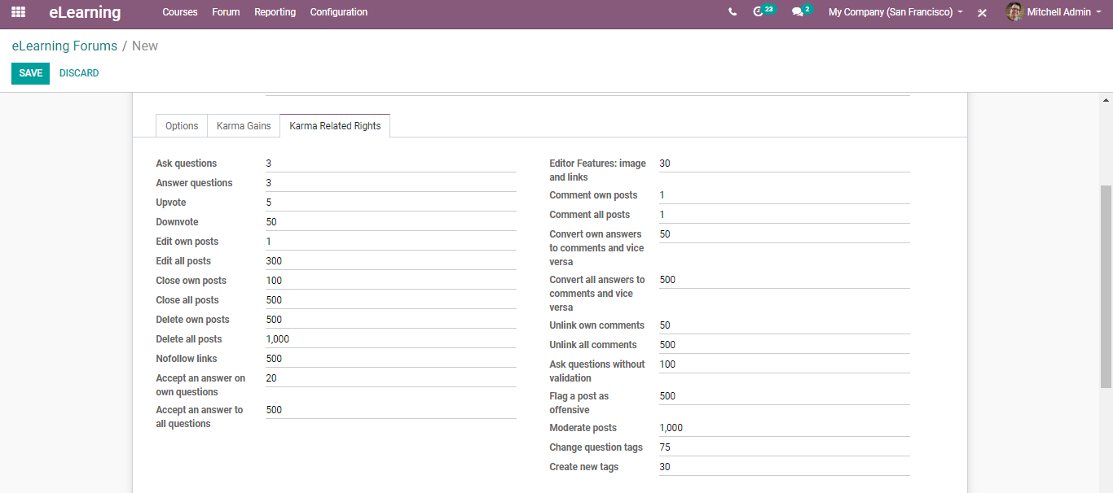

**Via going to eLearning> Forums> Post**

One can create content for forums.

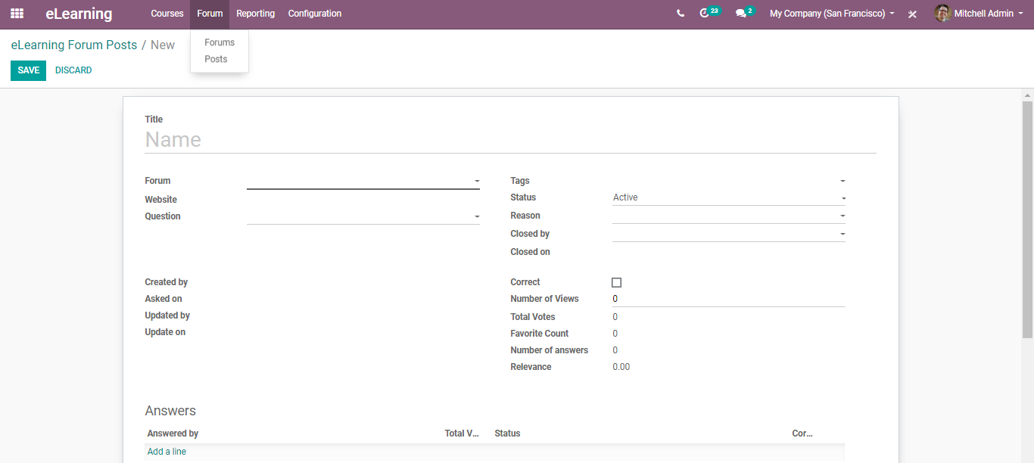

**Survey/Certifications**

Via going to eLearning> Reporting > Certifications

One can create a certificate for the course.

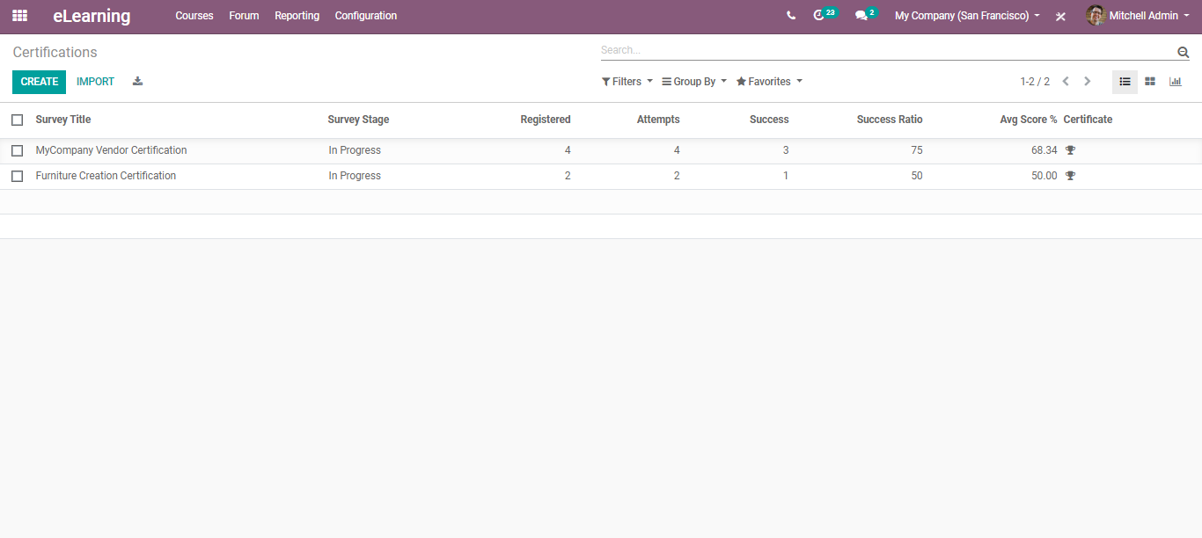

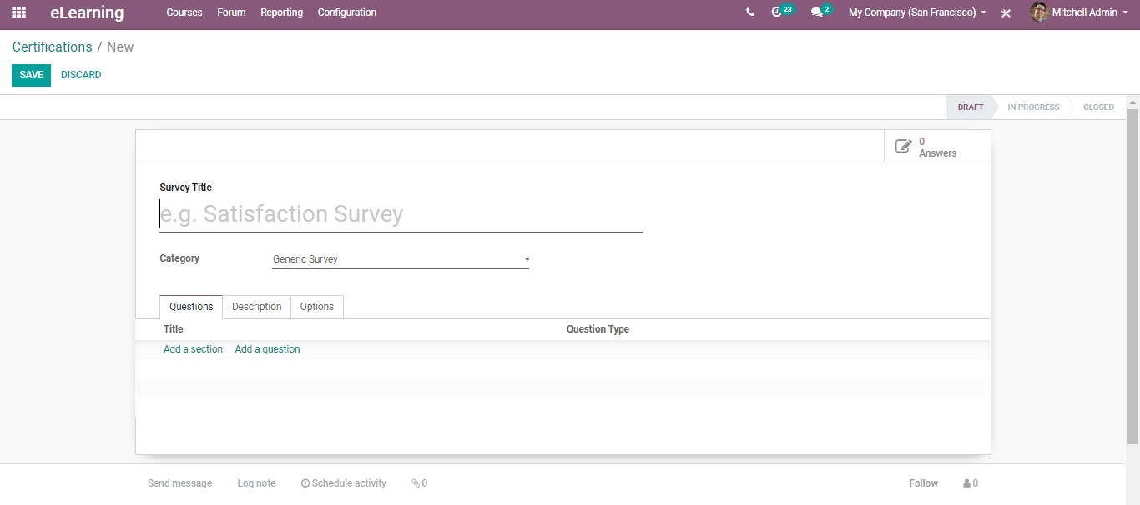

Here you can give away the title, category, add questions, question types

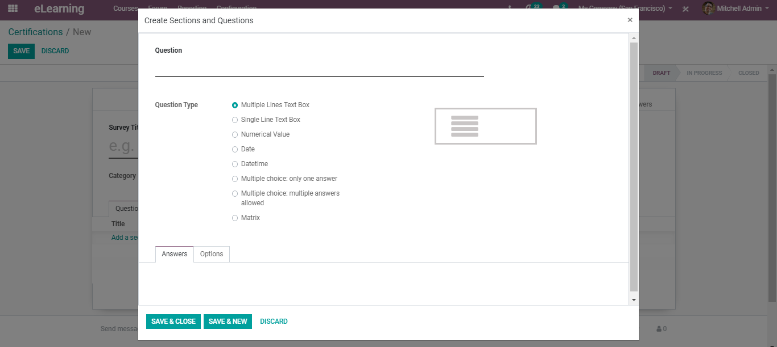

Also, options for setting question layouts, time limits, scoring rules, access mode etc.

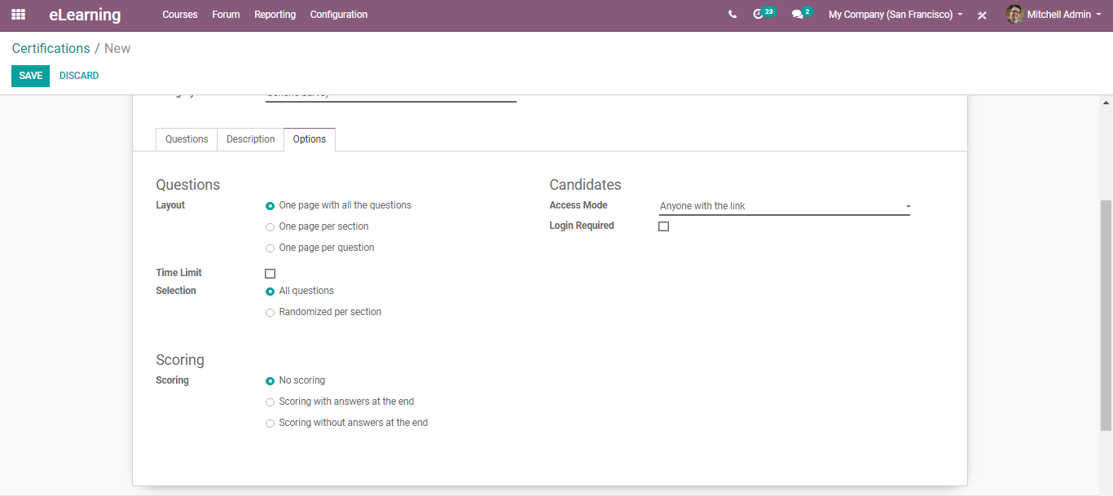

Upon setting, click SAVE to mark the changes.

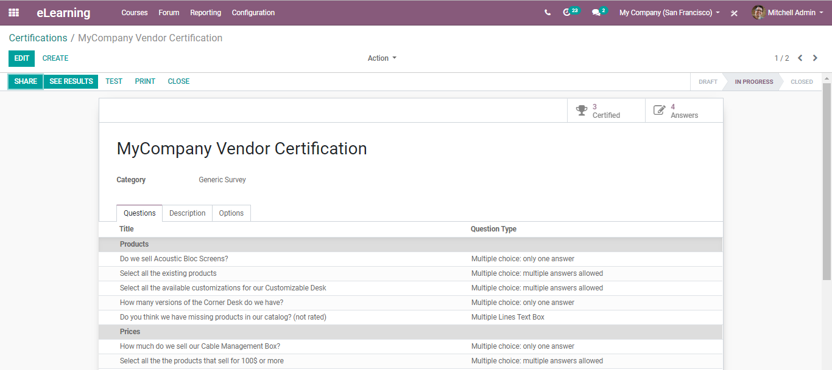

One can share the certification, see results, print, and close it via clicking the appropriate actions.

For sharing the survey, click the SURVEY button.

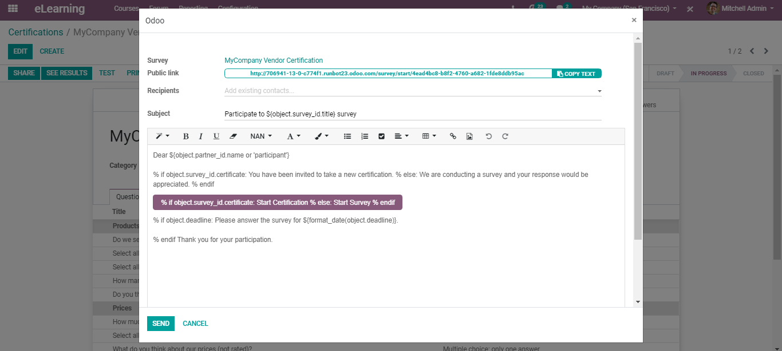

To see the survey results, click SEE RESULTS. You will be navigated to the webpage detailing the result overview.

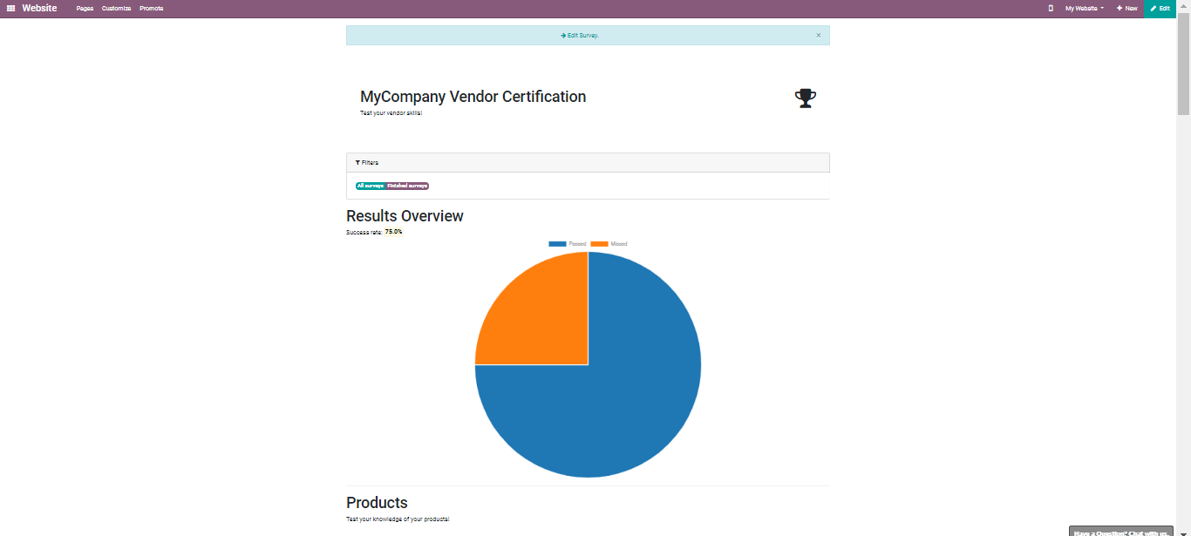

To start certification, click the TEST option.

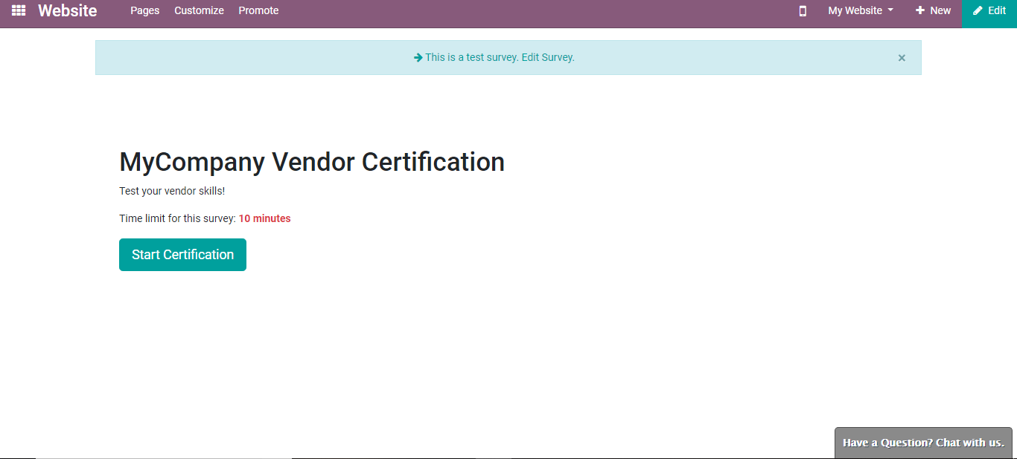

You can see the questions you framed. Alongside you can see the time running or the time left to complete the survey.

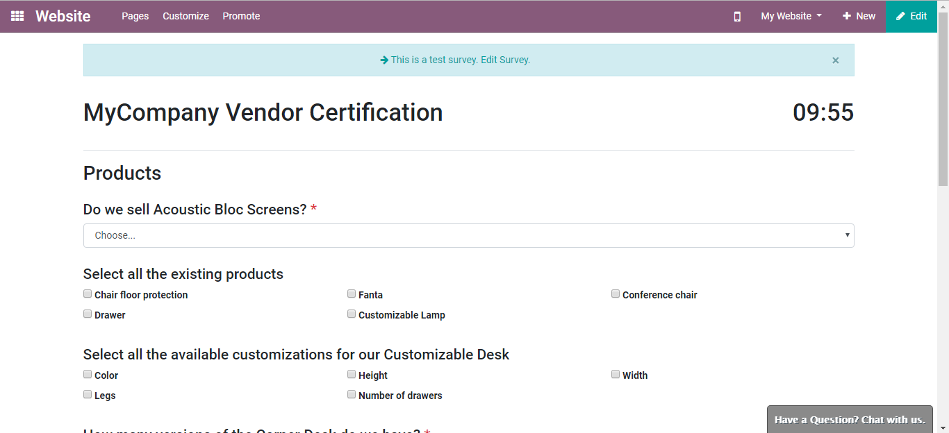

Via clicking the Edit button, one can make changes to it.

**View/Pick Course**

To view the published courses, click the VIEW COURSE button provided on each course segment.

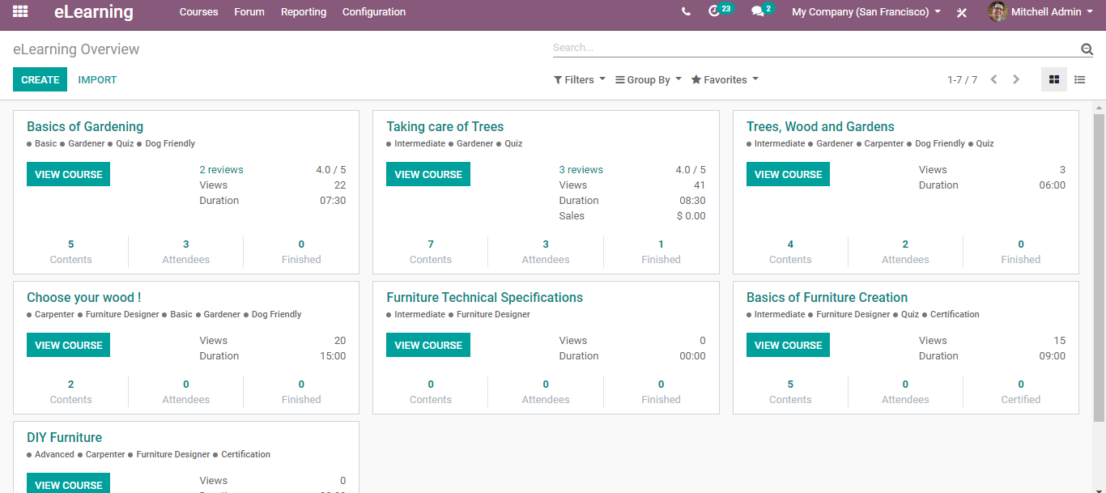

Upon clicking you are navigated to the website page of course.

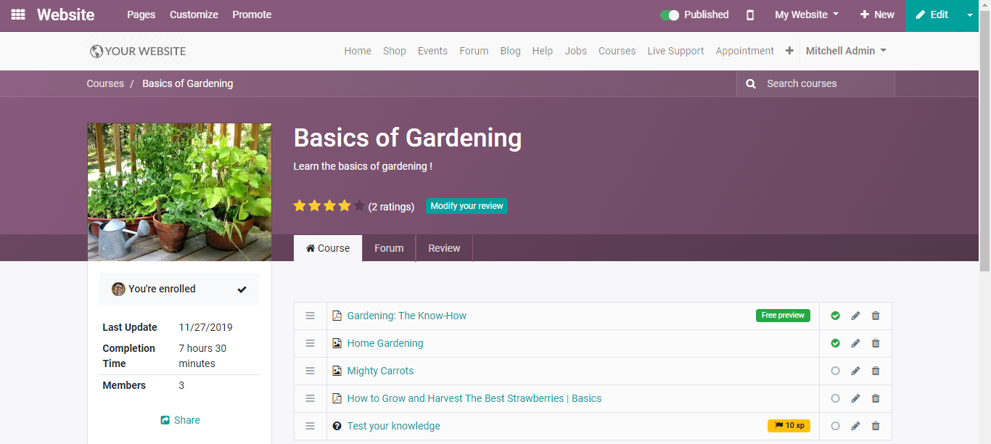

Here you can view, filter, and search the courses you want. Also, the end-user can get the details such as his rank, badges gained and more.